Year 9

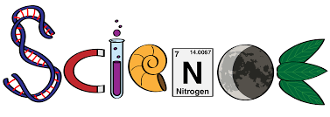

Topic 1 Cells (part 2)

Topic 2 Atomic structure (part 2)

Topic 3 Energy transfer by heating

Topic 4 Periodic table

Topic 5 Energy Resources

Topic 1: Cells (part 2)
5 lessons

Useful links

- Diffusion https://www.bbc.co.uk/bitesize/guides/zs63tv4/revision/1
- Osmosis https://www.bbc.co.uk/bitesize/guides/zs63tv4/revision/4
- Osmosis in plants https://www.bbc.co.uk/bitesize/guides/zs63tv4/revision/5
- Active transport https://www.bbc.co.uk/bitesize/guides/zs63tv4/revision/8
- Exchange materials https://www.bbc.co.uk/bitesize/guides/zpxv6yc/revision/3

Lesson 1. Diffusion
- Describe the process of diffusion. Include the types of particles involved.

- State 3 factors that affect the rate of diffusion.

- Explain why diffusion takes place faster when there is an increase in temperature.

Lesson 2: Osmosis
- Use the beakers to draw the particles in a concentrated and dilute solution. For each describe the number of particles of solute ( ) compared to the number of particles of water ( ).

Dilute solution: Concentrated solution:

Particles of water: Particles of water:

Particles of solute: Particles of solute:

- State the difference between osmosis and diffusion.

- Explain why it is so important for cells of the human body that the solute concentration of the fluid surrounding the cells is kept as constant as possible

Lesson 3: Osmosis in Plants
Use the website to hep you answer the questions:
https://www.bbc.co.uk/bitesize/guides/zs63tv4/revision/5

- Students carried out an investigation into the effects of osmosis on plant tissues, placing three sets of beetroot chips in three different sugar solutions for 30 minutes. The beetroot chips closely matched in size and were weighed, and their mass recorded. After 30 minutes, the chips were removed from the solutions, blotted with paper to remove surface water and reweighed and their final mass recorded.
  - State the following variables:
Independent:

Dependent:

Control:

- Why was it important that the chips were blotted with paper before being reweighed?

- One set has gained mass, another lost mass, and the third set did not change. One student thought the last experiment had not worked. Another disagreed. Explain the results in terms of osmosis in plant cells.

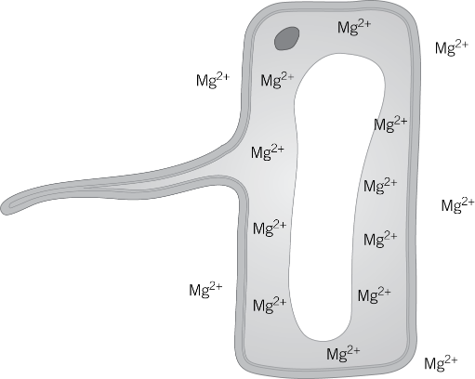
Lesson 4: Active Transport
- Look at the concentration of magnesium ions in the root hair cell and the concentration of magnesium ions in the soil solution. Suggest which way you expect the magnesium ions to move by diffusion.

- Explain how the root hair cell uses active transport to take up the ions.

- State two other examples of situations where active transport occurs.

- Describe how active transport differs from diffusion and osmosis.

- Explain why cells that carry out a lot of active transport also usually have many mitochondria.

Lesson 5: Exchange materials
- Describe two adaptations of an effective exchange surface.

- Summarise the adaptations you would expect to see in 3 exchange surfaces and explain the importance of each adaptation.

Topic 2: Atomic structure (part 2)
3 lessons

Useful links

- History of the atom
https://studyrocket.co.uk/revision/gcse-physics-combined-science-aqa/combined-trilogy-atoms-isotopes/history-of-an-atom
- Ions, atoms and isotopes https://www.bbc.co.uk/bitesize/guides/zd8hvcw/revision/1
https://www.bbc.co.uk/bitesize/guides/z964y4j/revision/2
- Electronic structure https://www.bbc.co.uk/bitesize/guides/zwt2k2p/revision/3

Lesson 1: History of the atom
https://studyrocket.co.uk/revision/gcse-physics-combined-science-aqa/combined-trilogy-atoms-isotopes/history-of-an-atom
Using the website, complete the timeline of the history of the atom. Include the following:
- Put the models in the correct order of development from earliest (at the top) to latest (at the bottom)
- Say who developed it
- Draw a diagram of the model
- State the evidence to support it

Lesson 2: Ions, isotopes and atoms

Use the websites to help you answer the following questions: https://www.bbc.co.uk/bitesize/guides/zd8hvcw/revision/1

- What is an ion?

- What type of ion do metals form? Explain why.

- What type of ion do non-metals form? Explain why.

https://www.bbc.co.uk/bitesize/guides/z964y4j/revision/2

- What is an isotope? Write a definition.

- Write down an example of an atom and its isotopes.

Lesson 3: Electronic structure
Use the knowledge organiser to help with these questions:
Figure 1 shows a lithium atom.
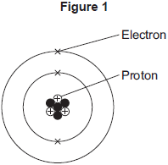
- What is the mass number of the lithium atom in Figure 1?

Tick (✔) one box.
3
4
7

- What is the charge of an electron?

Tick (✔) one box.
–1
0
+1

- Protons are in the nucleus.
Which other sub-atomic particles are in the nucleus?

Tick (✔) one box.
ions
molecules
neutrons

- Complete the diagram to show the electronic structure of a magnesium atom.
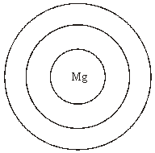

- The electronic structure of a neon atom shown in Figure 2 is not correct.
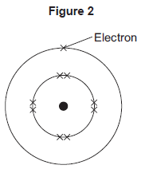
Explain what is wrong with the electronic structure shown in Figure 2

Topic 3 Energy transfer by heating
3 lessons

Useful links

- Conduction
https://www.bbc.co.uk/bitesize/guides/zttrd2p/revision/1
- Specific heat capacity
https://revisionscience.com/gcse-revision/physics/energy-resources-transfer/specific-heat-capacity
- Heating and insulating buildings
https://www.gcsescience.com/pinsulation.htm

Lesson 1: Conduction
Use the website to help you answer the following questions: https://www.bbc.co.uk/bitesize/guides/zttrd2p/revision/1

- List 3 examples of good thermal conductors.

- Name three materials which are insulators.

- What does it mean if a material has a high thermal conductivity?

Lesson 2: Specific heat capacity
- Define the specific heat capacity of a material.

- Write down the equation for specific heat capacity. State the units for each part of the equation.

Lesson 3: Heating and Insulating buildings
Use the website to help you answer the following questions: https://www.gcsescience.com/pinsulation.htm

- Name three ways to heat a house.

- Explain how cavity wall insulation reduces heat transfer through the walls of the house.

- Explain why placing aluminium foil behind a radiator reduces energy transfer through the walls.

The payback time of an energy-saving solution is a measure of how cost-effective it is. It can be calculated by:
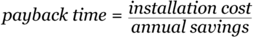

- A manufacturer of loft insulation claimed that each roll of loft insulation would save £10 per year on fuel bills. A householder bought 6 rolls of the loft insulation at £15 per roll and paid £90 to have the insulation fitted in the loft.
  - Calculate how much it cost in total to buy and install the insulation.

  - Calculate what the saving each year would be on fuel bills.

  - Calculate the payback time.

Topic 4: The Periodic Table
5 lessons

Useful links

- Development of the Periodic table
https://studyrocket.co.uk/revision/gcse-chemistry-combined-science-aqa/combined-science-the-periodic-table/history-of-the-periodic-table
- Electronic structure
https://www.bbc.co.uk/bitesize/guides/ztgbpbk/revision/5
- Group 1 – the Alkali metals
http://www.docbrown.info/page03/Alkali_Metals.htm
- Group 7 – The Halogens
http://www.docbrown.info/page03/The_Halogens.htm
- Explaining trends
http://www.passmyexams.co.uk/GCSE/chemistry/trends-in-alkali-metals.html
and
http://www.passmyexams.co.uk/GCSE/chemistry/trends-in-halogens.html

Lesson1: Development of the periodic table

- Label the diagram, identifying key parts of the periodic table. The atomic Structure knowledge organiser can help.
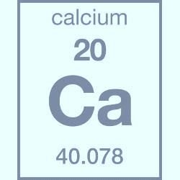

The modern periodic table is:
- Organised by atomic number
- Metals on left and non-metals on the right
- Groups of chemically similar elements
- Periods for each new electron shell

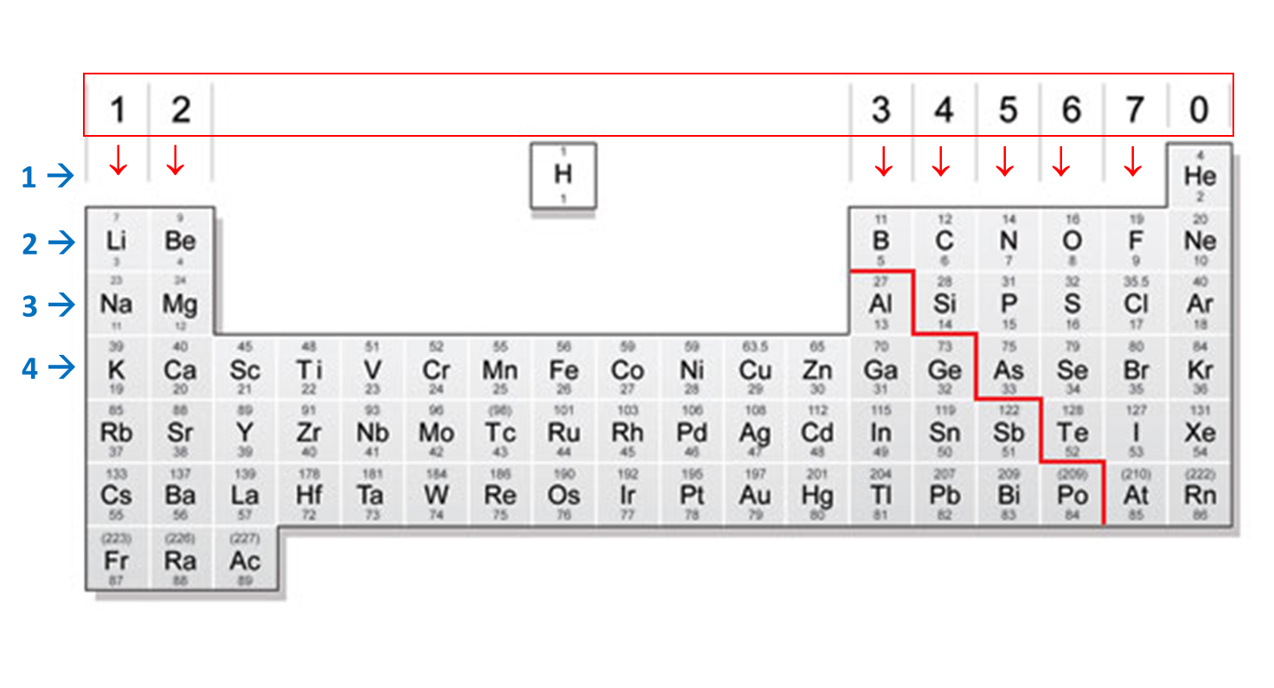

- Watch the video and answer the questions: https://www.youtube.com/watch?v=5SmqluhAMA0&list=PLW0gavSzhMlReKGMVfUt6YuNQsO0bqSMV&index=172

  - Are there more metals or non-metals in the periodic table?

  - What element is in group 2, period 4?

  - How many electrons does iodine have in its outer shell?

  - Why are carbon and silicon in the same group?

  - Why is sodium below lithium in the periodic table?

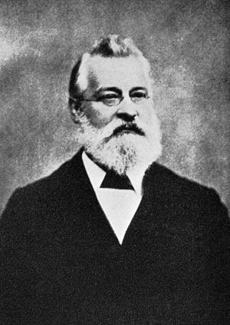
Two early periodic tables:
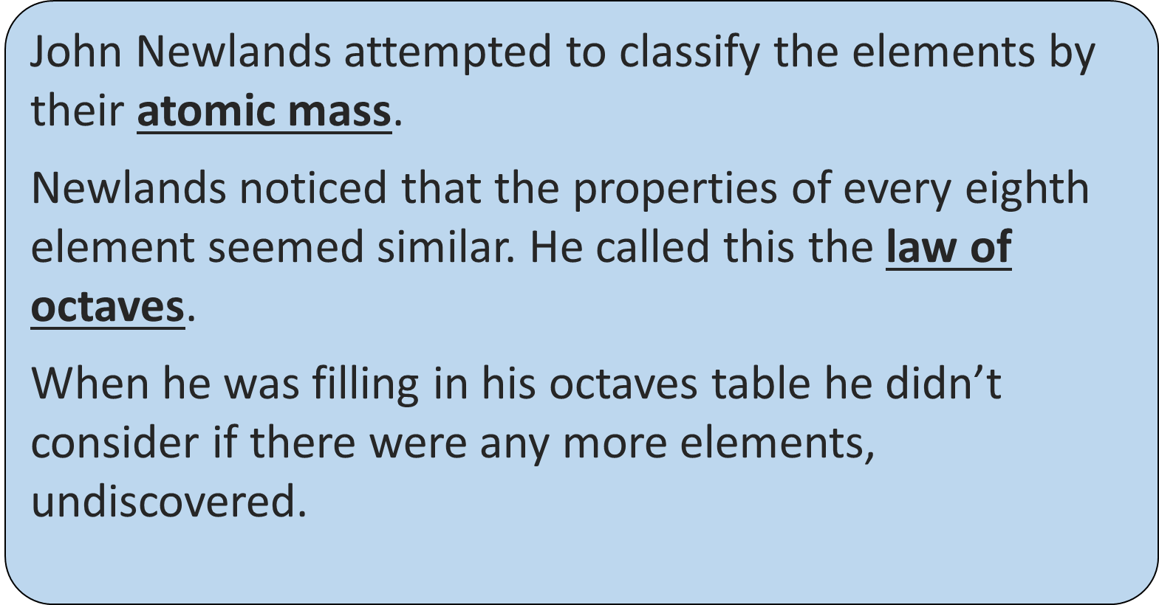
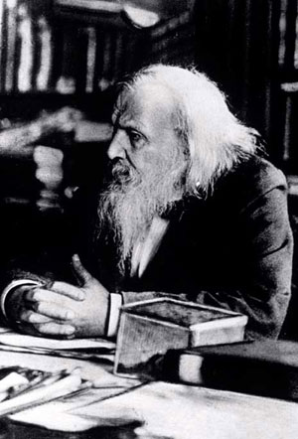
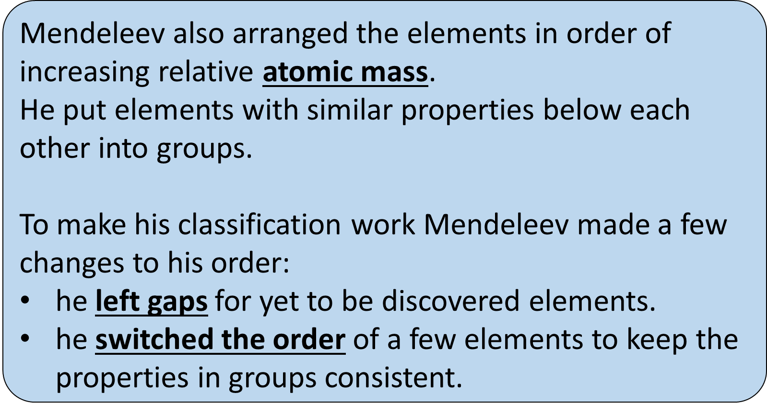

Watch this video and use the information on the previous page to answer the question
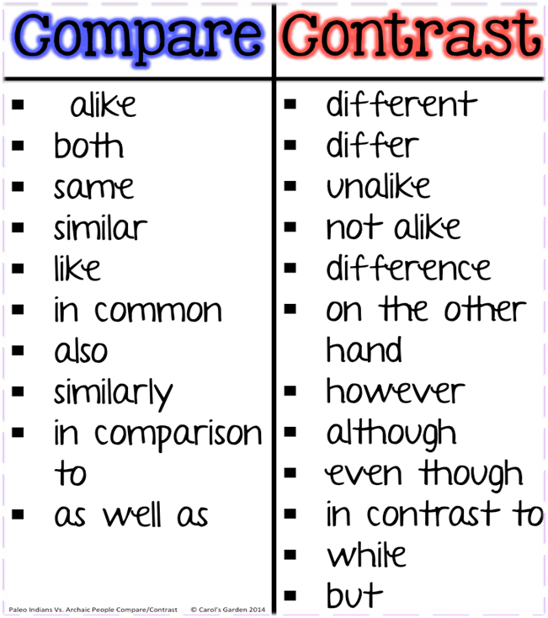
https://www.youtube.com/watch?v=L4M2VKASI1Q

- Write a paragraph (or bullet points in a table) explaining the similarities and differences between the two scientists’ discoveries and the reaction that each got.

Lesson 2: Electronic structure and the periodic table
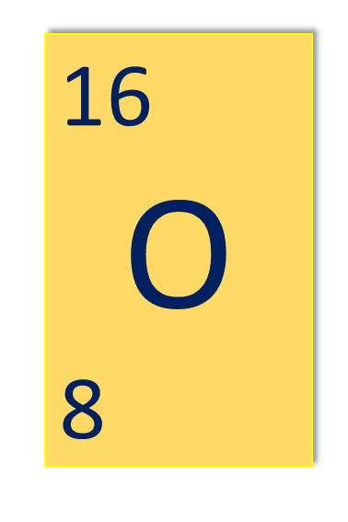
Oxygen has an atomic number of 8. This means it has 8 protons I the nucleus. It also has 8 electrons (each positive charge of the protons is balanced by the negative charge of the electrons.)

The electronic structure for oxygen is 2,6. This means oxygen has:
2 electrons in the first shell
6 electrons in the second shell
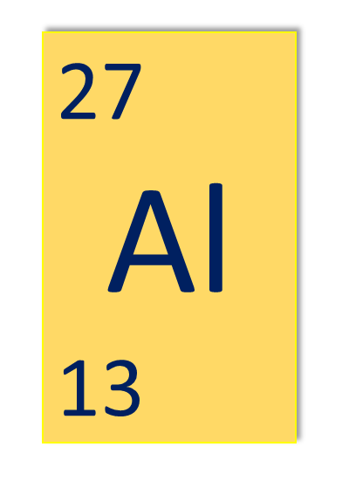
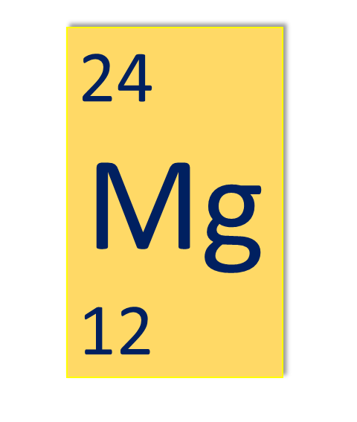
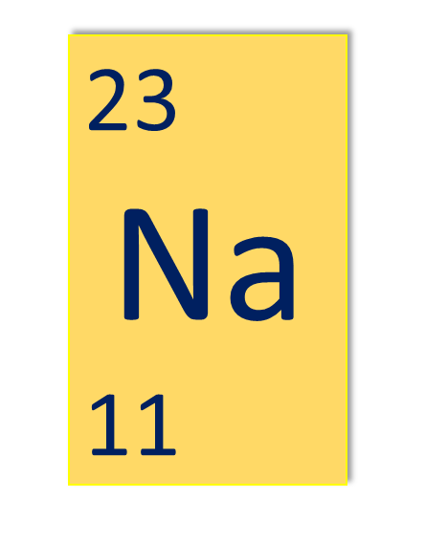

Use the C1 Atomic Structure periodic table to describe the electronic structure for the three elements here.

Lesson 3: Group 1 – The Alkali metals
- Use the information in the table to describe the trend in boiling points for group 1 elements.

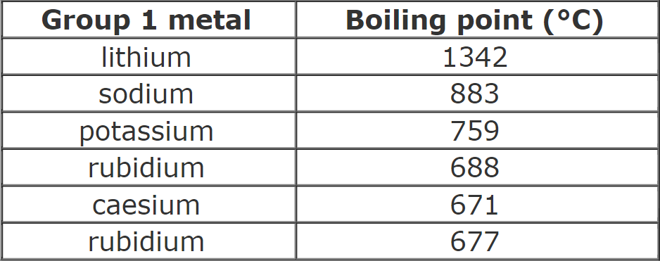

- Complete the sentences using the words in the box. The video can also help: https://www.youtube.com/watch?v=dZGDUKQa_6g

unreactive 0 1 noble gases less reactive 7
more stable alkali metals halogens.

Elements in Group 1 of the periodic table are known as the ________________________. All atoms of Group 1 elements have ________ electron in their outer shell. The more shells of electrons a Group 1 metal element has, the more __________________ it is. This means that Group 1 metals become ________________ reactive down the group.

Lesson 4: Group 7 – The Halogens
Complete the sentences using the words in the box. The video can help: https://www.youtube.com/watch?v=HT1zAPQIBAQ

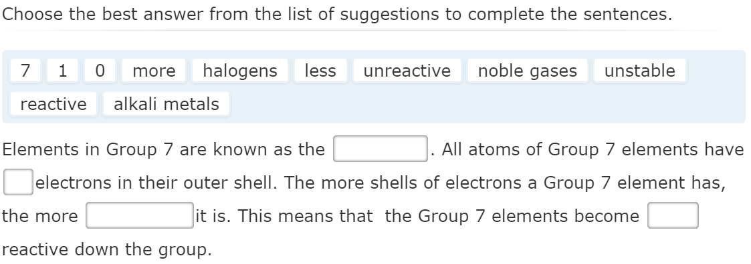

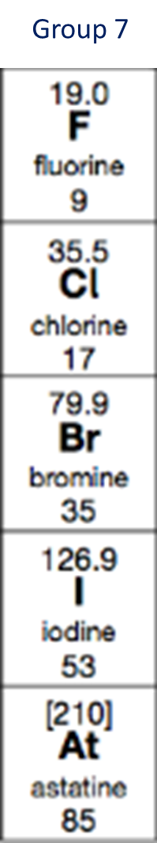
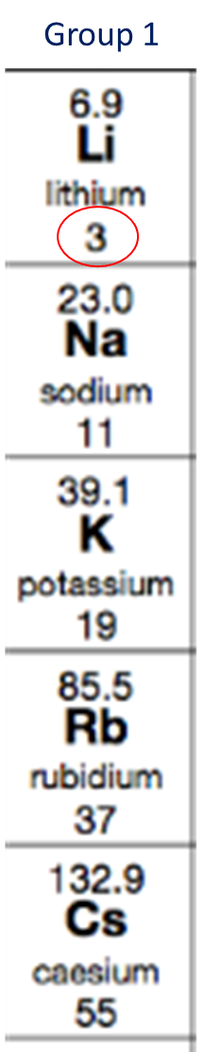
Lesson 5: Explaining trends in groups
- Draw the electronic structure of the first two elements in group 1 and group 7.

- How do group 1 elements get a full outer shell?

- How do group 7 elements get a full outer shell?

- What happens to the size of elements as you go down a group?

- As you go down a group are the outer electrons closer or further away from the positive nucleus?

- Will the outer electrons feel a stronger or weaker attraction to the nucleus as you go down the group?

Topic 4: Energy resources
5 lessons

Useful links

- Energy demands
http://www.darvill.clara.net/altenerg/index.htm
- Energy from wind and water
http://www.darvill.clara.net/altenerg/index.htm
- Energy from the sun and the earth
http://www.darvill.clara.net/altenerg/index.htm
- Energy and the environment
https://studyrocket.co.uk/revision/gcse-physics-aqa/energy/energy-resources
- Big energy issues
https://www.bbc.co.uk/bitesize/guides/z2wfxfr/revision/2

Lesson 1: Energy demands
- What do we mean by the term ‘renewable resource’?

- What do we mean by the term ‘non-renewable energy resource’?

- Complete the table comparing fossil fuels, biofuels and nuclear energy. Use the website to help. http://www.darvill.clara.net/altenerg/index.htm

 | Advantages | Disadvantages
Fossil fuels
Nuclear energy
Biofuels

Lesson 2: Energy from wind and water
- Complete the table comparing wind, tidal, wave and hydroelectric. Use the website to help. http://www.darvill.clara.net/altenerg/index.htm

 | Advantages | Disadvantages
Wind
Wave
Tidal
Hydro-electric

Lesson 3: Energy from the sun and the earth
- Complete the table comparing solar and geothermal energy. Use the website to help. http://www.darvill.clara.net/altenerg/index.htm

 | Advantages | Disadvantages
Solar power
Geo-thermal

- A satellite in space uses a solar cell panel for electricity. The panel generates 300 W of electrical power and has an area of 10 m². Each cell generates 0.2 W. Calculate how many cells are in the panel.

- The satellite mentioned in Q4 carries batteries that are charged by electricity from the solar cell panels. State why batteries are carried as well as solar cell panels.

Lesson 4: Energy and the environment
Use the websites to complete the table below:
https://studyrocket.co.uk/revision/gcse-physics-aqa/energy/energy-resources and https://www.bbc.co.uk/bitesize/guides/z8k9v9q/revision/2
 | Why is this a problem? | What can be done about it?
Burning fossil fuels releases carbon dioxide.
Burning fossil fuels releases sulfur dioxide.
Used fuel rods and other waste from nuclear power stations need to be disposed of.
Accidents, though rare, can happen at nuclear power stations. |  | There are no guarantees, but many safety precautions are used and accidents are rare. Steps can be taken after an accident to reduce harmful effects on humans.

Lesson 5: Big energy issues
https://www.bbc.co.uk/bitesize/guides/z2wfxfr/revision/2
- Name the type of power station that can be started the fastest [HINT: it’s a type of fossil fuel]

- Name the type of power station that does not produce greenhouse gases or radioactive waste.

- Name the type of renewable resource that can be used to store energy at times of low electricity demand.

- People need to cut back on fossil fuels to reduce the production of greenhouse gases. What could happen if the only energy people used was:
  - renewable energy?

  - nuclear power?

- Suggest three reasons why developed countries (like the UK) have high energy demand.

- Suggest why is it important to save energy in our homes.

- What is meant by the term ‘carbon footprint’?

