Lesson 1 and 2: Writing to show Viewpoint.
Please note: There is a lot to learn in these lessons. You won’t complete it all in one go! You can carry on in your next lesson – when you have spent 45 minutes on this lesson, stop and carry on with when your next English lesson would be. Once you have spent another 45 minutes in the next lesson finish, even if there are still some tasks to do.
Use the following link to access the video lesson we will be working alongside. I have created this resource to support you in approaching this lesson.
You will either need to print this document out or have it open in word alongside the video link and you can type in notes as you go.

https://classroom.thenational.academy/lessons/writing-to-show-viewpoint/activities/2/

Task 1: List of all the different types of non-fiction writing you can think of. Check your list next to the teacher’s list.

Task 2: Listen carefully to the teacher explain the following information below.

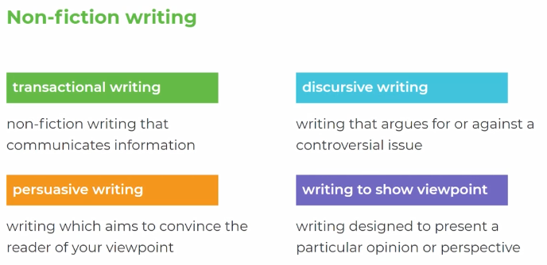
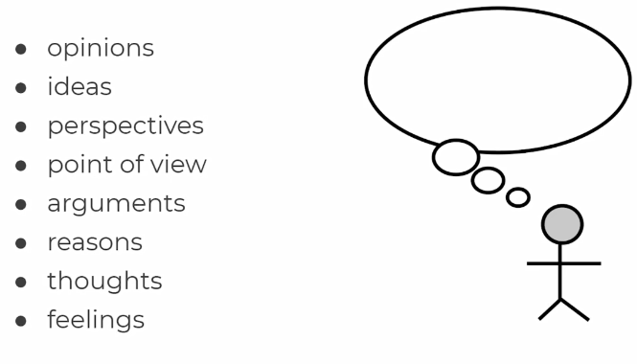
Task 3: Make a note of anything you can remember about how children were punished during the 19th century.

Task 4: Read carefully the following task – this is what we are going to be working towards writing about. Think about what your initial thoughts are on this statement.

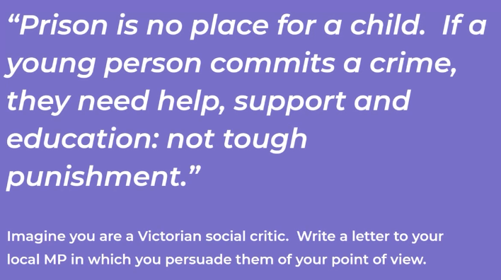

Task 5: Consider what Oscar Wilde think about children in prisons? What were the conditions like? What techniques does Oscar Wilde use to get across his thoughts?
Can you identify any of the following techniques:
Simile
Metaphor
Facts and opinions
Anecdotes
Emotive language
Hyperbolic/ exaggerations
Direct address ( use of pronouns ‘you’)
Modal verbs (should/could)

The terror of a child in prison is quite limitless. I remember once, in Reading, as I was going out to exercise, seeing in the dimly-lit cell right opposite my own, a small boy. Two warders — not unkindly men — were talking to him with some sternness apparently, or perhaps giving him some useful advice about his conduct. One was in the cell with him, the other was standing outside. The child’s face was like a white wedge of sheer terror. There was in his eyes the terror of a hunted animal.
This terror that seizes and dominates the child, as it seizes the grown man also, is of course intensified beyond power of expression by the solitary cellular system of our prisons. Every child is confined to its cell for twenty-three hours out of twenty-four. This is the appalling thing. To shut up a child in a dimly-lit cell for twenty-three hours out of twenty-four is an example of cruelty of stupidity. If an individual, parent or guardian, did this to a child he would be severely punished.

Of course no child under fourteen years of age should be sent to prison at all. It is an absurdity, and, like many absurdities, of absolutely tragic results.
If, however, they are to be sent to prison, during the daytime they should be in a workshop or schoolroom. At night, they should sleep in a dormitory, with a night-warder to look after them. They should be allowed exercise for at least three hours a day.
The dark, badly ventilated, ill-smelling prison cells are dreadful for a child, dreadful indeed for anyone. One is always breathing bad air in prison.
A resolution of the House of Commons could settle the treatment of children in half-an-hour. I hope you will use your influence to have this done. The way that children are treated at present is really an outrage on humanity and common sense. It comes from stupidity.

Task 6: Answer the following questions:
(check your answers with the examples the teacher gives)
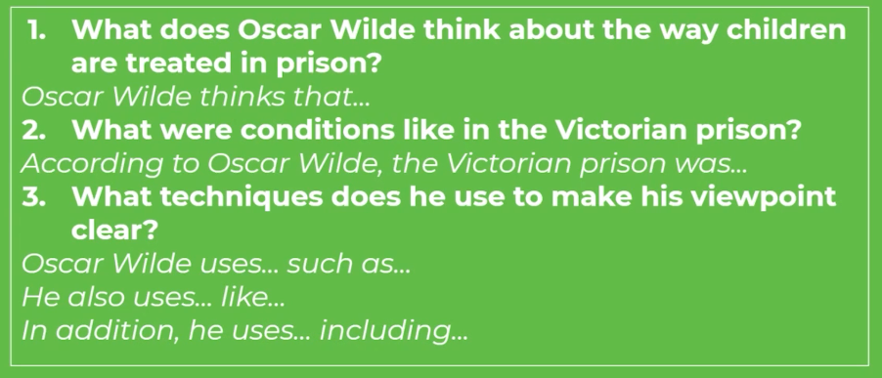

Task 7: Listen to the teacher explain the below parts of the letter and consider what Oscar Wilde is trying to achieve in each part.

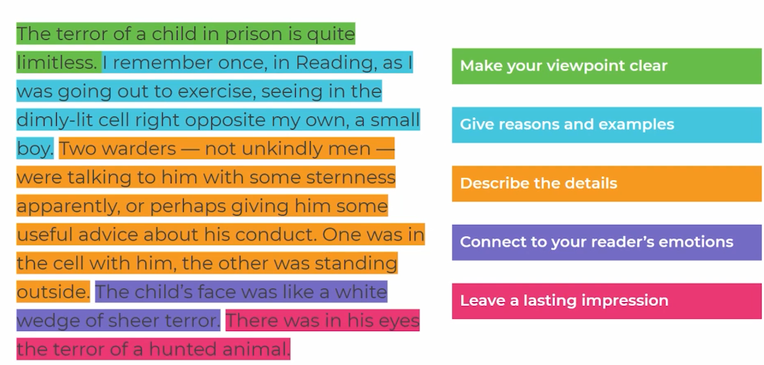

Task 8: Use the below structure to plan your ideas.

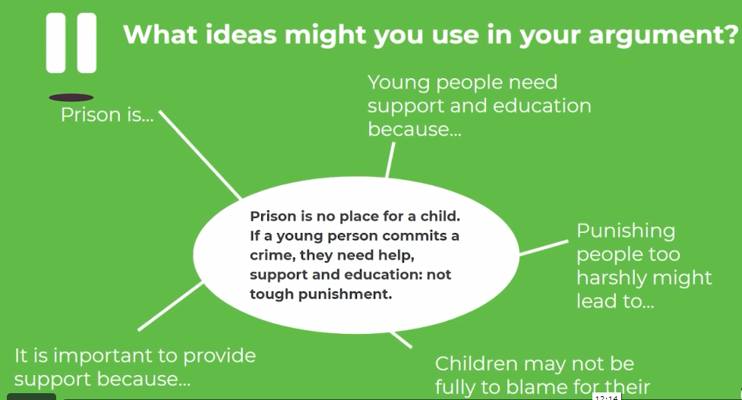

Task 9: Use the below ideas to help you:

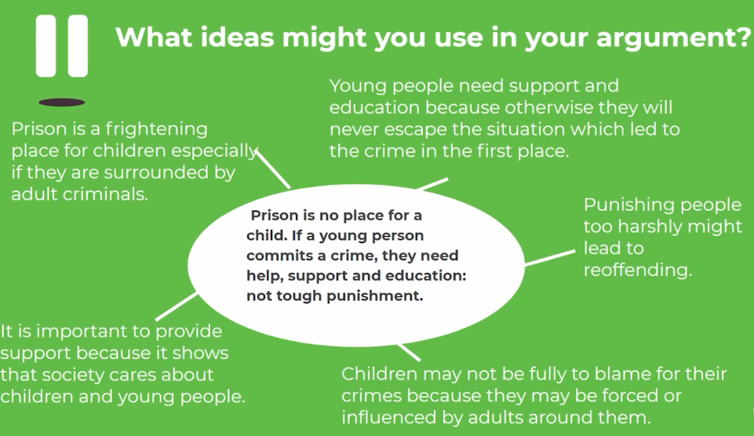

Task 10: Write for at least 20 minutes and complete the following task:

