Lesson 1 and 2: Structuring Narrative Writing

Please note: There is a lot to learn in these lessons. You won’t complete it all in one go! You can carry on in your next lesson – when you have spent 45 minutes on this lesson, stop and carry on with when your next English lesson would be – remember to make a note of where you pause the video at the end of each lesson.
Use the following link to access the video lesson we will be working alongside. I have created this resource to support you in approaching this lesson.
https://classroom.thenational.academy/lessons/structuring-narrative-writing/activities/2
You will either need to print this document out or have it open in word alongside the video link and you can type in notes as you go.

Task 1: Write down everything you know about narrative writing. Listen to the teacher’s ideas, to help you with this.

Task 2: Make a note of these key ideas:

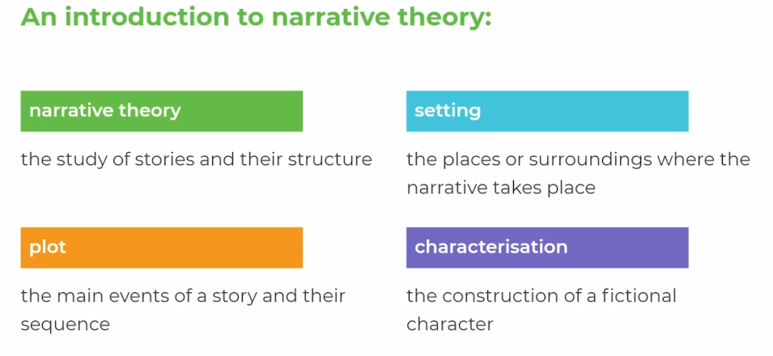

Task 3: Read along with the teacher as she shares this extract from the book ‘The Seven Basic Plots: Why we tell Stories.’
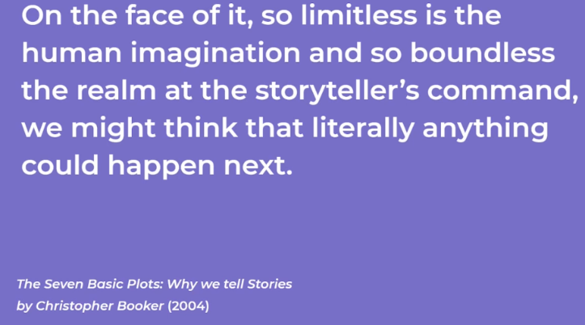

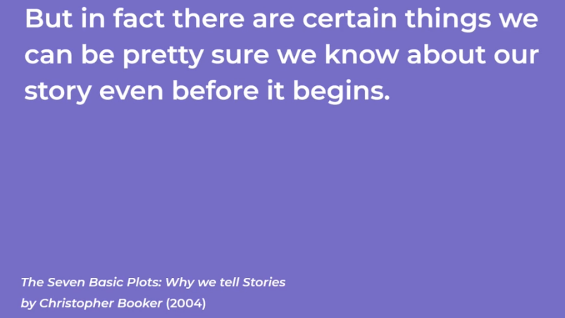
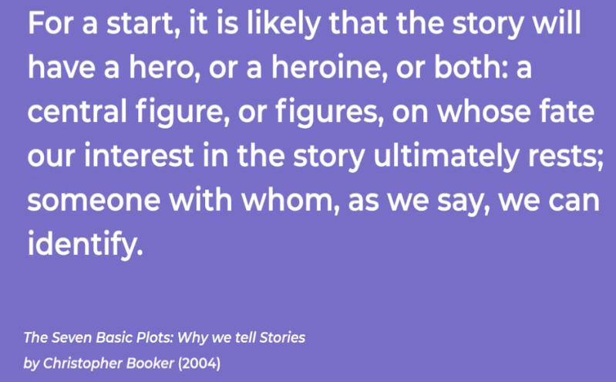
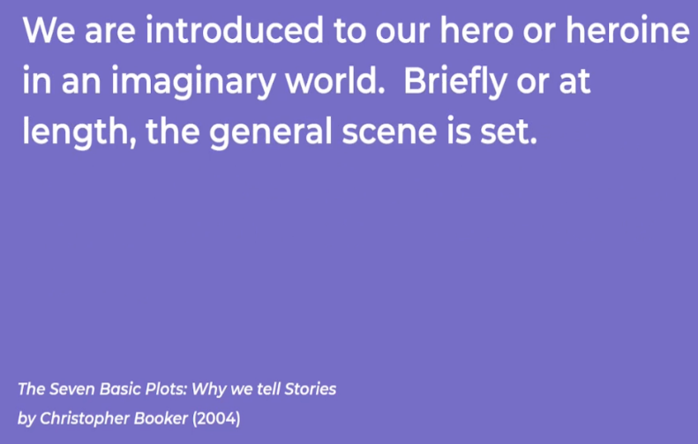
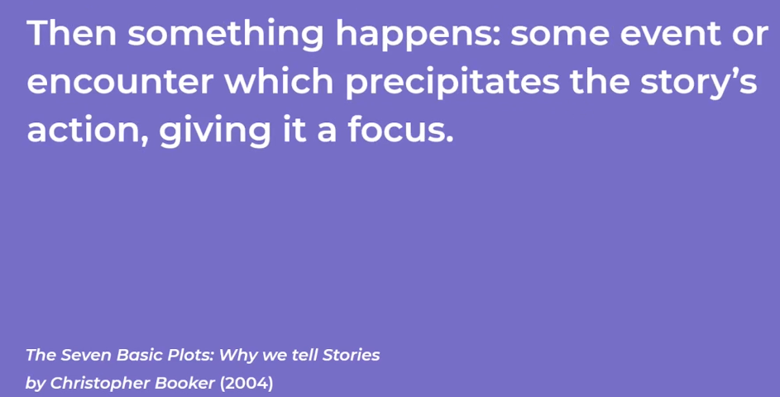
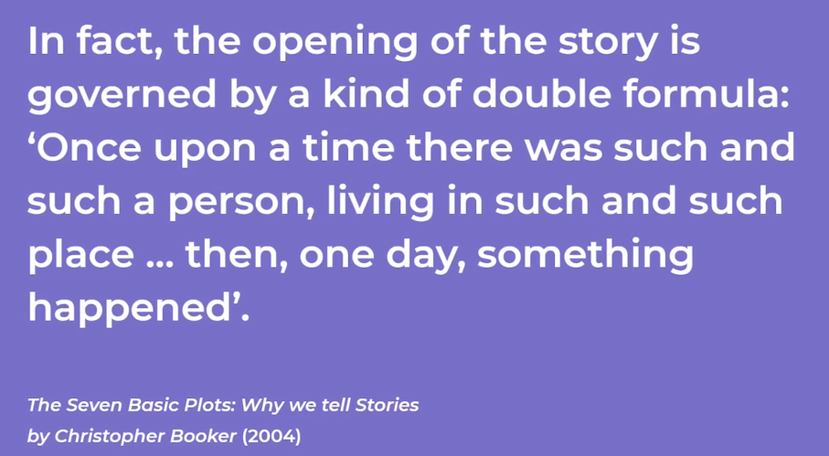

Task 4:
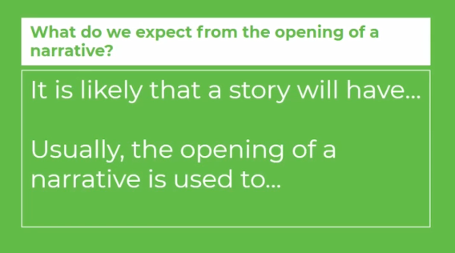

Task 5: As the teacher goes through each of the following, make notes in your own words about each one – feel free to pause the video if you need to.

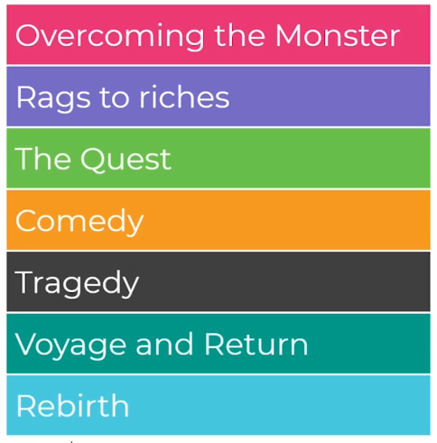

Task 6: Write the following prompt down and start to brainstorm some initial ideas about what your future story might be able.

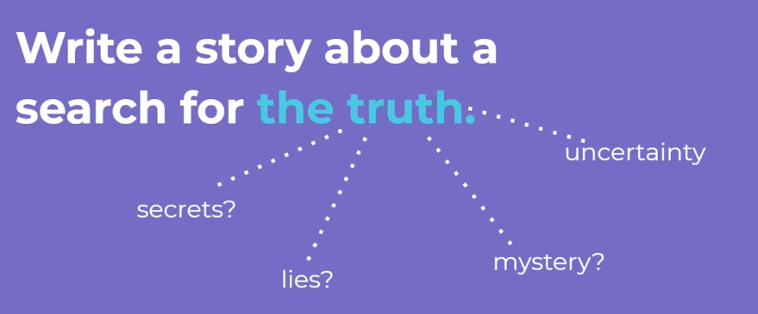

Task 7: Use the structure below to sketch out some initial ideas for a story. Look at the example below to help you.

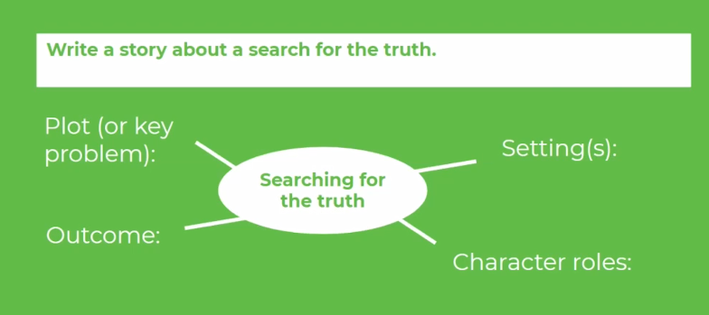

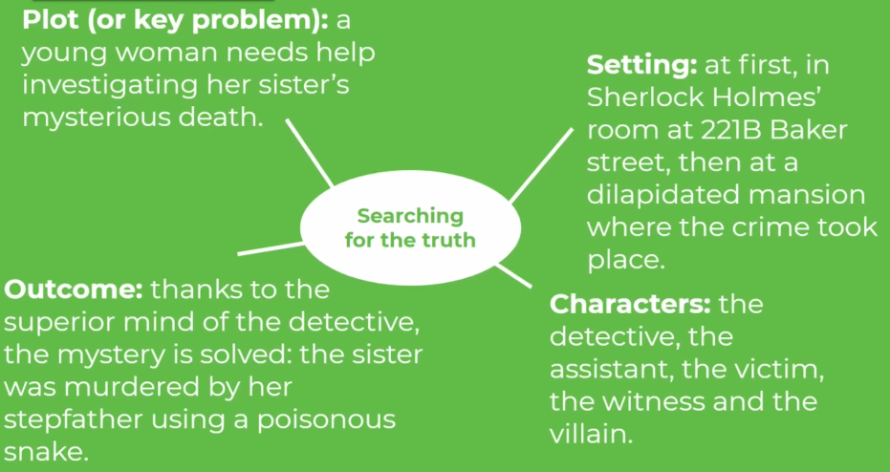

You may have spent 45 minutes by now, in which case you may want to pause now until your next English lesson – the video is at: 12:14.

Task 8: Have a think about which of the following you may have included in your planning:
Sketch out your basic plot - what will happen, in what order to which characters? How will the story end?
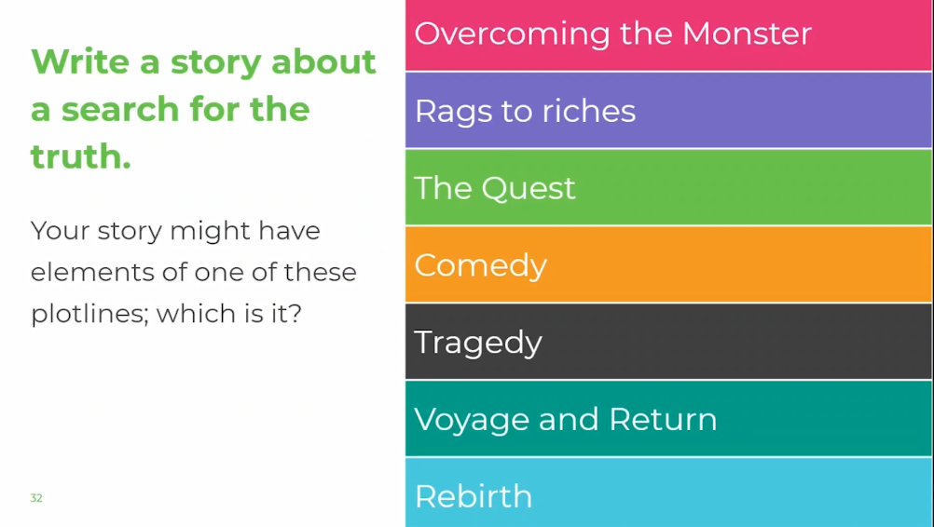

Task 9: Make a note of the following:

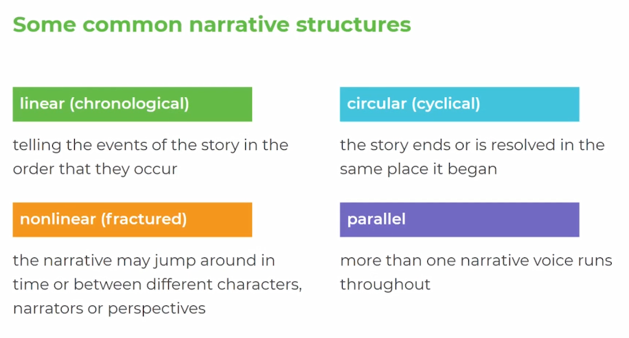

Task 10: Copy the follow table into your own notes:

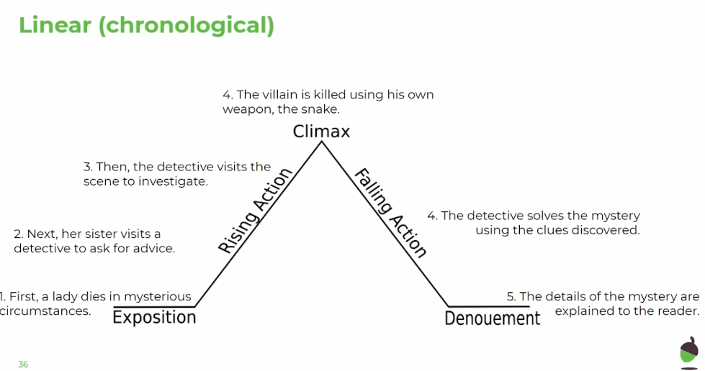

Task 11: Listen to the teacher’s ideas to guide you and then:

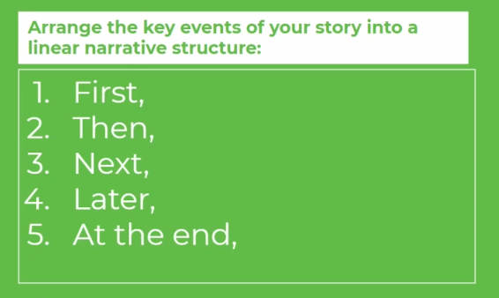

Task 12: Listen to the teacher’s ideas to guide you and then:
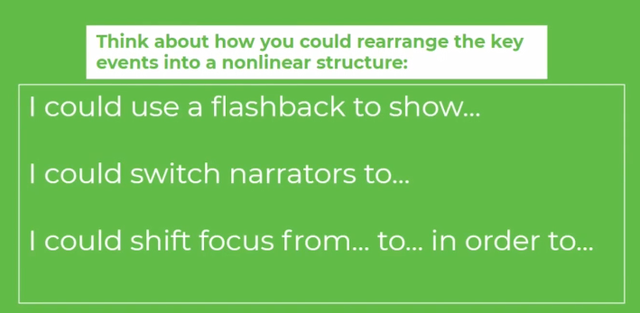

Task 13: Listen to the teacher’s ideas to guide you and then:

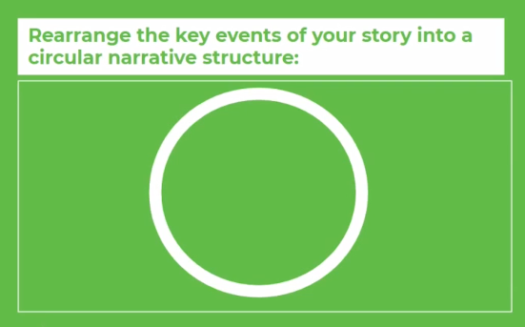
Task 14: Listen to the teacher’s ideas to guide you and then:
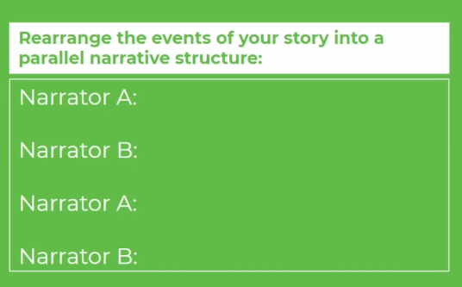

Task 15: Make a decision on the following:

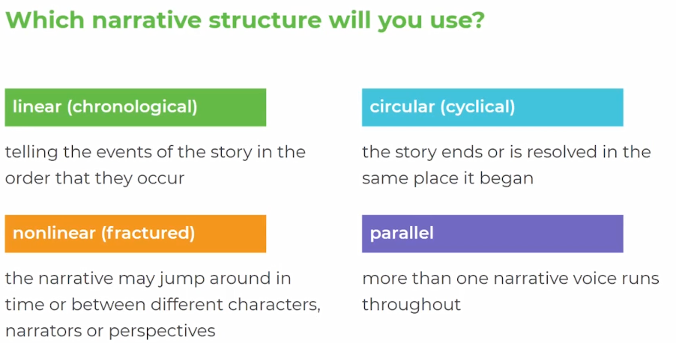

Task 16: Make a note of the following:

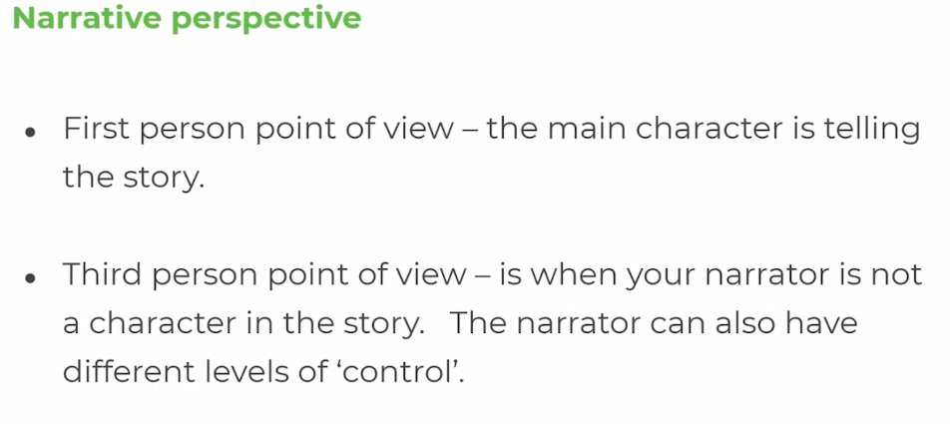
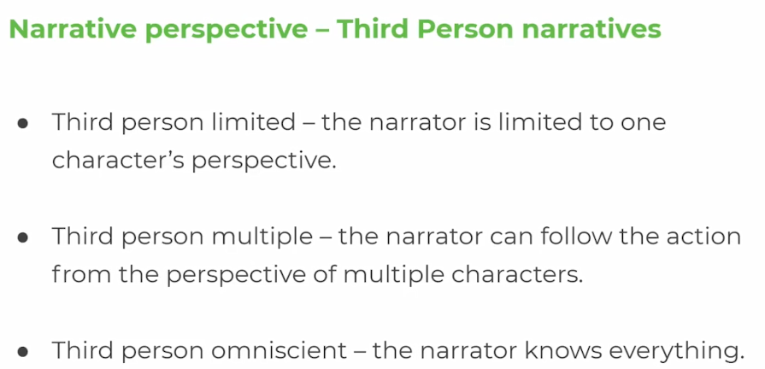
Task 17:
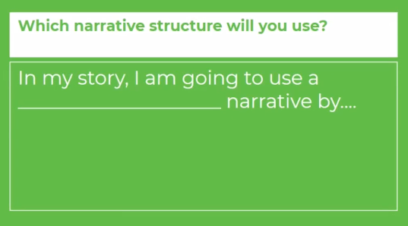

Lesson 3 and 4: Using Imagery in Narrative Writing

Please note: There is a lot to learn in these lessons. You won’t complete it all in one go! You can carry on in your next lesson – when you have spent 45 minutes on this lesson, stop and carry on with when your next English lesson would be – remember to make a note of where you pause the video at the end of each lesson.
Use the following link to access the video lesson we will be working alongside. I have created this resource to support you in approaching this lesson.
https://classroom.thenational.academy/lessons/using-imagery-in-narrative-writing/activities/2
You will either need to print this document out or have it open in word alongside the video link and you can type in notes as you go.

Task 1: Look back through the planning from your previous two lessons.

Task 2: Listen to the teacher talk through her planning and then:

Task 3: Listen to the teacher explain their plot structure and then check your own plot structure and make any changes accordingly.

Task 4: Copy the following table into your notes:

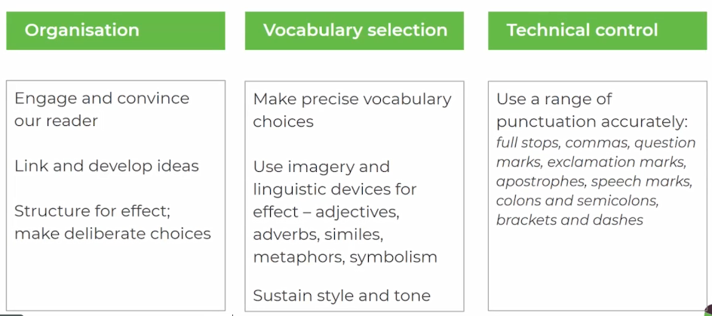

Task 5:

Task 6: Write a definition for each of the following – use google if you need to.

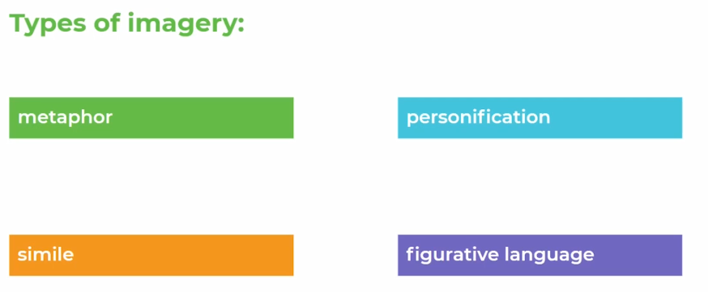

Task 7: Read the opening to the teacher’s story:
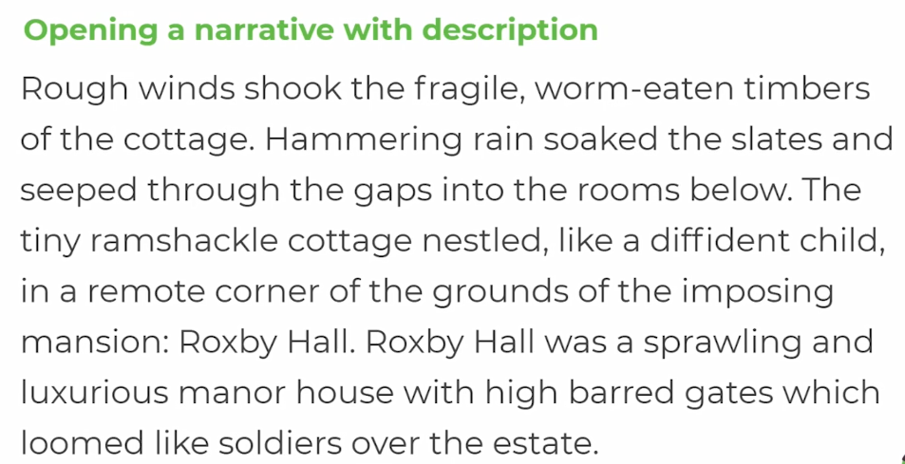

Task 8:

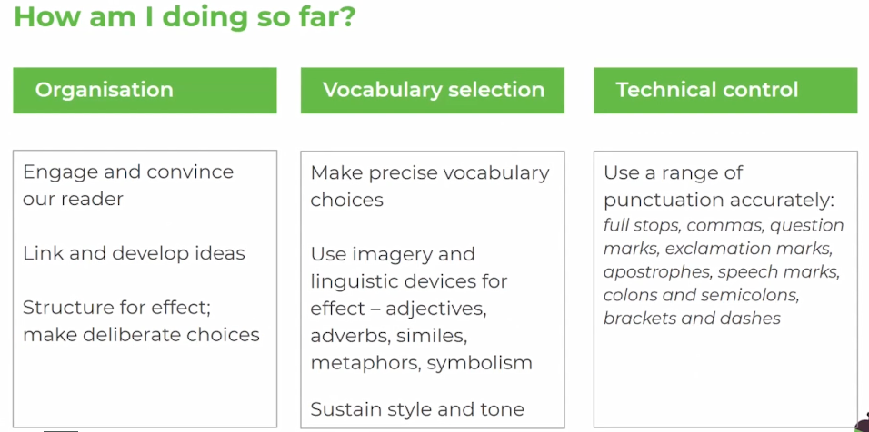

Task 9: Listen to the teacher give some explanations to some of the decisions she has made with the imagery in the opening to her story.

THE TEACHER NOW SPENDS THE REST OF THE VIDEO TALKING THROUGH HER STORY – YOU CAN EITHER WATCH THE REST OF THIS TO GET SOME MORE IDEAS, OR YOU CAN WRITE YOUR OWN DRAFT FIRST THEN WATCH THE REST OF THE VIDEO TO GET ANY FURTHER IDEAS – IT IS ENTIRELY UP TO YOU.

Task 10: Now spend your next lesson’s 45 minutes to have a go at writing a first draft of your own story:

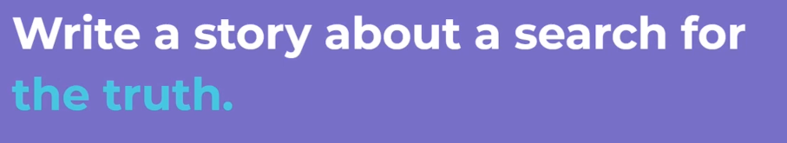

Do not send this first draft to your teacher, as we will be drafting the stories in further lessons – your English teachers will love to have your final drafts and I will let you know when to send them.

