Lesson 1, 2 and 3: Reading for meaning: The Adventures of the Speckled Band

Please note: There is a lot to learn in these lessons. You won’t complete it all in one go! You can carry on in your next lesson – when you have spent 45 minutes on this lesson, stop and carry on with when your next English lesson would be. Once you have spent another 45 minutes in the next lesson finish, even if there are still some tasks to do.
Use the following link to access the video lesson we will be working alongside. I have created this resource to support you in approaching this lesson.
You will either need to print this document out or have it open in word alongside the video link and you can type in notes as you go.
https://classroom.thenational.academy/lessons/reading-for-meaning-the-adventure-of-the-speckled-band/activities/2
Task 1: Listen carefully to the teacher reminding you of the genre of detective fiction and a brief overview of what we covered last week.

Task 2: Jot down what you can remember from last week’s lessons:

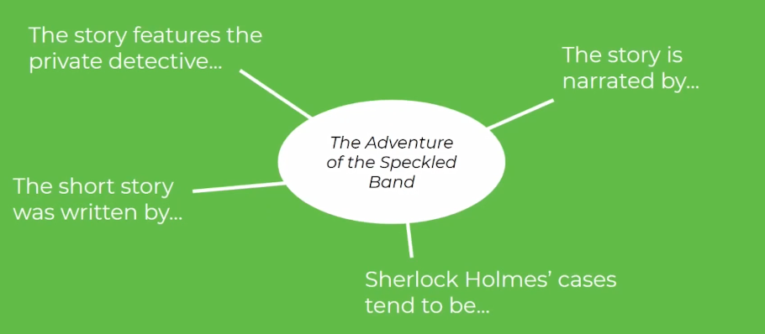

Task 3: Check your ideas with the teacher’s below:

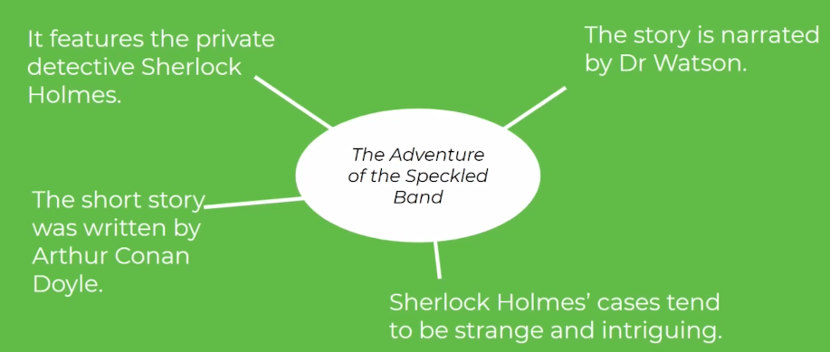

Task 4: Listen to the teacher reading the following part of the story:

“Good-morning, madam,” said Holmes cheerily. “My name is Sherlock Holmes. This is my intimate friend and associate, Dr. Watson, before whom you can speak as freely as before myself. Ha! I am glad to see that Mrs. Hudson has had the good sense to light the fire. Pray draw up to it, and I shall order you a cup of hot coffee, for I observe that you are shivering.”
“It is not cold which makes me shiver,” said the woman in a low voice, changing her seat as requested.
“What, then?”
“It is fear, Mr. Holmes. It is terror.” She raised her veil as she spoke, and we could see that she was indeed in a pitiable state of agitation, her face all drawn and grey, with restless frightened eyes, like those of some hunted animal.

Task 5:
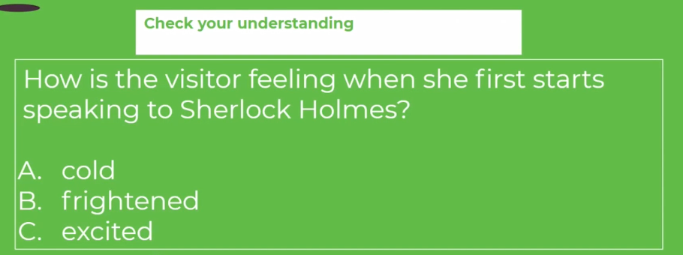

Task 6: Consider the following question when looking at this part of the story:

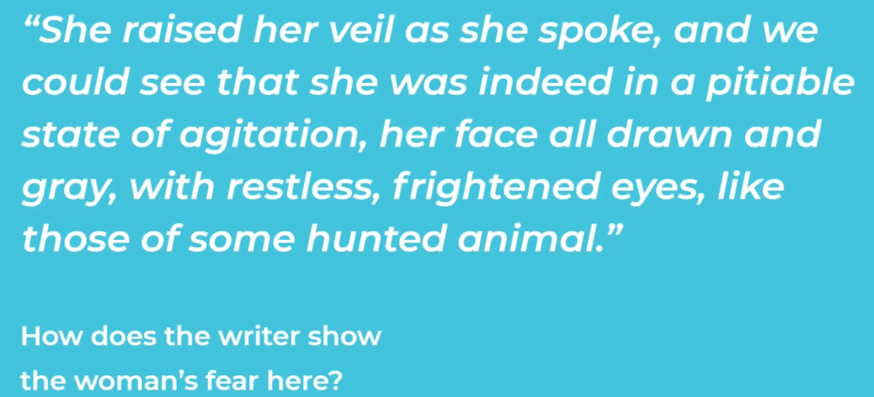

Task 7: Listen carefully to the teacher’s ideas explored about this specific quotation and make your own notes.

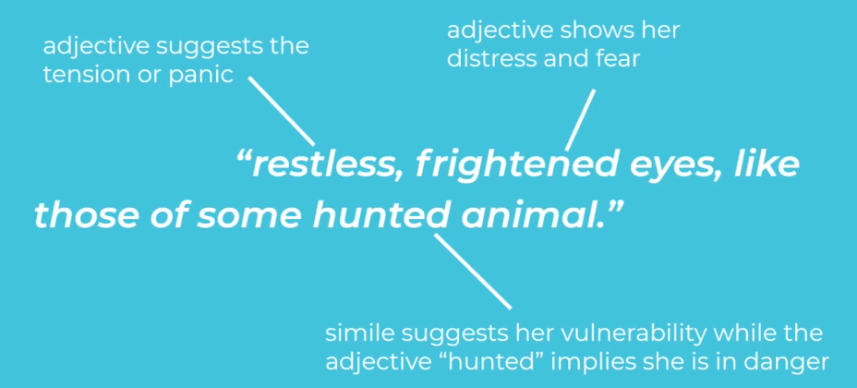

Task 8: Listen to the teacher reading the following part of the story:
Her features and figure were those of a woman of thirty, but her hair was shot with premature grey, and her expression was weary and haggard. Sherlock Holmes ran her over with one of his quick, all-comprehensive glances.
“You must not fear,” said he soothingly, bending forward and patting her forearm. “We shall soon set matters right, I have no doubt. You have come in by train this morning, I see.”
“You know me, then?”
“No, but I observe the second half of a return ticket in the palm of your left glove. You must have started early, and yet you had a good drive in a dog-cart, along heavy roads, before you reached the station.”
The lady gave a violent start and stared in bewilderment at my companion.
“There is no mystery, my dear madam,” said he, smiling. “The left arm of your jacket is spattered with mud in no less than seven places. The marks are perfectly fresh. There is no vehicle save a dog-cart which throws up mud in that way, and then only when you sit on the left-hand side of the driver.”
“Whatever your reasons may be, you are perfectly correct,” said she.

Task 9:
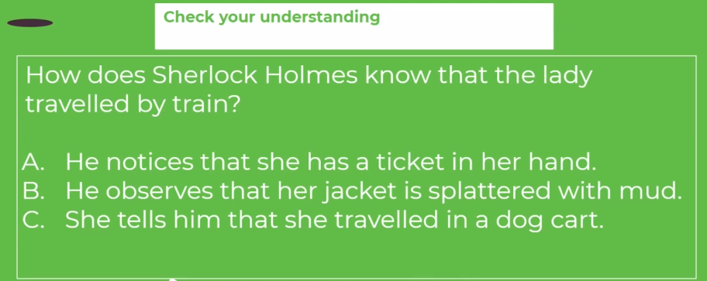

Task 10: Listen to the teacher reading the following part of the story:
“I started from home before six, reached Leatherhead at twenty past, and came in by the first train to Waterloo. Sir, I can stand this strain no longer; I shall go mad if it continues. I have no one to turn to—none, save only one, who cares for me, and he, poor fellow, can be of little aid. I have heard of you, Mr. Holmes; I have heard of you from Mrs. Farintosh, whom you helped in the hour of her sore need. It was from her that I had your address. Oh, sir, do you not think that you could help me, too, and at least throw a little light through the dense darkness which surrounds me? At present it is out of my power to reward you for your services, but in a month or six weeks I shall be married, with the control of my own income, and then at least you shall not find me ungrateful.”
Holmes turned to his desk and, unlocking it, drew out a small case-book, which he consulted.
“Farintosh,” said he. “Ah yes, I recall the case; it was concerned with an opal tiara. I think it was before your time, Watson. I can only say, madam, that I shall be happy to devote the same care to your case as I did to that of your friend. As to reward, my profession is its own reward; but you are at liberty to defray whatever expenses I may be put to, at the time which suits you best. And now I beg that you will lay before us everything that may help us in forming an opinion upon the matter.”

Task 11:
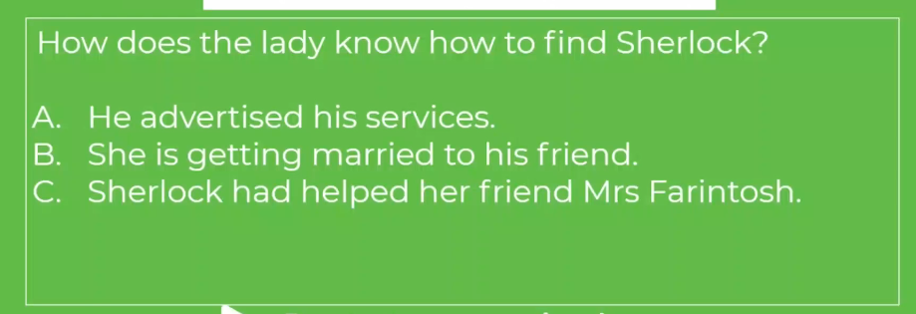

Task 12: Listen to the teacher reading the following part of the story:

“Alas!” replied our visitor, “the very horror of my situation lies in the fact that my fears are so vague, and my suspicions depend so entirely upon small points, which might seem trivial to another, that even he to whom of all others I have a right to look for help and advice looks upon all that I tell him about it as the fancies of a nervous woman. He does not say so, but I can read it from his soothing answers and averted eyes. But I have heard, Mr. Holmes, that you can see deeply into the manifold wickedness of the human heart. You may advise me how to walk amid the dangers which encompass me.”
“I am all attention, madam.”

Task 13:
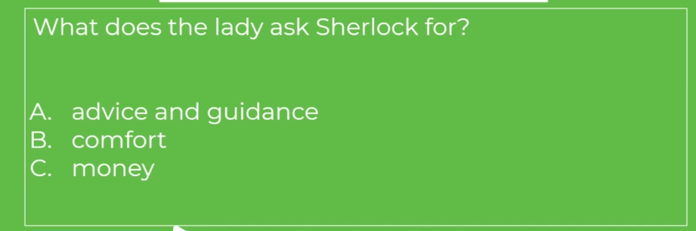
Task 14: Listen to the teacher reading the following part of the story:
“My name is Helen Stoner, and I am living with my stepfather, who is the last survivor of one of the oldest Saxon families in England, the Roylotts of Stoke Moran, on the western border of Surrey.”
Holmes nodded his head. “The name is familiar to me,” said he.
“The family was at one time among the richest in England, and the estates extended over the borders into Berkshire in the north, and Hampshire in the west. In the last century, however, four successive heirs were of a dissolute and wasteful disposition, and the family ruin was eventually completed by a gambler in the days of the Regency. Nothing was left save a few acres of ground, and the two-hundred-year-old house, which is itself crushed under a heavy mortgage. The last squire dragged out his existence there, living the horrible life of an aristocratic pauper; but his only son, my stepfather, seeing that he must adapt himself to the new conditions, obtained an advance from a relative, which enabled him to take a medical degree and went out to Calcutta, where, by his professional skill and his force of character, he established a large practice. In a fit of anger, however, caused by some robberies which had been perpetrated in the house, he beat his native butler to death and narrowly escaped a capital sentence. As it was, he suffered a long term of imprisonment and afterwards returned to England a morose and disappointed man.

Task 15:
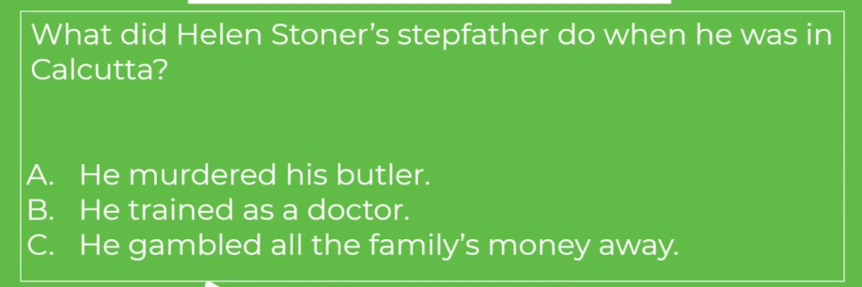

Task 16: Listen to the teacher reading the following part of the story:
“When Dr. Roylott was in India he married my mother, Mrs. Stoner, the young widow of Major-General Stoner, of the Bengal Artillery. My sister Julia and I were twins, and we were only two years old at the time of my mother’s re-marriage. She had a considerable sum of money—not less than £ 1000 a year—and this she bequeathed to Dr. Roylott entirely while we resided with him, with a provision that a certain annual sum should be allowed to each of us in the event of our marriage. Shortly after our return to England my mother died—she was killed eight years ago in a railway accident near Crewe. Dr. Roylott then abandoned his attempts to establish himself in practice in London and took us to live with him in the old ancestral house at Stoke Moran. The money which my mother had left was enough for all our wants, and there seemed to be no obstacle to our happiness.

Task 17:
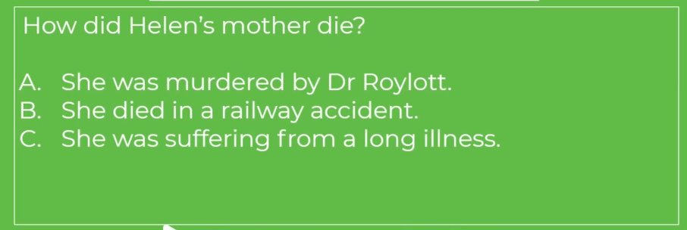

Task 18: Listen to the teacher reading the following part of the story:
“But a terrible change came over our stepfather about this time. Instead of making friends and exchanging visits with our neighbours, who had at first been overjoyed to see a Roylott of Stoke Moran back in the old family seat, he shut himself up in his house and seldom came out save to indulge in ferocious quarrels with whoever might cross his path. Violence of temper approaching to mania has been hereditary in the men of the family, and in my stepfather’s case it had, I believe, been intensified by his long residence in the tropics. A series of disgraceful brawls took place, two of which ended in the police-court, until at last he became the terror of the village, and the folks would fly at his approach, for he is a man of immense strength, and absolutely uncontrollable in his anger.
“Last week he hurled the local blacksmith over a parapet into a stream, and it was only by paying over all the money which I could gather together that I was able to avert another public exposure. He had no friends at all save the wandering gipsies, and he would give these vagabonds leave to encamp upon the few acres of bramble-covered land which represent the family estate, and would accept in return the hospitality of their tents, wandering away with them sometimes for weeks on end. He has a passion also for Indian animals, which are sent over to him by a correspondent, and he has at this moment a cheetah and a baboon, which wander freely over his grounds and are feared by the villagers almost as much as their master.

Task 19:

Task 20: Listen to the teacher reading the following part of the story:

“You can imagine from what I say that my poor sister Julia and I had no great pleasure in our lives. No servant would stay with us, and for a long time we did all the work of the house. She was but thirty at the time of her death, and yet her hair had already begun to whiten, even as mine has.”
“Your sister is dead, then?”
“She died just two years ago, and it is of her death that I wish to speak to you. You can understand that, living the life which I have described, we were little likely to see anyone of our own age and position. We had, however, an aunt, my mother’s maiden sister, Miss Honoria Westphail, who lives near Harrow, and we were occasionally allowed to pay short visits at this lady’s house. Julia went there at Christmas two years ago, and met there a half-pay major of marines, to whom she became engaged. My stepfather learned of the engagement when my sister returned and offered no objection to the marriage; but within a fortnight of the day which had been fixed for the wedding, the terrible event occurred which has deprived me of my only companion.”
Sherlock Holmes had been leaning back in his chair with his eyes closed and his head sunk in a cushion, but he half opened his lids now and glanced across at his visitor.
“Pray be precise as to details,” said he.

Task 21:
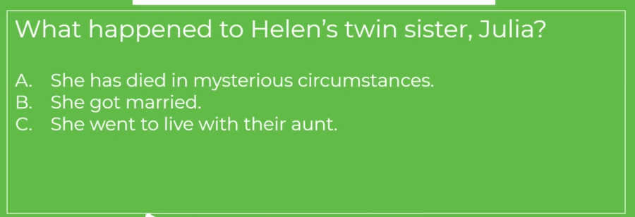

Task 22: Listen to the teacher reading the following part of the story:
“It is easy for me to be so, for every event of that dreadful time is seared into my memory. The manor-house is, as I have already said, very old, and only one wing is now inhabited. The bedrooms in this wing are on the ground floor, the sitting-rooms being in the central block of the buildings. Of these bedrooms the first is Dr. Roylott’s, the second my sister’s, and the third my own. There is no communication between them, but they all open out into the same corridor. Do I make myself plain?”
“Perfectly so.”

Task 23: Copy the below diagram into your notes:

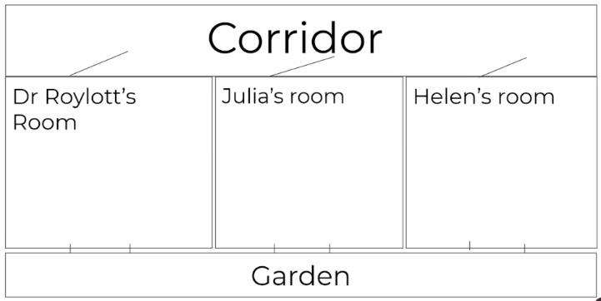

Task 24: Listen to the teacher reading the following part of the story:
“The windows of the three rooms open out upon the lawn. That fatal night Dr. Roylott had gone to his room early, though we knew that he had not retired to rest, for my sister was troubled by the smell of the strong Indian cigars which it was his custom to smoke. She left her room, therefore, and came into mine, where she sat for some time, chatting about her approaching wedding. At eleven o’clock she rose to leave me, but she paused at the door and looked back.
“‘Tell me, Helen,’ said she, ‘have you ever heard anyone whistle in the dead of the night?’
“‘Never,’ said I.
“‘I suppose that you could not possibly whistle, yourself, in your sleep?’
“‘Certainly not. But why?’
“‘Because during the last few nights I have always, about three in the morning, heard a low, clear whistle. I am a light sleeper, and it has awakened me. I cannot tell where it came from—perhaps from the next room, perhaps from the lawn. I thought that I would just ask you whether you had heard it.’
“‘No, I have not. It must be those wretched gipsies in the plantation.’
“‘Very likely. And yet if it were on the lawn, I wonder that you did not hear it also.’
“‘Ah, but I sleep more heavily than you.’
“‘Well, it is of no great consequence, at any rate.’ She smiled back at me, closed my door, and a few moments later I heard her key turn in the lock.”
“Indeed,” said Holmes. “Was it your custom always to lock yourselves in at night?”
“Always.”
“And why?”
“I think that I mentioned to you that the Doctor kept a cheetah and a baboon. We had no feeling of security unless our doors were locked.”
“Quite so. Pray proceed with your statement.”
Task 25:
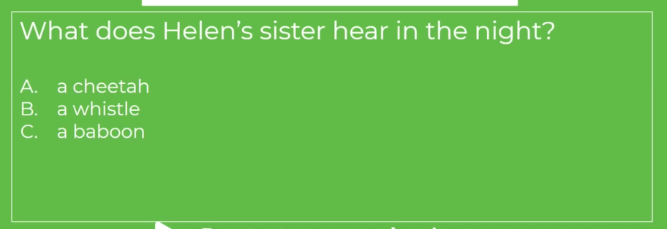

Task 26: Listen to the teacher reading the following part of the story:

“I could not sleep that night. A vague feeling of impending misfortune impressed me. My sister and I, you will recollect, were twins, and you know how subtle are the links which bind two souls which are so closely allied. It was a wild night. The wind was howling outside, and the rain was beating and splashing against the windows. Suddenly, amid all the hubbub of the gale, there burst forth the wild scream of a terrified woman. I knew that it was my sister’s voice. I sprang from my bed, wrapped a shawl round me, and rushed into the corridor. As I opened my door I seemed to hear a low whistle, such as my sister described, and a few moments later a clanging sound, as if a mass of metal had fallen. As I ran down the passage, my sister’s door was unlocked, and revolved slowly upon its hinges. I stared at it horror-stricken, not knowing what was about to issue from it. By the light of the corridor-lamp I saw my sister appear at the opening, her face blanched with terror, her hands groping for help, her whole figure swaying to and fro like that of a drunkard. I ran to her and threw my arms round her, but at that moment her knees seemed to give way and she fell to the ground. She writhed as one who is in terrible pain, and her limbs were dreadfully convulsed. At first I thought that she had not recognised me, but as I bent over her she suddenly shrieked out in a voice which I shall never forget, ‘Oh, my God! Helen! It was the band! The speckled band!’ There was something else which she would fain have said, and she stabbed with her finger into the air in the direction of the Doctor’s room, but a fresh convulsion seized her and choked her words. I rushed out, calling loudly for my stepfather, and I met him hastening from his room in his dressing-gown. When he reached my sister’s side she was unconscious, and though he poured brandy down her throat and sent for medical aid from the village, all efforts were in vain, for she slowly sank and died without having recovered her consciousness. Such was the dreadful end of my beloved sister.”
Task 27:
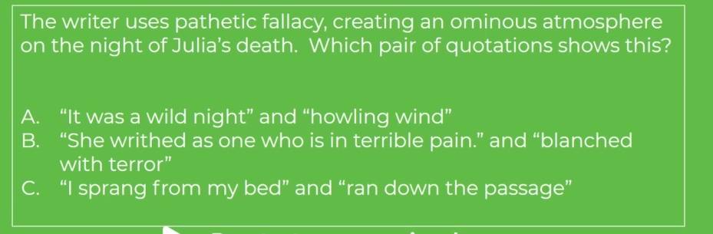

Task 28: Listen to the teacher reading the following part of the story:
“One moment,” said Holmes, “are you sure about this whistle and metallic sound? Could you swear to it?”
“That was what the county coroner asked me at the inquiry. It is my strong impression that I heard it, and yet, among the crash of the gale and the creaking of an old house, I may possibly have been deceived.”
“Was your sister dressed?”
“No, she was in her night-dress. In her right hand was found the charred stump of a match, and in her left a match-box.”
“Showing that she had struck a light and looked about her when the alarm took place. That is important. And what conclusions did the coroner come to?”
“He investigated the case with great care, for Dr. Roylott’s conduct had long been notorious in the county, but he was unable to find any satisfactory cause of death. My evidence showed that the door had been fastened upon the inner side, and the windows were blocked by old-fashioned shutters with broad iron bars, which were secured every night. The walls were carefully sounded, and were shown to be quite solid all round, and the flooring was also thoroughly examined, with the same result. The chimney is wide, but is barred up by four large staples. It is certain, therefore, that my sister was quite alone when she met her end. Besides, there were no marks of any violence upon her.”
“How about poison?”
“The doctors examined her for it, but without success.”
“What do you think that this unfortunate lady died of, then?”
“It is my belief that she died of pure fear and nervous shock, though what it was that frightened her I cannot imagine.”

Task 29:
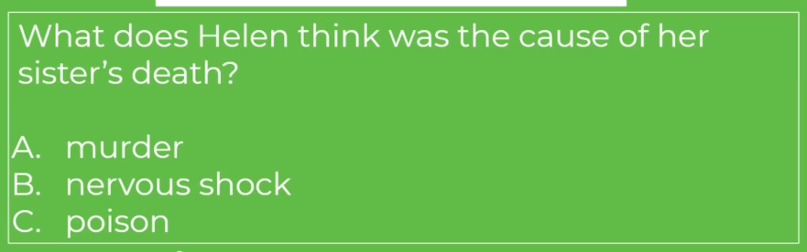

Task 30: Listen to the teacher’s explanation of the following information:

Task 31: Listen to the teacher reading the following part of the story:

“Were there gipsies in the plantation at the time?”
“Yes, there are nearly always some there.”
“Ah, and what did you gather from this allusion to a band—a speckled band?”
“Sometimes I have thought that it was merely the wild talk of delirium, sometimes that it may have referred to some band of people, perhaps to these very gipsies in the plantation. I do not know whether the spotted handkerchiefs which so many of them wear over their heads might have suggested the strange adjective which she used.”
Holmes shook his head like a man who is far from being satisfied.
“These are very deep waters,” said he; “pray go on with your narrative.”
“Two years have passed since then, and my life has been until lately lonelier than ever. A month ago, however, a dear friend, whom I have known for many years, has done me the honour to ask my hand in marriage. His name is Armitage—Percy Armitage—the second son of Mr. Armitage, of Crane Water, near Reading. My stepfather has offered no opposition to the match, and we are to be married in the course of the spring. Two days ago some repairs were started in the west wing of the building, and my bedroom wall has been pierced, so that I have had to move into the chamber in which my sister died, and to sleep in the very bed in which she slept. Imagine, then, my thrill of terror when last night, as I lay awake, thinking over her terrible fate, I suddenly heard in the silence of the night the low whistle which had been the herald of her own death. I sprang up and lit the lamp, but nothing was to be seen in the room. I was too shaken to go to bed again, however, so I dressed, and as soon as it was daylight I slipped down, got a dog-cart at the Crown Inn, which is opposite, and drove to Leatherhead, from whence I have come on this morning with the one object of seeing you and asking your advice.”

Task 32:
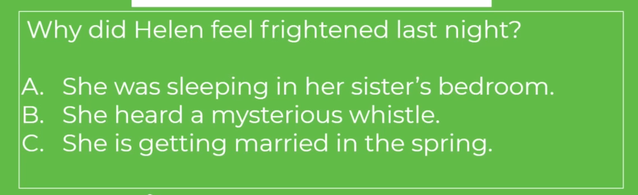

Task 33: Listen to the teacher reading the following part of the story:

“You have done wisely,” said my friend. “But have you told me all?”
“Yes, all.”
“Miss Roylott, you have not. You are screening your stepfather.”
“Why, what do you mean?”
For answer Holmes pushed back the frill of black lace which fringed the hand that lay upon our visitor’s knee. Five little livid spots, the marks of four fingers and a thumb, were printed upon the white wrist.
“You have been cruelly used,” said Holmes.
The lady coloured deeply and covered over her injured wrist. “He is a hard man,” she said, “and perhaps he hardly knows his own strength.”
There was a long silence, during which Holmes leaned his chin upon his hands and stared into the crackling fire.
“This is a very deep business,” he said at last. “There are a thousand details which I should desire to know before I decide upon our course of action. Yet we have not a moment to lose. If we were to come to Stoke Moran to-day, would it be possible for us to see over these rooms without the knowledge of your stepfather?”
“As it happens, he spoke of coming into town to-day upon some most important business. It is probable that he will be away all day, and that there would be nothing to disturb you. We have a housekeeper now, but she is old and foolish, and I could easily get her out of the way.”

Task 34:
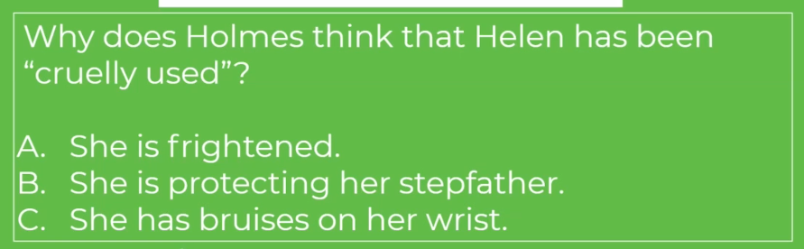

Task 35: Listen to the teacher reading the following part of the story:
“Excellent. You are not averse to this trip, Watson?”
“By no means.”
“Then we shall both come. What are you going to do yourself?”
“I have one or two things which I would wish to do now that I am in town. But I shall return by the twelve o’clock train, so as to be there in time for your coming.”
“And you may expect us early in the afternoon. I have myself some small business matters to attend to. Will you not wait and breakfast?”
“No, I must go. My heart is lightened already since I have confided my trouble to you. I shall look forward to seeing you again this afternoon.” She dropped her thick black veil over her face and glided from the room.

Task 36:
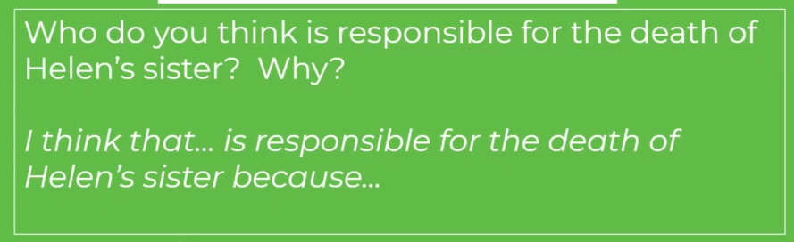

Task 37: Make a note of the key terms below:

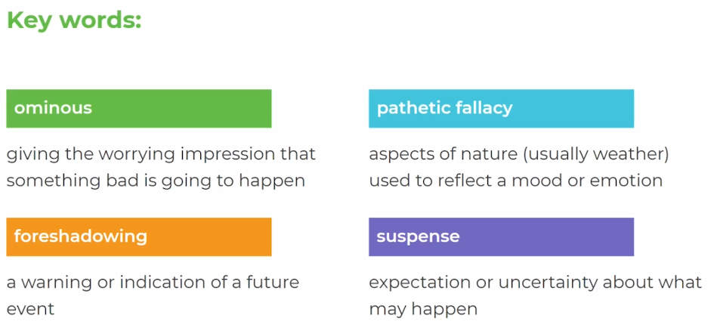

Task 38: Have a go at answering the following question – use the sentence starters to help you.

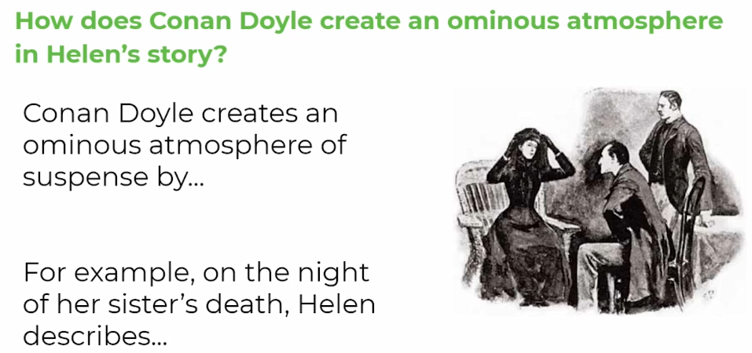

Task 39: Check your ideas with the teacher’s and add any important information in that you feel you’ve missed:

