Lesson 1: An Introduction to Victorian Literature
Please note: There is a lot to learn in this lesson. You might not complete it all in one go! You can carry on in your next lesson if you need to or skip the ‘Optional Activity’
Use the following link to access the video lesson we will be working alongside. I have created this resource to support you in approaching this lesson.

https://www.thenational.academy/year-8/english/introduction-to-victorian-literature-year-8-wk1-1/

You will either need to print this document out or have it open in word alongside the video link and you can type in notes as you go.

Task 1: Start playing the video lesson. Either make a mind map or bullet pointed list of anything you know about the Victorian Period. Use the below information to help you.

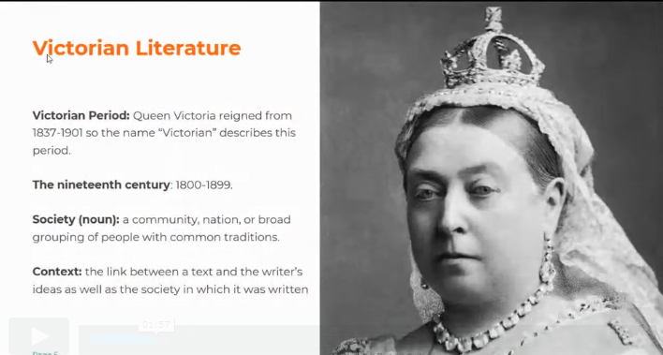

Task 2: Keep watching the video, use it to help you add some ideas about each of the following aspects of Victorian England (aim for at least two bullet points of information for each section), listen to the teacher, as she says more than is just written – remember you can pause the video and rewind if you need to:

Growth of Industry:

Scientific developments:

Technological advances:

Victorian Society:

Education:

The British Empire:

Task 3: Using the video write down the definitions of the following:

A genre:

A literary form:

Journalism and Periodical writing:

Realism:

The Novel:

Task 4: Using the below extract, and notes you have made throughout this lesson, answer the following questions, then watch the video to check your answers:

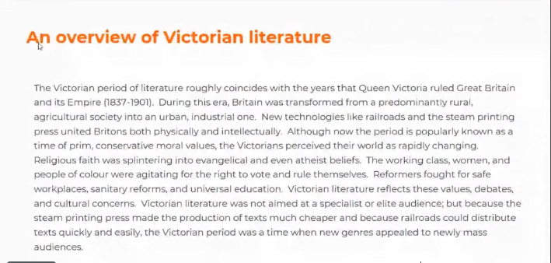

- When was the Victorian period?

- Why do you think Victoria society was divided?

- What was the British Empire?

- How might scientific discoveries or new inventions have challenged people’s views?

- What is context? Why is it useful to learn about it?

- What is a genre?

- What is a literary form?

Task 5: (Optional Activity) Write a paragraph summarising what you have learnt about Victorian Literature and society. Try to include the following details:

- What Victorian society was like.
- The different influences writers might have been interested in.
- The different forms and genres in Victorian literature.

Lesson 2: Oliver Twist by Charles Dickens
Please note: There is a lot to learn in this lesson. You might not complete it all in one go! You can carry on in your next lesson if you need to or skip the ‘Optional Activity’
Use the following link to access the video lesson we will be working alongside. I have created this resource to support you in approaching this lesson.

https://www.thenational.academy/year-8/english/oliver-twist-by-charles-dickens-year-8-wk1-2/

You will either need to print this document out or have it open in word alongside the video link and you can type in notes as you go.
Task 1: Start playing the video lesson. Using the video, write down the definition of the following:

Eponymous:

Task 2: Create a mind map or bullet point list – gather at least 6 pieces of information about Charles Dickens. Remember you can pause the video if you need more time to note ideas down.

Task 3: Using the video, write down the definitions of the following AND a sentence using it correctly:

Dickensian:

Critic:

Reformer:

Social commentator:

Task 4: Create a mind map or bullet point list – gather at least 4 pieces of information about The Workhouse. Remember you can pause the video if you need more time to note ideas down.

Task 5: (Optional Activity) Write a couple of sentences responding to the following question: What do you think it would have felt like to be forced into a workhouse?

Task 6: Read through the extract from Oliver Twist on your own. Then listen to the teacher in the video read through it again – follow it as she reads it.

Oliver had not been within the walls of the workhouse a quarter of an hour, and had scarcely completed the demolition of a second slice of bread, when Mr. Bumble, who had handed him over to the care of an old woman, returned; and, telling him it was a board night, informed him that the board had said he was to appear before it forthwith. Not having a very clearly defined notion of what a live board was, Oliver was rather astounded by this intelligence, and was not quite certain whether he ought to laugh or cry. He had no time to think about the matter, however; for Mr. Bumble gave him a tap on the head, with his cane, to wake him up: and another on the back to make him lively: and bidding him to follow, conducted him into a large white-washed room, where eight or ten fat gentlemen were sitting round a table. At the top of the table, seated in an arm-chair rather higher than the rest, was a particularly fat gentleman with a very round, red face.
'Bow to the board,' said Bumble. Oliver brushed away two or three tears that were lingering in his eyes; and seeing no board but the table, fortunately bowed to that.
'What's your name, boy?' said the gentleman in the high chair.
Oliver was frightened at the sight of so many gentlemen, which made him tremble: and the beadle gave him another tap behind, which made him cry. These two causes made him answer in a very low and hesitating voice; whereupon a gentleman in a white waistcoat said he was a fool. Which was a capital way of raising his spirits, and putting him quite at his ease.
'Boy,' said the gentleman in the high chair, 'listen to me. You know you're an orphan, I suppose?'
'What's that, sir?' inquired poor Oliver.
'The boy IS a fool--I thought he was,' said the gentleman in the white waistcoat.
'Hush!' said the gentleman who had spoken first. 'You know you've got no father or mother, and that you were brought up by the parish, don't you?'
'Yes, sir,' replied Oliver, weeping bitterly.
'What are you crying for?' inquired the gentleman in the white waistcoat. And to be sure it was very extraordinary. What COULD the boy be crying for?
'I hope you say your prayers every night,' said another gentleman in a gruff voice; 'and pray for the people who feed you, and take care of you--like a Christian.'
'Yes, sir,' stammered the boy. The gentleman who spoke last was unconsciously right. It would have been very like a Christian, and a marvellously good Christian too, if Oliver had prayed for the people who fed and took care of HIM. But he hadn't, because nobody had taught him.
'Well! You have come here to be educated, and taught a useful trade,' said the red-faced gentleman in the high chair.
'So you'll begin to pick oakum to-morrow morning at six o'clock,' added the surly one in the white waistcoat.
For the combination of both these blessings in the one simple process of picking oakum, Oliver bowed low by the direction of the beadle, and was then hurried away to a large ward; where, on a rough, hard bed, he sobbed himself to sleep. What a novel illustration of the tender laws of England! They let the paupers go to sleep!

Task 7: Scan back through the extract and answer the following question – try to include exact evidence from the text in your response. What have we learnt about Oliver’s experience in front of the ‘the board’?

Task 8: Look back through the extract and answer the following questions, try to include exact evidence from the text in your answers:

- How does Oliver seem to feel at the beginning of the extract?
- How are the authority figures in the extract presented? For example, the men on the board.
- Write down a quotation which shows how the men of the board treat Oliver in a condescending way.
- What is Oliver told his work is going to be?
- How does Oliver behave throughout the extract? Why do you think this is?

Task 9: Using the video, check your answers and add any relevant information to your responses.

Lesson 3: Oliver Twist: Analysis Practice
Please note: There is a lot to learn in this lesson. You might not complete it all in one go! You can carry on in your next lesson if you need to or skip the ‘Optional Activity’
Use the following link to access the video lesson we will be working alongside. I have created this resource to support you in approaching this lesson.
https://www.thenational.academy/year-8/english/oliver-twist-analysis-practice-year-8-wk1-3/

You will either need to print this document out or have it open in word alongside the video link and you can type in notes as you go.

Task 1: Start playing the video lesson. Using the video, write down the definition of the following:

Satirical:

Ironic:

Critical:

Mocking:

Task 2: What do you think Charles Dickens is trying to suggest or imply in the below quotation from the extract?

‘What a novel illustration of the tender laws of England! They let the paupers go to sleep!’
Novel – new or unusual
Tender – kind and gentle
Paupers – very poor people

Task 3: Reread the extract from last lesson

Oliver had not been within the walls of the workhouse a quarter of an hour, and had scarcely completed the demolition of a second slice of bread, when Mr. Bumble, who had handed him over to the care of an old woman, returned; and, telling him it was a board night, informed him that the board had said he was to appear before it forthwith. Not having a very clearly defined notion of what a live board was, Oliver was rather astounded by this intelligence, and was not quite certain whether he ought to laugh or cry. He had no time to think about the matter, however; for Mr. Bumble gave him a tap on the head, with his cane, to wake him up: and another on the back to make him lively: and bidding him to follow, conducted him into a large white-washed room, where eight or ten fat gentlemen were sitting round a table. At the top of the table, seated in an arm-chair rather higher than the rest, was a particularly fat gentleman with a very round, red face.
'Bow to the board,' said Bumble. Oliver brushed away two or three tears that were lingering in his eyes; and seeing no board but the table, fortunately bowed to that.
'What's your name, boy?' said the gentleman in the high chair.
Oliver was frightened at the sight of so many gentlemen, which made him tremble: and the beadle gave him another tap behind, which made him cry. These two causes made him answer in a very low and hesitating voice; whereupon a gentleman in a white waistcoat said he was a fool. Which was a capital way of raising his spirits, and putting him quite at his ease.
'Boy,' said the gentleman in the high chair, 'listen to me. You know you're an orphan, I suppose?'
'What's that, sir?' inquired poor Oliver.
'The boy IS a fool--I thought he was,' said the gentleman in the white waistcoat.
'Hush!' said the gentleman who had spoken first. 'You know you've got no father or mother, and that you were brought up by the parish, don't you?'
'Yes, sir,' replied Oliver, weeping bitterly.
'What are you crying for?' inquired the gentleman in the white waistcoat. And to be sure it was very extraordinary. What COULD the boy be crying for?
'I hope you say your prayers every night,' said another gentleman in a gruff voice; 'and pray for the people who feed you, and take care of you--like a Christian.'
'Yes, sir,' stammered the boy. The gentleman who spoke last was unconsciously right. It would have been very like a Christian, and a marvellously good Christian too, if Oliver had prayed for the people who fed and took care of HIM. But he hadn't, because nobody had taught him.
'Well! You have come here to be educated, and taught a useful trade,' said the red-faced gentleman in the high chair.
'So you'll begin to pick oakum to-morrow morning at six o'clock,' added the surly one in the white waistcoat.
For the combination of both these blessings in the one simple process of picking oakum, Oliver bowed low by the direction of the beadle, and was then hurried away to a large ward; where, on a rough, hard bed, he sobbed himself to sleep. What a novel illustration of the tender laws of England! They let the paupers go to sleep!

Task 4: What does the following quotation suggest about Oliver?

‘Oliver….had scarcely completed the demolition of a second slice of bread’

Task 7: What does the following quotation suggest Oliver is feeling?

‘Oliver brushed away two or three tears that were lingering in his eyes; and seeing no board but the table; fortunately bowed to that.’

Task 8: What does the following quotation suggest about the attitude of the board?

‘The boy IS a fool – I thought he was.’

Task 9: (Optional Activity) What could Dickens be criticising here?

‘It would have been very like a Christian, and a marvellously good Christian too, if Oliver had prayed for the people who fed and took care of HIM. But he hadn’t, because nobody had taught him.’

Task 10: How does Dickens create sympathy for Oliver here?

‘On a rough, hard bed, he sobbed himself to sleep’

