Lesson 1 (and a little of lesson 2): Read Sherlock Holmes – The Adventures of the Speckled Band
Listen to the audio book of the following short story:
https://www.youtube.com/watch?v=yaRIKossxKs
As you listen, read along with the story – there is a separate document with the whole story in it. We recommend you listen to this story and read it along with an older relative, who can explain any parts you are unsure of. Feel free to have them read it to you or you take it in turns with them instead of the audio book.

Lesson 2 and 3: Detective fiction and the short story

Please note: There is a lot to learn in these lessons. You won’t complete it all in one go! You can carry on in your next lesson – when you have spent 45 minutes on this lesson, stop and carry on with when your next English lesson would be. Once you have spent another 45 minutes in the next lesson finish, even if there are still some tasks to do.
Use the following link to access the video lesson we will be working alongside. I have created this resource to support you in approaching this lesson.
You will either need to print this document out or have it open in word alongside the video link and you can type in notes as you go.

https://classroom.thenational.academy/lessons/victorian-literature-mystery-and-the-short-story/activities/2

Task 1: Consider the following question: What is Detective fiction? Listen to the teacher’s explanation and bullet point some ideas down.

Task 2: Make a note of the following key vocabulary.
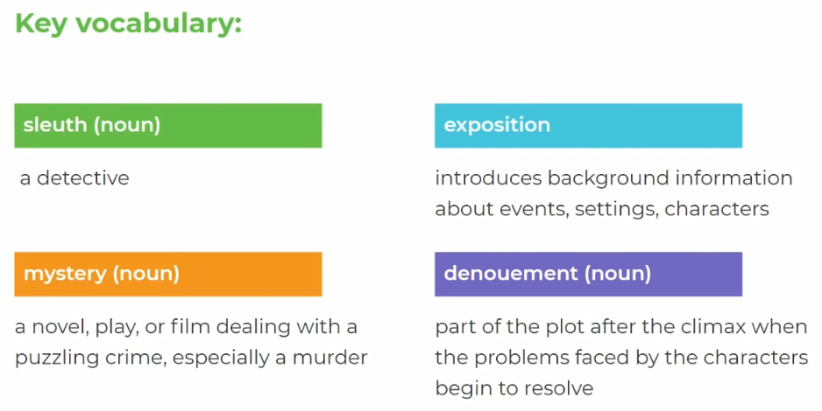

Task 3: Using your bullet points from earlier, now complete the following sentence starters:

Detective fictions is….
Detective fiction became more and more popular in the Victorian period because…

Task 4: Check your ideas with the teacher’s below:

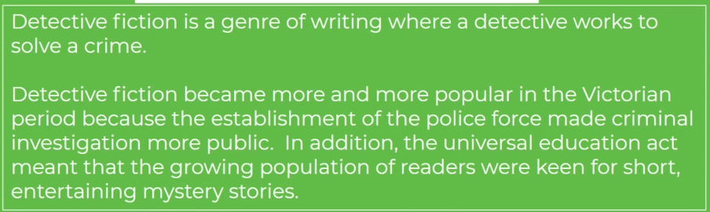

Task 5: List what you think the conventions of Detective fiction are:

Task 6: Look at the list of suggested conventions below, listen carefully the teacher’s explanation of each:

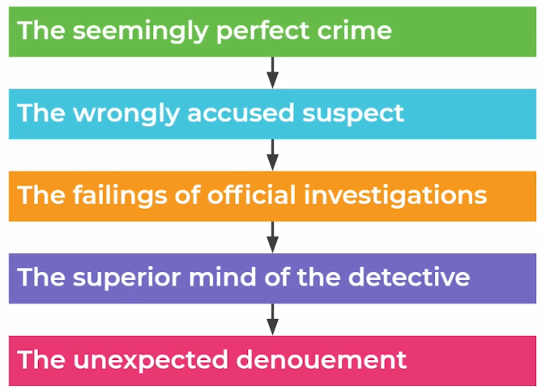

Task 7: Complete the following sentences:

Task 8: Check your ideas with the teacher’s:

Task 9: Read the opening section of the short story:

On glancing over my notes of the seventy odd cases in which I have during the last eight years studied the methods of my friend Sherlock Holmes, I find many tragic, some comic, a large number merely strange, but none commonplace; for, working as he did rather for the love of his art than for the acquirement of wealth, he refused to associate himself with any investigation which did not tend towards the unusual, and even the fantastic. Of all these varied cases, however, I cannot recall any which presented more singular features than that which was associated with the well-known Surrey family of the Roylotts of Stoke Moran.

Task 10:

Task 11: Read the next section of the short story:

The events in question occurred in the early days of my association with Holmes, when we were sharing rooms as bachelors in Baker Street. It is possible that I might have placed them upon record before, but a promise of secrecy was made at the time, from which I have only been freed during the last month by the untimely death of the lady to whom the pledge was given. It is perhaps as well that the facts should now come to light, for I have reasons to know that there are widespread rumours as to the death of Dr. Grimesby Roylott which tend to make the matter even more terrible than the truth.

Task 12:
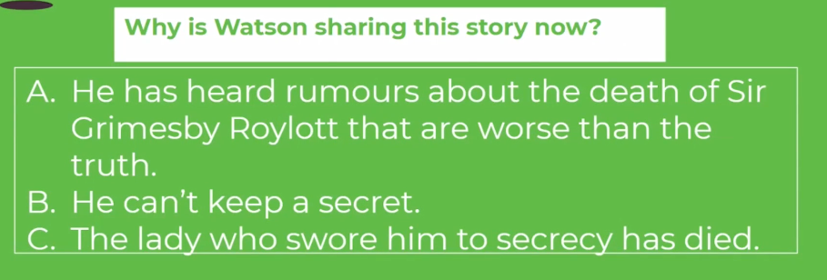
Check your answers with the video.

Task 13: Read the next section of the short story:

It was early in April in the year ’83 that I woke one morning to find Sherlock Holmes standing, fully dressed, by the side of my bed. He was a late riser, as a rule, and as the clock on the mantelpiece showed me that it was only a quarter-past seven, I blinked up at him in some surprise, and perhaps just a little resentment, for I was myself regular in my habits.
“Very sorry to knock you up, Watson,” said he, “but it’s the common lot this morning. Mrs. Hudson has been knocked up, she retorted upon me, and I on you.”
“What is it, then—a fire?”
“No; a client. It seems that a young lady has arrived in a considerable state of excitement, who insists upon seeing me. She is waiting now in the sitting-room. Now, when young ladies wander about the metropolis at this hour of the morning, and knock sleepy people up out of their beds, I presume that it is something very pressing which they have to communicate. Should it prove to be an interesting case, you would, I am sure, wish to follow it from the outset. I thought, at any rate, that I should call you and give you the chance.”
“My dear fellow, I would not miss it for anything.”
I had no keener pleasure than in following Holmes in his professional investigations, and in admiring the rapid deductions, as swift as intuitions, and yet always founded on a logical basis with which he unravelled the problems which were submitted to him. I rapidly threw on my clothes and was ready in a few minutes to accompany my friend down to the sitting-room. A lady dressed in black and heavily veiled, who had been sitting in the window, rose as we entered.
Task 14:

Task 15:
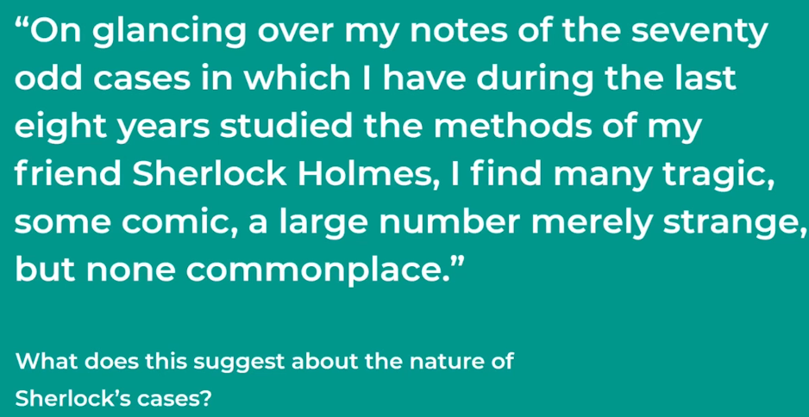

Task 16: Check your answer with the teacher’s below:

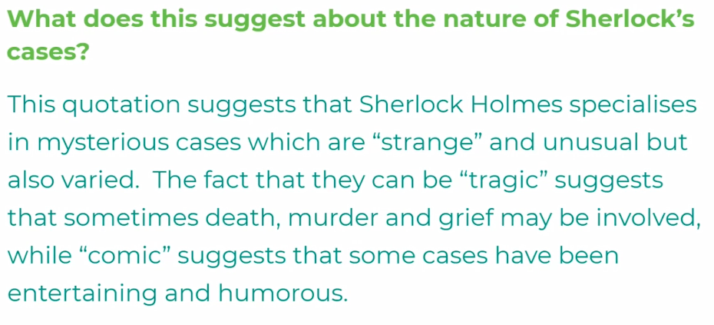

Task 17:

Task 18: Check your answer with the teacher’s below:

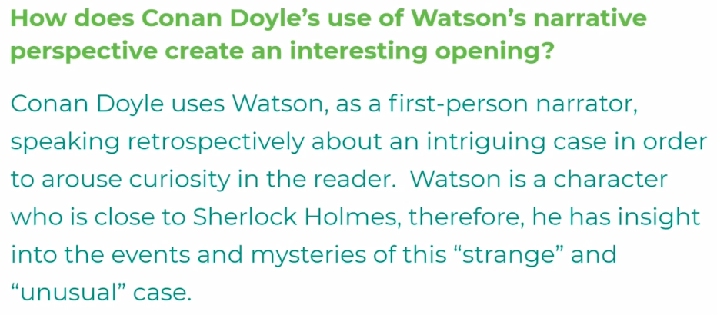

Task 19:

Task 20: Check your ideas with the teacher’s:

