Lesson 1 and 2: Crime in Victorian Literature – summarising Non-fiction texts
Please note: There is a lot to learn in these lessons. You won’t complete it all in one go! You can carry on in your next lesson – when you have spent 45 minutes on this lesson, stop and carry on with when your next English lesson would be. Once you have spent another 45 minutes in the next lesson finish, even if there are still some tasks to do.
Use the following link to access the video lesson we will be working alongside. I have created this resource to support you in approaching this lesson.
You will either need to print this document out or have it open in word alongside the video link and you can type in notes as you go.
https://www.thenational.academy/year-8/english/crime-in-victorian-literature-summarising-non-fiction-texts-year-8-wk3-2#slide-3

Task 1:

Task 2: Consider the following question in your head and then listen to the teacher’s explanation.

Task 3:

Task 4: Consider the following question:

Task 5: Jot down some initial ideas answering the following question:

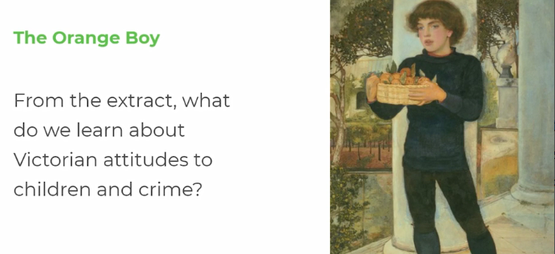

Task 6: Read the following letter (as many times as you need to) – listen to the teacher read it as well, and check the meaning of the words in bold – there is a glossary below.

Sir, - As The Times is always open for the insertion of any remarks likely to caution the unwary or to put the unsuspecting on their guard against the numerous thefts and robberies committed daily in the streets of London, I am induced to ask you to insert a case which happened on Saturday last, and which I trust may serve as a warning to those of your lady readers who still carry purses in their pockets.
A young lady (and, as the police reports add,) of very prepossessing appearance, a relation of the narrator's, was walking between 12 and 1 o'clock with another young lady, a friend of hers, in Albany-street, where she resides, when she was accosted by a boy about 11 years of age, who asked her in the most beseeching tones "to buy a few oranges of a poor orphan who hadn't a bit of bread to eat." She told him to go away, but he kept alongside, imploring assistance, and making some cutting remarks about "the ingratitude of the world in general and of young ladies in particular." As his manner became very troublesome the lady threatened to give him in charge of a policeman, and looked down every area to find one; but there was not one even there, and the boy kept up his sweet discourse and slight pushes alternately (the latter with the basket on which he carried his oranges), until the lady reached her own door-step. It then occurred to her that in the boy's ardour to sell his oranges he might have taken her purse; her friend thought so too. A trembling hand was inserted into the pocket; the purse was gone, and so was the lady's happiness. She flew after the thief, who, knowing young ladies were not made for running, coolly deposited his basket on a door-step a little way off and ran away whistling. This brave young lady ran also, shouting "Stop thief! stop thief!" (but then young ladies are not made for shouting, God forbid!) and she looked in the fond hope that a policeman might be found. But no such luck, the culprit got safely off with the purse and its contents; and no kind passer by tried to help the young lady, who was thus shamefully duped and robbed. Ladies, young and old, never carry your purses in your pockets; beware of canting beggars, and beggars of all sorts, that infest the streets; and, above all, keep a watchful eye about you and give the widest possible berth to THE ORANGE BOY.
letter to The Times, March 5, 1850

Prepossessing: attractive
Accosted: approached aggressively
Beseeching: asking urgently or begging
Imploring: appealing desperately
Discourse: speech or conversation
Ardour: enthusiasm or passion
Duped: tricked
Canting: talking hypocritically as if you are morally superior
Widest possible berth: avoid

Task 7: Jot down your initial ideas answering this question:

Task 8: Look at the parts highlighted: consider, what these tell us about the purpose of this letter and what the writer thinks about people like the Orange Boy? Use the below sentence starter to help you…
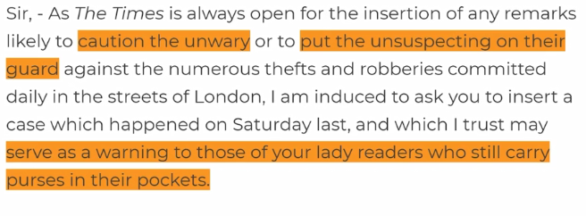

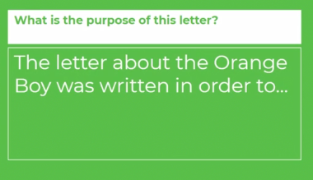

Task 9: Read through the model answer and add any relevant ideas to your own.

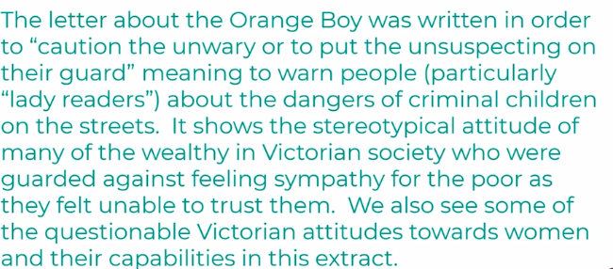

Task 10:
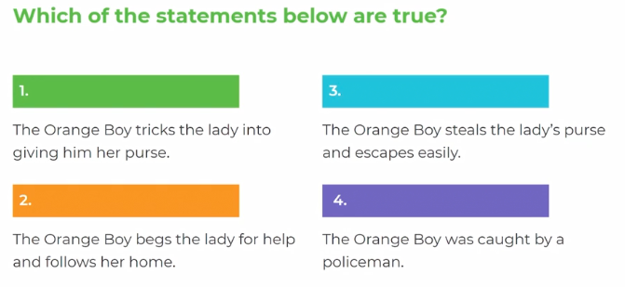

Task 11: Using the highlighted extract below to guide you (as well as the teacher’s ideas in the video) have a go at the following task:

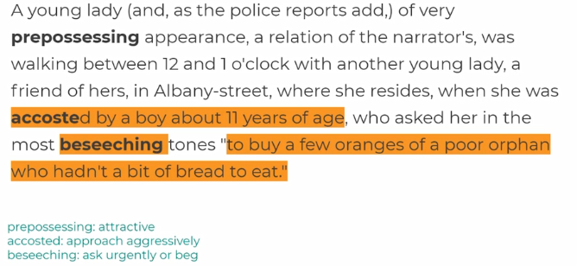

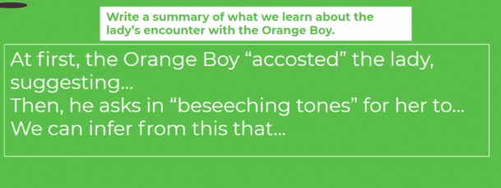

Task 12: Read through the model answer and add any relevant ideas to your own work.

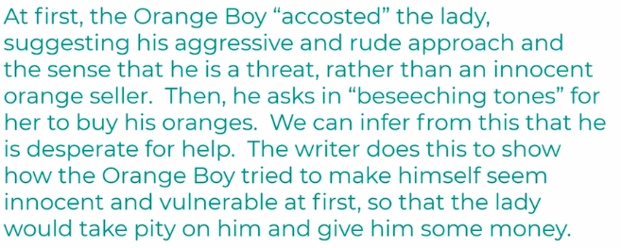

Task 13: Using the highlighted extract below to guide you (as well as the teacher’s ideas in the video) continue to summarise what we learn about the encounter:

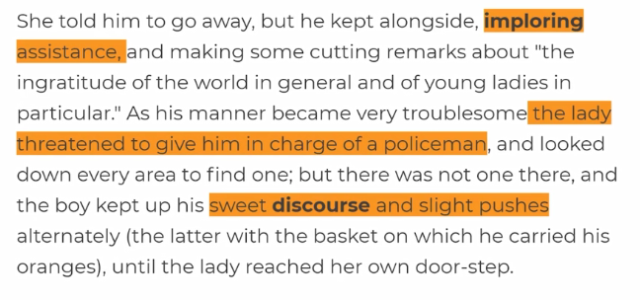
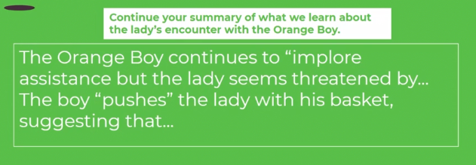

Task 14: Read through the model answer and add any relevant ideas to your own work.

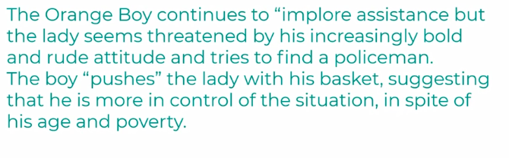
Task 15: Using the highlighted extract below to guide you (as well as the teacher’s ideas in the video) continue to summarise what we learn about the encounter:

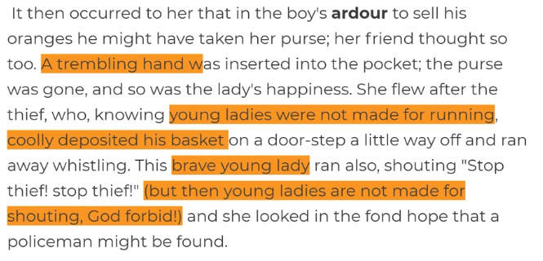
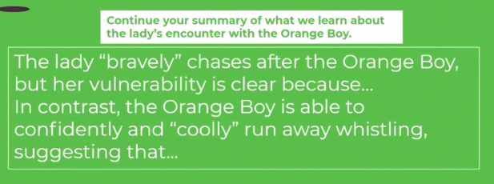

Task 16: Read through the model answer and add any relevant ideas to your own work.

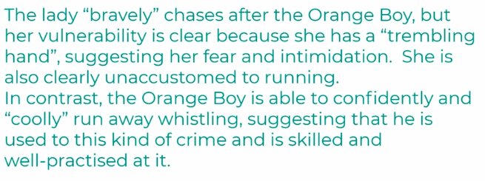

Task 17: Using the highlighted extract below to guide you (as well as the teacher’s ideas in the video) continue to summarise what we learn about the encounter:
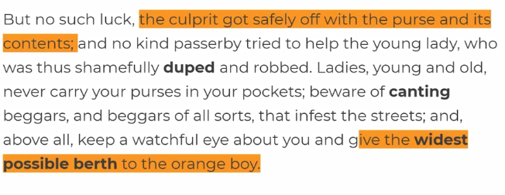
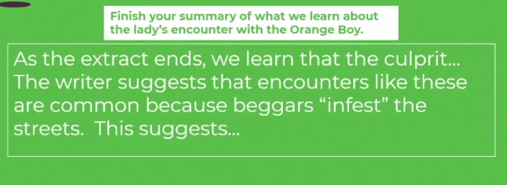

Task 18: Read through the model answer and add any relevant ideas to your own work.

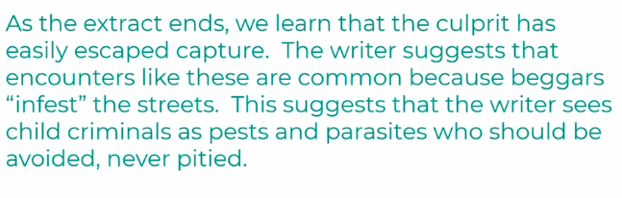
(Optional) Task 19: Answer the following questions:

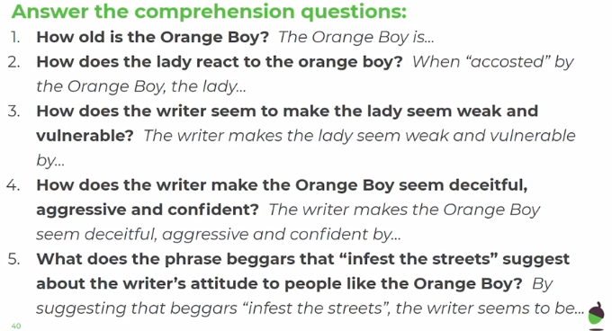
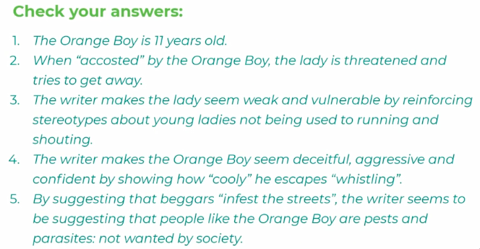

Lesson 3 – Grammar, punctuation and spelling skills.

Follow the below link to Seneca – log into Seneca. If you have forgotten your login details, email ahawkins@okehamptoncollege.devon.sch.uk asking for advice on how to retrieve this.

Spend 45 minutes working through the English courses set – particularly the KS3 punctuation, spelling and grammar course or/and the decoding course.

https://senecalearning.com/en-GB/

