Lesson 1: Oliver Twist Language Analysis
Please note: There is a lot to learn in this lesson. You might not complete it all in one go! You can carry on in your next lesson if you need to or skip the ‘Optional Activity’
Use the following link to access the video lesson we will be working alongside. I have created this resource to support you in approaching this lesson.
https://www.thenational.academy/year-8/english/language-analysis-year-8-wk2-1
You will either need to print this document out or have it open in word alongside the video link and you can type in notes as you go.

Please also print off or have open the extract from Oliver Twist – I would recommend you read through the extract at the start of the lesson once on your own.

Task 1: Using the teacher’s explanation of LANGUAGE ANALYSIS – write down in your own words what you think this means. After you’ve done this, check your ideas with the teacher’s example.

Task 2: As the teacher goes through each of the below steps to exploring a text, add any extra notes you think you might find useful.

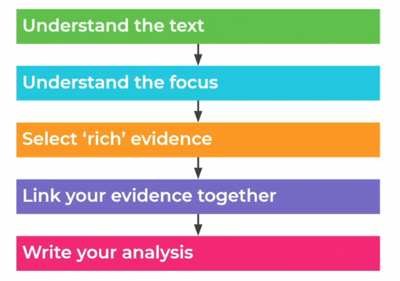

Task 3: Look at the illustration of Oliver Twist in the video lesson – why do you think the Master looks so surprised?

Task 4: Compare your answer to the teacher’s model on the next page.

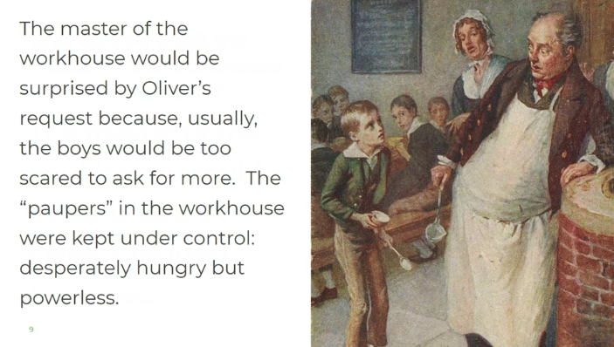

Task 5: Using the video to help you, write down the definition of the new below vocabulary – remember you can pause and rewind the video if you need to:

Voracious:

Gruel:

Allotted:

Temerity:

Rebel:

Reckless:

Countenance:

Assiduously:

Task 6: As the teacher reads through the extract, make sure you read along with your own copy or the video screen.

Task 7: Scan back through the extract and have a go at answering the following questions:

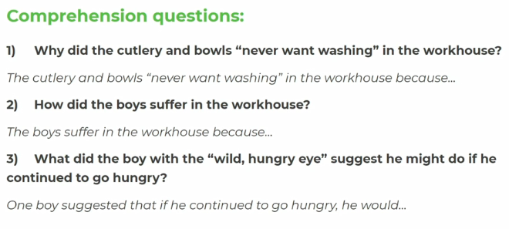
Task 8: Using the teacher’s feedback, check your own answers and correct them if needed.

Task 9: How does Dickens use language to show the hunger of the boys?
Read the below extract and underline any key evidence that relates to the hunger of the boys.

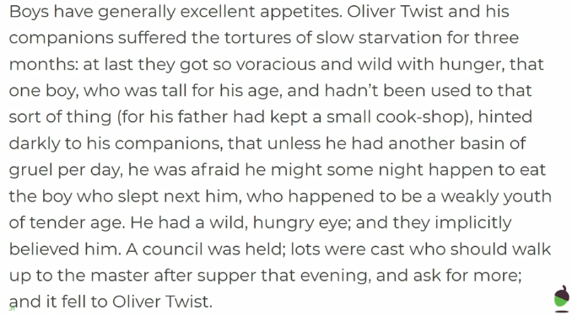

Task 10: Compare the quotations you have chosen to the ones the teacher has chosen – highlight these quotations as well and annotate the extract with ideas about these pieces of evidence based on the ideas the teacher shares. Remember to link your ideas to how these pieces of evidence explore the boys’ hunger.

Task 11: Read through the model answer, based on a different part of the text.

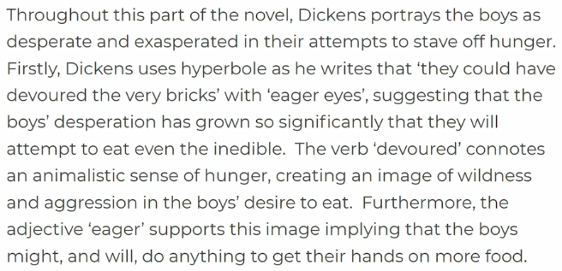

Task 12: Using the below guidance, have a go at writing your own paragraph:

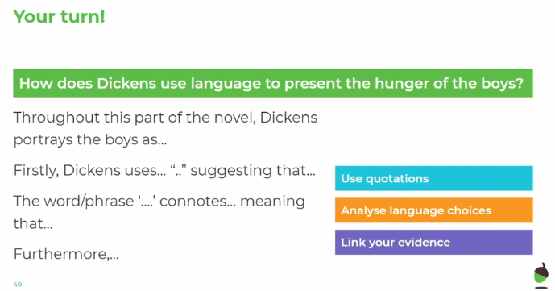

Lesson 2 &3: Victorian Literature: The Social Problem Novel
Please note: There is a lot to learn in these lessons. You might not complete it all in one go! Please spread this work over two hours – feel free to complete it all in one go or during the two days you would have English.
Use the following link to access the video lesson we will be working alongside. I have created this resource to support you in approaching this lesson.
https://www.thenational.academy/year-8/english/mary-barton-by-elizabeth-gaskell-year-8-wk2-2
You will either need to print this document out or have it open in word alongside the video link and you can type in notes as you go.

Task 1: Using the video to help you, write down the definitions of the following vocabulary:

Class:

Industrial:

Urban:

Conflict:

Task 2: Listen carefully to the teacher’s information about Elizabeth Gaskell and Victorian class conflict.

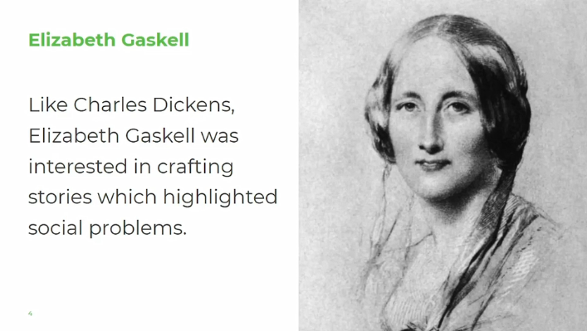

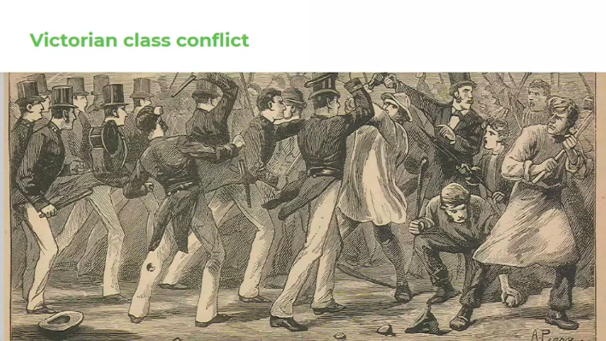

Task 3: Now complete the following sentence starters – feel free to rewind the video if you need to.

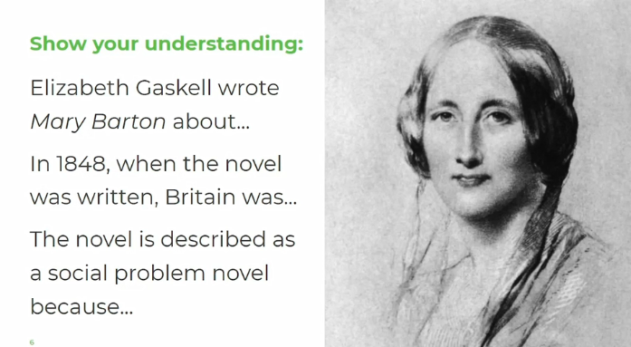

Task 4: Now check your ideas with the teacher’s response on the next page. Add anything to yours that you have missed.

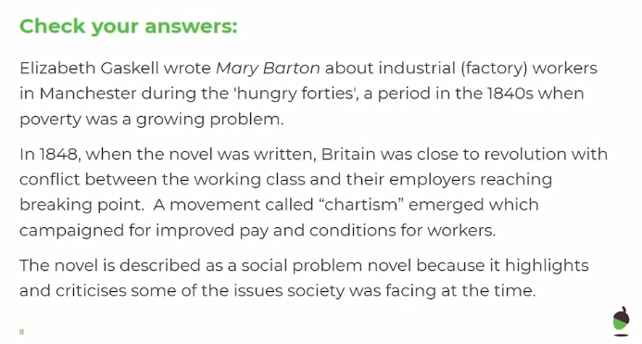

Task 5:
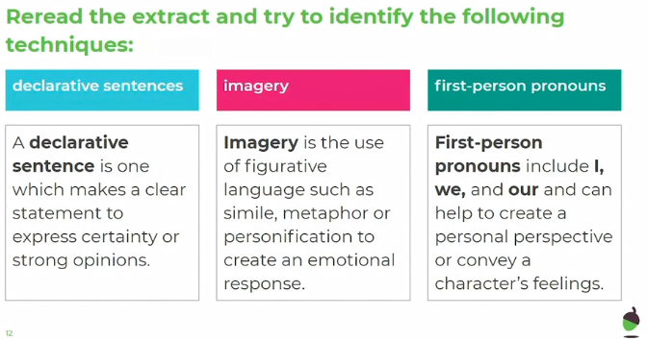

The rich know nothing of the trials of the poor; I say, if they don't know, they ought to know. We're their slaves as long as we can work; we pile up their fortunes with the sweat of our brows, and yet we are to live as separate as if we were in two worlds…

Task 6: Consider, how does Gaskell highlight the divisions in society? Pick out the rich evidence that you think shows this and annotate the extract with some of your ideas.

Task 7: Listen to the teacher’s ideas about the extract and add any ideas you’ve missed to your own notes.

Task 8: Draw out and complete the below quotation explosion.

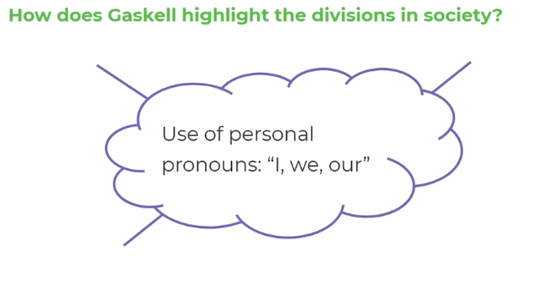

Task 9: Listen to the teacher feeding back her ideas and add any relevant ideas to your own work.

Task 10: Draw out and complete the below quotation explosion.

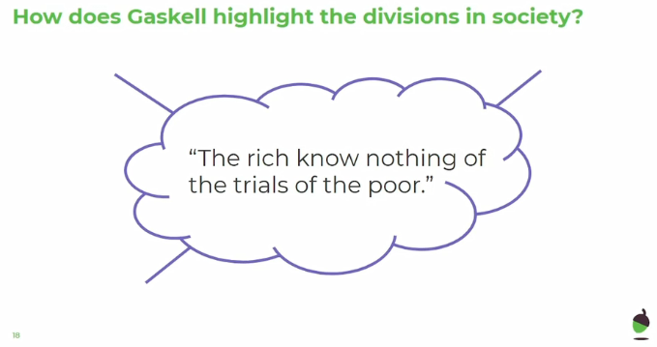
Task 11: Listen to the teacher feeding back her ideas and add any relevant ideas to your own work.
Task 12: Draw out and complete the below quotation explosion.
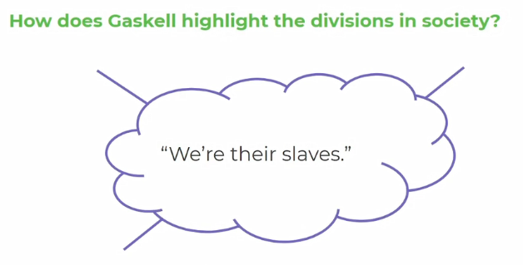

Task 13: Listen to the teacher feeding back her ideas and add any relevant ideas to your own work.
Task 14: Draw out and complete the below quotation explosion.
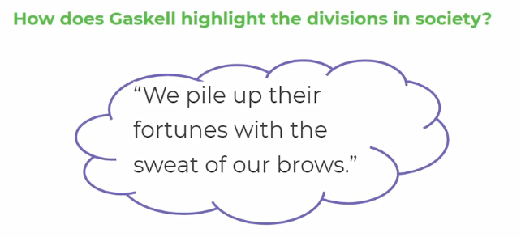
Task 15: Listen to the teacher feeding back her ideas and add any relevant ideas to your own work.
Task 16: Draw out and complete the below quotation explosion.

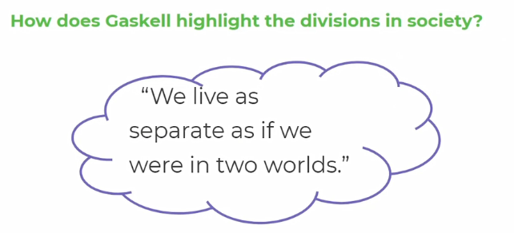

Task 17: Listen to the teacher feeding back her ideas and add any relevant ideas to your own work.

Task 8: Now spend 15 minutes in focussed silence, answering the following question. Make sure use quotations to support your ideas and bring in your analysis of these to prove your ideas.
