Year 7

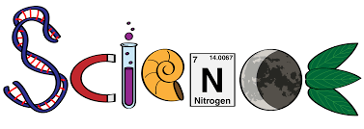

Topic 1 Chemical reactions

Topic 2 Motion

Topic 3 Energy

Topic 4 Plant reproduction

Topic 1: Reactions
6 lessons
- Chemical reactions
- Work equations
- Combustion
- Thermal decomposition
- Conservation of mass
- exothermic and endothermic reactions

Useful links

Reactions: https://www.bbc.co.uk/bitesize/topics/zypsgk7/articles/zwxhk2p
Types of reaction: https://www.bbc.co.uk/bitesize/guides/zqd2mp3/revision/1
Combustion: https://www.bbc.co.uk/bitesize/topics/zypsgk7/articles/zcwxcj6
Lesson 1: Chemical reactions

- What is the difference between a chemical reaction and a physical change?

- What are 4 key signs that show a chemical reaction is taking place?

- Write down 2 examples of chemical reactions and 2 examples of physical changes

Lesson 2: Word equations
a) reactants: ________________________
products: ________________________
b) reactants: ________________________
products: ________________________
c) reactants: _______________________
products: ________________________

Lesson 3: combustion

- Name 4 examples of fuels

- What does a fuel do that is useful?

- What 2 elements are fuels mainly made up of?

- What are the two products of combustion?

- Write a word equation for a fuel burning below

Lesson 4: Thermal decomposition

- What does thermal decomposition mean?

Lesson 5: Conservation of mass

- What does the principle of conservation of mass state?

- Complete the sentence:
In a reaction the total mass of the reactants ___________ the total mass of the products. This is called ____________ of mass.
- In a reaction, 15g of a reactant was weighed out. What is the TOTAL mass of products the reaction will make? ________g
- A combustion reaction made 20g of water and 30g of carbon dioxide as the products, what is the total mass of the reactants? ________g
Lesson 6: exothermic and endothermic reactions

- What does exothermic mean?

- What does endothermic mean?

- Complete the sentences…

In an exothermic reaction the surroundings get __________, the temperature on the thermometer _________. In an endothermic reaction the surroundings get _________, the temperature on the thermometer __________.

Topic 2: Motion
4 lessons
- Vectors and scalars
- Calculating speed
- Distance-time graphs
- Velocity-time graphs

Useful links

Calculating speed: https://www.bbc.co.uk/bitesize/guides/zwwmxnb/revision/1
Using distance-time graphs https://www.bbc.co.uk/bitesize/guides/zwwmxnb/revision/2

Lesson 1 Vectors and scalars
- Scalars are quantities with only m______________________.
- Vectors are quantities with magnitude and d____________________.
- Distance is a ________________ quantity.
- Displacement is a vector as it is distance with d__________________________.
- Speed is a scalar quantity. Velocity is s_____________ with direction so it is a v_______________.
- Circle the vectors and underline the scalars
Distance  Velocity  Acceleration  Energy  Power  Time  Speed | Temperature  Force  Magnetic Field  Density  Volume  Displacement
Lesson 2 Speed
What is speed, and how is it measured?
the formula for calculating speed is:
Speed (m/s) = distance (m) ÷ time (s)

OR sometimes written as

Speed (m/s) = distance (m)
time (s)

The formula for speed can be rearranged to either make speed, distance or time the subject of the equation.
Speed (m/s) = distance (m)
time (s)
Distance (m) = speed (m/s) x time (s)

Time (s) = distance (m)
speed (m/s)

- Luke walks 200 metres in 40 seconds. What is his speed?

- Laura covers 2000 m in 1,000 seconds. What is her speed?

- How long would it take to run 100 metres if you run at 10m/s?

- Lisa travels at 50 m/s for 10s. How far does she go?

Lesson 3 Distance-time graphs
We can describe the journey represented by a distance time graph by using the key terms that you have already learned. To do this the graph must be split up into sections so that they can be clearly described.

Graph | Description of journey
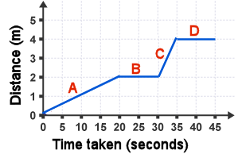 | Section A -
 | Section B -
 | Section C -
 | Section D -
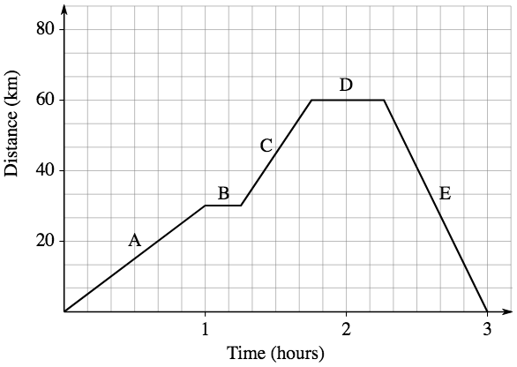 | Section A -
 | Section B -
 | Section C -
 | Section D -
 | Section E -
Lesson 4 Velocity-time graphs

$$\text{Acceleration (m/s/s)=} \frac{\text{Change in velocity (m/s)}}{\text{Time taken for change (s)}}$$
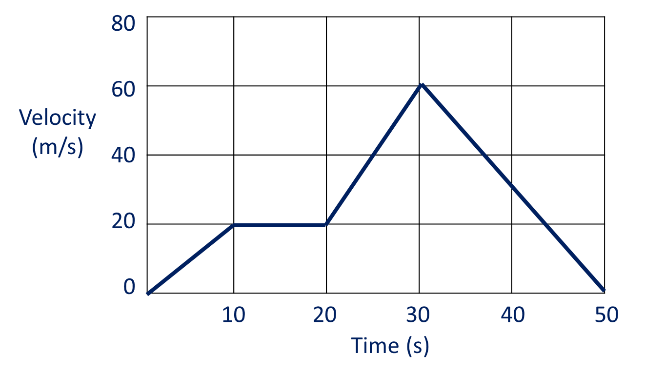

- How fast was the object going after 10 seconds?
………………………………………………………………………………………………………………………………………………………………..
………………………………………………………………………………………………………………………………………………………………..

- Describe what was happening between 10 and 20 seconds.
………………………………………………………………………………………………………………………………………………………………..
………………………………………………………………………………………………………………………………………………………………..
- Calculate the acceleration between 20 and 30 seconds.
………………………………………………………………………………………………………………………………………………………………..
………………………………………………………………………………………………………………………………………………………………..
………………………………………………………………………………………………………………………………………………………………..

Topic 3: Energy
6 lessons
- Energy resources
- Energy and Power
- Work, energy and power
- Kinetic energy
- Gravitational potential energy
- Efficiency

Useful links

Energy resources: http://www.darvill.clara.net/altenerg/index.htm
Energy and power: https://filestore.aqa.org.uk/textbooks/sample/KS3-Science/AQA-KS3SCI-OXFORD-SAMPLE-SB1.PDF
Work, energy and power: https://www.bbc.co.uk/bitesize/guides/zttfyrd/revision/7
Kinetic energy: https://www.bbc.co.uk/bitesize/guides/zhvv2sg/revision/1
Gravitational energy: https://www.bbc.co.uk/bitesize/guides/zhvv2sg/revision/3
Efficiency: https://www.bbc.co.uk/bitesize/guides/zp8jtv4/revision/3

Lesson 1: energy resources
Match up the energy resource to how it works. Then match the advantages and disadvantages. Add an R next to the renewable resources. The first one has been done for you. http://www.darvill.clara.net/altenerg/index.htm
Energy resource | How it works |  | Advantages and disadvantages | Rank
1  Nuclear | Radiation given off by fuels like uranium is used to heat water. This makes steam, which turns a turbine, and then a generator, which produces electricity. |  | + cheap fuel  + reliable  - produces greenhouse gases  - non-renewable
2 | Solar panels convert sunlight into electricity. |  | + doesn’t give off any greenhouse gases  - expensive  - radiation is harmful  - non-renewable
3 | Coal, oil and natural gas are burnt to release heat to boil water. This makes steam, which turns a turbine, and then a generator, which produces electricity. |  | + fuel is free  + doesn’t produce greenhouse gases  - only works in a few parts of the world
4 | Water from a reservoir flows through turbines which are connected to generators to produce electricity. |  | + fuel is free  + doesn’t produce greenhouse gases  - Doesn’t work at night  - Solar panels can be expensive
5 | In some places, rocks underground are hot. Water can be heated by pumping it through the rocks. |  | + doesn’t produce greenhouse gases  - reservoirs take up huge amounts of space  - dams can destroy habitats
6 | Wind turns the large turbine blades which are connected to a generator to produce electricity. |  | + fuel is easy to grow/produce  + uses waste products  - produces greenhouse gases
7 | When plants and animal waste rots, they produce methane gas (the same as natural gas). An example is wood. Alternatively, fast growing trees are use to produce wood to burn. |  | + fuel is free  + doesn’t produce greenhouse gases  - doesn’t work if it isn’t windy  - wind turbines are expensive
Lesson 2: Energy and Power

Power can be measured in Watts (W) or kilowatts (kW). To convert a power in kW into Watts you need to multiply the value in kW by 1000
e.g. 2 kW = 2000 W or 0.9 kW = 900 W.
Time is measured in seconds. To convert from minutes to seconds, you need to multiply by 60
e.g. 5 minutes = 5 x 60 = 300 seconds.
To convert from hours to seconds you need to multiply by 3600 – this is because there are 60 minutes in an hour and 60 seconds in a minute, so 60 x 60 = 3600
e.g. half and hour = 0.5 x 3600 = 1800 seconds or 2 hours = 2 x 3600 = 7200 seconds.

- A kettle is rated 1800 W. It is used for 2 minutes (120 seconds) to boil water. Calculate the energy used.

- A microwave is rated 1000 W. It is used for 8 minutes to heat up some food. Calculate the energy used.

- A television is rated 0.5 kW. It is used for 1 hour. Calculate the energy used.

Lesson 3: Work, energy and power

- Calculate the work done when a book of 3 N is lifted from the floor to a table 0.7 m. high. Show your working.
- Pete pulls a pulley and lifts a 20 N weight by 0.5 m. Calculate the work done.
- Fill in the gaps using the following words:

force multiplier force distance pivot
simple machine bigger smaller

A lever is a ________________ _______________. In this example, a screwdriver is used to open a paint tin. The ________________ is where the end of the screwdriver is resting on the edge of the paint tin. The ________________ applied to the lid by the lever is ________________ than the ________________ that you apply with just your hand. This means that a lever is a ________________ ________________.

Lesson 4: Kinetic energy
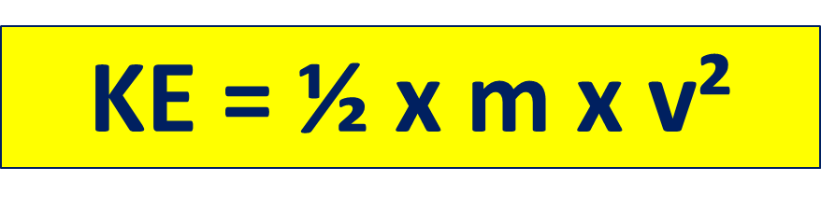
- A sprinter has a mass of 68 kg. He can reach a top speed of 11 m/s. What is his maximum kinetic energy?

- Calculate the kinetic energy of a pigeon of mass 0.40 kg that is flying with a velocity of 20m/s.

- A car of mass 500 kg is a moving with a velocity of 10m/s. calculate the kinetic energy.

- The car now accelerates and doubles its speed to 20 m/s. what is the new kinetic energy?

Lesson 5: Gravitational potential energy

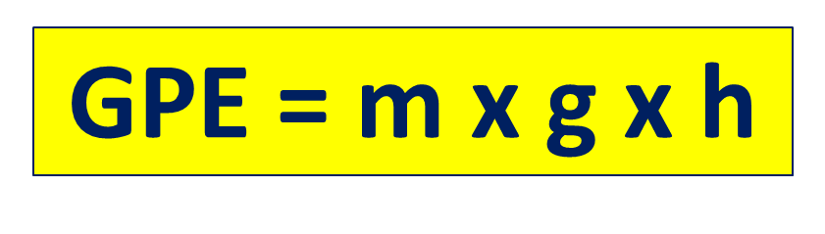
- A 5 kg cat is lifted 2 m into the air. How much gravitational potential energy does it gain?

- A cyclist has a mass of 68 kg. He cycles up a hill that is 50 m high. What is his gravitational potential energy?

- An astronaut has a mass of 70 kg. He climbs 2 m to get into his space shuttle before take-off. What gravitational potential energy does he gain?

- An astronaut lands on the moon. He has a mass of 70 kg. He climbs 2 m to get back into his space shuttle what gravitational potential energy does he gain? The value of g on the moon is g = 1.6 N/kg.

Lesson 6: Efficiency
Calculate the efficiencies of these 3 cars. These can be found in your workbook. Write your answer as both a decimal and a percentage.

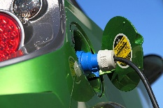
Hydrogen fuel cell car
Total energy input = 2000 J
Useful energy output (kinetic) = 800 J

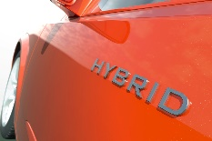

Hybrid car
Total energy input = 100 J
Useful energy output (kinetic) = 68 J

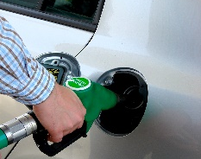

Petrol car
Total energy input = 500 J
Useful energy output (kinetic) = 95 J

Topic 4: reproduction in plants
3 lessons
- Flowers and Pollination
- Fertilisation and germination
- Sexual and Asexual reproduction

Useful links

Flowers and Pollination: https://www.bbc.co.uk/bitesize/guides/zs7thyc/revision/1
https://www.bbc.co.uk/bitesize/guides/zs7thyc/revision/4

Fertilisation and germination: https://www.bbc.co.uk/bitesize/guides/zs7thyc/revision/2
https://www.bbc.co.uk/bitesize/guides/zs7thyc/revision/3

Sexual and Asexual reproduction: https://www.bbc.co.uk/bitesize/guides/z2xg87h/revision/1

Lesson 1: Flowers and Pollination

- The male parts of the flower are called the __________ and consists of the ___________ and ___________. The female part of the flower is called the ___________. It consists of the ___________, ___________ and ____________. The male gamete is made in the ___________ and is found inside the __________ grain. The female gamete is found in the ___________ and is called an ____________.

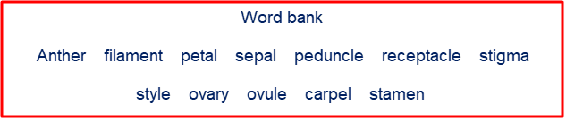

- What is pollination?

- What is the difference between insect pollinated flowers and wind pollinated flowers?

- How are insect-pollinated flowers adapted?

- How are wind-pollinated flowers adapted?

Lesson 2: Fertilisation and germination

- What is a fruit?

- What is a seed?

- Put these sentences in the correct order:

  - As the bee passes the anthers, pollen grains stick to the hairs on the bee’s body.

  - The pollen-grain nucleus joins with the egg-cell nucleus.

  - The bee flies to another flower, carrying pollen from the first flower with it.

  - A bee visits a flower to feed on nectar. The bee wriggles deep into the flower past the anthers.

  - Pollen grains from the bee get stuck on the sticky stigma.

  - The fertilised egg develops into a seed

  - A pollen grain develops a pollen tube that grows down the style to the ovule.

  - The bee feeds on the nectar of the second flower.

D |  |  |  |  |  |  | F

- What is germination?

Lesson 3: Sexual and Asexual reproduction

 | Sexual | Asexual
Number of parents
Involves gametes?
Offspring are clones?
Does it lead to variation?

Examples of organisms that can reproduce this way

