Okehampton College
Mathematics
Year 7
Summer Term Review
Name:

Core and Higher
Topic 1 | Fractional Thinking – Addition and Subtraction of Fractions
Topic 2 | Lines and Angles – Geometric Reasoning
Topic 3 | Reasoning with Number – Developing Number Sense
Topic 4 | Reasoning with Number – Prime Numbers and Proof
 | Answers

Introduction – how to use this booklet
This booklet is to help you review and revise the key topics covered towards the end of the academic year (and mostly by remote learning).
Early in the Autumn term you will have a written assessment on questions from these topics and your performance will help your teachers plan how to support you next year.
Each section contains a Knowledge Organiser on the topic, followed by practice questions (Core and Higher level). The answers are at the end of the booklet.
If you have completed most of the remote learning lessons set on Class Charts, you may still like to use this booklet to review what you have learnt and help you prepare for the assessment.
If you have not been able to complete many of the lessons, the knowledge organisers should help you catch up on the topics and answer the practice questions. You should check your work against the answers and if necessary, go back and correct any mistakes.
You will still be able to log in to the Sparx lessons (codes given on Class Charts for your class) until 31st July, so you can use this resource to catch up on some topics and practise the skills.

If your maths group is 7x/Ma1 or 7y/Ma1, you should be able to answer the Core questions but may like to concentrate on the Higher questions.
For all other students, you should concentrate on the Core questions (though of course you are welcome to try the Higher ones as well!)

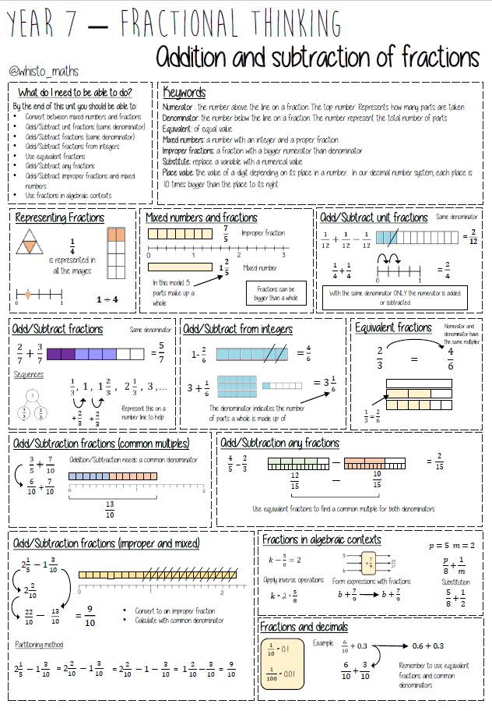
Year 7 Core – Addition and Subtraction of Fractions Questions
1. | 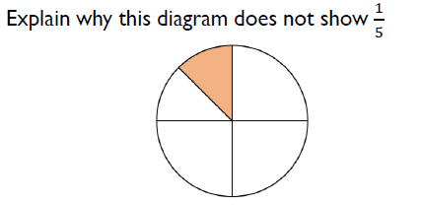 | 2. | 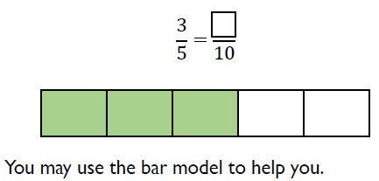
3. | 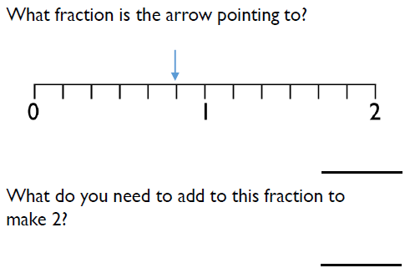 | 4. | 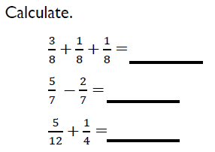
5. | 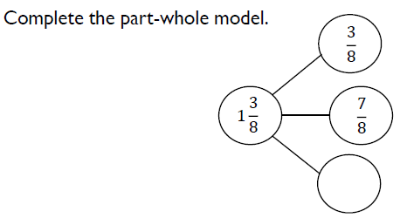 | 6. | 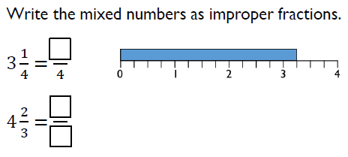

Year 7 Core Questions – Addition and Subtraction of Fractions
7. | 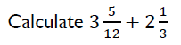 | 8. | 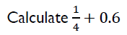
9. | 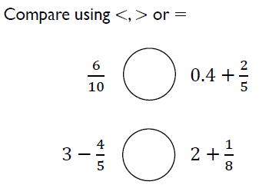 | 10. | 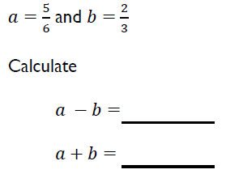
11. | 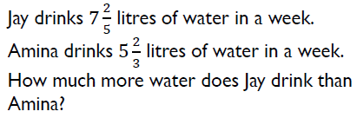 | 12. | 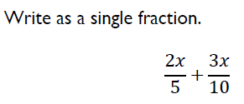

Year 7 Higher Questions - Addition and Subtraction of Fractions
 | 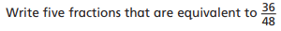 |  | 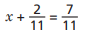  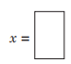
 | 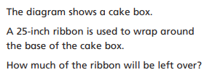  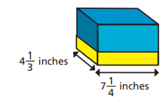  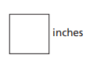 |  | In the fraction pyramid, the number in each box is the sum of the two numbers below.  Is the number on the top box greater than 5.25?  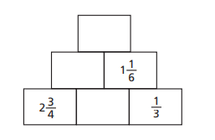
 | 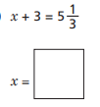 |  | 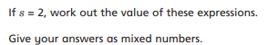  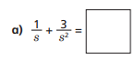
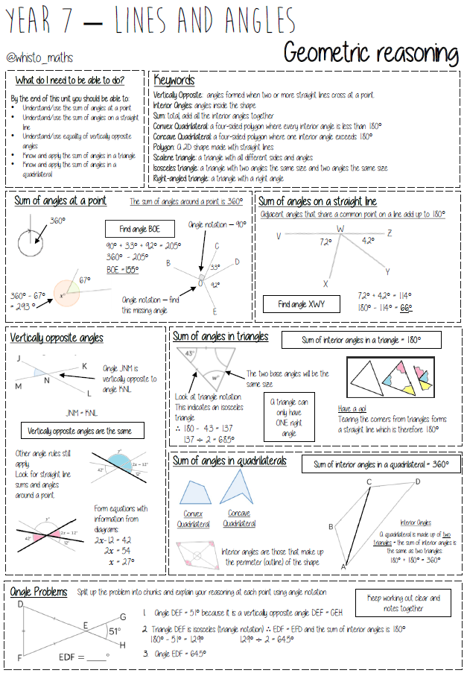
Year 7 Core Questions – Geometric Reasoning
1. | 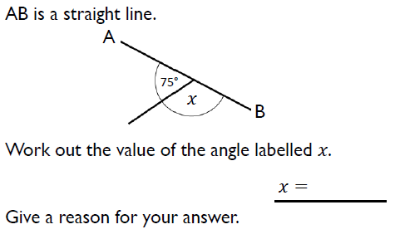 |  | 2. |  | 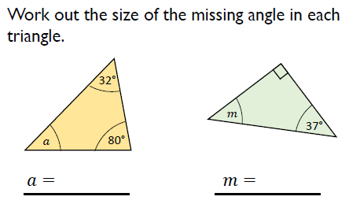
3. | 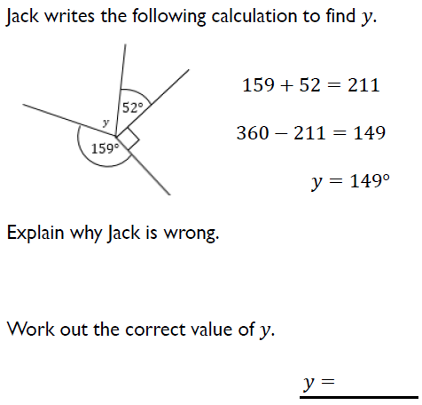 |  | 4. |  | 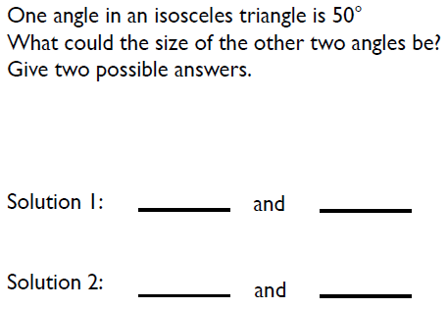
5. | 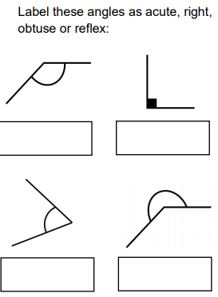 |  | 6. |  | 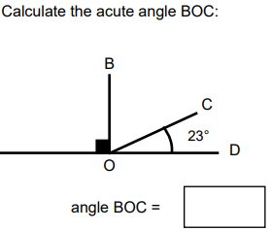
Year 7 Core Questions – Geometric Reasoning
7. | 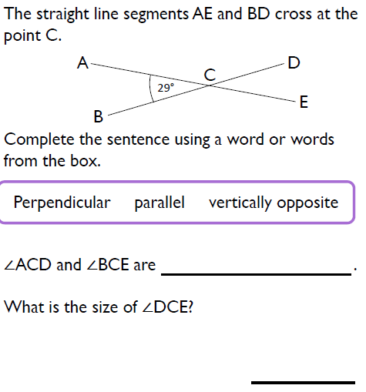 | 8. |  | 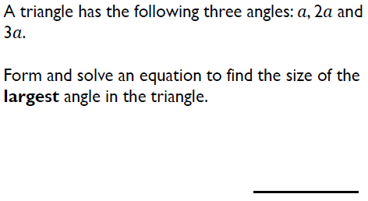
9. | 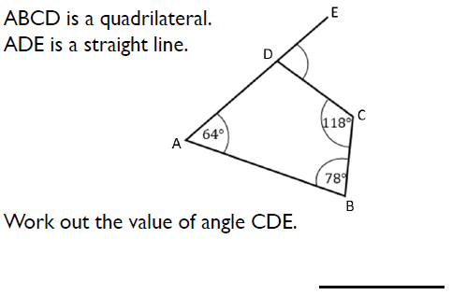 | 10. |  | 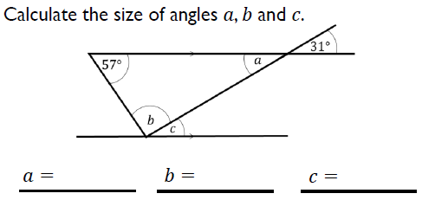
11. | 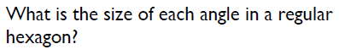

 | 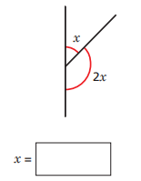 |  | 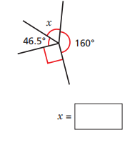
 | One of the angles in a triangle is 38˚. Another angle is twice the size of the first angle. What is the size of the third angle? |  | 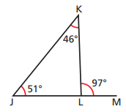  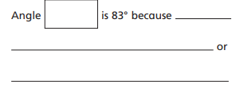
 | The diagram shows three straight lines intersecting at a single point. Work out the value of $x$and $y.$  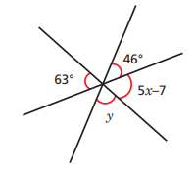  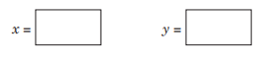 |  | Two isosceles triangles are joined to form a kite.  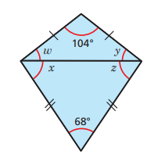  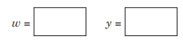  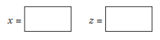
Year 7 Higher Questions - Geometric Reasoning

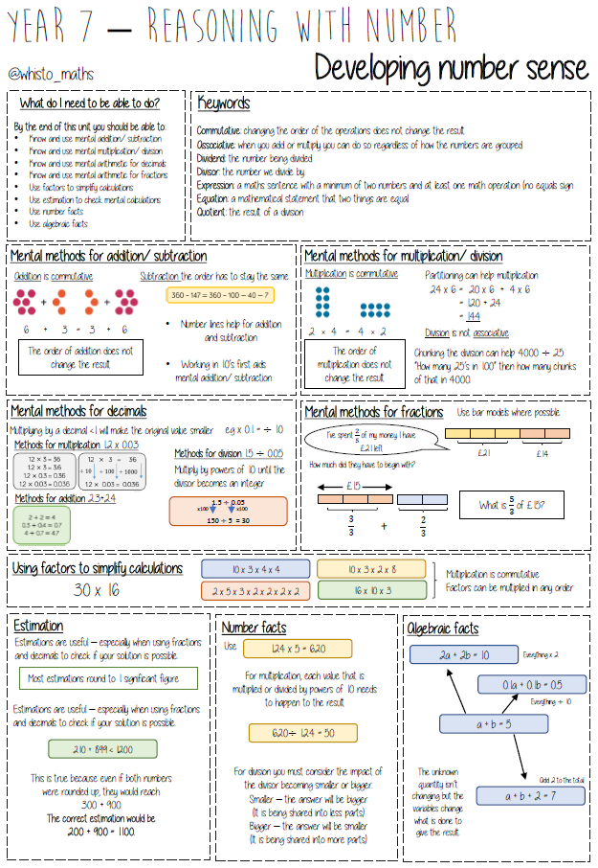
Year 7 Core Questions – Developing Number Sense
1. | 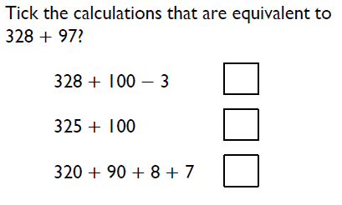 | 2. | 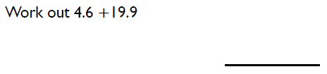
3. | 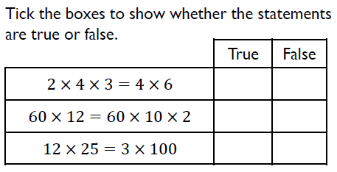 | 4. | 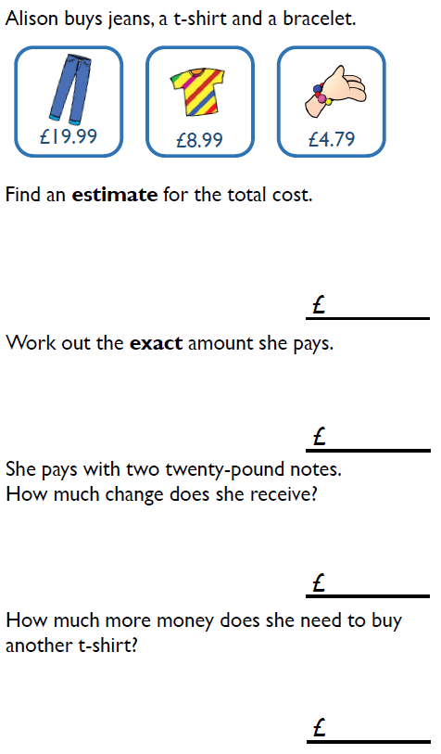
5. | 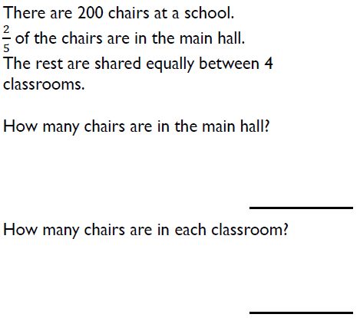

Year 7 Core Questions – Developing Number Sense
6. | 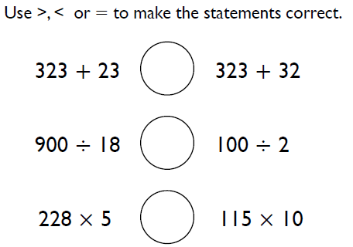 | 7. | 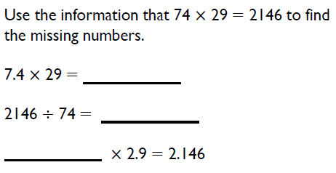
8. | 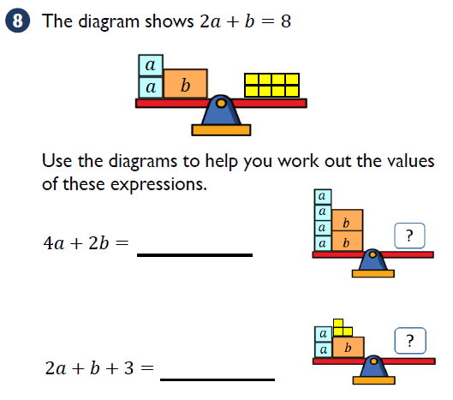
9. | Estimate $0.2×436$ | 10. | Estimate $\frac{54.3+45}{1.96}$

 | 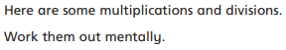  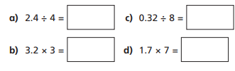 |  | 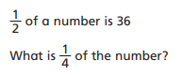
 | Find three different ways to multiply 16 by 50 using factors.  _________________________________________  _________________________________________  _________________________________________ |  | 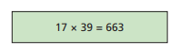  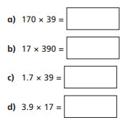
 | 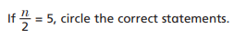  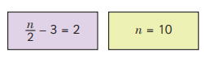  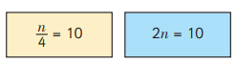  What are the correct answers for the statements you have not circled? |  | 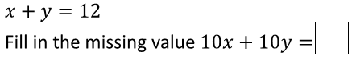
Year 7 Higher Questions - Developing Number Sense

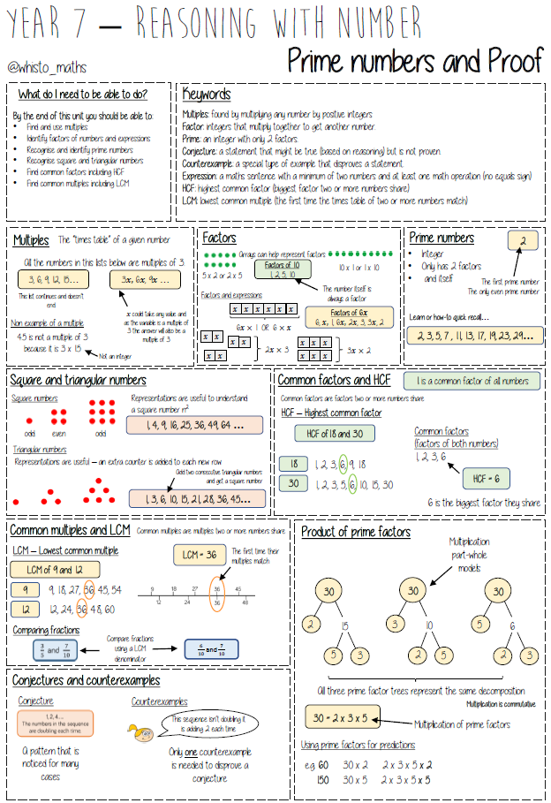
Year 7 Core Questions – Prime Numbers and Proof
1. | 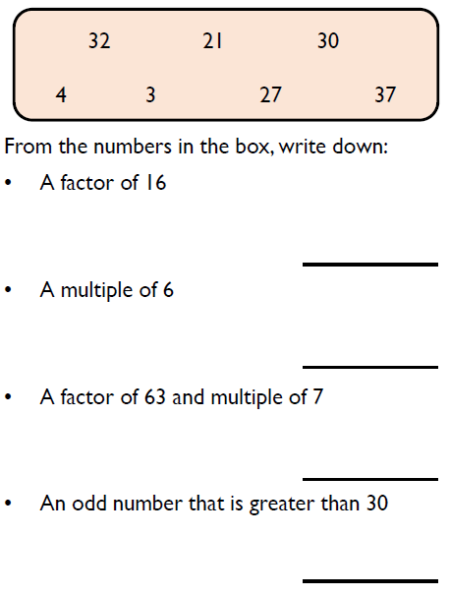 | 2. | 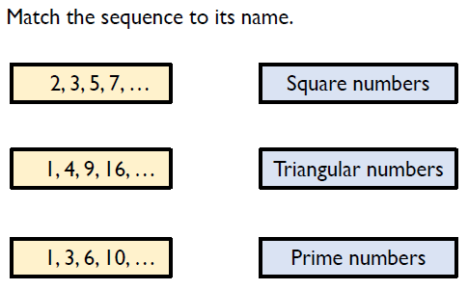
 |  | 3. | 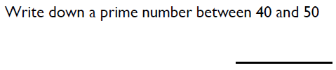
4. | 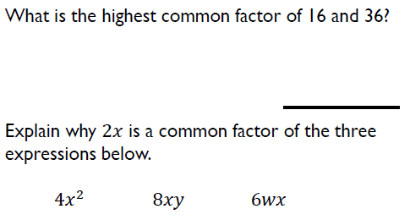 | 5. | 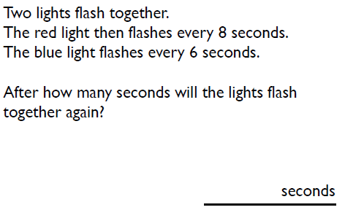

Year 7 Core Questions – Prime Numbers and Proof
6. | 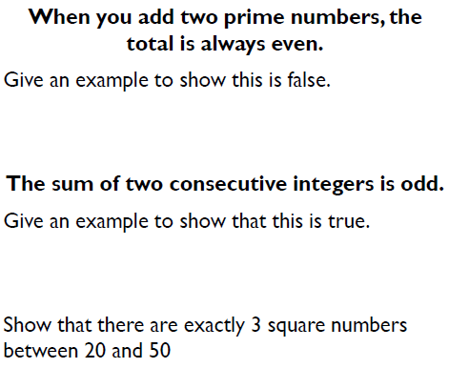 | 7.
 |  | 8.
9. | 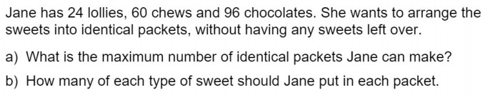

 | 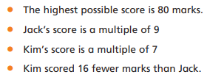 |  | Use the clues to find four consecutive numbers that fit in the boxes.  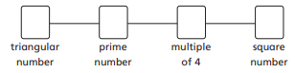
 | Write a common factor of $15a^{2}$ $+ 10a$ |  | Complete a factor tree and give the number as a product of its prime factors.  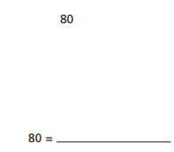
 | 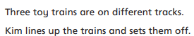  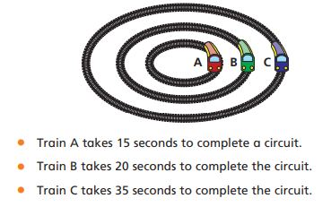  After how many minutes will the trains next line up in the same position?  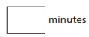 |  | 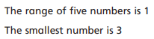  Aisha thinks the median must be 3.5 as the greatest number of 4 and 3.5 is in the middle.  Give a counter-example to Aisha’s conjecture.  _____________________________________
Year 7 Higher Questions - Prime Numbers and Proof

Year 7 Core Answers – Addition and Subtraction of Fractions
1. | 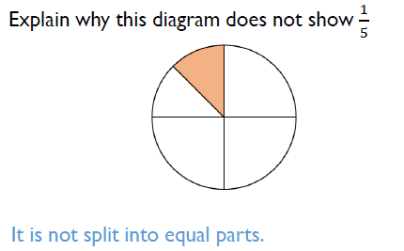 | 2. | 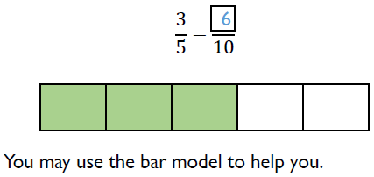
3. | 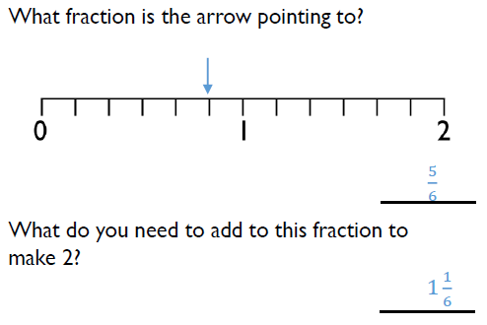 | 4. | 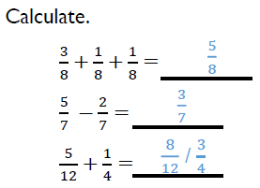
5. | 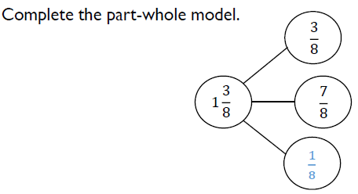 | 6. | 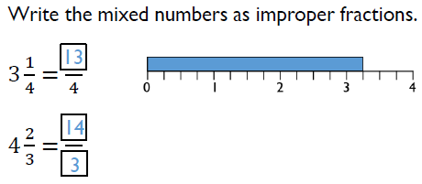
Year 7 Core Answers – Addition and Subtraction of Fractions
7. | 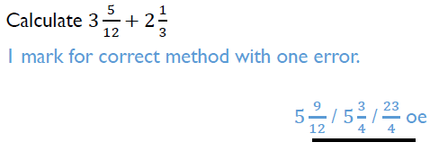 | 8.
9. | 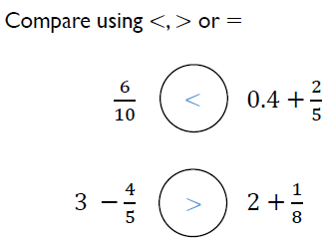 | 10. | 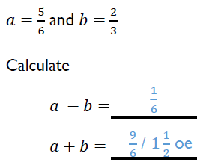
11. | 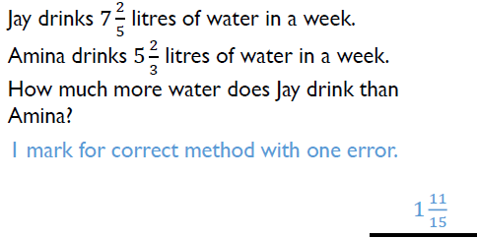 | 12. | 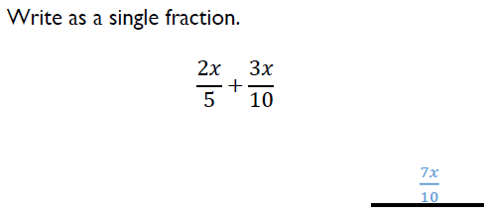

 | 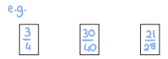  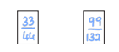 |  | 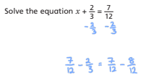  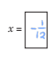
 | 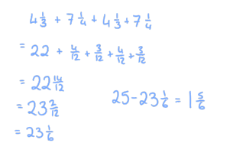  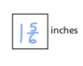 |  | 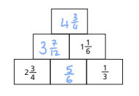  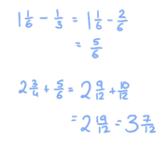  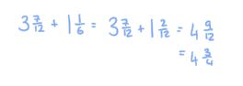
 | 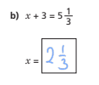 |  | 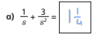
Year 7 Higher Answers - Addition and Subtraction of Fractions

Year 7 Core Answers – Geometric Reasoning
1. | 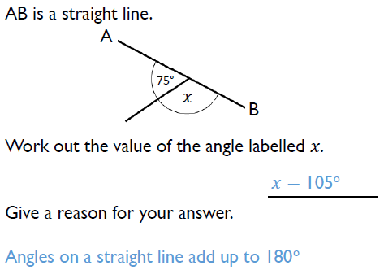 | 2. | 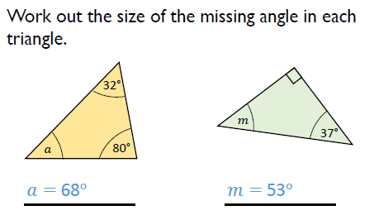
3. | 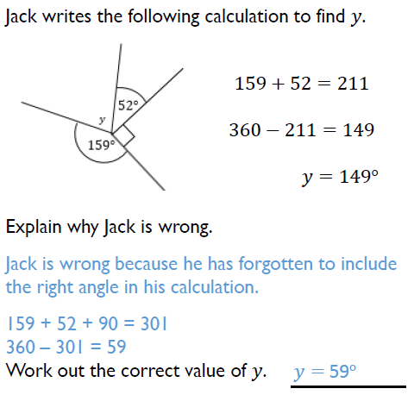 | 4. | 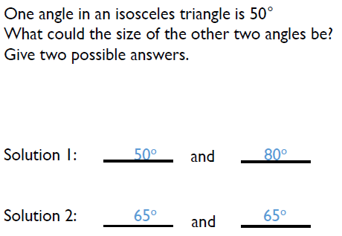
5. | 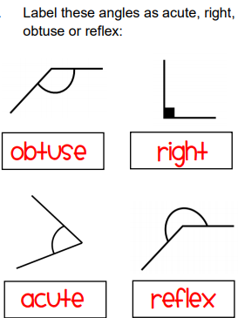 | 6. | 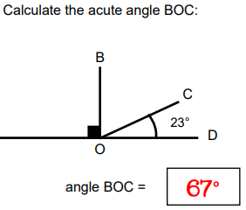

Year 7 Core Answers – Geometric Reasoning
7. | 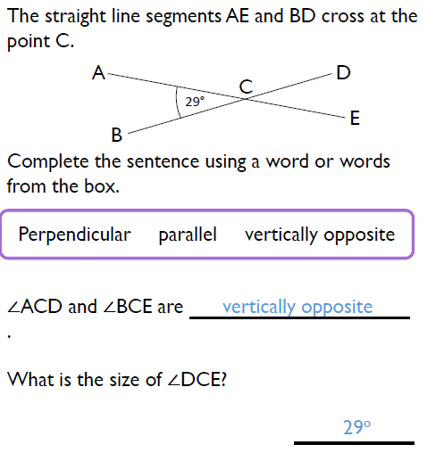 | 8. | 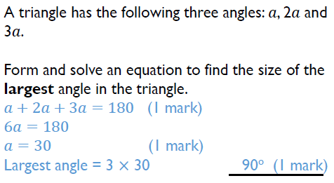
9. | 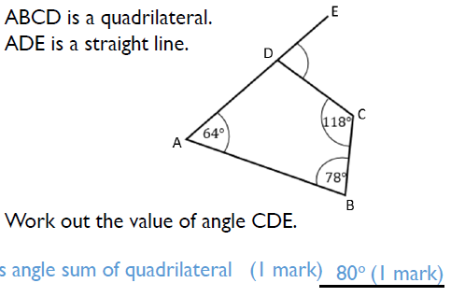 | 10. | 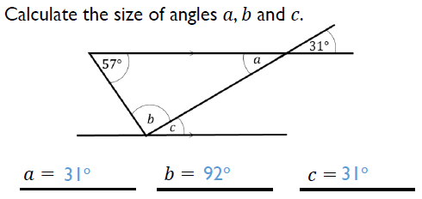
11. | 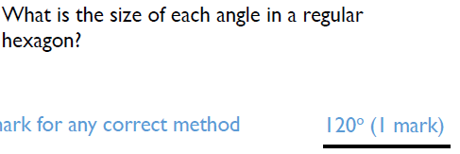  $\frac{6-2}{6}×180=$

 | 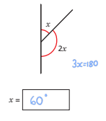 |  | 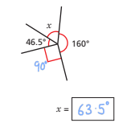
 | One of the angles in a triangle is 38˚. Another angle is twice the size of the first angle. What is the size of the third angle?  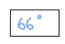 |  | 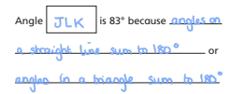
 | 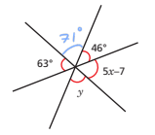  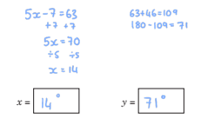 |  | 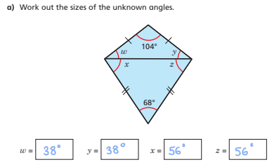
Year 7 Higher Answers - Geometric Reasoning

Year 7 Core Answers – Developing Number Sense
1. | 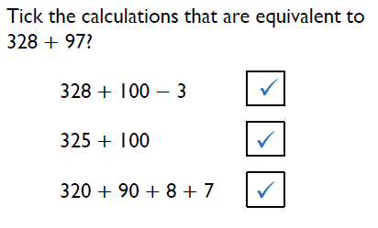 | 2. | 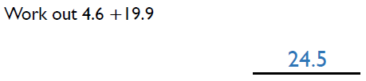
3. | 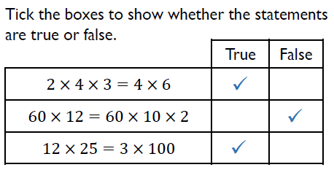 | 4. | 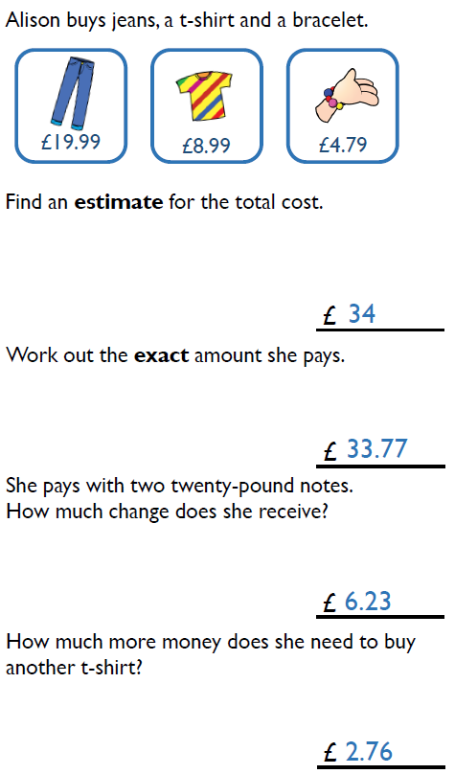
5. | 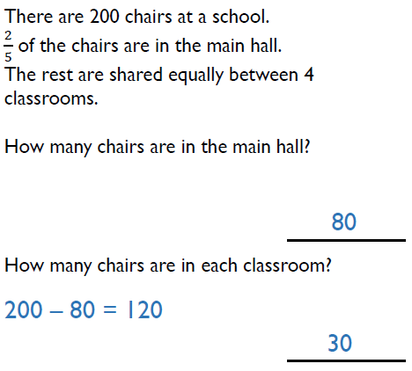

Year 7 Core Answers – Developing Number Sense
6. | 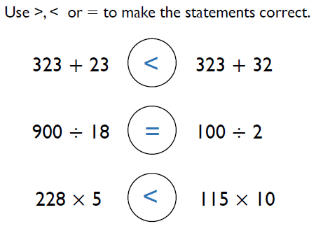 | 7. | 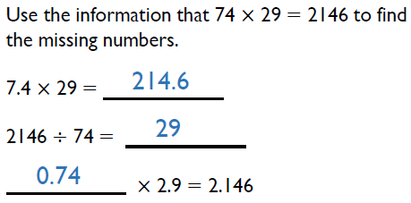
8. | 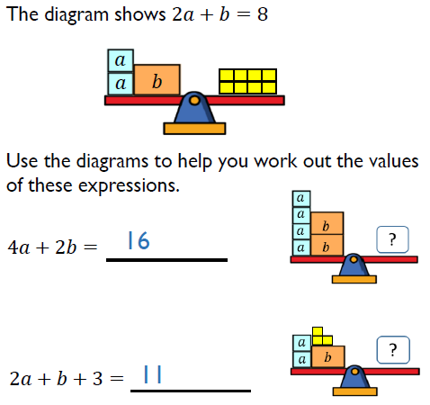
9. | Estimate $0.2×436$  $$0.2×436≈0.2×400$$  $$0.2×400=400×\frac{2}{10}$$  $$=40×2=80$$ | 10. | Estimate $\frac{54.3+45}{1.96}$  $$\frac{54.3+45}{1.96}≈\frac{50+50}{2}=50$$

 | 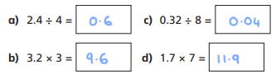 |  | 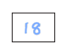
 | 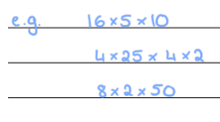 |  | 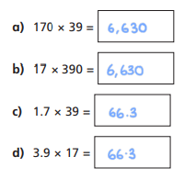
 | 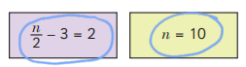 |  | 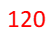
Year 7 Higher Answers - Developing Number Sense

Year 7 Core Answers – Prime Numbers and Proof
1. | 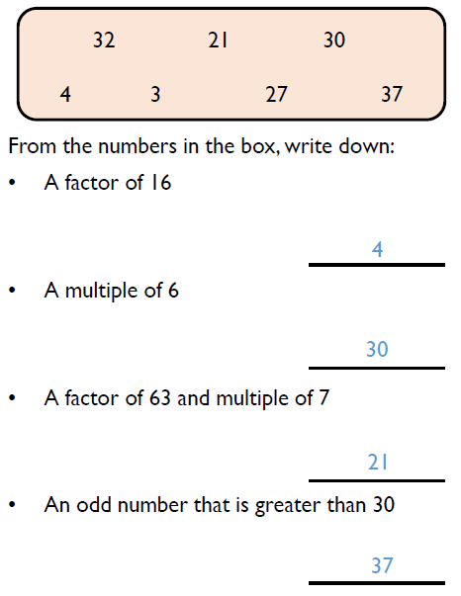 | 2. | 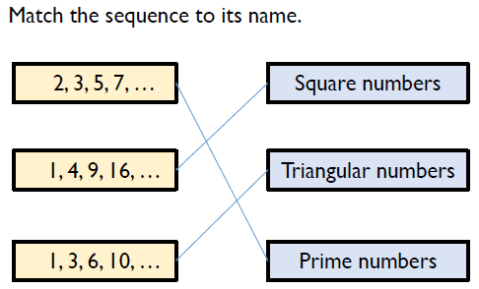
 |  | 3. | 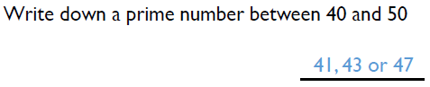
4. | 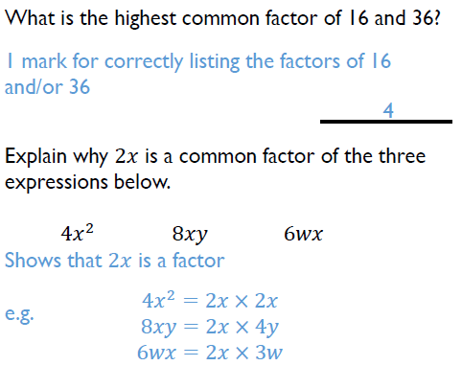 | 5. | 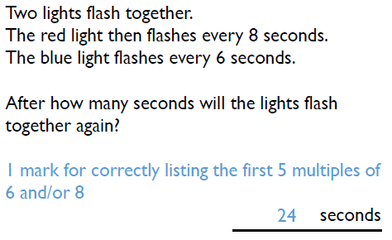

Year 7 Core Answers – Prime Numbers and Proof
6. | 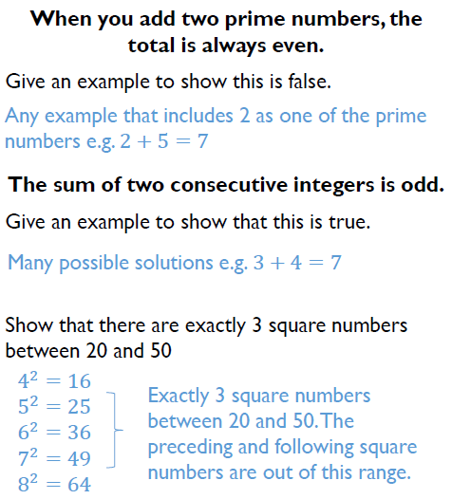 | 7. | 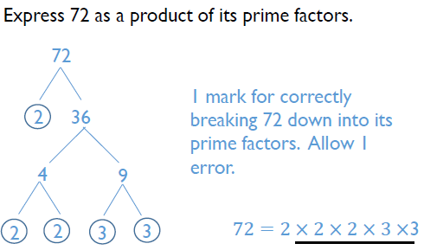
 |  | 8. | 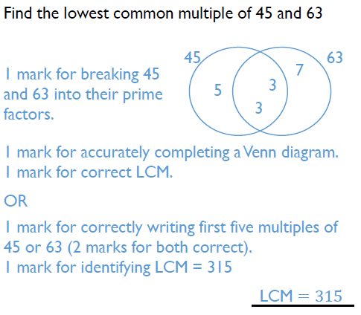
9. | 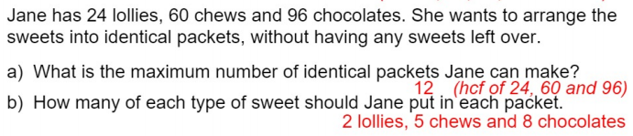

 | 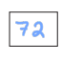 |  | 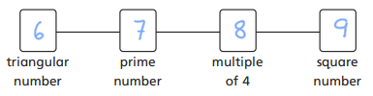
 | 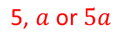 |  | 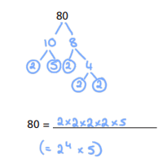
 | 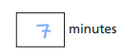 |  | 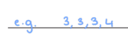
Year 7 Higher Answers - Prime Numbers and Proof

