Faculty of Technology – Summative Assessment

Subject: Year 7/8 Electronics (Mr Wilson/Mr Henderson)
If you studied electronics during lockdown, you will be assessed on the following topics when you return to college in September.
Topics to be Assessed:
1: Electric Current & Electric Circuits
2: Circuit Symbols, Cells & Batteries and Circuit Diagrams
3: Measuring Current & Potential Difference
4: Series and Parallel Circuits
5: Resistance
6: Conductors and Insulators

Resources to Help You:

Electric Current

https://www.bbc.co.uk/bitesize/guides/zsfgr82/revision/1
An electric current is a flow of charge, and in a wire this will be a flow of electrons. We need two things for an electric current to flow:
- something to transfer energy to the electrons, such as a battery or power pack
- a complete path for the electrons to flow through (an electric circuit)

Electric Circuits
The simplest complete circuit is a piece of wire from one end of a battery to the other. An electric current can flow in the wire from one end of the battery to the other, but nothing useful happens. The wire just gets very hot and the battery loses stored internal energy – it ‘goes flat’ and stops working.
To do something useful with the electric current, you need to put an electrical component into the circuit (such as a lamp), that can use the current in a useful way.
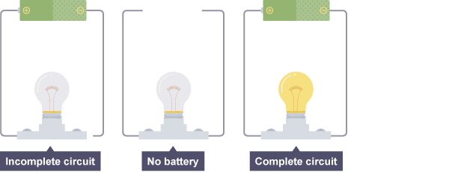
Circuit Symbols, Cells & Batteries and Circuit Diagrams
https://www.bbc.co.uk/bitesize/guides/zsfgr82/revision/2
Circuit Symbols
We use circuit symbols to draw diagrams of electrical circuits, with straight lines to show the wires. The diagram shows some common circuit symbols.
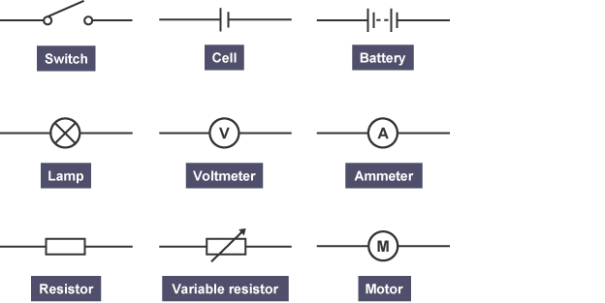

Cells & Batteries
The symbol for a battery is made by joining two more symbols for a cell together.

Circuit Diagrams
The idea of a circuit diagram is to use circuit symbols instead of drawing each component in the circuit. Always try to make the wires straight lines. Do not be tempted to make them wiggly because the whole point is to make it easier to see what is connected to what.
Here you can see how the symbols for a cell and a lamp look in a circuit diagram:
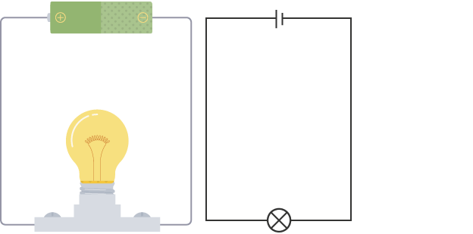
If you have to draw a circuit diagram:
- draw the circuit symbols first, then
- draw all the wires
If you have to draw wires to join circuit symbols that have been drawn for you already, use a ruler and do not let the wires cross each other.

Current

https://www.bbc.co.uk/bitesize/guides/zsfgr82/revision/3
Current is a measure of how much electric charge flows through a circuit. The more charge that flows, the bigger the current.
Current is measured in amperes. The symbol for ampere is A. For example, 20 A is a bigger current than 5 A. The word ‘ampere’ is often abbreviated to ‘amp’, so people talk about how many amps flow.

Measuring current
A device called an ammeter is used to measure current. Some types of ammeter have a pointer on a dial, but most have a digital display. To measure the current flowing through a component in a circuit, you must connect the ammeter in series with it.
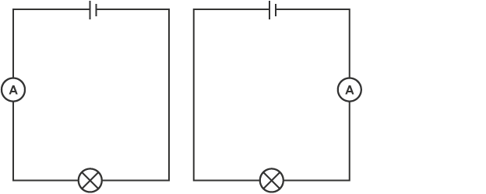
When two components are connected in series, you can follow the path through both components without lifting your finger or going back over the path you have already taken.

Potential difference
Potential difference is a measure of the difference in energy between two parts of a circuit. The bigger the difference in energy, the bigger the potential difference.
Potential difference is measured in volts. The symbol for volts is V. For example, 230 V is a bigger potential difference than 12 V. Instead of talking about potential difference, people often talk about voltage, so you may hear or see ‘voltage’ instead of ‘potential difference’.

Measuring potential difference
Potential difference is measured using a device called a voltmeter. Just like ammeters, some types have a pointer on a dial, but most have a digital display. However, unlike an ammeter, you must connect the voltmeter in parallel to measure the potential difference across a component in a circuit.
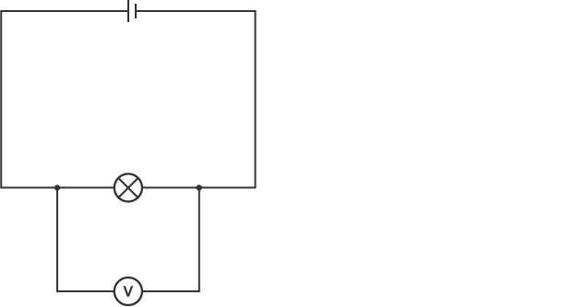

Series Circuits

https://www.bbc.co.uk/bitesize/guides/zsfgr82/revision/4
In a television series, you get several episodes, one after the other. A series circuit is similar. You get several components one after the other.
If you follow the circuit diagram from one side of the cell to the other, you should pass through all the different components, one after the other, without any branches.
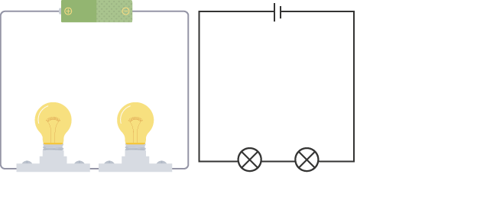
Two lamps in series
In a series circuit, if a lamp breaks or a component is disconnected, the circuit is broken and all the components stop working.
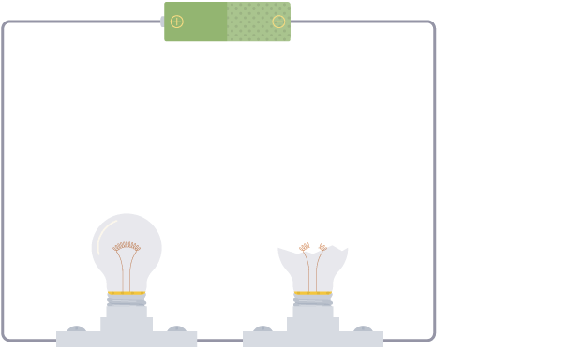
In a series circuit, if one lamp is removed or broken the other goes out
Series circuits are useful if you want a warning that one of the components in the circuit has failed. They also use less wiring than parallel circuits.

Current in series circuits
The current is the same everywhere in a series circuit. It does not matter where you put the ammeter, it will give you the same reading.
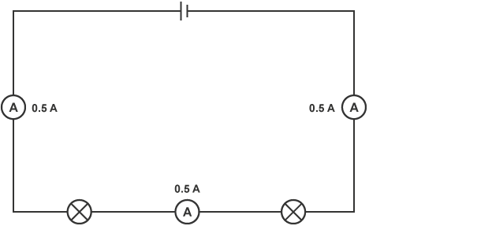
All three ammeters read 0.5 A in this series circuit

Adding more cells
The current in a series circuit depends upon the number of cells. If you make the cells face in the same direction, the more cells you add, the greater the current.
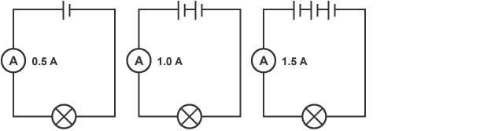

Parallel circuits

https://www.bbc.co.uk/bitesize/guides/zsfgr82/revision/5
In a parallel circuit, different components are connected on different branches of the wire. If you follow the circuit diagram from one side of the cell to the other, you can only pass through all the different components if you follow all the branches.
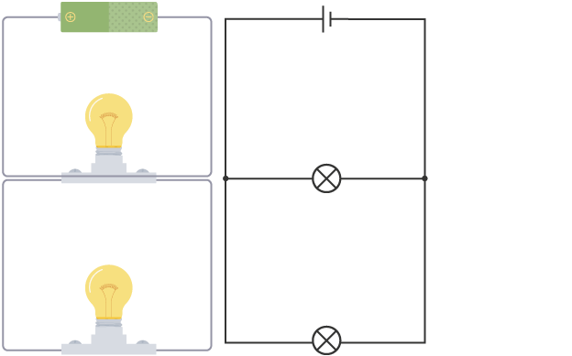
Two lamps connected in parallel
In a parallel circuit, if a lamp breaks or a component is disconnected from one parallel wire, the components on different branches keep working. Unlike a series circuit, the lamps stay bright if you add more lamps in parallel.
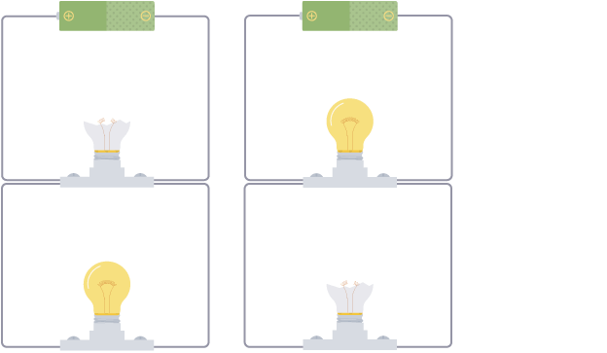
In a parallel circuit, if one lamp is removed or broken the other stays on
Parallel circuits are useful if you want everything to work, even if one component has failed. This is why our homes are wired up with parallel circuits.

Current is shared
When two components are connected in parallel, the current is shared between the components. The current is shared when it reaches the branches, then adds again where the branches meet.
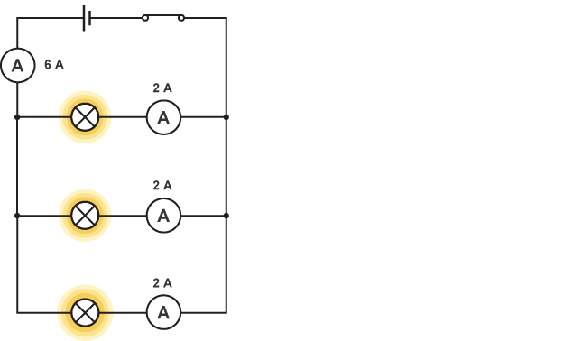
Current flowing through three identical lamps in parallel
In the diagram, 6 A flows through the cell. The circuit has three branches, each with an identical lamp, so 2 A flows through each one.
If the lamps were not identical, their resistances would be different and the current flowing through each lamp would not be the same. The greater the resistance of a lamp, the smaller the current that flows through it. The current would still be shared between them, and it would still add where the branches meet.

Resistance

https://www.bbc.co.uk/bitesize/guides/zsfgr82/revision/6
The wires and the other components in a circuit reduces the flow of charge through them. This is called resistance.
The unit of resistance is the ohm, and it has the symbol Ω (an uppercase Greek letter omega). For example, a 2 Ω component has a greater resistance than a 1 Ω component, and will reduce the flow of charge through it more effectively.

Adding components
The resistance increases when you add more components in series. For example, the resistance of two lamps is greater than the resistance of one lamp, so less current will flow through them.
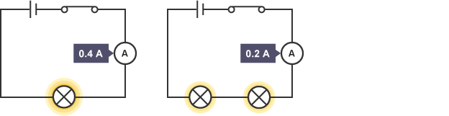
The more lamps, the greater the resistance and the lower the current

Calculating resistance
To find the resistance of a component, you need to measure:
- the potential difference across it
- the current flowing through it
The resistance is the ratio of potential difference to current. We use this equation to calculate resistance:
resistance = potential difference ÷ current
For example, 3 A flows through a 240 V lamp. What is the resistance of the lamp?
resistance = 240 ÷ 3 = 80 Ω
If you plot a graph of current against potential difference for a wire, you get a straight line.

Conductors and insulators of electricity

https://www.bbc.co.uk/bitesize/guides/zsfgr82/revision/7
Different materials have different resistances:
- an electrical conductor has a low resistance
- an electrical insulator has a high resistance
You can easily find out which materials are conductors and which are insulators using a simple circuit. You set up a series circuit with a cell, lamp and wires. Leave a gap in the circuit between two of the wires. Then connect the two wires using pieces of each material and see if the lamp lights up:
- it will light up if the material is a conductor
- it will not light up if the material is an insulator
The table lists some examples of conductors and insulators:
Conductors | Insulators
Metal elements | Most non-metal elements, e.g. sulfur, oxygen
Graphite (a form of carbon, a non-metal element) | Diamond (a form of carbon, a non-metal element)
Mixtures of metals, e.g. brass, solder | Plastic
Salt solution | Wood
Liquid calcium chloride | Rock

………………………………………………………………………………………………………………………………………………
Sample Questions:
What needs to be done to this circuit so that the lamp lights up?
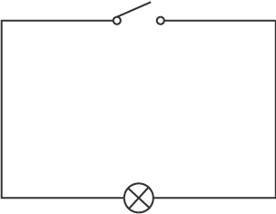
(a) Close the Switch
(b) Add another Lamp
(c) Add a cell and close the switch

What component does this circuit symbol represent?
(a) Cell
(b) Voltmeter
(c) Resistor
Which switch or switches must be closed to make the lamps light?
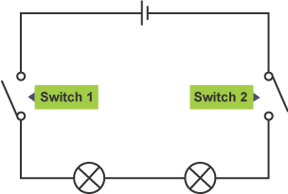
(a) Only Switch 1
(b) Only Switch 2
(c) Switch 1 & 2

If lamp 1 is unscrewed from its holder, what will happen to lamp 2?
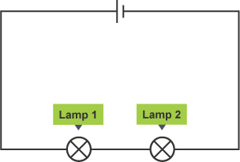
(a) It will get brighter
(b) It will stay the same brightness
(c) It will stay the same brightness

Which term is used instead of voltage?
(a) Resistance
(b) Potential Difference
(c) Current

What is the definition of current?
(a) The flow of charge
(b) A measure of the difference in energy
(c) How difficult it is for electrons to flow

