Core Knowledge Map
Subject: Business | Year: 10 | Term: Autumn 2
What are we learning?
1.3 Putting a business idea into practice
How will I be assessed
Answering questions on Smart revise. Marked by teacher, peer and self. Assessment - 1.3 end of topic test - 45 mins
Big questions:
How does a make business idea happen through identifying aims and objectives and concentrating on the financial aspects?
How does this build on previous learning? |  |  | How will this link to my future learning?
1.1 Enterprise and entrepreneurship and 1.2 Spotting a business opportunity |  |  | 1.4 Making the business effective
Core knowledge: |  |  | Key vocabulary:
Business aims and objectives when starting up: ● financial aims and objectives: survival, profit, sales, market share, financial security ● non-financial aims and objectives: social objectives, personal satisfaction, challenge, independence and control. Why aims and objectives differ between businesses  The concept and calculation of: ● revenue ● fixed and variable costs ● total costs ● profit and loss ● interest ● breakeven level of output ● margin of safety.  Interpretation of breakeven diagrams: ● the impact of changes in revenue and costs ● breakeven level of output ● margin of safety ● profit and loss.  The importance of cash to a business: ● to pay suppliers, overheads and employees ● to prevent business failure (insolvency) ● the difference between cash and profit.  Calculation and interpretation of cash-flow forecasts: ● cash inflows ● cash outflows ● net cash flow ● opening and closing balances.  Sources of finance for a start-up or established small business: ● short-term sources: overdraft and trade credit● long-term sources: personal savings, venture capital, share capital, loans, retained profit and crowd funding.  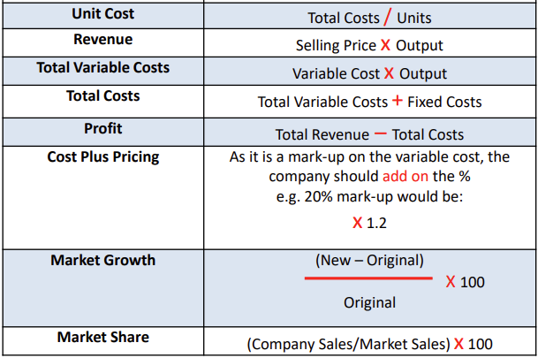 |  |  | Aims and objectives  Breakeven  Cash inflow  Cash outflow  Closing balance  Crowdfunding  Financial aim  Fixed cost Costs  Insolvency  Margin of safety  Net cash flow  Non-financial aim  Opening balance  Overdraft  Profit  Retained profit  Selling assets  Share capital  Variable cost  Venture capital
Need more help?
Google Website for revision maps, exam technique and revision guides. Business 9-1 - 1.3 (google.com)

