Core Knowledge Map
Subject: Mathematics | Year: 10 (Foundation) |  | Term: Autumn 1
What are we learning?
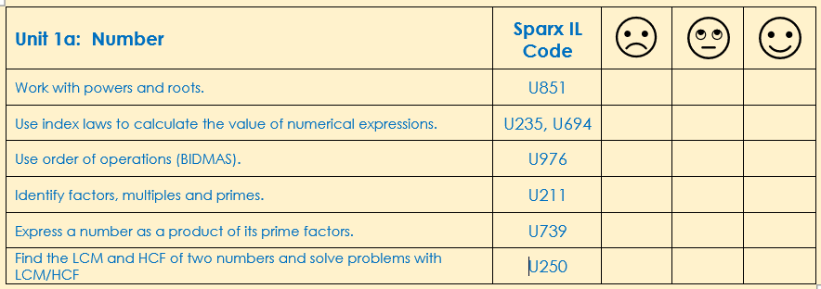
How will I be assessed
Retrieval tasks, exit tickets, end of half-term test.
Big questions:
Can You….?
- Evaluate 7²
- Give two possible values for $\sqrt{25}$
- Prove that the square root of 45 lies between 6 and 7
- Correctly work out 3 + 4 x 2 using BIDMAS
- Write any number as a unique produce of its prime factors
- Use a Venn diagram to sort information to find HCF and LCM
- Recall prime numbers up to 100

How does this build on previous learning? |  | How will this link to my future learning?
- Calculating powers and roots  - Finding factors and prime factors of a number.  - Finding HCF and LCM of a number  - Using basic index rules  - Convert large and small numbers to standard form. |  | - Index numbers appear in many topics and in some formulae for area and volume of shapes  - Order of operations will be important in future algebra work
Core knowledge: |  | Key vocabulary:
A factor of a number or algebraic expression divides that number or expression evenly with no remainder.  A multiple is the product result of one number multiplied by another number.  A prime number only has two factors, itself and one.  Rules of indices:  - $n^{a}×n^{b}= n^{a+b}$  - $n^{a}÷n^{b}= n^{a-b}$  - ${\left(n^{a}\right)}^{b}=n^{ab}$  Know that, n⁰ = 1 and $n^{\frac{1}{2}}=\sqrt{n}$ |  | Index (indices)  Factor  Multiple  Power  Square  Cube  Root  Odd  Even  Prime  Product
Need more help? Use the Sparx Independent Learning Codes above

Core Knowledge Map
Subject: Mathematics | Year: 10 (Foundation) |  | Term: Autumn 1
What are we learning?
How will I be assessed
Retrieval tasks, exit tickets, end of half-term test.
Big questions:
Can You….?
- Evaluate 7²
- Give two possible values for $\sqrt{25}$
- Prove that the square root of 45 lies between 6 and 7
- Correctly work out 3 + 4 x 2 using BIDMAS
- Write any number as a unique produce of its prime factors
- Use a Venn diagram to sort information to find HCF and LCM
- Recall prime numbers up to 100

How does this build on previous learning? |  | How will this link to my future learning?
- Calculating powers and roots  - Finding factors and prime factors of a number.  - Finding HCF and LCM of a number  - Using basic index rules  - Convert large and small numbers to standard form. |  | - Index numbers appear in many topics and in some formulae for area and volume of shapes  - Order of operations will be important in future algebra work
Core knowledge: |  | Key vocabulary:
A factor of a number or algebraic expression divides that number or expression evenly with no remainder.  A multiple is the product result of one number multiplied by another number.  A prime number only has two factors, itself and one.  Rules of indices:  - $n^{a}×n^{b}= n^{a+b}$  - $n^{a}÷n^{b}= n^{a-b}$  - ${\left(n^{a}\right)}^{b}=n^{ab}$  Know that, n⁰ = 1 and $n^{\frac{1}{2}}=\sqrt{n}$ |  | Index (indices)  Factor  Multiple  Power  Square  Cube  Root  Odd  Even  Prime  Product
Need more help? Use the Sparx Independent Learning Codes above

