Year 10 Business Studies
By September you should have completed the following tasks:
- Write a short introduction to Unit 2 which explains that you are planning to set up a new small business in the local area.
- Create a list of 20 business ideas - some can be unrealistic (selling holidays on Mars, etc.) – but some must be realistic (e.g. dog-walking). They need to be ideas that you could actually do, and they MUST BE legal!
- Write down the advantages and disadvantages of each idea, and then narrow your list to the three best ideas, giving your reasons.
- Write down a list of skills you already have that will help you with your chosen business idea. Are there other skills you will need (e.g. first aid)? If so, add them to the list.
- And you need to do research – see below
In order to be able to complete your coursework you will need to conduct both Primary & Secondary research. Ideally you will use Microsoft Forms to create your questionnaires. The following pages describe how to use Microsoft Forms to build your questionnaires.
If you are struggling with access to ICT then you can complete all the tasks above on paper. If you do this, make sure you don’t lose your work! A good idea is to take a photo of your papers and email them to me (lturnbull@okehamptoncollege.devon.sch.uk). If you can’t access Microsoft Forms, send me a photo of your questions and I will create the Microsoft Form for you.

COMPLETING THESE TASKS IS ESSENTIAL FOR PASSING UNIT 2

For the “Primary” research go to OFFICE 365 & click on FORMS
It’s very easy to use but I’ve created a picture guide below
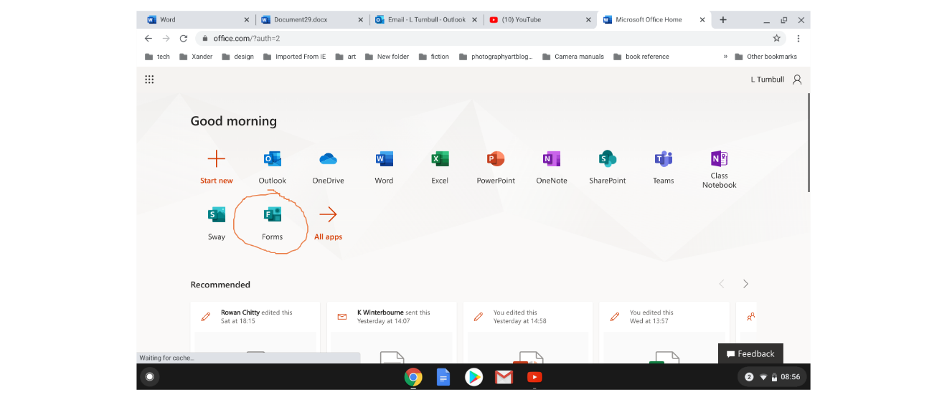
Click “NEW FORM”
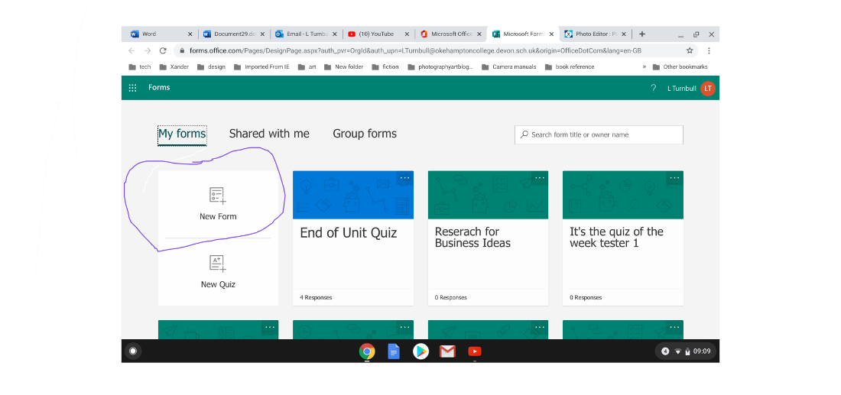
In the title –Write your name followed by Business ideas (see below)
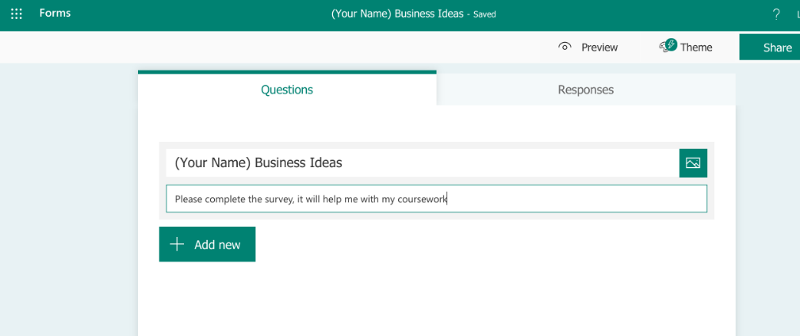
You can add questions by clicking on the “Add New” button

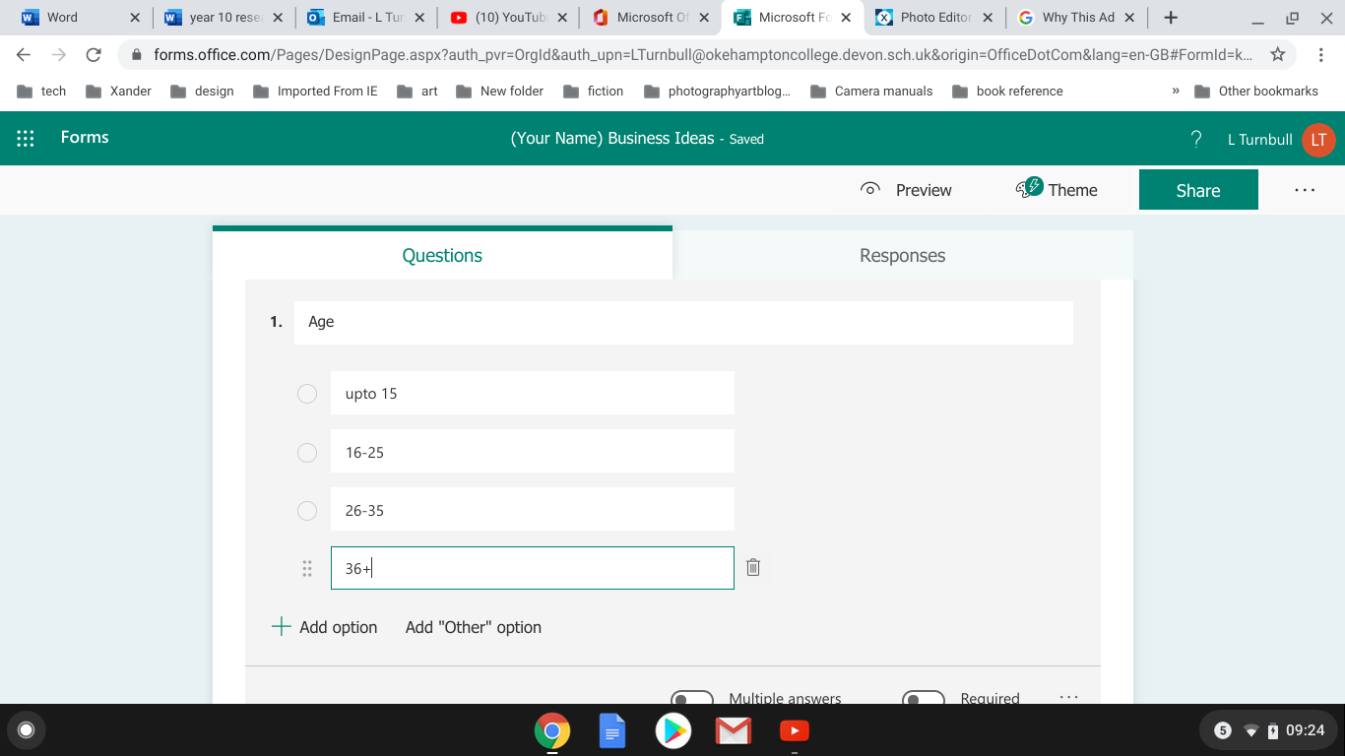
Add a different option by clicking on “Add Option”
Can you do the same for GENDER. Then you need to ask at least another 3 questions
- Which business idea do you think is the best?
- How much would you pay for the item/service?
- How often would you pay/use the item/service?
Then you may wish to add other questions but if you have those 5 that will be fine.

Then when you are happy with the survey can you click SHARE, then COPY
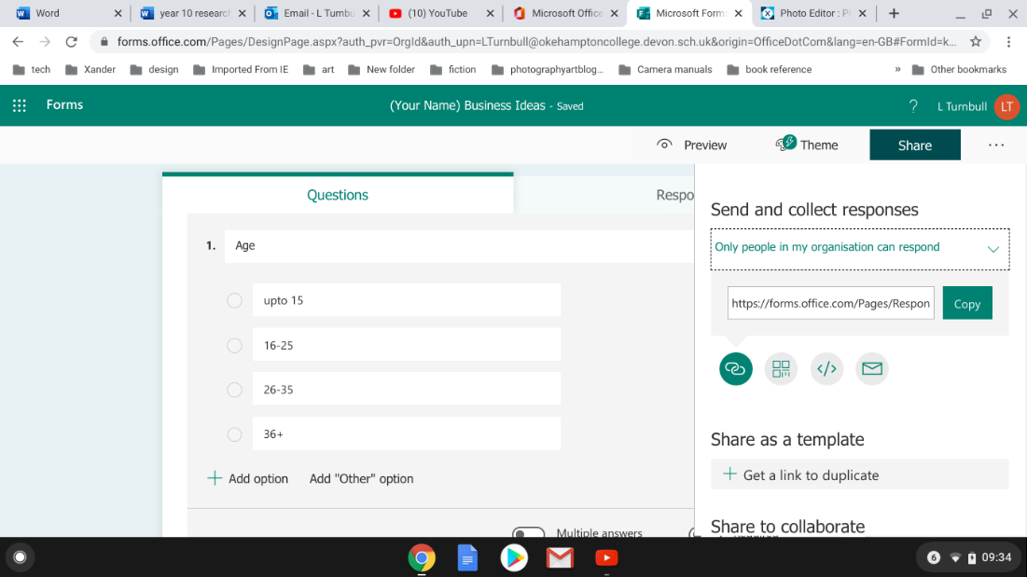

Then email me the link to lturnbull@okehamptoncollege.devon.sch.uk , I will collect them all and place them in a document so I can share with the rest of the group. This will help your coursework.
You also need to carry out secondary research. The easiest thing to do would be go to Google and search your business ideas
Type in things like “Value of UK dog walking market”, “average price of a UK cupcake” “Car washes in Devon” etc
You will NOT find the exact information you are looking for, take what information you can –at this stage we need information. When we get back in September, we can analyse what we have collected.
If you have any issues or you are struggling to find any information, then please email me. I am about most of the summer and will have access to emails wherever I am, in which case I can reply quite quickly.
I can’t state enough how important this for your coursework.

