How can I transition effectively to Year 11?
Why is setting goals important?
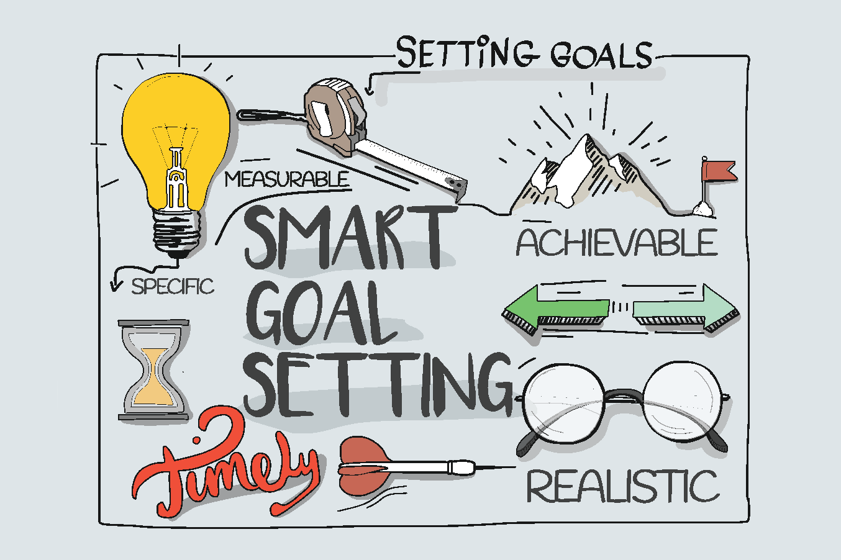
- Making achievable goals will allow you to focus. Think SMART goals.
- Consider a larger goal to strive for, but then think about little goals to help you achieve the big goal. Think about my steps to running 5k!
- By achieving the smaller goals, you will feel good and continue to push to get to the larger goal.
- Your goals do not have to be just academic – think about your personal goals too!
How do you become an Independent effective learner?
- Remember you could have the best teacher in front of you but unless you are interested and take the initiative, you will struggle to succeed.
- Take effective notes in lessons as this will be an important part of your revision material
  - Cornell notes is a great way to take notes – look at this for some support on how use this technique: https://www.youtube.com/watch?v=lsR-10piMp4
- Decide the best ways for your to revise – these links will help you with some ideas – why not give them a go!
  - https://www.youtube.com/watch?v=eZQ7ILUAsek
  - https://www.youtube.com/watch?v=-Y1HJMuqAPY
- Remember:
  - Colour need to have a purpose!
  - You are looking for a flow of knowledge.
  - They are not a ‘one hit wonder’ – you should reuse them to aid revision.
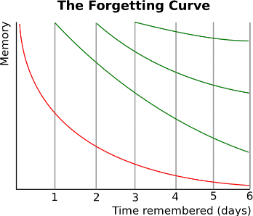
How to create good habits?
- SLEEEEEEEEP! You need at least 8 hours a night to be fully functioning. The best sleep is before midnight
- Start revising early! Remember our forgetting curve...
- Revision in chunks is best – I suggest 25 minutes and then a break (even if that is just getting a drink).
- To-do lists: like with your goals, make them achievable.
- Trial to find the best revision method for you – mind-maps, videos, revision clocks (I will have some of these for you in September.
- Avoid using your phone for social media while working or trying to sleep. Is there a safe place that you could put it rather than your bedroom?
Why is downtime/relaxation so important?
- You need time away from work – this is just as important as revision!
- What do you enjoy doing? Can you make this part of a break? Or, do you need to have a whole day out and switch off from work?
- Fried egg analogy – remember being in the white means that you feel supported enough to stretch yourself, take risks and be the best version of yourself.
  - Which part of the egg are you in?
  - Is there anything/anyone who can help you get to/remain in the white area?
The year 11 tutor team and I want to see happy and smiley year 11s by the end of your exams, so if you need us, just shout! Miss Marchant

