S E C O N D A R Y / K E Y S T A G E 3 M U S I C – I ’ V E G O T R H Y T H M T H E O R Y WATCH THE TIME
BEAT and PULSE mean the same thing in music. Keeping a steady beat is most important when people are moving to the music. Otherwise, they would get out of step! Two types of music where keeping a steady beat is very important are:
A MARCH – Left Right, Left Right – a march usually contains 2 beats in a bar with a strong emphasis on the first beat.
A WALTZ – Oom-cha-cha, Oom-cha-cha – a waltz usually contains 3 beats in a bar with a strong emphasis on the first bear.
4 beats in a bar is also common – 1 2 3 4, 1 2 3 4 – especially in pop songs. Here, the first beat of the bar has a strong emphasis and the third beat of the bar also has an emphasis, although not as strong as the first.
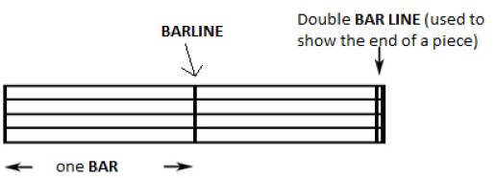
A BAR is a small section of music which contains a specified number of beats. A BARLINE shows where the end of the bar is and a DOUBLE BAR LINE shows the end of a piece of music or a section within a piece of music.
The first beat of the bar is always the strongest. This helps to keep the music steady. The most common type of pulse/beat is a CROTCHET PULSE.
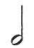
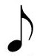
Here is a one-beat note: a CROTCHET
Here is a two-beat note: a MINIM
Here is a four-beat note: a SEMIBREVE
Here is a half-beat note: a QUAVER
Here are two half-beat notes: a PAIR OF QUAVERS. These two quavers take the same time as one crotchet (½ + ½ = 1).
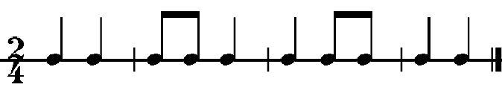
Here is an example of a MARCH rhythm with 2 beats in a bar – the numbers in front of each pattern tell us how many beats there are in each bar 2/4 = two crotchets beats in each bar – this is called the TIME SIGNATURE.

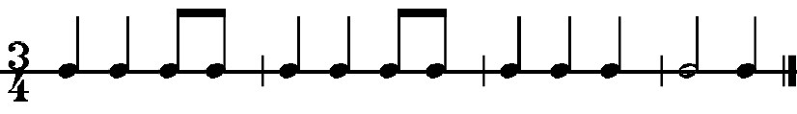
Here is an example of a WALTZ rhythm with 3 beats in a bar – the numbers in front of each pattern tell us how many beats there are in each bar 3/4 = two crotchets beats in each bar – this is called the TIME SIGNATURE.

© W W W . M U S I C A L C O N T E X T S . C O . U K
S E C O N D A R Y / K E Y S T A G E 3 M U S I C – I ’ V E G O T R H Y T H M T H E O R Y WATCH THE TIME
Name Form

- Explain in your own words what “keeping a steady beat” means

- Keeping a steady pulse/beat is very important in marches and waltzes. Give another example.

- What is the difference between “pulse/beat” and “rhythm”?

- Write these notes in the boxes below. Label each box with its correct name.
1 beat ½ beat 2 beats 4 beats 2 half-beats

Name
- Look at the rhythm below. The time signature is 4/4. How many beats are there in each bar? . Now draw in the bar lines in the correct places so that each bar adds up to 4 beats. Put a double bar line at the end.
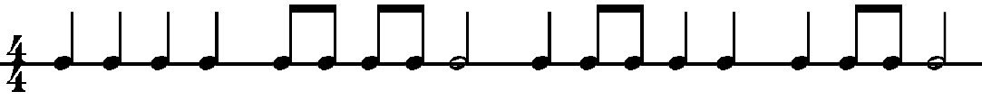
- Now make up your own 4/4 rhythm and write it in the bars below.
- Look at the rhythm below. The time signature is 3/4. How many beats are there in each bar? . Now draw in the bar lines in the correct places so that each bar adds up to 3 beats. Put a double bar line at the end
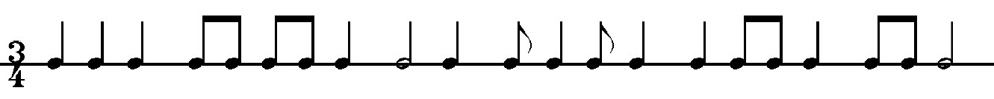
- Now make up your own 3/4 rhythm and write it in the bars below.
© W W W . M U S I C A L C O N T E X T S . C O . U K

