C O V E R B A N K
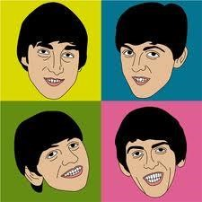
The Beatles
Name Form

The Beatles were perhaps the most influential group of the 1960’s. They formed in Liverpool in the late 1950’s playing in the Cavern Club in Liverpool and became
famous in the early 1960’s with records such as She Loves You. There were four of them – John Lennon, Paul McCartney, George Harrison and Ringo Starr. Their style developed constantly over the next few years, the Sergeant Pepper’s Lonely Hearts Club Band album of 1967 being a landmark in the history of rock music. In this album, The Beatles insisted that everything had to be different, therefore pushing music technology into new areas. The Beatles split up in 1970, developing their careers separately. John Lennon was killed in 1980 and
George Harrison died on 30th November 2001. Paul McCartney was knighted in 1997 making him Sir Paul McCartney for his outstanding contribution to the music industry over the years.
- How many Beatles were there?
- Write their names in alphabetical order
- Where did The Beatles come from?
- Which years were The Beatles famous as a group in?
- Who was knighted in 1997 and why?
- Do you know any Beatles songs? If so, what are they? Do you have a favourite?
- Can you guess the following Beatles-associated words from the pictograms below?
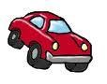

Answer

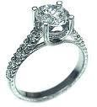
Answer

© W W W . M U S I C A L C O N T E X T S . C O . U K

C O V E R B A N K
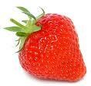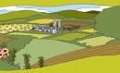
Answer

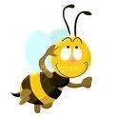

Answer
ALL MY LOVING  ALL YOU NEED IS  LOVE  COME TOGETHER  DAY TRIPPER  ELEANOR RIGBY  GET BACK | HELLO GOODBYE  HEY JUDE  I FEEL FINE  IN MY LIFE  LADY MADONNA  LET IT BE  LOVE ME DO | PAPERBACK WRITER  PENNY LANE  SHE LOVES YOU  SOMETHING  TICKET TO RIDE  YELLOW SUBMARINE  YESTERDAY
 |  | © W W W . M U S I C A L C O N T E X T S . C O . U K
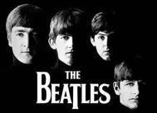
8. Find the following song titles by The Beatles in the word search grid below.

P | A | P | E | R | B | A | C | K | W | R | I | T | E | R | K | E | X | A
S | Q | Y | L | D | G | O | D | E | M | E | V | O | L | Z | B | J | M | N
E | E | M | Q | R | N | K | N | Q | Q | I | O | R | E | T | Y | M | N | N
D | N | I | E | Y | I | U | I | F | E | E | L | F | I | N | E | S | G | O
I | Y | I | O | S | H | O | A | B | Z | O | W | T | H | C | Z | A | M | D
R | Y | I | R | G | T | E | Y | E | S | T | E | R | D | A | Y | E | H | A
O | B | B | H | A | E | R | X | Y | H | L | I | L | L | D | P | N | E | M
T | G | X | E | V | M | A | E | P | L | N | P | Z | C | A | R | A | L | Y
T | I | I | Y | L | O | B | F | H | M | S | I | L | V | Y | J | L | L | D
E | R | N | J | U | S | L | U | Y | T | H | H | S | A | T | F | Y | O | A
K | R | T | U | J | E | Q | L | S | S | E | Z | Z | U | R | E | N | G | L
C | O | Z | D | F | U | I | E | I | W | L | G | H | H | I | Y | N | O | F
I | N | Q | E | Q | F | R | D | H | D | O | V | O | W | P | K | E | O | C
T | A | R | V | E | Q | W | S | F | C | V | L | A | T | P | X | P | D | W
G | E | T | B | A | C | K | P | K | A | E | N | L | C | E | T | S | B | D
Y | L | W | P | M | E | P | Z | S | J | S | Q | Y | E | R | M | D | Y | A
D | E | M | S | Q | W | J | U | R | A | Y | X | U | A | Y | B | O | E | M
V | F | H | P | R | R | G | N | I | V | O | L | Y | M | L | L | A | C | C
E | V | O | L | S | I | D | E | E | N | U | O | Y | L | L | A | G | H | L

