Faculty of Technology – Summative Assessment

Subject: Year 7/8 Resistant materials (Mr May)
If you studied Resistant materials during lockdown, you will be assessed on the following topics when you return to college in September.
Topics to be Assessed:
- What is a mechanism?
- Types of motion.
- Cams and followers.
- Levers and linkages.
- Pulleys.
Resources to Help You:

What is a mechanism?
Mechanisms are devices that have been designed to make jobs easier. They all have certain things in common:
- They involve some kind of motion
- They involve some kind of force
- They must have some kind of input to make them work
- They produce some kind of output
If we connect mechanisms together we can build mechanical systems called machines.
Mechanisms can also be used to make moving toys like the caterpillar and the other toys featured in this program

Types of motion

Linear motion
Linear motion is movement in a straight line. An example of linear motion is the cutting arm of a paper guillotine as it travels from one side of the machine to the other.

Oscillating motion
Oscillating motion is movement backwards and forwards in a circular arc. E.g. playground swings (photo) and clock pendulums.

Reciprocating motion
Reciprocating motion is a backwards and forwards movement in a straight line. Sewing machine needles work with this type of motion.

Rotary motion
When something moves in a circle it is called rotary motion.

Cams and followers
A cam is a specially shaped piece of wood, metal or hard wearing plastic, which is usually fixed to a rotating shaft.
A follower is held against the cam, either by its own weight or by a spring. As the cam turns (rotary motion) the follower moves up and down (reciprocating motion).
The distance and speed at which the follower moves depends on the shape of the cam.

Circular cam
A circular cam is also known as an 'eccentric' cam. The centre of rotation of the cam is offset from the centre of the circle.

Pear shaped cam
A pear shaped cam has a long dwell period during which time the follower does not move. This is ideal for the 'Sailing Ship' model where various parts move in sequence as the crank is turned.

Triangular cam
Followers working with triangular cams do not have a dwell period like other cams. This means they move continuously as the cam turns. Triangular cams are found in mechanisms that use clapping movements, e.g. Perky Porky.

Follower motion
The distance that a follower moves when a cam turns through one complete rotation is called the stroke. The stroke is determined by the cam shape and the cam offset.

Levers
Levers make it possible to open things and move heavy weights using a small amount of effort. E.g. opening a can of paint with a screwdriver.
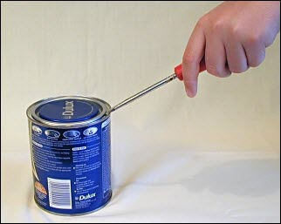

A lever is a rigid rod pivoted about a fixed axis called a fulcrum. Levers are used to change the direction of motion of a force, and to make it bigger (magnify) or smaller (diminish).
Levers are also used to link together parts mechanisms.
Examples of levers: wheelbarrow, nutcracker, scissors, claw hammer, tweezers, shovel, sack trolley.

Linkages
Mechanical linkages are made up of a series of levers which are connected together.
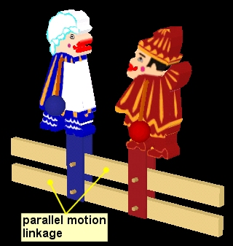
Linkages can change the direction of a movement, alter the size of a force or make things move in a particular way.
Parallel motion linkages are used to make two or more parts of a mechanism move together and stay parallel to each other as the linkage moves.

Reverse motion linkages are used to change the direction of motion. A single lever with a pivot at its centre reverses an input motion without affecting the input force.

Bell crank linkages are useful for changing the direction of motion or transmitting it round a corner. E.g. Bicycle brakes.

Pulley systems
One method of transmitting rotary motion from one shaft to another is by using pulley wheels and belts.
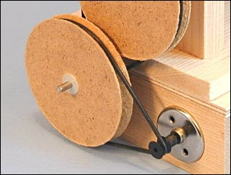
By altering the size (diameter) of the pulley wheels it is possible to change the speed of rotation of the output shaft.
To achieve a large speed reduction or increase, it is sometimes necessary to combine more than two pulleys in a system. This removes the need to have very big pulleys as this can cause problems where space is limited.

Online resources.
- https://www.focuselearning.co.uk/
- http://www.technologystudent.com/
You will need to answer Qs such as those on the focus website.

