Faculty of Technology – Summative Assessment

Subject: Year 7/8 Core (Mr May/Mr Henderson)
If you studied Core during lockdown, you will be assessed on the following topics when you return to college in September.
Topics to be Assessed:
- Climate Change
- Energy use
- Types of fuel
- Renewable energy and non-renewable energy
- Waste management and recycling
- Carbon footprint
- Designers.
Resources to Help You:
All human activities need energy.
A large part of this energy comes from burning fossil fuels (coal, oil and gas) which releases carbon dioxide into the atmosphere.
It is now generally accepted that this is having an effect on the Earth's climate by causing the average temperature to increase. Some of the consequences are:
- Unpredictable weather such as storms, floods and drought
- Rising sea levels as the polar ice melts
- Loss of habitats and the animals that depend upon them

The Evidence for Climate Change
The Earth's climate is very complex and all sorts of factors influence it.
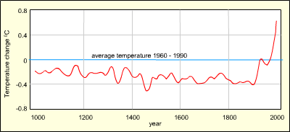
There is a clear and ever-growing body of evidence showing that:
- The world is warming
- This warming is due to human activity increasing levels of greenhouse gases in the atmosphere
- If emissions continue unabated the warming will too, with increasingly serious consequences
The graph above shows how the temperature has varied over the last 1000 years. The line represents the average of measurements from a whole range of sources and while there is some uncertainty, most scientists agree that the trend is broadly correct. i.e. there has been a temperature rise of about 0.6°C in the last 150 years. This may not seem very much, but is enough to change the climate: already glaciers are melting.
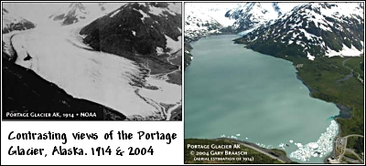
If the trend continues, IPCC predict a rise of between 1.4 and 5.8°C by 2100

Climate Change - What Could Happen
The world's habitats and ecosystems depend on a delicate balance of rainfall, temperature, and soil type. A rapid change in climate could upset this balance and seriously endanger many living things.
Some possible consequences are detailed below.
Melting ice caps
Sea level rise
The weather
Coral reefs
Most past climate changes occurred slowly, allowing plants and animals to adapt to the new environment or move somewhere else over generations. However, if future climate changes occur as rapidly as scientists predict, plants and animals may not be able to react quickly enough to survive.
In fact the change in climate may reverse much of the conservation work that has been advancing in
recent years. For example, the earlier annual break-up of sea ice (above) is cutting short the spring hunting season for polar bears, which rely on floating banks of ice to reach their prey and, in trying to swim the greater distances, many are drowning.
The disappearance of the sea ice in summer months is forcing the hungry bears to spend longer on land, giving a false impression that numbers are increasing.

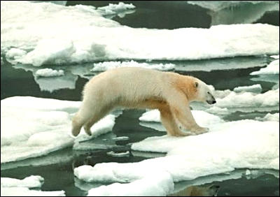
Higher temperature will make glaciers and the polar ice sheets melt, adding more water to the ocean. Also as the oceans warm up the water will expand.
Sea levels may rise between several inches and as much as 1 metre during the next century causing flooding in coastal areas.
Since many major cities such as London, New York, Hong Kong, Tokyo, Mumbai (Bombay) and Sydney are on the coast, the sea rise would be devastating.
If the seas warm up, more water vapour will get into the air. This would cause more rain, winds and storms. Also a change in sea temperature would disturb the weather pattern that produces the rainy season in India causing droughts and crop failure.
This would reduce the winter rainfall, and make the summer monsoon slightly wetter and more unpredictable.
Another worry is the increase in water transmitted disease in the summer months.
Although we speak of global warming, it is possible that north west Europe will experience cooling as the Gulf stream slows down. Some reports suggest that it has already decreased by over 10%. At the moment the warm water from the tropics around the Caribbean flows across the Atlantic Ocean and up past Europe. The water cools and sinks as it reaches the Arctic Circle, and the cold water flows back at great depths to complete the cycle.
If too much fresh water enters the Arctic Sea from melting glaciers and the polar ice cap, the Gulf Stream water would be unable to sink, and the process would grind to a halt. We would then experience weather closer to that in Canada.
Coral reefs are import marine ecosystems. They are under threat from two factors.
Rise in sea temperature
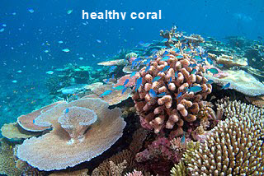
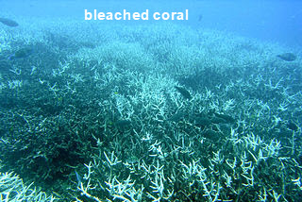
Higher than normal sea temperatures cause the coral to eject their symbiotic algae. This turns the coral white and is called "bleaching". It is fatal unless conditions are reversed in a reasonably short time. But even if temperatures fall back quickly, it can still take many years for damaged reefs to fully recover.
Rise in CO₂ levels
When carbon dioxide dissolves in the sea, it raises the water's acidity level. This prevents the build up of calcium carbonate, which corals use to build their skeleton

The carbon cycle
When the plants are eaten, the food they provide is used for growth and energy. During respiration in nearly all living things, the carbon dioxide is reformed and returned to the atmosphere.
When living things die they decompose and carbon dioxide is returned to the atmosphere. If the creatures and plants live in water, they quite often fall to the seabed where the shells eventually can turn into chalk, and then into limestone and marble when earth movements cause the chalk to be heated and compressed. The plants and creatures were also turned into coal, oil and gas over a similar time period.
There is a huge amount of carbon trapped in the rocks and in fossil fuels in the ground. The amount of carbon dioxide in the atmosphere is maintained at a fairly constant level when there is no human interference. However, we are burning fossil fuels at such a rate that too much of the stored carbon is being released back into the atmosphere.

The greenhouse effect
The Greenhouse effect is caused by the presence of gases such as carbon dioxide, water vapour, and methane in the atmosphere that allow incoming sunlight to pass through but absorb heat radiated back from the earth's surface.
Carbon dioxide has always been part of the Earth's atmosphere. It is essential for the plants which use it to make food by photosynthesis. The food stored in plants forms the basis for all the food for all other living things.
When sunlight reaches the Earth it warms up the ground, and at night-time (when the Sun is not shining on the ground) heat is lost back into space and the Earth cools down.
Most of the time the level of carbon dioxide has remained fairly constant, and the temperature of the Earth has not changed very quickly, so that all the living things can get used to the changes and cope with them. When the amount of carbon dioxide falls there could be an ice age, as the temperature also falls. When the amount of carbon dioxide increases the Earth warms up and the ice sheets at the poles melt. These changes cause the sea level to change.
The amount of carbon dioxide in the atmosphere is increasing rapidly as a result of human activity. We are burning more and more fossil fuels and we are also burning trees, that are not being replanted. This is disturbing the balance of nature. Creatures are moving away from the equator, further north and south into new and unfamiliar habitats, many will not survive the change. e.g. Where will animals living at the Poles go to?

Greenhouse gases
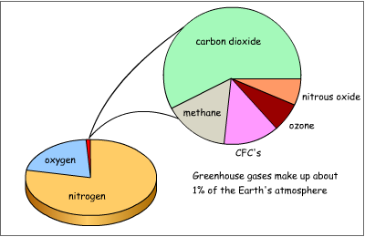
Almost all of the Earth's atmosphere (99%) is made up of nitrogen (about 78%) and oxygen (about 21%).
While these gases play important roles in the vast number of processes that support life on Earth, they play almost no direct role in regulating the climate.
This is carried out by some of the trace gases in the remaining 1% of the atmosphere.
Although the proportion of the trace gases in the atmosphere appears relatively small, they can still have a big impact on climate change - and they are mainly caused by human activities:
Carbon dioxide
Methane
Nitrous oxide
Ozone
Water vapour
Halocarbons
Carbon dioxide is probably the most important of the greenhouse gases as it accounts for the largest proportion of the 'trace gases' and is currently responsible for 60% of the 'enhanced greenhouse effect'. It is thought that it's been in the atmosphere for over 4 billion of the Earth's 4.6 billion year geological history and in much larger proportions (up to 80%) than today.
Most of the carbon dioxide was removed from the atmosphere as early organisms evolved photosynthesis. This locked away carbon dioxide as carbonate minerals, oil shale and coal, and petroleum in the Earth's crust when the organisms died. This left 0.03% in the atmosphere today.
Atmospheric carbon dioxide levels have risen by more than 30% since the beginning of the industrial revolution.
The importance of methane in the greenhouse effect is its warming effect. Even though it occurs in lower concentrations than carbon dioxide, it produces 21 times as much warming as Carbon Dioxide.
Methane accounts for 20% of the 'enhanced greenhouse effect'. Methane is generated naturally by bacteria that break down organic matter, it is found in the guts of termites and other animals and in natural gas deposits.
The impact of human activities: An increase in livestock farming and rice growing has led to an increase in atmospheric methane. Other sources are the extraction of fossil fuels, landfill sites and the burning of biomass.
Nitrous oxide makes up an extremely small amount of the atmosphere - it is less than one-thousandth as abundant as carbon dioxide. However, it is 200 to 300 times more effective in trapping heat than carbon dioxide.
Nitrogen is removed from the atmosphere by plants and converted into forms such as ammonia, which can then be used by the plants. This is called nitrogen fixation. At the same time, micro-organisms remove nitrogen from the soil and put it back into the atmosphere - denitrification - and this process produces nitrous oxide. Nitrous oxide also enters the atmosphere from the ocean.
Nitrous oxide has one of the longest atmosphere lifetimes of the greenhouse gases, lasting for up to 150 years. Burning fossil fuels and wood and emissions from cars all produce nitrous oxide, however the main contributor is believed to be the widespread use of nitrogen-base fertilisers. Sewage treatment plants may also be a major source of this gas.
Since the Industrial Revolution, the level of nitrous oxide in the atmosphere has increased by 16%. Due to the long time it spends in the atmosphere, the nitrous oxide that we release today will still be trapping heat well into the next century.
Ozone is an everyday part of the atmosphere and is constantly being created and destroyed. In the upper atmosphere ozone in the Ozone Layer is vital in screening the Earth from harmful ultra violet rays which can cause skin cancer and cataracts in eyes.
At lower levels ozone does function as a greenhouse gas, but its strength compared to carbon dioxide is yet to be calculated. In the natural ozone cycle, ozone is created and destroyed by ultraviolet light from the Sun. It is created from oxygen by high energy rays, while low energy rays destroy it.
Some ozone is man-made by various kinds of air pollution, particularly car exhausts which then react in sunlight, producing low level ozone which is a particularly unpleasant pollutant.
Water Vapour is the biggest contributor to the 'natural greenhouse effect' and varies the most in the atmosphere. Cold air can hold little water and so the atmosphere over the polar regions contains very little water vapour. In contrast, air over the tropics is very humid and the atmosphere can contain up to 4% water vapour.
It is this 'positive feedback' that makes water vapour important in climate change as a small increase in global temperature would lead to a rise in global water vapour levels thus further enhancing the greenhouse effect.
The best known in this group of gases are CFCs (chlorofluorocarbons), HCFCs (hydrochlorofluorocarbons) and the newer substitutes HFCs (hydroflurocarbons). While the concentration of halocarbons are much lower than those of the other greenhouse gases, the warming effect that they produce ranges from 3000 to 13000 times that of carbon dioxide. These gases very rarely occur naturally.
CFCs were used as spray can propellents, solvents, cleaners and coolants until the mid 1970s. Many of the world's nations agreed to control the use of CFCs in 1987 when they signed the Montreal Protocol on Substances that depleted the ozone layer. The substitute HFCs, while less damaging to the ozone layer, still trap heat in the atmosphere and are adding to the greenhouse effect.
Once these gases are in the atmosphere, they resist breakdown and don't disappear for many decades. They can remain in the atmosphere for up to 400 years.

What is sustainability?
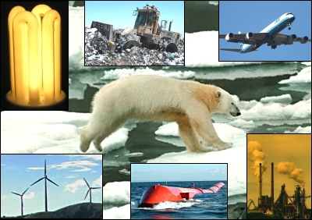
Sustainability is about human impact on the environment; from the way we use natural resources such as water, coal, trees and gas, through to how we manage the waste from the production and consumption of goods.
The aim is to lessen our "footprint" on the Earth so that, whilst living our lives in a way that fulfills our needs, we also leave our world in good shape for generations to come.
There are 6 R's related to sustainability:
Re-Think
We should re-think our current lifestyles and question whether we can continue to live the way we do now in terms of energy use and products we buy.
Re-Use
Many products are so plentiful we throw them away without any thought after using them. Re-using products or parts of products can often use less energy than recycling them.
Recycle
Recycling can help prevent environmental damage by minimising the amount of material and energy used during production and processing by taking existing product waste and re-processing the material for use in new products.
Repair
We should choose products that can be repaired when a part breaks and not simply the whole product thrown away and then a replacement purchased.
Reduce
Manufacturers should look at reducing the amount of material and energy used during a product's life cycle.
Refuse
We should consider refusing to buy or use certain products. Food is said to be the largest single factor affecting our eco-footprint. Packaging, processing and transport use huge amounts of energy and the discarded packaging creates massive waste.

Sources of energy
Most of our energy comes from the Sun. We call this solar energy.
Solar energy is made up of light energy and thermal (heat) energy.
As the Sun will continue to shine, solar energy is renewable. It will not run out.

Moving things have kinetic energy.
The sun heats the atmosphere and makes winds.
The moving air (wind) and moving water have kinetic energy that can be used.
These are also renewable sources of energy.

A fuel is a store of energy.
Cavemen had kinetic energy when they moved.
The energy was provided by the food they ate.
To cook the food they used a fuel - wood.
The wood is one form of biomass - a renewable fuel.

Today we use fuels such as oil and gas to heat our homes and cook our food.
We also have electricity as a source of energy to operate many of the things in our homes.
Click on the animation to and find some of the energy changes that take place in a kitchen.

Conservation of energy
Types of energy
Energy conversions
The list below shows the main forms of energy.
Kinetic Energy | All moving objects have kinetic energy.
Gravitational Potential Energy | Anything that is lifted up so it can fall back to ground.
Elastic Potential Energy | Anything that is stretched, squashed or bent and can spring back into shape.
Heat Energy | All objects have some heat energy. The higher the temperature, the greater the heat energy.
Light Energy | Luminous objects give off light energy. (e.g. light bulbs)
Sound Energy | Anything that makes a noise produces sound energy.
Electrical Energy | The energy produced when an electric current flows.
Chemical Energy | Energy that can be released by a chemical reaction.
Energy cannot be created or destroyed. This means that although energy can be changed from one form to another, the total amount of energy stays constant.
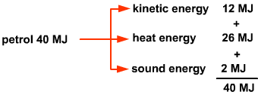
e.g. A moving car uses the energy in a fuel (e.g. petrol) to produce kinetic energy, heat energy and sound energy. 1 litre of petrol contains about 40MJ of energy, so the maximum energy can be produced is 40MJ
This is known as the principal of Conservation of Energy.

Renewable energy
Renewable energy is a source of energy that won't run out. Using renewable energy produces no carbon dioxide.
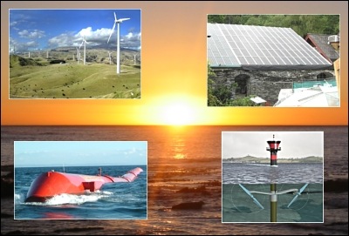
Most renewable energy comes directly or indirectly from the Sun's light. One exception to this is tidal power. Tides are caused by the gravitational attraction of the Moon and Sun on the Earth's oceans.
Hydroelectric, Wind, Wave, Tidal barrage, Tidal stream, Solar electricity, Solar water heating, Geothermal, Ground source Biomass.

Non-Renewable Energy: Introduction
Non-renewable energy is an energy source that will run out and cannot be placed.
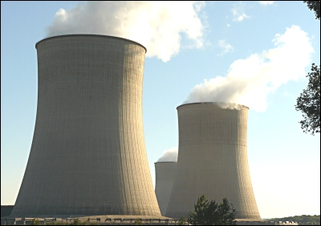
Non-renewable sources like coal, oil and gas have to be burnt to release the energy as heat. This also produces carbon dioxide.
Nuclear energy produces no carbon dioxide directly, but large amounts are produced during the building of the power station.

Waste Management: Introduction
Domestic and industrial waste has traditionally been buried in landfill sites. However, waste materials are increasingly being seen as a resource to be exploited, instead of simply a challenge to be managed and disposed of.
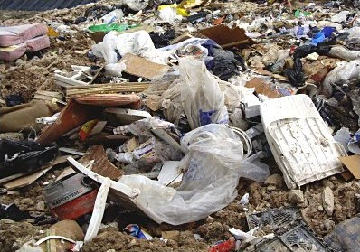
The two most common ways of extracting resources from waste are
- Recycling
- Energy-from-Waste production of electricity
In many countries there is resistance to the opening new landfill sites due to environmental factors and a lack of understanding that supplies of certain raw materials will run out if more waste isn't recycled.
Our number one priority should be to reduce consumption of goods and products. By continuing to have a high consumption, even if we recycle, means factories, delivery lorries and the manufacture of the packaging still produces carbon dioxide.

Waste Management
Landfill
Landfill gas
Waste that isn't recycled is put into huge holes in the ground called landfill sites. Lorries transport waste to the landfill which is then spread out and compacted so that it takes up less space. The need for landfills will continue to grow if we do not recycle more and reduce the amount of waste we produce in the first place.
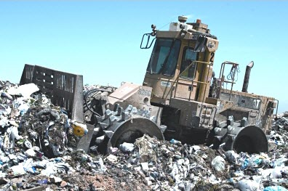

Landfills, often sited in disused quarries or mining voids, can create a number of adverse environmental impactssuch as:
- wind-blown litter
- attraction of vermin and birds
- contamination of groundwater supplies
- production of landfill gas(methane and carbon dioxide)
Many local authorities, especially in urban areas, have found it difficult to establish new landfills due to opposition from residents living near the proposed sites. Few people want a landfill in their local neighbourhood.
Burning waste in Waste-to-Energy plants to produce electricity is seen as a solution to the problem of finding more landfill sites.

Landfill gas is produced from organic waste disposed of in landfill sites. This gas builds up and is slowly released into the atmosphere.
Methane, which forms about 65% of landfill gas, is flammable and also a greenhouse gas. This has led to the development of landfill gas control systems (left) to reduce emissions.
Once collected, landfill gas can be burnt as a fuel to run electricity generators.

Waste management: Composting
Home composting
Commercial composting
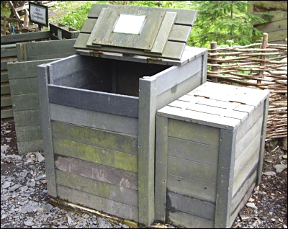
Composting 'green' waste (biodegradable, organic waste) at home can reduce the amount of waste that has to be transported to landfill sites by about thirty percent. This is important as organic waste going to landfill will produce methane which is a greenhouse gas.
Producing your own homemade compost also removes the need to buy in artificial fertiliser.

(Over) Packaging
Many products that we buy contain an unnecessary amount of packaging. Packets of biscuits are a good, or should we say bad, example of this.
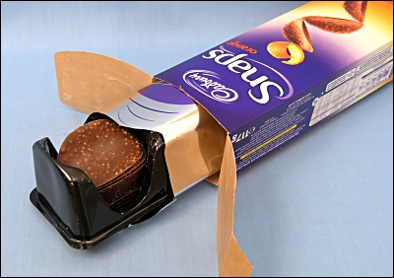
E.g. Three materials are used in the packaging of Snaps:
- Cardboard outer casing on which advertising information is printed in order to make the product stand out from those of other companies when displayed on supermarket shelves
- Aluminium / plastic foil inner packet which, when sealed from the air, keeps the product fresh
- Plastic tray for attractive presentation of the product to the consumer
Of these three packaging materials only the foil packet is absolutely necessary in order to keep the product fresh and only the cardboard casing is suitable for recycling. Packaging that can't be recycled inevitably ends up as waste on landfill sites.
The most effective way of persuading companies to change their packaging methods is to refuse to buy products that contain unnecessary packaging.

Recycling: Introduction
Increased re-use and recycling brings environmental benefits (e.g. in resource and energy efficiency) and it also means less waste goes to landfill. Landfill is generally the worst option for the environment as it is a waste of valuable resources and methane from biodegradable waste decomposing in landfills is a potent greenhouse gas.
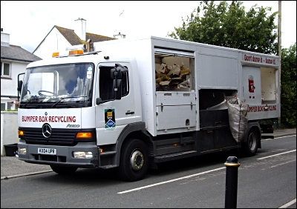
With suitable landfill sites becoming increasingly difficult to find in the UK, recycling has become a necessary and highly organised business.
Manufacturing products from recycled materials often uses much less energy than if manufacturing from raw materials.
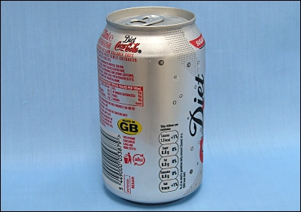
Aluminium drinks cans are a good example of this as they can be melted down and recycled time and time again.
The recycling of 1kg of aluminium saves 8kg of bauxite, 4kg of chemicals and 14kWh of electricity.
Recycling activities in countries like the UK is better regulated than in some others, with much more importance being placed on the health and safety of workers in the industry. E.g. in developing nations such as Nepal (below) manual labourers sift through unsorted waste to salvage material that can be sold in the recycling market.
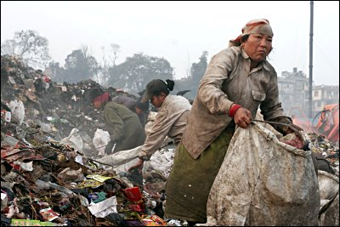
There can be a high human cost for these waste or rag pickers including disease, injury and reduced life expectancy through contact with toxic or infectious materials. This would not be tolerated in most developed countries.
More information:
Lets Recycle
Recycle-more
SITA UK
Recycled Products Guide

Recycling symbols and labels
The Möbius loop symbol is the universally recognised recycling symbol designed in 1970 by Gary Anderson who was a student at the University of Southern California.
The symbol is in the public domain, and is not a trademark. Therefore anyone is free to use the symbol, although local laws may restrict its use on product labelling.
The Green Dot logo on a package means that the company putting this product on the market is participating in the financing of selective collection, sorting and recycling of household packaging. This logo is used in many European countries. It does not mean that the package and/or the product that it contains is composed of recycled materials.
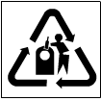 | This symbol is found on glass bottles and jars that can be recycled.
 | Drinks cans made from Aluminium.
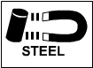 | Cans and products made from steel.
 | Drinks bottles and containers made from PET (Polyethylene Terephthalate).
 | Plastic products made from High Density Polyethylene.
 | Products made from Polystyrene.

Carbon Footprint: Introduction
Your carbon footprint is the impact you make on the earth by the way you live your life. The more carbon you release the bigger your footprint. It is calculated by measuring our direct emissions of carbon dioxide from the burning of fossil fuels including domestic energy consumption and transportation.
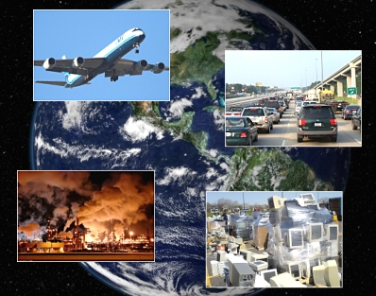
Carbon footprint calculations should also include carbon dioxide emissions from the whole lifecycle of products we use - those associated with their manufacture and eventual breakdown.
Climate scientists estimate the earth can cope with up to 4 billion tonnes of carbon each year without causing climate change. This is because the trees and oceans can clean up excess carbon dioxide.
In 2018 there are about 7.7 billion people on the earth so our fair share is around 2.5 tonnes of carbon dioxide per year. Typically a person living a modern western lifestyle has a carbon footprint 4 times greater than their fair share.
By measuring the carbon footprint through such tools as carbon calculators, we can get a better sense of what our individual impact is and which parts of our lifestyle deserves the greatest attention.

Designers
Please ensure you have researched designers as listed in your Classcharts work.

Alessi. Apple. Laura Ashley. Harry Beck. Braun. Charles Rennie Macintosh. William Morris. Shigeru Miyamato. Pixar. Mary Quant. Tesla. Louis comfort Tiffany. Vivienne Westwood. Walt Disney Company.

Online resources.
- https://www.focuselearning.co.uk/
- http://www.technologystudent.com/
You will need to answer Qs such as those on the focus website.

