Faculty of Technology – Summative Assessment

Subject: Year 7/8 Food (Mr Quick, Mrs O’Connell and Mrs Hill)
If you studied food during lockdown, you will be assessed on the following topics when you return to college in September.
Topics to be Assessed:
- Hygiene and Safety
- Nutrition
- Accurate weighing and measuring
- Healthy cooking methods
- High risk foods
Resources to Help You:
- Hygiene and Safety
https://www.foodafactoflife.org.uk/11-14-years/cooking/hygiene-and-safety/
- Nutrition
https://www.nutrition.org.uk/healthyliving/healthydiet.html
https://www.foodafactoflife.org.uk/11-14-years/healthy-eating/energy-and-nutrients/
- Accurate weighing and measuring
https://www.foodafactoflife.org.uk/media/1230/measuring-ws-711lwssa.docx
- Healthy cooking methods
https://www.bbc.co.uk/bitesize/guides/zdr8y9q/revision/1
- High risk foods
https://www.foodafactoflife.org.uk/11-14-years/cooking/hygiene-and-safety/

- Hygiene and Safety
https://www.foodafactoflife.org.uk/11-14-years/cooking/hygiene-and-safety/
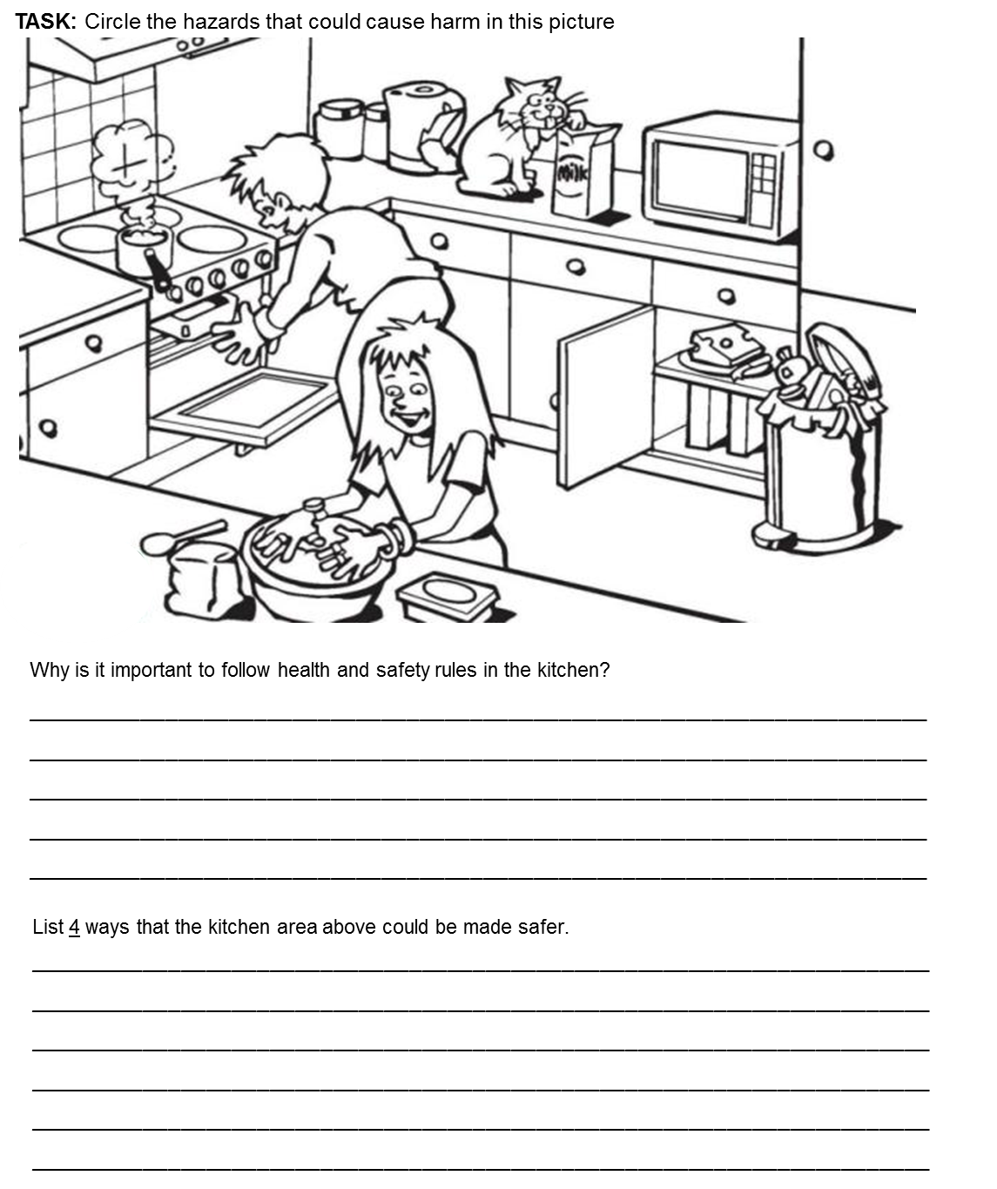

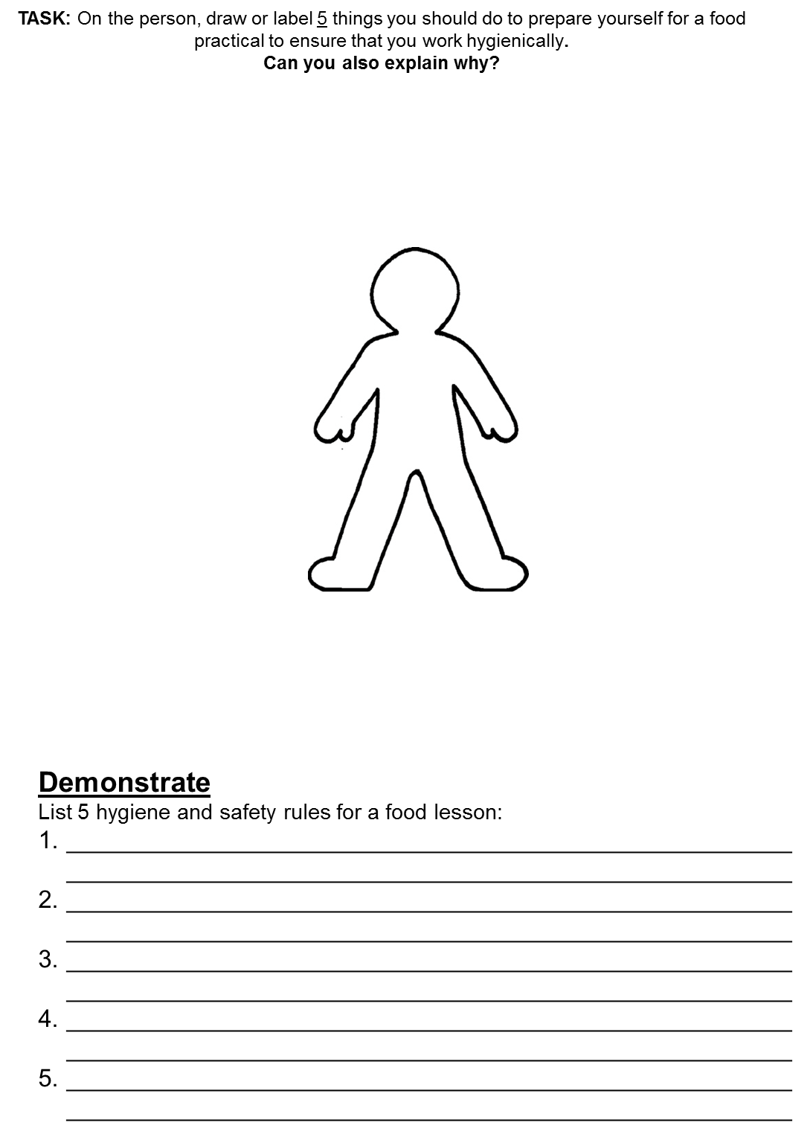

- Nutrition
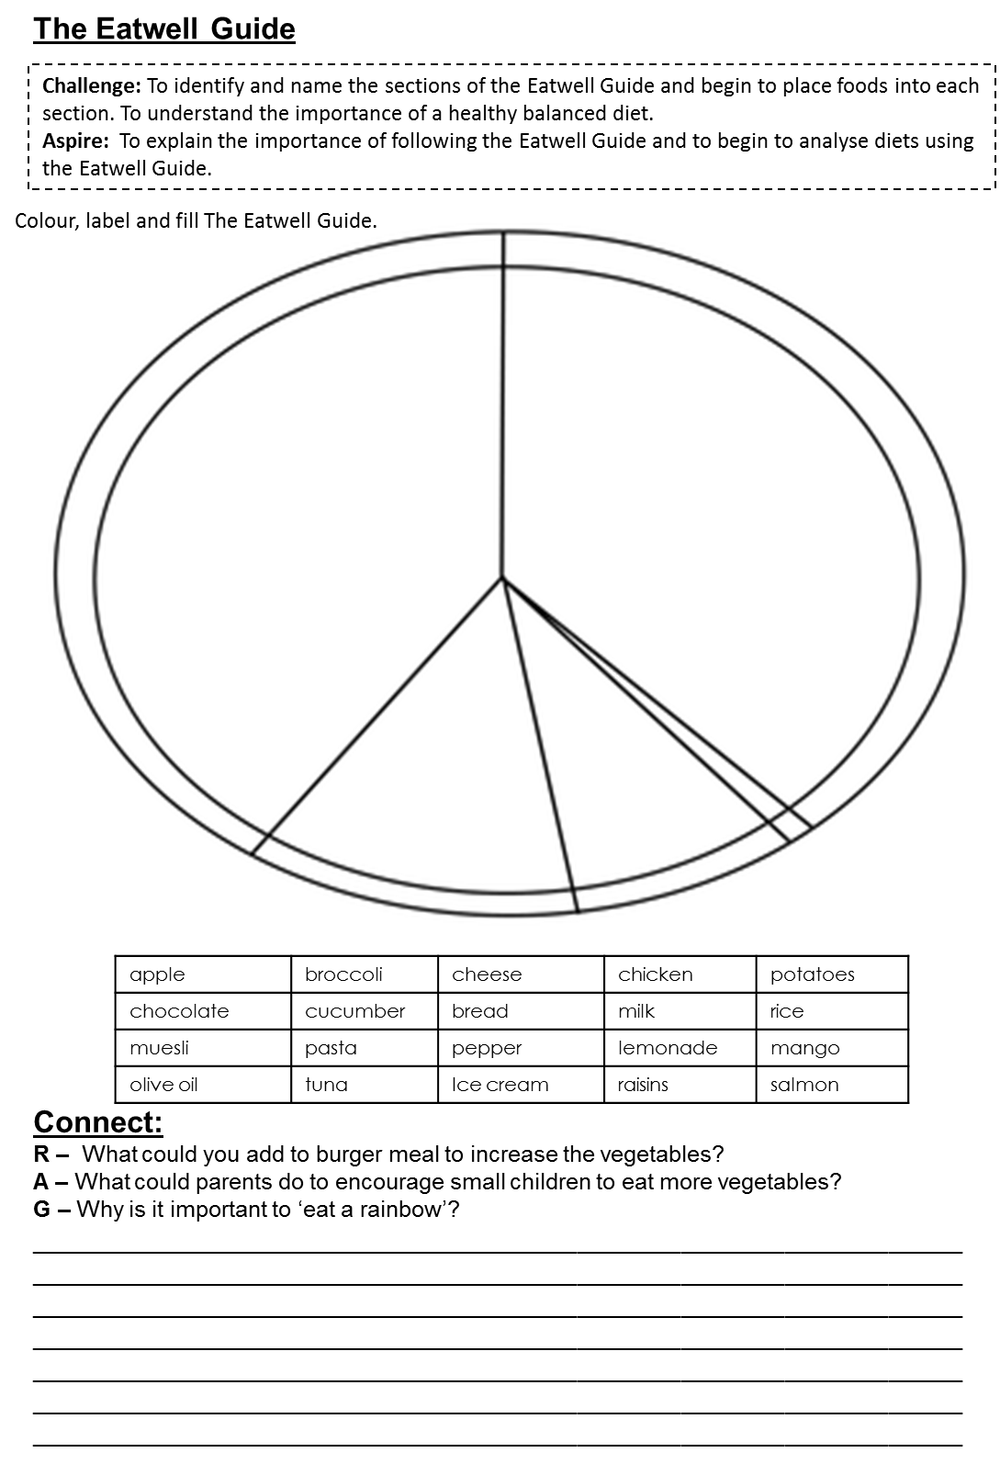
https://www.nutrition.org.uk/healthyliving/healthydiet.html
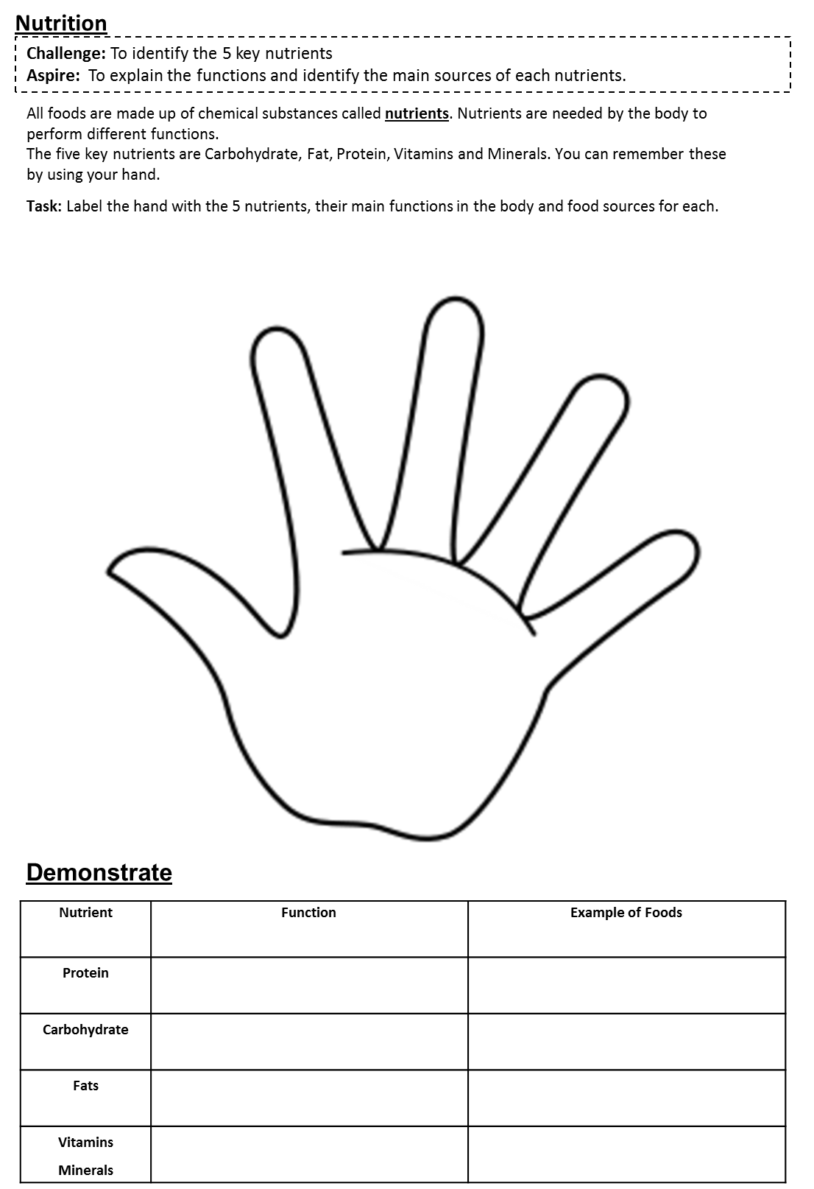
https://www.foodafactoflife.org.uk/11-14-years/healthy-eating/energy-and-nutrients/

- Accurate weighing and measuring
https://www.foodafactoflife.org.uk/media/1230/measuring-ws-711lwssa.docx
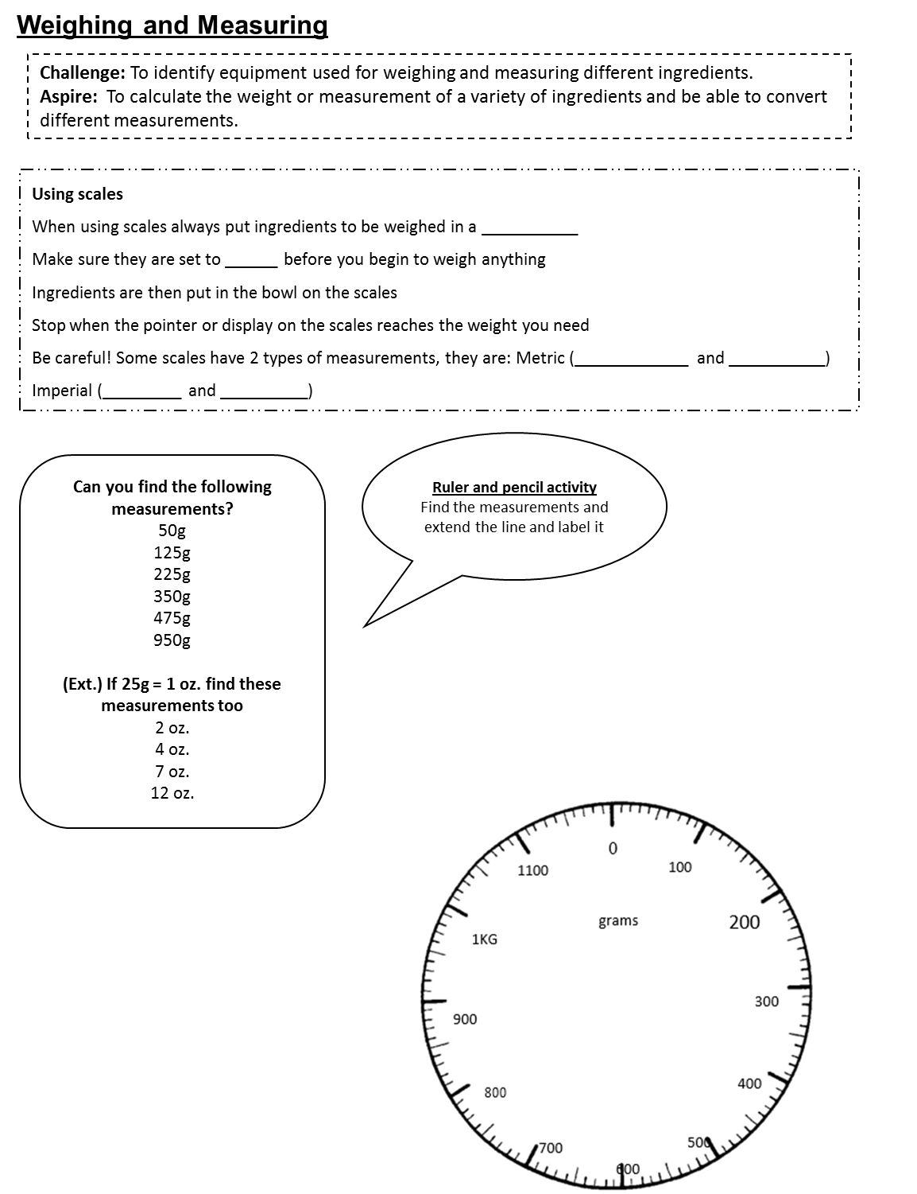

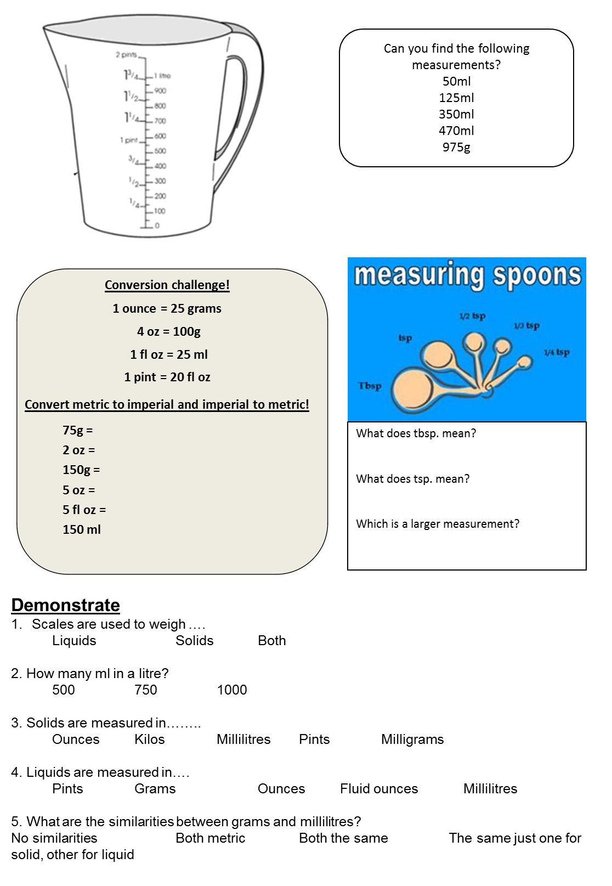
- Healthy cooking methods
https://www.bbc.co.uk/bitesize/guides/zdr8y9q/revision/1
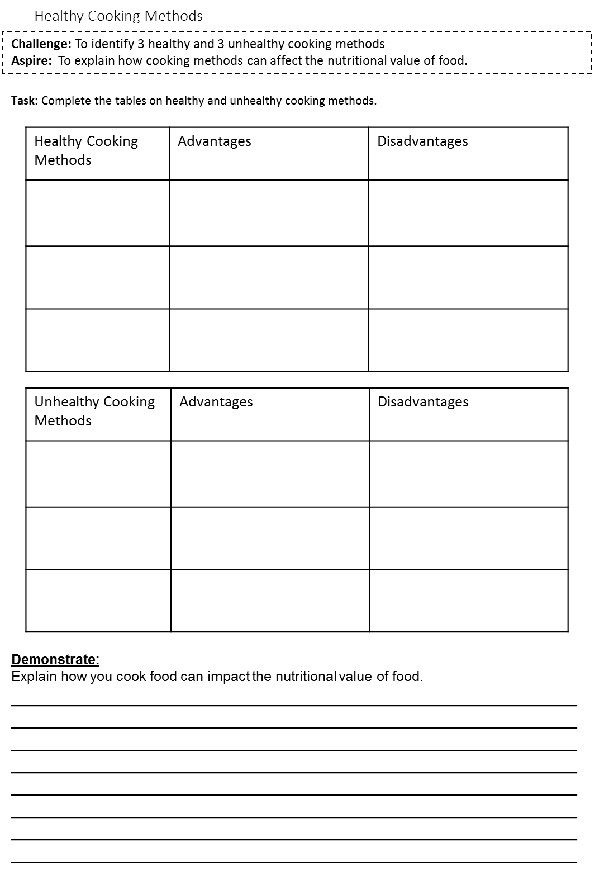
- High risk foods
https://www.foodafactoflife.org.uk/11-14-years/cooking/hygiene-and-safety/
