Faculty of Technology – Summative Assessment

Subject: Year 10 Hospitality and Catering (Mr Quick and Mrs Hill)
If you studied Hospitality and Catering during lockdown, you will be assessed on the following topics when you return to college in September.
Topics to be Assessed:
- Time plan task
- High skill recipe book – practical skills
- Planning a high skill menu
- Special Diets (AC 1.2)
- Nutrients and their functions (AC 1.1)

Resources to Help You:

- Time plan task
- High skill recipe book – practical skills
- Planning a high skill menu
https://www.bbcgoodfood.com/
- Special Diets (AC 1.2)
https://www.bbc.co.uk/bitesize/guides/zdr8y9q/revision/2
- Nutrients and their functions (AC 1.1)
https://www.bbc.co.uk/bitesize/guides/zkmpwty/revision/3#:~:text=Nutrients%20%20%20%20Nutrient%20%20%20,%20%20%20%203%20more%20rows%20

- Time plan task
For your Practical assessment you need to work from a time plan.
The plan should be split into 3 columns: time / Process/ Special points
The plan should start at the beginning of your practical session with mise-en-place (initial preparation of self, area, equipment and ingredients).
This is then followed with the instructions of how you will make the product/s indicating how much time is needed for each step. Regular washing up and cleaning should be included and the plan concludes at the end of the session with the presentation of your product /s
Things to remember:
  - In the special points column you need to include health, safety and hygiene, cooking temperatures, cooling temperatures, storage places and food quality checks.
  - Dishes that take the longest to cook or cool should be prepared first; e.g. bread, pastry, mousses, desserts that need to be chilled/set, cakes that need to cool before decorating.
  - Remember serving temperatures of your dishes will determine when they are cooked. Think about if dishes should be served hot or cold and make the timings fit.
  - You will need lots of rows to break down each step. They should not include lots of actions or things to do

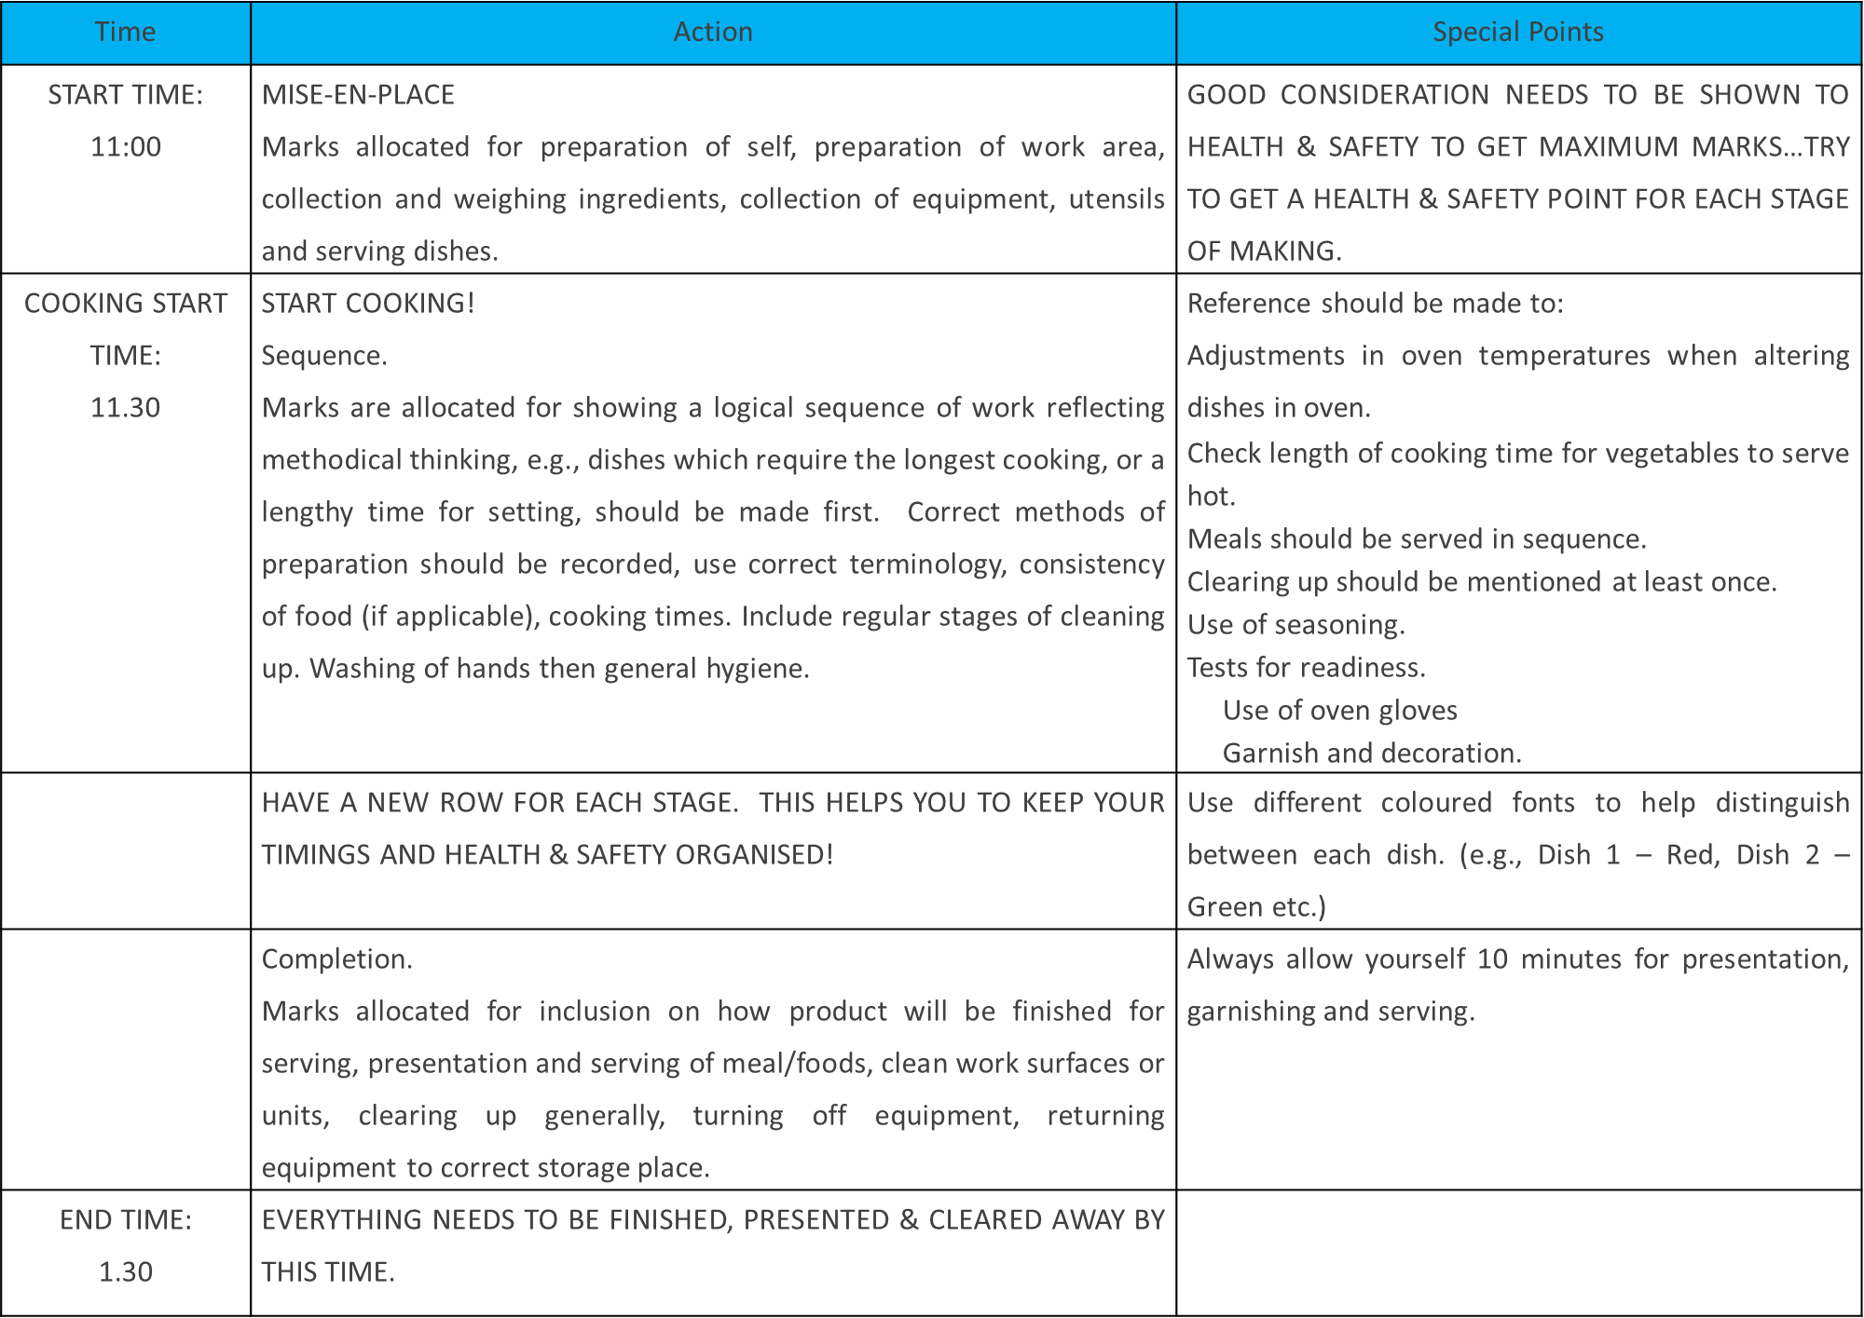
TASK
Your task is to write a detailed time plan for making:
Cheeseburger with Wedges and Coleslaw
And
Strawberry cheesecake
- On the next slides you will have the recipes. You will need to use these to formulate your time plan.
- Remember to sequence the cooking so that your burger would be served hot.

- High skill recipe book – practical skills
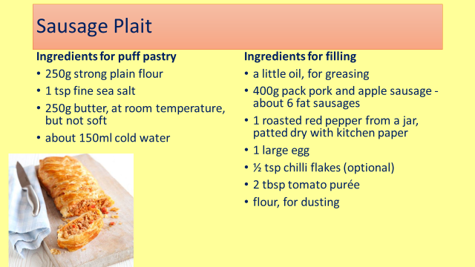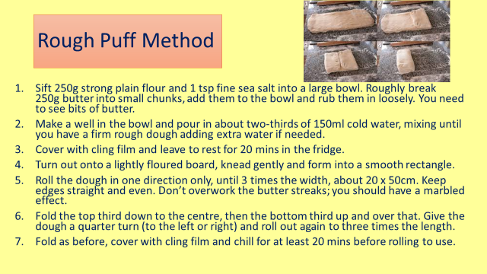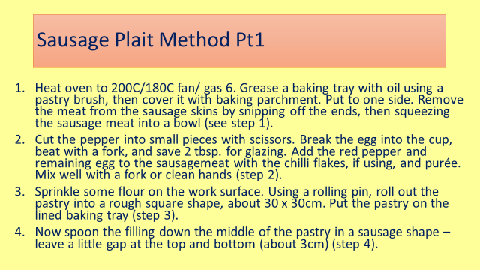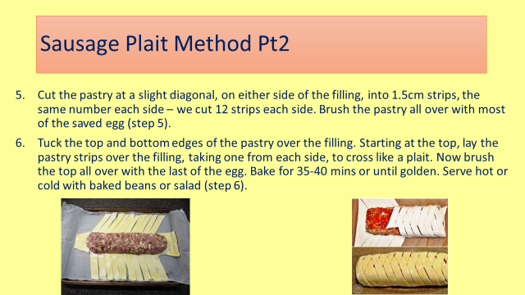

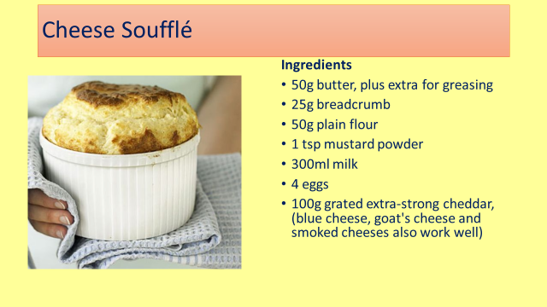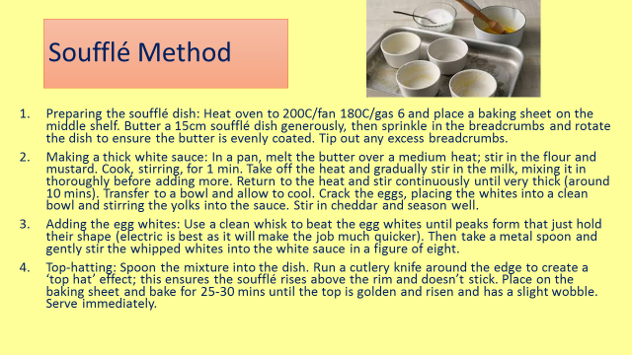
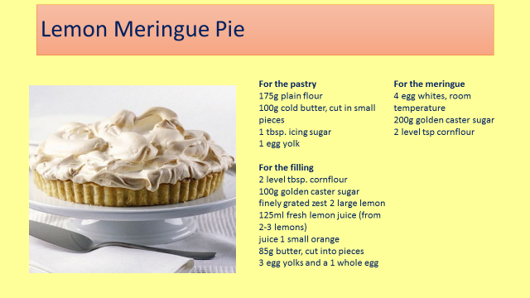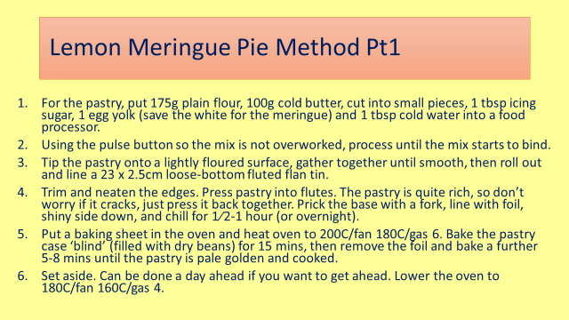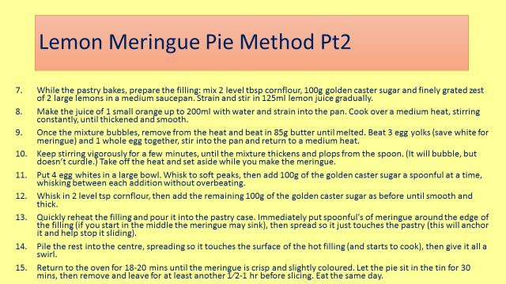
- Planning a high skill menu
https://www.bbcgoodfood.com/

Plan a menu of high skill dishes with 5 starters, 5 mains and 5 desserts
- At least 1 starter and main must be vegetarian
- At least 1 dish must be lactose free

Remember that dishes can be made more skilful by the accompaniments that they are served with. For example a beef burger with a shop bought bread roll, chips and peas would be low skill.
But a Beef burger with a homemade roll, homemade burger relish, wedges and coleslaw would be high skill.

- Special Diets (AC 1.2)
Plan a menu for each of the target groups. Use the link below to help.

https://www.bbc.co.uk/bitesize/guides/zdr8y9q/revision/2

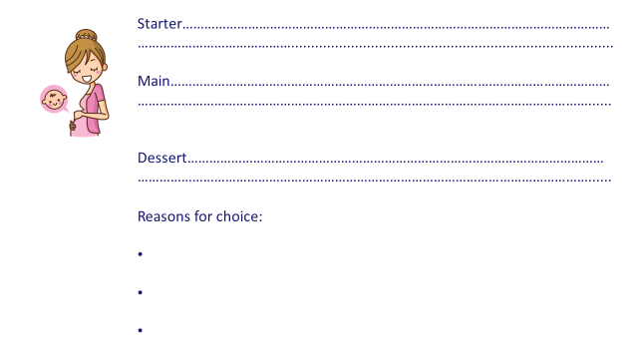
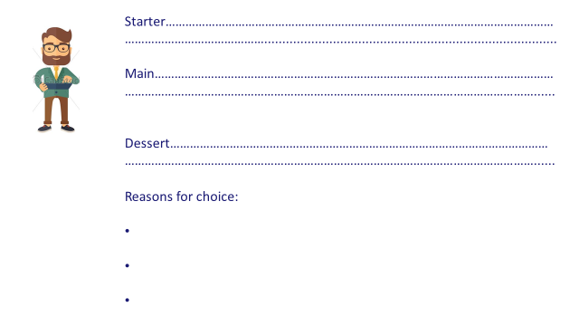
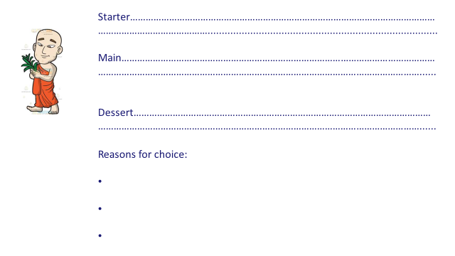
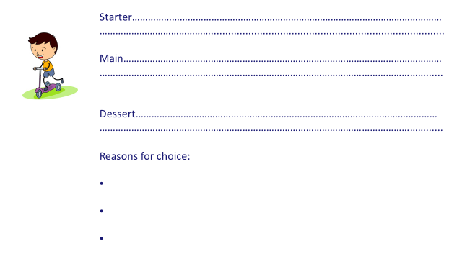
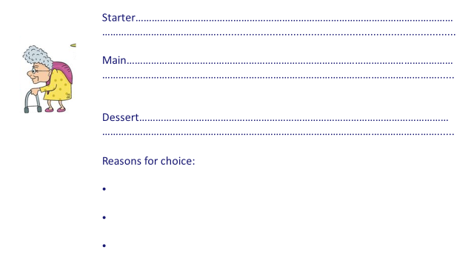

- Nutrients and their functions (AC 1.1)
https://www.bbc.co.uk/bitesize/guides/zkmpwty/revision/3#:~:text=Nutrients%20%20%20%20Nutrient%20%20%20,%20%20%20%203%20more%20rows%20

Nutrient | Function in the human body | Sources
Protein
Carbohydrates
Fats
Vitamin A
Vitamin B Group
Vitamin C
Vitamin D
Vitamin E
Fibre
Iron
Calcium
Sodium
Water

