NAME:
Resistant Materials

Health and Safety in the Workshop

It is very important that people behave properly in the school workshops. If not someone could get hurt. Below is a list of ways to stop accidents.
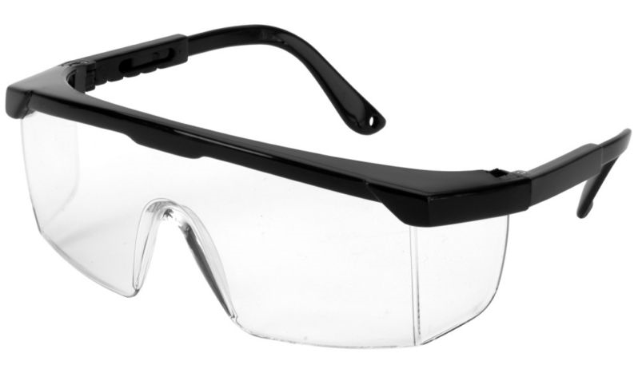
- I must wear safety glasses when using machines: Why?
I wear goggles to protect my eyes from …..

- I must tie long hair back when using machines : Why?
I must tie back my long hair because…

- I must only use a machine when I know how to use it safely: Why?
I must only use a machine when I know how to, because…
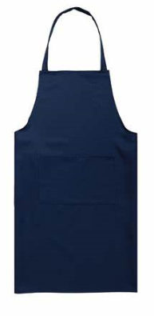

- I must wear an apron when I am in the workshop: Why?

- When using machines, I must concentrate on what I am doing: Why?
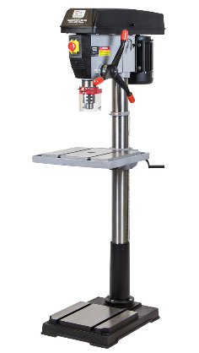

- When using machines, I must not talk to the person behind me: Why?

- When using machines, I must avoid having loose clothing: Why?

