DESIGN & TECHNOLOGY
Product Design

Get Yourself Organised
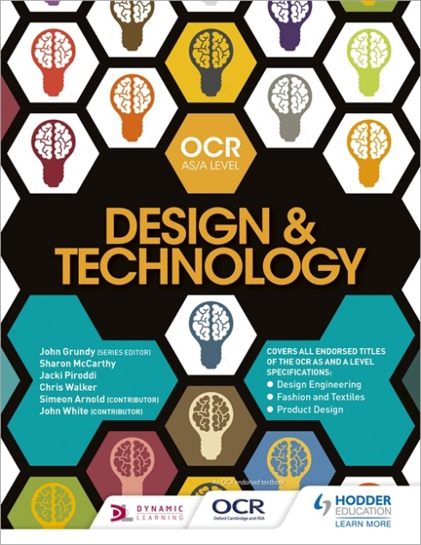
Over the summer there are a few things that you need to sort out so you are ready to get underway in September.
Purchase a course book
OCR AS/ A Level Design and Technology Under £30 new and covers both Y12 & Y13 including exam prep and NEA Guidance. A further 2 publications are available for revision and help specifically for the Maths content.
Purchase an A4 ring binder with at least 9 divides for your theory module and coursework notes. Have in it an A4 pad so you can always write/sketch things down.
Identify and collect a product that you could dismantle for a product investigation/analysis task. It must contain at least 3 different materials. It does not need to work but it might be helpful if it does in some cases. You can pick a suitable product yourself.
Examples could be anything from a bic biro to a an Anglepoise lamp. It should have a variety of metallic and polymer parts and be easy to disassemble. It should not be too reliant on electronics and must have a clear, specific, and easily described range of functions.
Summer Task – USING PTC CREO ON YOUR HOME COMPUTER
On the school system we have
PTC CREO which you can download from
www.ptc.com/en/academic-program/products/free-software or Google PTC CREO STUDENT.
This is a large download or is avaiable on a memory stick from school (YOU MUST PROVIDE THE USB STICK YOURSELF).
You will need to register to use it on PTC’s website.
The following link is helpful for tutorials that you should follow to help you learn how to use the program CREO 2.0 tutorials or straight to the You Tube channel.
Please familiarise yourself with the program and follow the instructions recording screen shots of each tutorials result on an A4 document for printing. There is a chance we will upgrade over the summer to CREO 3.0 so if you have the option please download the upgraded version.

WHAT IS PRODUCT DESIGN ALL ABOUT? Please watch these.
Interesting Video’s to watch on You Tube
Product Design Sketching and rendering - https://www.youtube.com/watch?v=xrzwFKRTxPM
Product Design at Dyson - https://www.youtube.com/watch?v=R_IV_JnNJGg
Dieter Ramms Design - http://www.youtube.com/watch?v=-N5aQyCzm4I
The Design Ethos of Dieter Ramms - http://www.youtube.com/watch?v=A6-wA-7QIeE
Design – Apple Mac https://www.youtube.com/watch?v=3q6ULOT9Q4M
Subscribe to this guy https://www.youtube.com/user/producttank

The course Specification is found online at https://www.ocr.org.uk/qualifications/as-a-level-gce/design-and-technology-h004-h006-h404-h406-from-2017/ .
Below is a simple overview of the Course Structure.

