**Okehampton College - Year 6 Athletics Taster**

THE HOME PENTATHLON

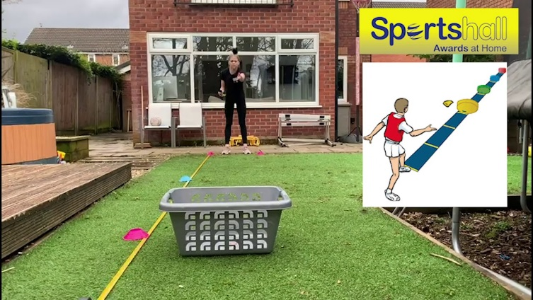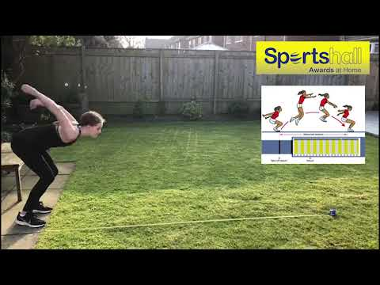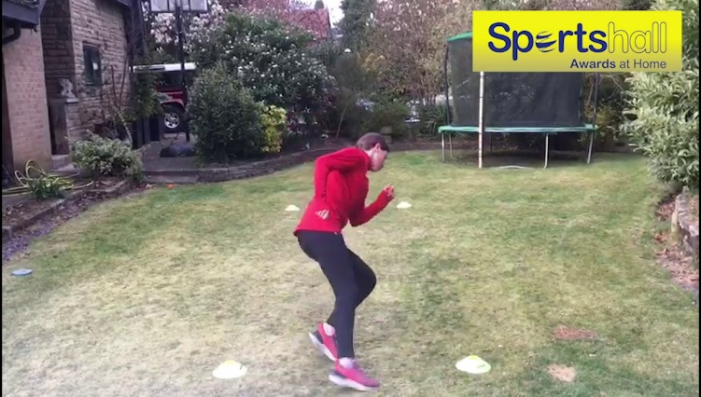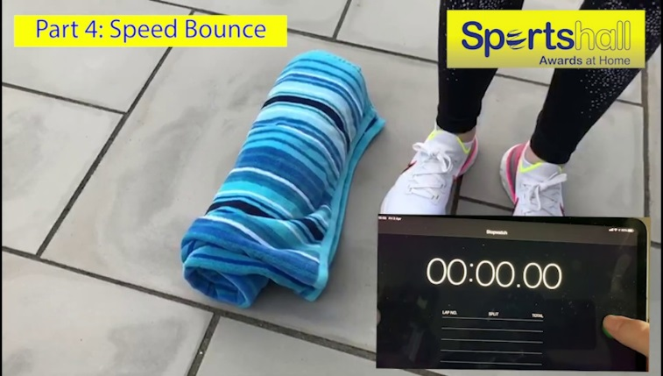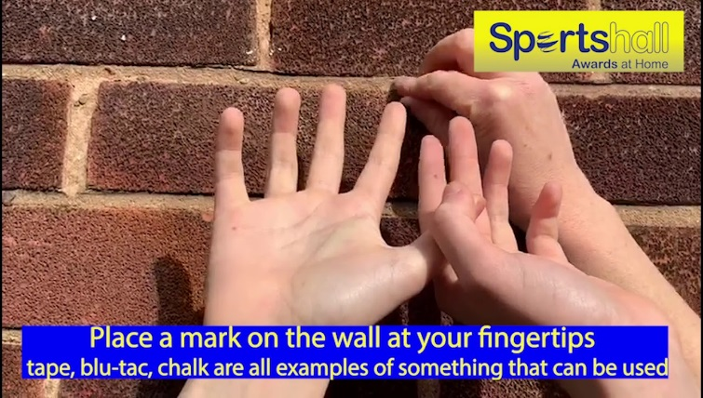

**Event 5:** The Standing Vertical Jump

Stand with your back and your heels touching a flat wall. Stretch your arms upwards, keeping both your arms and legs straight. Mark the top of your finger-tips (a post-it note or blue tac is good for this). Turn side on and take a step away from the wall. Swing your arms, bend your knees and jump as high as you can, touching the wall at the top of your jump – place a marker here. Measure the distance between the two markers. This is your score!

**Event 4:** The Speed Bounce

You need to create a small barrier using either a rolled up towel, a line of socks, a jump, toilet rolls, or anything suitable. Start one side with two feet together. How many times can you jump across this barrier in 20 seconds? You must land with two feet every time. Every time your feet touch the floor on one side of the barrier this counts as one jump.

**Event 3:** The 20x5m Shuttle Run

Set up a distance of 5 metres marked at either end using a marker (this could be a cone, a sock, a jumper), to create your running lane.

Start at one end and run the 5-metre distance 20 times to cover 100 metres.

Use a stopwatch or a phone to record your time.

**PLEASE USE A FLAT/DRY SURFACE!**

**Event 2:** The Standing Long Jump

Mark out a tape measure along the floor. Start from a standing position, with two feet on the floor, in line with ‘0’ on the tape measure. Jump as far as possible landing on two feet.

Measure from the back of your feet across to the tape measure.

**PLEASE USE A FLAT/DRY SURFACE!**

**Event 1:** The Target Throw

Mark out a starting line using a cone, or a pair of socks. Place a target at 3 metres (a bucket or waste paper bin is suitable), using a small ball, a bean bag or a pair of socks, you have three throws to land the ball in the target at 3 metres. Move the target back to 5 metres, and have another 3 throws.

Ball lands in target = 4pts.Ball hits the target and bounces out = 2pts.

Ball touches the floor before landing in the target = 2pts