P6 Particle model of matter Quiz Questions
- Define “atom”.
- Define “element”.
- Define “isotope”.
- What is the charge of each subatomic particle in the nucleus?
- What is radioactive decay?
- What is nuclear radiation?
- Define “half-life”.
- What is alpha radiation?
- What is beta radiation?
- What is gamma radiation?
- What is the range of alpha radiation in air?
- What is the range of gamma radiation in air?
- What's the range of beta radiation in air?
- What will absorb (stop) alpha radiation?
- What will absorb (stop) gamma radiation?
- What is the ionising power of alpha radiation?
- What is the ionising power of beta radiation?
Exam question:
(a) The graph shows how the count rate from a sample containing the radioactive substance cobalt-60 changes with time.
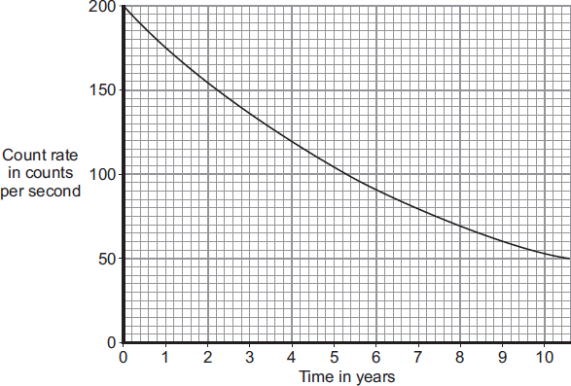
(i) What is the range of the count rate shown on the graph?
From __________ counts per second to __________ counts per second.
(1 mark)
(ii) How many years does it take for the count rate to fall from 200 counts per second to 100 counts per second?
Time = _____________________ years (1 mark)
(iii) What is the half-life of cobalt-60?
Half-life = _____________________ years (1 mark)
(b) The gamma radiation emitted from a source of cobalt-60 can be used to kill the bacteria on fresh, cooked and frozen foods. Killing the bacteria reduces the risk of food poisoning. The diagram shows how a conveyor belt can be used to move food past a cobalt-60 source.
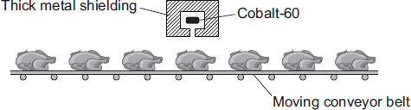
(i) Which one of the following gives a way of increasing the amount of gamma radiation the food receives?
Put a tick () in the box next to your answer. (1 mark)

Increase the temperature of the cobalt-60 source.
Make the conveyor belt move more slowly.
Move the cobalt-60 source away from the conveyor belt.
(ii) To protect people from the harmful effects of the gamma radiation, the cobalt-60 source has thick metal shielding. Which one of the following metals should be used? Draw a ring around your answer.

aluminium | copper | lead
(1 mark)
(c) A scientist has compared the vitamin content of food exposed to gamma radiation with food that has not been exposed. The table gives the data the scientist obtained when she tested 1 kg of cooked chicken.

Vitamin | Food not exposed to gamma radiation | Food exposed to gamma radiation
 | Mass in milligrams | Mass in milligrams
B6 | 1.22 | 1.35
B12 | 21.00 | 28.00
E | 3.30 | 2.15
Niacin | 58.00 | 55.50
Riboflavin | 2.10 | 2.25
Considering only this data, which one of the following is a correct conclusion?
Put a tick () in the box next to your answer.

Vitamin content is not affected by gamma radiation.
Gamma radiation completely destroys some types of vitamin.
Exposure increased the content of some types of vitamin.
(1 mark)

