Combined Science

P7
Atomic Structure
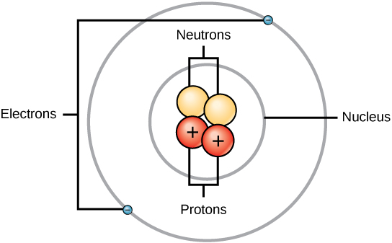

Name ______________________________
Class ______________________________
Teacher ______________________________
Atomic structure facts
- The smallest part of an element that can exist.
- Atom
- 0.1 nm (1 x 10⁻¹⁰ m)
- zero/neutral
- An atom of the same element with different numbers of neutrons
- An unstable nucleus changes to become more stable and gives out radiation
- random
- Rate at which decay occurs
- Becquerels (Bq)
- Number of decays recorded each second by a Geiger-Muller tube
- The time taken for number of radioactive nuclei in a sample to halve OR time taken for count rate (or activity) from a sample to fall to half its initial value
- proton, neutron, electron
- protons, neutrons
- proton +1, neutron 0, electron -1
- proton 1, neutron 1, electron ≈ 0
- alpha, beta and gamma
- two protons and two neutrons
- an electron
- electromagnetic wave (NOT a particle)
- radiation that is around us all the time from sources such as the air, rocks, food and drink, building materials, cosmic rays from space, medical procedures etc.
- short - 5 cm in air
- unlimited in air
- medium - about 1 m
- paper/skin
- about 5 mm aluminium
- several centimetres of lead
- very high
- medium
- low
- How likely it is to ionise atoms which it comes into contact with

Fold page here
- Define an atom
- All substances are made up of…?
- The radius of an atom is …?
- The overall charge on an atom is…
- Define isotope
- Define radioactive decay
- We cannot predict when a given atom will decay, this means that radioactive deacy is ….?
- Define activity
- What are the units of activity?
- Define count rate
- Define half life
- Name the three subatomic particles
- Which particles are located in the nucleus?
- What is the charge of each subatomic particle?
- What is the mass of each subatomic particle?
- Name the three types of radiation
- What is an alpha particle?
- What is a beta particle?
- What is gamma radiation?
- What is background radiation?
- What is the range of alpha radiation in air?
- What is the range of gamma radiation in air?
- What's the range of beta radiation in air?
- What will absorb (stop) alpha radiation?
- What will absorb (stop) beta radiation?
- What will absorb (stop) gamma radiation?
- What is the ionising power of alpha radiation?
- What is the ionising power of beta radiation?
- What is the ionising power of gamma radiation?
- What is meant by the ionising power of radiation?

P7 Atomic structure Tutorial questions
Q1 Radioactive nuclei can emit alpha, beta or gamma radiation.
(a) Which type of radiation is the most penetrating?
Tick one box.

Alpha (α)
Beta (β)
Gamma (γ)
(1)
(b) Which type of radiation is the most ionising?
Tick one box.

Alpha (α)
Beta (β)
Gamma (γ)
(1)
(c) Which type of radiation has the longest range in air?
Tick one box.

Alpha (α)
Beta (β)
Gamma (γ)
(1)

When radioactive isotopes in the Earth’s crust decay they release energy.
The decay causes the heating of rocks in the crust.
(d) The diagram below shows the decay of uranium-238 (U-238) into thorium-234 (Th-234).
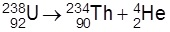
Complete the table below to show the number of neutrons and protons in the nuclei.

Isotope | Number of neutrons | Number of protons
uranium-238 | 146
thorium-234 |  | 90
(2)
(Total 5 marks)
Q2. (a) Over 100 years ago, scientists thought the atom was like a ‘plum pudding’.
The diagram below shows the plum pudding model of the atom.
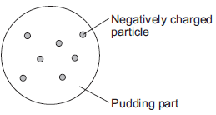
The scientists knew that an atom has negatively charged particles. They also knew that an atom has no overall charge.
What did the scientists conclude about the charge on the ‘pudding part’ of the atom?
______________________________________________________________
______________________________________________________________
(1)

(b) Two scientists named Rutherford and Marsden devised an experiment to investigate the plum pudding model of the atom. The experiment involved firing alpha particles at a thin sheet of gold. The scientists measured how many of the alpha particles were scattered.
Using the plum pudding model, the scientists predicted that only a few of the alpha particles would be scattered by more than 4°.
Over several months, more than 100 000 measurements were made.
(i) The results from this experiment caused the plum pudding model to be replaced by a new model of the atom.
Explain why.
__________________________________________________________
__________________________________________________________
__________________________________________________________
__________________________________________________________
_________________________________________________________
__________________________________________________________
(2)
(ii) Suggest one reason why other scientists thought this experiment provided valid evidence for a new model of the atom.
__________________________________________________________
__________________________________________________________
__________________________________________________________
(1)
(c) In this question you will be assessed on using good English, organising information clearly and using specialist terms where appropriate.
Describe the model now used for the structure of an atom.
In your answer you should:
• give details of the individual particles that make up an atom
• include the relative masses and relative charges of these particles.
Do not include a diagram in your answer.
______________________________________________________________
_____________________________________________________________
_____________________________________________________________
______________________________________________________________
____________________________________________________________________________________________________________________________
______________________________________________________________
______________________________________________________________
______________________________________________________________
______________________________________________________________
(6)
(Total 10 marks)
Q3. The diagrams below represent three atoms, A, B and C.
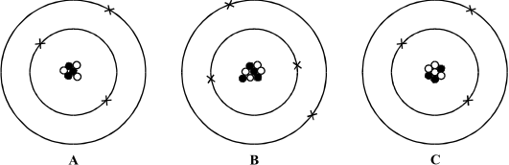
(a) Two of the atoms are from the same element.
(i) Which of A, B and C is an atom of a different element? _____________
(ii) Give one reason for your answer.
__________________________________________________________
__________________________________________________________
__________________________________________________________
(2)
(b) Two of these atoms are isotopes of the same element.
(i) Which two are isotopes of the same element? _________ and ____________
(ii) Explain your answer.
__________________________________________________________
__________________________________________________________
__________________________________________________________
(3)
(Total 5 marks)

Q4. The diagram shows how the thickness of aluminium foil is controlled. The thicker the aluminium foil, the more radiation it absorbs.
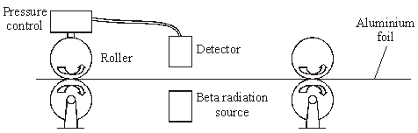
(a) The designers used a beta radiation source for this control system.
(i) Why would an alpha radiation source be unsuitable in this control system?
__________________________________________________________
__________________________________________________________
(1)
(ii) Why would a gamma radiation source be unsuitable in this control system?
__________________________________________________________
__________________________________________________________
(1)
(b) The substance used in the beta radiation source is radioactive.
(i) Why are some atoms radioactive?
__________________________________________________________
__________________________________________________________
(1)
(ii) Explain why radiation is dangerous to humans.
__________________________________________________________
_________________________________________________________
__________________________________________________________
__________________________________________________________
(2)
(Total 5 marks)

Q5. (a) The graph shows how a sample of barium-143, a radioactive isotope with a short half-life, decays with time.
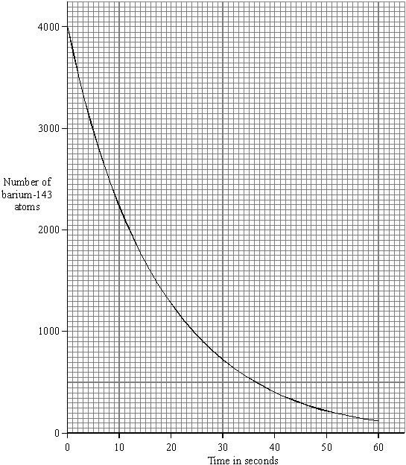
(i) What is meant by the term isotope?
__________________________________________________________
__________________________________________________________
(1)
(ii) What is meant by the term half-life?
__________________________________________________________
__________________________________________________________
(1)
(iii) Use the graph to find the half-life of barium-143.

Half-life = _______________ seconds
(1)
(b) Humans take in the radioactive isotope carbon-14 from their food. After their death, the proportion of carbon-14 in their bones can be used to tell how long it is since they died. Carbon-14 has a half-life of 5700 years.
(i) A bone in a living human contains 80 units of carbon-14. An identical bone taken from a skeleton found in an ancient burial ground contains 5 units of carbon-14. Calculate the age of the skeleton. Show clearly how you work out your answer.
__________________________________________________________
__________________________________________________________
__________________________________________________________
Age of skeleton = _______________ years
(2)
(ii) Why is carbon-14 unsuitable for dating a skeleton believed to be about 150 years old?
__________________________________________________________
__________________________________________________________
(1)
(c) The increased industrial use of radioactive materials is leading to increased amounts of radioactive waste. Some people suggest that radioactive liquid waste can be mixed with water and then safely dumped at sea. Do you agree with this suggestion? Explain the reason for your answer.
______________________________________________________________
______________________________________________________________
______________________________________________________________
______________________________________________________________
______________________________________________________________
______________________________________________________________
______________________________________________________________
(3)
(Total 9 marks)
Q6. In the early part of the 20th century, scientists used the ‘plum pudding’ model to explain the structure of the atom.
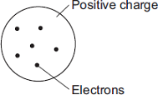
Following work by Rutherford and Marsden, a new model of the atom, called the ‘nuclear’ model, was suggested.
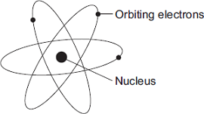
Describe the differences between the two models of the atom.
__________________________________________________________________
__________________________________________________________________
__________________________________________________________________
__________________________________________________________________
__________________________________________________________________
__________________________________________________________________
__________________________________________________________________
__________________________________________________________________
(Total 4 marks)

Mark schemes
Q1. (a) gamma
1
(b) alpha
1
(c) gamma
1
(d)
isotope | number of neutrons | number of protons
uranium-238 | 146 | 92 | 1
thorium-234 | 144 | 90 | 1
[5]
Q2. (a) (an equal amount of) positive charge
do not accept charge on the atom / nucleus is positive
1
(b) (i) a (significant) number of alpha particles were scattered by more than 4°
or
alpha particles deflected backwards
accept (some) measurements / results were unexpected
1
measurements / results could not be explained by ‘plum pudding’ model
or
measurements / results did not support predictions
can be explained by the nuclear model is insufficient
accept measurements / results did not support hypothesis
1
(ii) many / (over)100 000 measurements / results taken
accept Rutherford(and Marsden) were respected scientists
or
scientists were respected
accept measurements / results taken over several months
the experiment was repeated many times is insufficient
1

(c) Marks awarded for this answer will be determined by the Quality of Written Communication (QWC) as well as the standard of the scientific response.
0 marks  no relevant content | Level 1  (1−2 marks)  A brief description is given with some particles correctly named | Level 2 (3−4 marks)  A description is given with all three particles named  plus either  the polarity of charge associated with the  three particles  or  the relative mass of the three particles  or  the relative mass for one particle and the relative charge for one particle given | Level 3 (5−6 marks)  A more detailed description is given, naming the particles and polarity of charge  and either  the relative mass is given for at least two particles  or  the relative charge is given for at least two particles
Examples of the points made in the response
brief description
contains protons, neutrons and electrons
protons are positive
electrons are negative
neutrons are uncharged
has a nucleus
relative charge
proton +1
electron − 1
neutron 0
relative mass
proton 1
neutron 1
electron (about) 1 / 2000
accept protons and neutrons have the same mass
accept electrons have tiny / negligible mass
zero mass is neutral
more detailed description
protons and neutrons make up the nucleus
electrons orbit the nucleus
electrons are in shells
most of the atom is empty space
nucleus occupies a very small fraction of the volume of the atom
electrons orbit at a relatively large distance from the nucleus
most of the mass of the atom is contained in the nucleus
the nucleus as a whole is positively charged total number of protons in the nucleus equals the total number of electrons orbiting it in an atom
6
[10]
Q3. (a) (i) B
for one mark
2
(ii) has a different number of electrons (protons)
for one mark
(b) (i) A and C
for one mark
1
(ii) same number of protons / electrons, same nuclear charge
different number of neutrons / nuclear masses different
for 1 mark each
2
[5]
Q4. (a) (i) cannot penetrate aluminium
allow can only pass through air / paper too weak is neutral
1
(ii) gamma rays not affected (by aluminium)
allow all / most (gamma rays) to pass through
too strong is neutral
danger is neutral
1
(b) (i) (nuclei) unstable
1
(ii) causes harm / damage to body / cells
allow radiation sickness
1
detail e.g., causes mutations / causes cancer / damages DNA /
damages chromosomes
allow two effects for 2 marks
1
[5]
Q5. (a) (i) element with equal number of protons, different number neutrons
or
same atomic/proton number different mass/nuclear number
1
(ii) time taken for activity or count rate or number of nuclei to decrease to half
accept parents atoms or radioactive isotope
do not accept time taken for radioactivity/substance/ material to halve
1
(iii) 12 (s)
1
(b) (i) 22800 (years)
allow 1 mark for iterative steps 80-40-20-10-5 or statement of 4 half-lives
2
(ii) decay (of carbon 14) over 150 years is insignificant
accept very little decay
accept change is too small
1
(c) either argument gains full credit
accept any 3 valid points from for and/or against arguments
FOR
  - massive dilution of waste
  - reduces concentration (within a given volume) to insignificant levels
  - distant from habitation
AGAINST
- pollution (of the sea/beach)
- mutation or harm caused to living things (animals/plants)
- effect on food chain
- long period of time necessary
3
[9]
Q6. any two pairs from:
to gain credit it must be clear which model is being described
do not accept simple descriptions of the diagram without comparison
• nuclear model mass is concentrated at the centre / nucleus (1)
accept the nuclear model has a nucleus / the plum pudding model does not have a nucleus for 1 mark
plum pudding model mass is evenly distributed (1)
• nuclear model positive charge occupies only a small part of the atom (1)
plum pudding model positive charge spread throughout the atom (1)
• nuclear model electrons orbit some distance from the centre (1)
accept electrons in shells / orbits provided a valid comparison is made with the plum pudding model
plum pudding electrons embedded in the (mass) of positive (charge) (1)
do not accept electrons at edge of plum pudding
• nuclear model the atom mainly empty space (1)
plum pudding model is a ‘solid’ mass (1)
[4]

