model
Particle
Combined Science
Name ______________________________
Class ______________________________
Teacher ______________________________
Particle model facts
- ρ = m ÷ V
- density – kg/m³, mass – kg, volume - m³

- The particles are touching and vibrate around a fixed pattern.
- Particles are touching but not in fixed positions. They are free to flow around.
- Particles are far apart and move around quickly and randomly.
- Solid.
- Melting (solid → liquid), evaporating (liquid → gas), freezing (liquid → solid), condensing (gas → liquid), sublimating (solid → gas/gas → solid).
- Measure the length of the three sides and multiply together.
- Place the irregular solid in water in a measuring cylinder. Measure how much the water level has gone up by.
- Internal energy is the total kinetic energy and potential energy of all the particles that make up a system.
- The energy needed to heat up 1kg of a material by a temperature of 1°C.
- The energy needed to change state of 1kg of a substance without changing temperature.
- Energy goes into breaking/making bonds.

- In random motion.
- The speed of the particles increases as the gas is heated.
- The pressure would increase as particles would hit the walls of the container more often.
- From solid to liquid.

- From liquid to gas.

- ΔE = m × c × Δθ

- E = m × L

Fold page here
- What is the equation for density?
- What are the units for density, mass and volume?
- How are the particles in a solid arranged?

- How are the particles in a liquid arranged?

- How are the particles in a gas arranged?

- Which state of matter is most dense?
- What are the names of the five state changes?

- How do you measure the volume of a regular solid.
- How do you measure the volume of an irregular solid.

- What is internal energy?

- What is the definition of specific heat capacity?
- What is the definition of latent heat?

- Why doesn’t the temperature of a material change as it’s changing state?
- How do the molecules in a gas move?
- What happens to the speed of particles in a gas as the gas is heated?
- What happens to pressure if the size of a container is reduced?
- The specific latent heat of fusion gives what state change?
- The specific latent heat of vaporisation gives what state change?
- What is the equation to calculate energy change from specific heat capacity?
- What is the equation to calculate energy needed for a state change?

Task: Kinetic theory

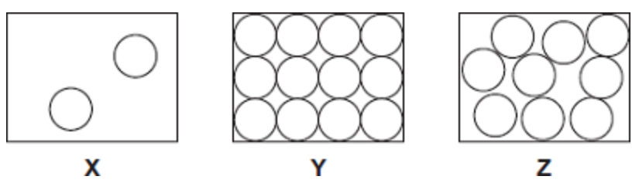
The diagrams X, Y and Z show how the particles are arranged in the three states of matter.
- Which one of the diagrams shows the arrangement of particles in a solid?
- Which one of the diagrams shows the arrangement of particles in a liquid?
- Which one of the diagrams shows the arrangement of particles in a gas?
- Which state(s) of matter:
- Can be compressed.
- Takes up the shape of the container
- Has no fixed volume
- Has no fixed shape.
- Has a low density.
- Causes pressure.

- Describe the difference between the solid and gas states, in terms of the arrangement and movement of their particles (4).
___________________________________________________________________
___________________________________________________________________
___________________________________________________________________
___________________________________________________________________

- The figure below shows a balloon filled with helium gas.
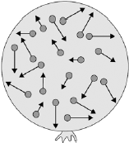
(a) Describe the movement of the particles of helium gas inside the balloon. (2)
___________________________________________________________________
___________________________________________________________________
___________________________________________________________________
___________________________________________________________________

Task: Specific latent heat

(a) (i) What is meant by specific latent heat of fusion? (2)
______________________________________________________________
______________________________________________________________
______________________________________________________________
(ii) Calculate the amount of energy required to melt 15 kg of ice at 0 °C.
Specific latent heat of fusion of ice = 340,000 J/kg. (2)
______________________________________________________________
______________________________________________________________
Energy = ___________________ J

Answers
Task: Kinetic theory
- Y
- Z
- X
- a) gas only b) liquids and gases c) liquids and gases d) liquids and gases e) gases f) gases
- solid particles vibrate about fixed positions (1)
(solids) are closely packed (1)
accept regular
gas particles move randomly (1)
accept particles move faster accept freely for randomly
(gas particles) are far apart (1)
- range of speeds (1)
moving in different directions (1)
accept random motion
Task: Specific latent heat
1a. E = mL  E = 10 kg x 25 000 = 250 000 J | 1b. E = mL  E = 15.5 kg x 15 000 = 232 500 J
2a. E = mL  50 500 = m x 2 200  $$m= \frac{50 500}{2 200}=22.95 kg$$  $$(30 kg to s 2f)$$ | 2b. E = mL  24 300 = m x 1 300  $$m= \frac{24 300}{1 300}=18.69 kg$$  $$(17 kg to s 2f)$$
3a. E = mL  3 500 = 20 x L  $$L= \frac{3 500}{20}=175 J/kg$$ | 3b. E = mL  6 800 = 0.3 x L  $$L= \frac{6 800}{0.3}=22 667 J/kg$$  (22 700 J/kg to 3 sf)

(a) (i) (Specific latent heat of fusion of a substance) is the amount of energy required to change a 1kg of a substance from solid to liquid state (1)
accept liquid to solid
without any change in the temperature (1)
(a) (ii) E = mL
E = 15 kg x 340 000 = 5 100 000 J
(b) (Specific latent heat of vaporisation of a substance) is the amount of energy required to change a 1kg of a substance from liquid to gas state (1)
accept gas to liquid
without any change in the temperature (1)
(c) E = mL
E = 0.018 kg x 2.3 x 10⁶ = 41 400 J

