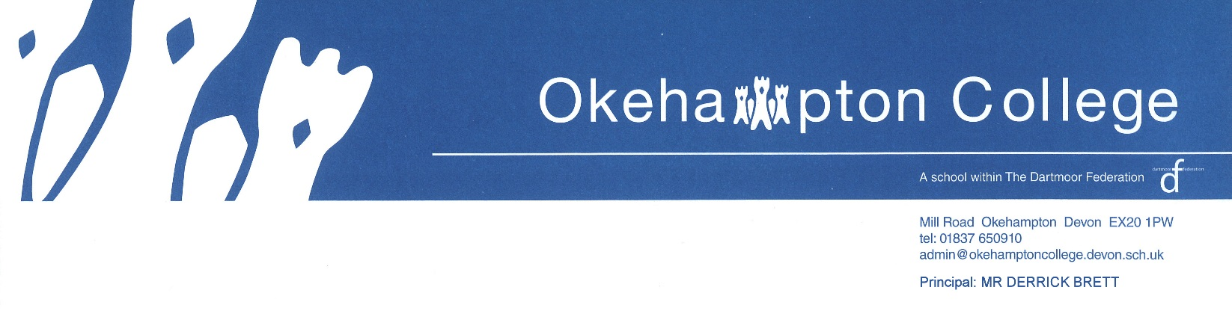
Music Department Instrumental Tuition 2020-21

Music has a high profile at the College and we always endeavour to provide quality instrumental tuition alongside curriculum lessons. If you would like your child to learn an instrument, please read the following information carefully and in order to accommodate all students, please hand back the request form to Mrs Berry as soon as possible. The form will be given to the relevant teacher who will then contact parents directly to discuss when lessons can begin.

Instrumental tuition is provided privately by individual tutors who will invoice parents directly each term.
Teachers will accommodate a settling in period but thereafter, half a terms notice must be given to terminate lessons.

Please indicate on the form where funding for lessons is coming from, and make it clear who the teacher
needs to contact for payment if not from parents/guardians.

Prices are based around the assumption that teachers will teach 30 lessons in a year.
Piano

Piano is taught by Mrs Z Williams. There will be 30 lessons over the year and the cost will be £90 per term for 20 mins and £135 per term for 30 mins. It is recommended that beginners have 20 mins but from grade 2 onwards, it is advised that 30 mins would be more appropriate in order to cover the necessary range of styles and technique in detail. Students follow the ABRSM exams grade 1 to Diploma level inclusive, and ABRSM Theory grades are also taught in every lesson.
Strings  Violin & Viola is taught by Francisca van Holthoon. She also offers dedicated theory tuition. Lessons are individual and are either for 30 or 45 minutes. The cost is from £140 per term, depending on the length of the term.  Mr Tim Pratt will be teaching cello. Lessons are charged at £15 per 30mins payable termly, and there will be an estimated 34 lessons per year.  Beginner double bass lessons are also available  www.dartmoorcello.co.uk  Brass  Mr Peter Jones teaches the full range of brass instruments, including brass band and orchestral. The cost is £100 per term for 20mins and £150 per term for 30mins. | Woodwind  Clarinet & Saxophone lessons are taught by Mrs Osborne in both jazz & classical Styles. Examinations with ABRSM & TRINITY. Shared lessons by request if possible. 32 individual lessons over the year are charged per term:- 20 mins @ £105; 30 mins @ £157.50.  Guitar  Electric, bass and acoustic guitar are all taught by Mr Molins. Individual lessons of 20 minutes are charged at £100 per term and 30 minute individual lessons are £150.  Drums  This also includes orchestral percussion and all kit styles. The cost is £100 per term. All lessons are individual and 20 minutes in length. The drum tutor is Mr Miller. | Flute  The flute is taught by Ms Mel Orriss . Individual lessons are priced at £15.50 for 30 minutes. An average of 10 lessons per term are timetabled, (30 per year) with lessons charged in advance for 10 lessons (£155). If fewer or more lessons are given the amount is adjusted on the next invoice.  Singing  Singing is taught by Miss Mott. Her charges are £100 for 10 x 20 minute individual lessons per term. Miss Mott teaches a variety of styles including classical, London College of Music ‘Pop Music Vocals’ and ‘Music Theatre’.  Theory Lessons  £15 per 30 minutes individual lesson. Lessons are with Martin Gaughan and will take place after school.
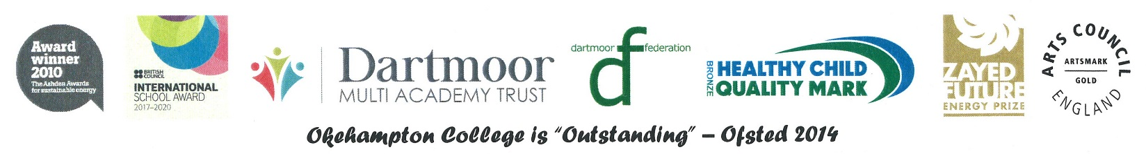

Instrument Hire

Instruments are available to hire from Devon Music Services.
A wide range of instruments can be selected from for a termly fee.
If you are interested in hiring an instrument, contact:
Devon Music Education Hub 01392 287235
www.dmeh.org

Okehampton College Remission Scheme

The College offers a remission scheme which can provide remission per term.
It is available to students in receipt of Pupil Premium.

The Music Department reserves the right
to cancel students’ lessons
if 3 lessons are missed during one half term.

Okehampton College ~ Music Department
Instrumental Tuition
Request Form

Name of student: .............................................................................. Year Group: .............
Instrument: .............................................................. Teacher: ..............................................................
Standard (e.g. beginner, Grade 3 etc.) .........................................................................................................
Requested length of lesson: ................................. Individual or shared: .........................................................
Address: ..................................................................................
.........................................................................................................
.........................................................................................................
Post Code: .........................................................................................................
Telephone Number:....................................................... Email Address:............................................................................
Signature of Parent/Guardian: ..........................................................Print name...........................................
Date: ..................................................................
If funding is coming from another source, please indicate where and give contact details.
Address: ..................................................................................
.........................................................................................................
.........................................................................................................
Post Code: .........................................................................................................
Telephone Number:....................................................... Email Address:............................................................................

Please return to Mrs V Berry as soon as possible -

vberry@okehamptoncollege.devon.sch.uk

