Core Knowledge Map
Subject: Mathematics | Year: 7 |  | Term: Autumn 1
What are we learning?
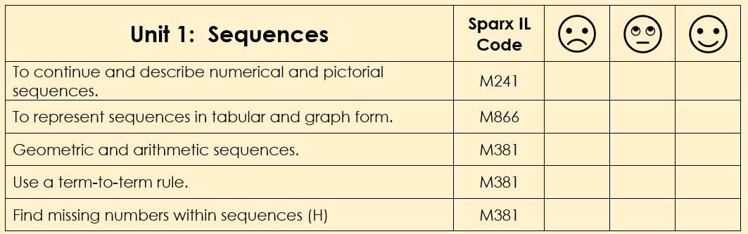
How will I be assessed
Topic Test at the end of the unit.
Big questions:
How is a linear sequence different to a non-linear sequence?
What do you look for in a sequence to tell you if it is a linear sequence?
How would you explain the difference between an arithmetic and geometric sequence?
Do geometric sequences always grow faster than arithmetic sequences?
How does this build on previous learning? |  | How will this link to my future learning?
Pattern spotting from KS2  Finding differences by using subtraction.  Addition and multiplication.  Plotting coordinates. |  | Generating sequences by using algebraic rules.  Finding algebraic rules for linear sequences.
Core knowledge: |  | Key vocabulary:
Linear or arithmetic sequence – constant difference between terms.  A linear sequence is a straight line in graphical form.  A non-linear sequence is a curved line in graphical form.  Geometric sequence – constant ratio between terms.  Fibonacci sequence – add two previous terms to generate the next term. |  | Sequence  Term  Position  Rule  Term-to-term  Linear  Non-linear  Arithmetic  Geometric  Fibonacci
Need more help? Use the Sparx Independent Learning Codes above

