Lesson 9 – Effect of Language
- Recap: What were the three important things to remember about ‘The Odyssey’ from last lesson?

- As read this section of ‘The Odyssey’, or afterwards, answer these questions:

  - What does Telemachus inform Menelaus of?

  - Why does Telemachus feel threatened?

  - What does Telemachus ask of Menelaus?

  - How does Menelaus react to Telemachus’ news?

  - What comparison does Menelaus make between the suitors and Odysseus?

(Telemachus is Odysseus’ son)
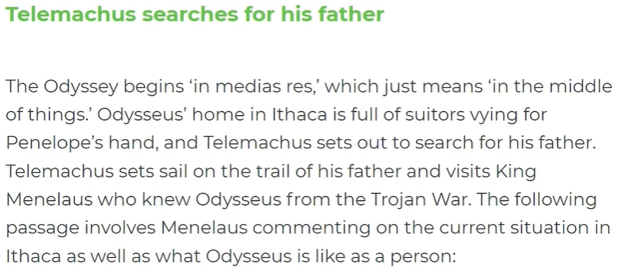

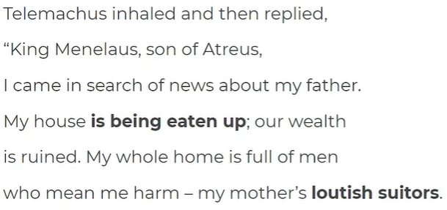
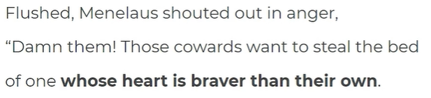
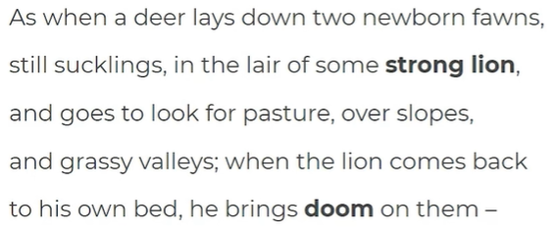
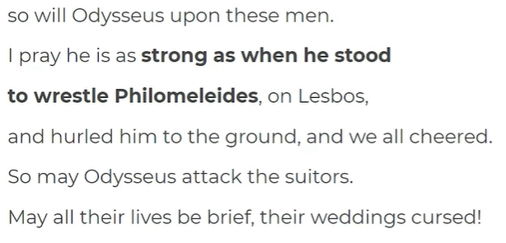

- Complete the questions on these quotations, focusing on the key question for today: How is Odysseus presented as honourable and great?
This one has been done for you as an example:
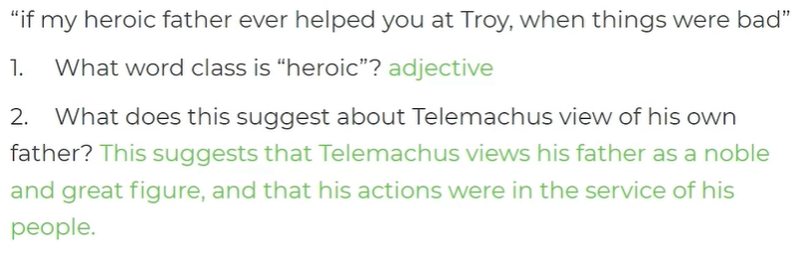
Now, do these yourself:
