Early Tudors Bridging Course (2020-2021)
Part I: War of the Roses

Henry VII was crowned king of England in 1485, following an era of chaos and unrest known as the ‘Wars of the Roses.

The Wars of the Roses were a long series of civil conflicts as the Houses of York and Lancaster battled for the Crown. The Wars of the Roses provide the crucial context for Henry VII’s successful usurpation in 1485, and it is important to understand the wars if we are to assess both the reception and the task that Henry would face when he became king.

Task One: Read p.12-13 carefully and list the different causes of the Wars of the Roses

Task Two: Read p.14-16 carefully and create a timeline to show the key events of the Wars of the Roses.

Task Three: Study the family tree on p.17 carefully and answer the questions in the textbook to explain how strong Henry VII’s claim to the throne.

Part II: 15th Century European Context

A key aspect of the Early Tudor course will focus on is foreign policy. The main players in English foreign policy under Henry VII were:
- France
- Scotland
- Burgundy
- Holy Roman Empire
- Spain (Castile and Aragon)

Task One: Circle the countries above on your map.
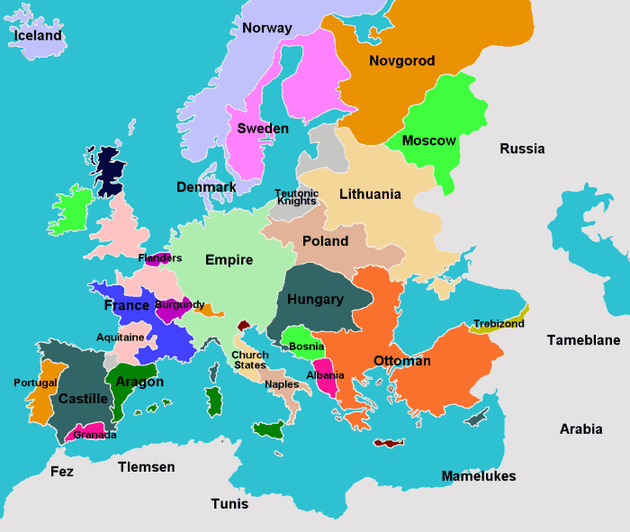

During the 15th century, the monarchs of the countries listed above were often related to one another through blood and/or marriage. The Tudor Family tree is shown on the next page.

Task Two: Create a family tree of the ruling dynasties of:

- France (Beginning with Charles VIII)
- Scotland (Beginning with James IV)
- Burgundy (Beginning with Charles I)
- Holy Roman Empire (Beginning with Maximilian)
- Spain (Beginning with Isabella and Ferdinand)

You only need to show three generations for each of the dynasties. Where possible, please show where the dynasties connect to one another.

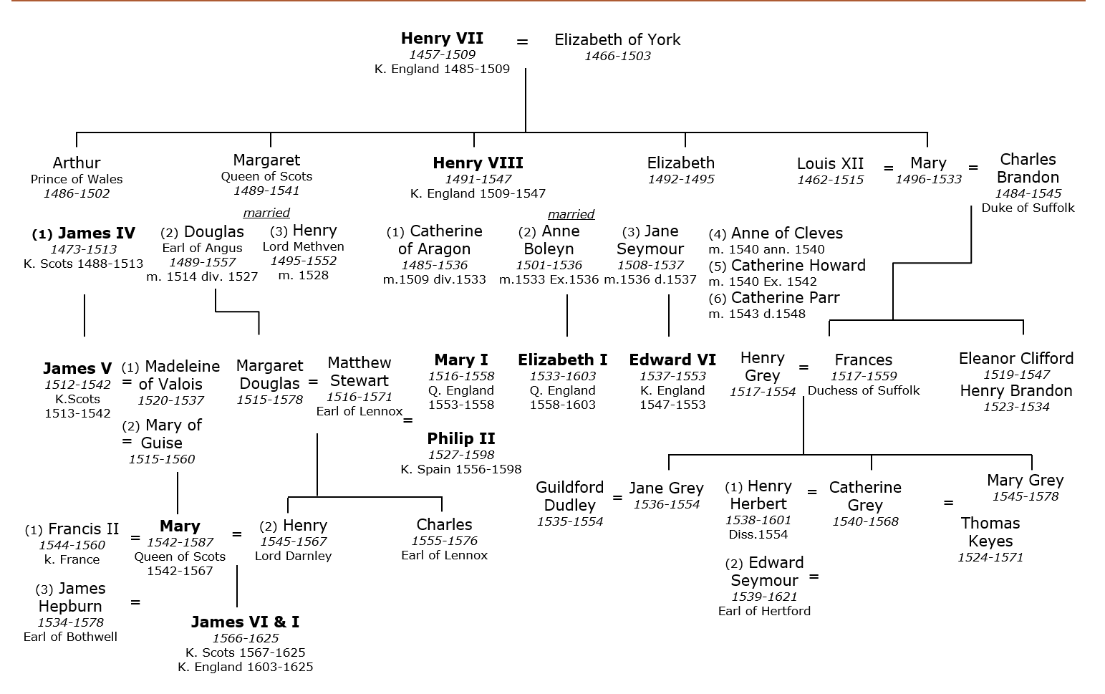

If you need any help or have any questions about the course, please email us at:

bpickett@okehamptoncollege.devon.sch.uk
kmarchant@okehamptoncollege.devon.sch.uk

CIVIL RIGHTS 1865-1992 bridging course 2020-21)

NB: I am not expecting really detailed responses to TASK 1 questions, but these questions will help you to think in the right way for this course.

TASK 1:
Read the pdf pages from the text book you will receive in September and answer the following questions:
- Which civil right do you think is the most important and why: right to vote, protection under the law or equality of opportunity? (AIM to explain the most important by comparing it to the other two civil rights)
- Watch www.youtube.com/watch?v=HuFR5XBYLfU
- Study the US system of government diagram (you need to know it well – so produce your own version if it helps). Which part of the government system do you think will play the most significant role in obtaining civil rights for the each of the 4 groups (African Americans, Native Americans, women and workers) you will be studying?
EG Congress will play a more significant role in improving the rights of African Americans because………..
OR
The Executive will play a more significant role in women’s rights because……..

TASK 2:

Research a civil rights activist/group between 1865-1992 and produce a fact file on that person/group. YOU CANNOT DO MARTIN LUTHER KING, JR! They can be from any of the 4 groups you will study.

Include:
Name
DOB/DOD
What were their aims
Main events in their life (choose between 5-10)
How successful were they in achieving their aims

TASK 3:

Read the following 3 articles and complete the attached reading review for each one.
https://www.commondreams.org/views/2015/02/21/malcolm-x-relevant-today-50-years-ago
https://www.commondreams.org/views/2015/02/02/malcolm-x-was-right-about-america
https://www.commondreams.org/views/2015/08/04/w-e-b-du-bois-malcolm-x-untold-history-movement-ban-bomb

EXTENSION:
Watch either ‘Malcolm X’ film by Spike Lee, starring Denzil Washington OR/AND ‘Selma’ film by Ava DuVernay OR/AND the “13th” on Netflix (Warning: some shocking scenes at the end of the documentary with bodycam images of people being killed)
Produce a film review including:
- Synopsis of the story
- How did you feel about the film? Explain
- What does it say about the Civil Rights struggle?
I would be really interested to know what your thoughts are on these films. Malcolm X is one of my favourite films and Selma is an interesting portrayal. The “13” talks about the era relevant to your studies but also brings it into the modern context.

The History Department are incredibly excited about next year and look forward to seeing you in Year 12. Any problems/questions, do not hesitate to contact me over the summer: jrodgers@okehamptoncollege.devon.sch.uk

Best wishes!

