Year 7/8

Design & Technology:

Design Communication: Product Design

Product 1: Red Nose Box (New Product)

- Importance of Packaging

- Design Briefs and Specifications

- Initial Designs for a Red Nose Box

- Final Design for a Red Nose Box

Importance of Packaging:

Why is the information and images, put on packaging, so important?
What is the purpose of packaging anyway?
How do designers make packaging appealing to the target market (people who buy the product) so as to encourage them to buy the product?
On a separate piece of paper, answer the following questions:
1) Write down 10 different pieces of information you might see on packaging
2) Write down as many reasons as you can (at least 5 reasons) about why we need packaging for products
3) Write down at least 8 examples of how designers make packaging interesting to potential buyers
Consider packaging you have in your home, think about supermarkets, DIY shops etc

Design Briefs and Specifications

On a separate piece of paper, answer the following questions:
- What is a Design Brief?
- What is a Specification?
For this project, you are Designer/Manufacturers of packaging for products. I am the client (customer) who wants you to design and make a package/box to help sell Red Noses.

Specification To be successful my red nose box must:
- Be able to hold a red nose which is no bigger than 50mm in any direction
- Stand out and be an ‘eye-catching’ design
- Show the cost or price of the red nose
- Have a picture of the red nose on the box

- On a separate piece of paper, write 6 more specification points your Red Nose Box must achieve to be a success

Initial Designs for a Red Nose Box

Having completed your specification. On a separate piece of paper, you are now to:
1) Create some designs for your red nose box
- Create a drawing for each side (6 in total) of the box
- Do not use lots of text, you won't have the room.
- Use initials only or short words
- You should make sure you cover all the points from your specification.
- Use colouring pencils to make your design more eye-catching/attractive.

Final Design for a Red Nose Box

Having sketched your design for a Red Nose Box, the next stage is to generate a final design.
1) Produce a final neat and rendered (coloured-in) drawing of your Red Nose Box.

Design Communication: Product Analysis

Product 2: Staple Remover (Existing Product)

- Manufacture & Materials

- Ergonomics

- Aesthetics

- Packaging

- Design Exercise 1: Initial Designs

- Design Exercise 2: Final Design

Staple Remover Manufacture & Materials
Read the following & answer the questions below:

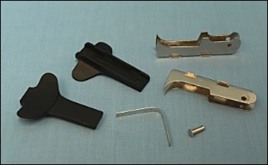
The staple remover has six different components made from steel and thermoplastic. It is probable that the components have been sourced from more than one supplier.

This is because companies specialising in injection moulding will probably not have the presses required for manufacturing the pressed steel components as well.
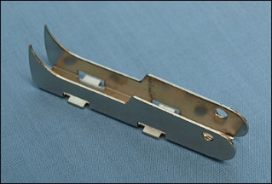
Jaws
The two pivoting jaws interlock with each other and are made of chrome-plated pressed steel, which is harder than the wire of the staple and strong enough to withstand the force required to remove it.

The chrome plating provides a reflective and rust-resistant finish. The jaws are made from sheet metal, cut using the process of blanking in a mechanical press, then bending in a press brake. This process produces high tolerance components at a production rate of up to 1,500 units per minute.

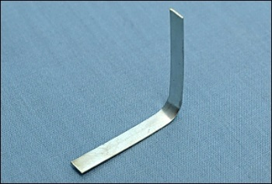
Spring
The spring is a standard component made from spring steel.

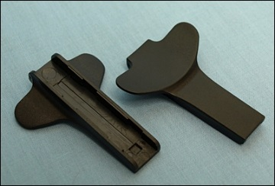
Finger grips
These components are injection moulded in a thermoplastic such as ABS. The two grips are similar, but not identical. This is because the teeth of the jaws need to close past each other in order to force the staples out. Therefore the grooves in the finger grips have to be of differing widths to fit the jaws.

The injection moulding process is used because it allows for large quantities of identical intricate components to be manufactured at a low unit cost, in a variety of colours and with minimal finishing.
Pin axle
The pin axle is a cylindrical bar (pivot) about which the jaws rotate.

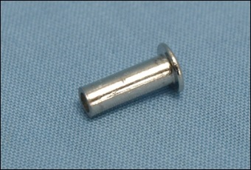
It is made of stainless steel, which will not rust in areas that have been worn by contact with other metals.

Sustainability and Recycling
This product is not made from sustainable materials as steel is a metal that is made mostly of iron with small amounts of other elements, such as carbon, added to strengthen or make it more workable. There is a finite amount of iron ore in the world and once that runs out any steel for new products and building will have to be made from recycled materials.
Compared to steel made from iron ore, recycled steel is cheaper, quicker and safer to use and there’s far less environmental impact.
The ABS Finger Grips are made from oil which also isn't a sustainable material.
It is possible to recycle the components once the device is no longer of use. However, in order to do so it would have to be forcibly broken apart as it hasn't been designed for disassembly. This is a labour intensive process and is unlikely to happen.
On a separate piece of paper, answer the following questions:
- What type of plastic was used to make some of the parts of the staple remover?
- Name the manufacturing process for making the finger grips
- Name 2 properties of stainless steel
- What does ‘sustainability’ mean?
- What does ‘recyclability’ mean?

Ergonomics
Read the following & answer the questions below:
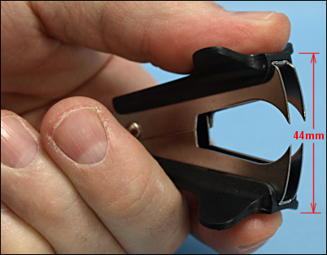
The device is designed to be held in a pincer grip (palmar pinch) between thumb and one or two fingers. The distance between the plastic grips is 44mm when the device is open. This means the stapler will fit comfortably between the thumb and fingers of 95% of the adult population.

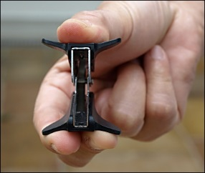
This measurement will have been decided by the designer after identifying the target user group and then by studying anthropometric data. An alternative method would be to take measurements from similar existing products. The measurements used will have been confirmed as correct through modelling the design. The injection moulded plastic grips are unnecessary to the function of the device. Their purpose is to make the stapler more comfortable to hold and easier to control.

Each grip is slightly concaved which means that the user's the finger(s) and thumb sit naturally in the correct position above the jaws. The curve in the finger grip also means that the device, when resting on a flat surface, sits like a tripod, on three points, so it doesn't wobble around.
On a separate piece of paper, answer the following questions:
- What is ‘anthropometric data’?
- What does ‘ ergonomics’ mean?
- How is the staple remover ergonomically friendly (easier to use)?

Aesthetics
Read the following & answer the questions below:

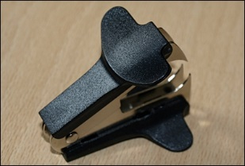
The design of this product is essentially utilitarian, i.e. it has been designed to be useful or practical rather than attractive. The staple remover is well-proportioned in order to be comfortably held in one hand. The curves in the finger grips and jaws contribute to the functionality of the product and give the device a purposeful look.

The surface of the grips is textured to give a positive non-slip feel, pleasant to the touch. This texture has been machined into the injection moulding mould so that each finished component has the same identical texture. The corners and edges of the moulding have been rounded to make the finger grips feel comfortable and safe to hold. The shape and distribution of weight is such that the device feels balanced when being used.
On a separate piece of paper, answer the following questions:
- What does ‘aesthetics mean?
- How do you think the staple remover could be made more ‘aesthetically pleasing’?

Packaging

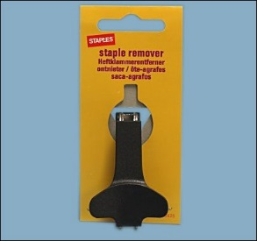
The staple remover packaging is designed for hanging on a 'point of sale' display rack. The packaging is purely for display and information purposes, giving little or no protection to the product.

It is made of a single piece of die-cut card, 4 colour printed and sealed on one side, folded and then stapled together.
Printed Information
The front of the packaging shows: company logo, the words "Staple Remover" in five languages, stock code number. There is no description or list of features as this is considered unnecessary for this product. Several pieces of information are displayed on the reverse side of the packaging:
3 graphic images showing the product can be bought in-store, by catalogue or online.
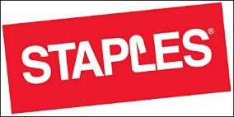
The packaging is printed on 250gsm card, which can be recycled and is biodegradable. There is no recycling information printed on the packaging.
Logos and Symbols
The Staples logo is displayed on the front of the packaging. The L in the logo is a stylised staple.

On a separate piece of paper, answer the following questions:
- What does ‘PoS- Point of Sale’ mean?
- Just like you did for the red nose box, write down 5 different pieces of information you might see on the packaging for the staple remover.
- What is the purpose of the packaging for the staple remover?

Design Exercise 1: Initial Designs

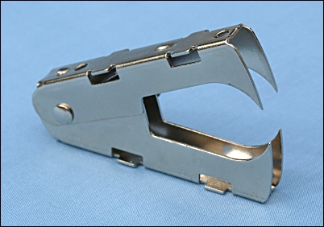
On a separate piece of paper, draw a set of initial design sketches for the body of a new staple remover. Base your design around the mechanism in the photo. Suggestion: incorporate a theme in the design e.g. animals, people, transport, places, cartoon characters. The design could be hand held or desk mounted.

Annotate your sketches with information about:
- Manufacture and Materials
- Ergonomics
- Aesthetics

Design Exercise 2: Final Design

Having sketched your design for a staple remover, the next stage is to generate a final design.
1) Produce a final neat and rendered (coloured-in) drawing of your staple remover.

