Well done Year 10’s! I’ve taken the some of the work I’ve received to share with you all!
We have got this! Instead of giving written instructions ( I have extended deadline dates on Classcharts for that!) here is a step-by-step guide in pictures. Please use this document alongside the the mock NEA 2 checklist given out and on Classcharts. Follow my handy hints and tips in red.
Start with a mood board for your chosen life stage group….
Section A Task Analysis/ Research/ Trials / Justification of Final Menu choices and Planning the Practical ( 15/70 marks)
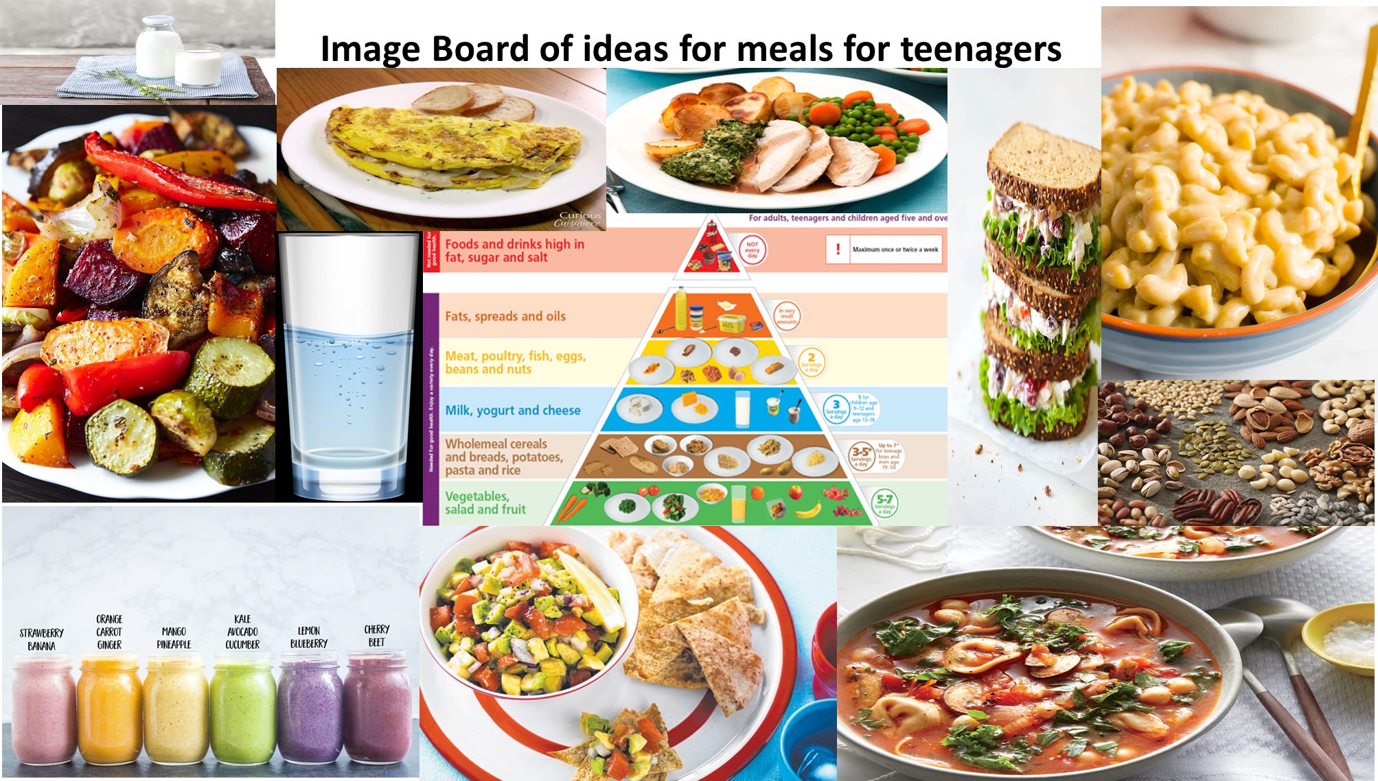
Complete an image board like this for your chosen life stage group and then copy and paste the slide into the task analysis Powerpoint slide as shown in the next slide.
You can add words as well as google images – e.g for teenagers I might write ‘ready in a hurry’ or ‘save the planet’ anything that gives ideas or considerations when designing a meal for your target group. Add it to your task analysis sheet. DON’T FORGET to write a paragraph about WHY you picked the photos and used the words you did – it shows understanding!
On this first sheet, show the examiner you understand the task set. Copy it out, highlight the key words in the task title.

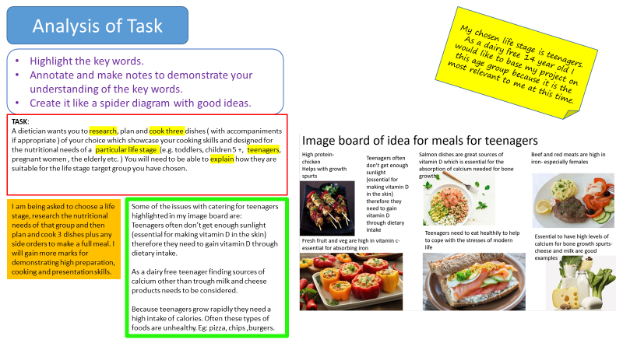
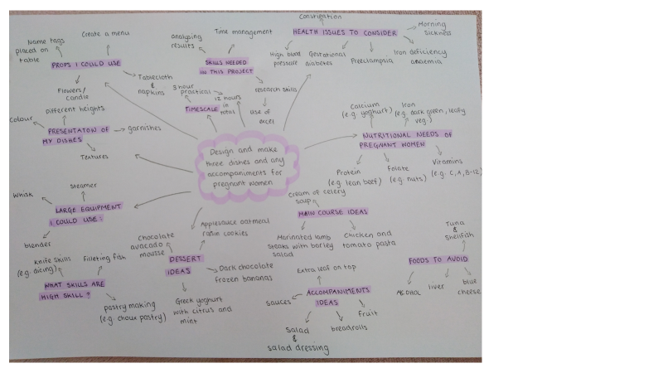
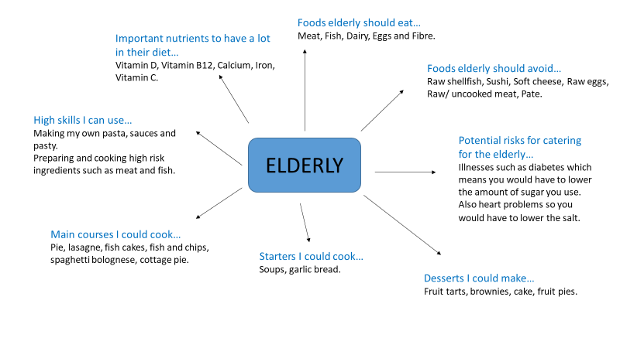As part of your task analysis, you should include a mind map of the things you will have to consider along the way. This is what you know already as no research has been done yet! E,g. you could consider issues about possible issues for catering for your target group/ hygiene points/ initial ideas for dishes and presentation/ what you know about the assessment and the skills you will need to develop e.g time management/ menu planning and analysis skills. Tip – do it by hand and then photograph it and insert into your work as you can get more detail in that way!
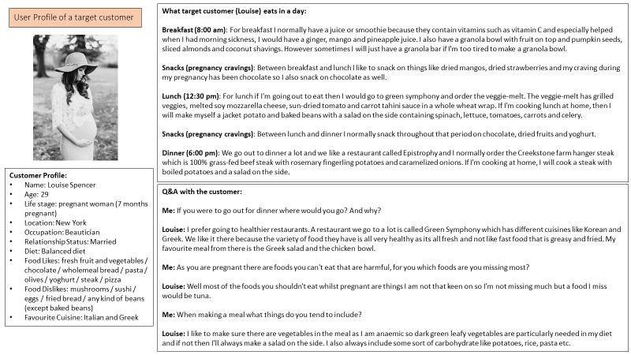b
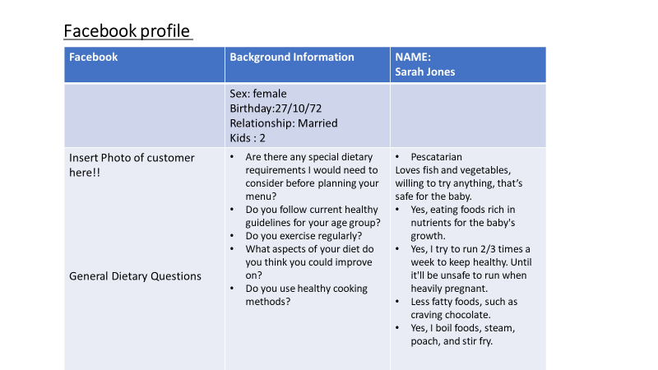

If completing a questionnaire is difficult; say for pregnant women ( it would be hard to find 10 pregnant women to ask a questionnaire to then you can complete a customer profile.
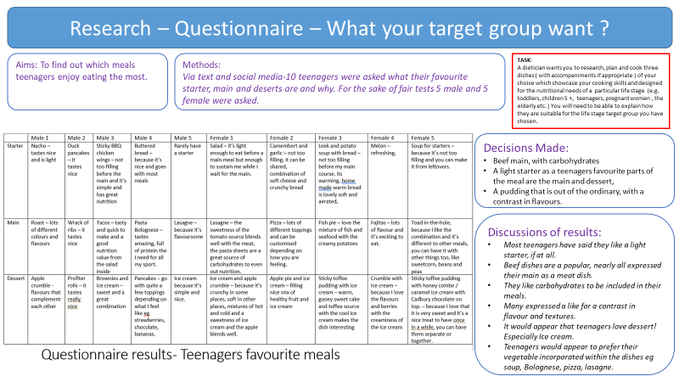
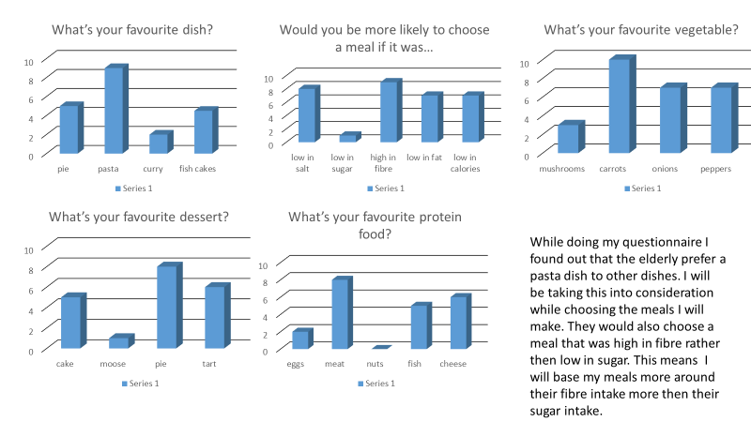
Go to http://gcsefood.weebly.com/questionnaire.html# for ideas for good question ideas and also a link to a questionnaire results template. All you have to do is enter your questions on page one of the excel spreadsheet and the barchart with your data on appears on page 2 of the template. Just copy and paste the ones you want you’re your Powerpoint slide. Genius! Remember to say WHAT YOU HAVE LEARNT THAT WILL HELP YOU WITH THE NEXT STAGE.
Research Page on your chosen Life Stage Group
Love this! – I have found this out….. so I will need to find foods that do …. The elderly tend to have this issue so to counteract this I will need to do x… For example the elderly can have a poor appetite and this student has then gone on to suggest that because smaller portions are being served or eaten that the amount of vitamins and minerals in what she serves needs to be high. Great analysis!
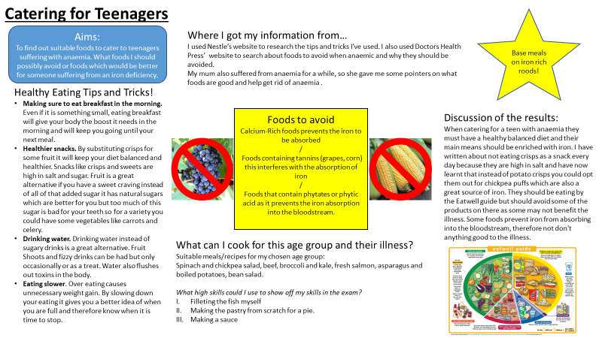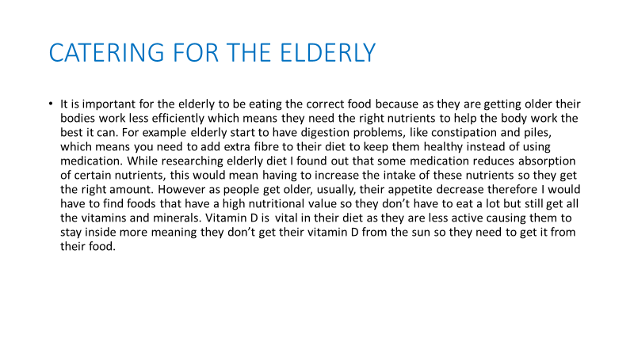

Two excellent pieces of research here on the nutritional needs of teenagers and the elderly. Look at the fabulous layout of the teenager slide above! Colourful/ well laid out and easy to read the key points.

Trial dishes need to be written up like the examples below : ………. What an eyecatching and well set out page! Ingredients; taste test results, photos, nutritional information, skills executed/ any issues when making, good and bad points and improvements. Remember, completing trial dishes are a chance to ditch/ keep/ find any problems/ tricky aspects and correct them before the final assessment – you need to tell us about the process you went through to arrive at your final menu
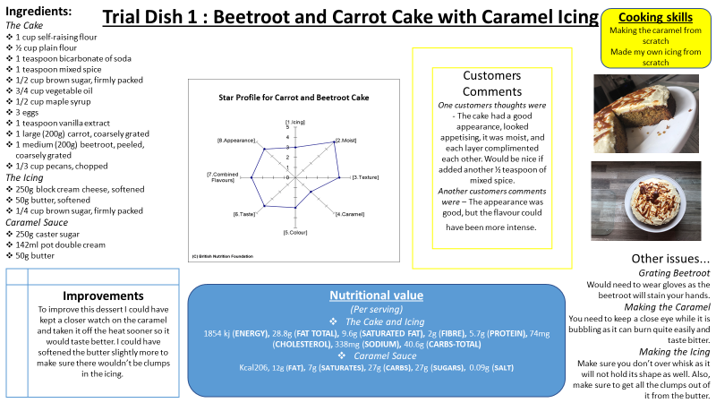

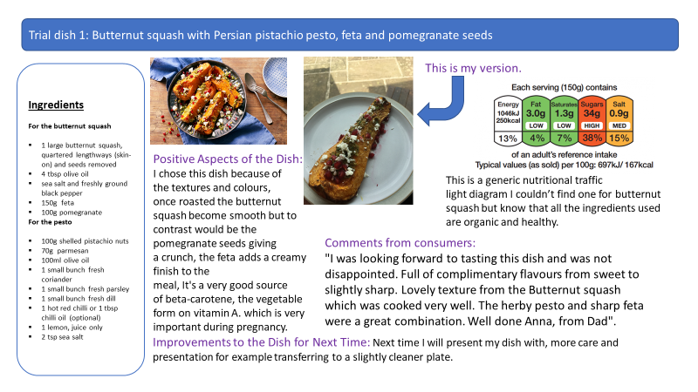
A trial dish can be any aspect of your meal e.g an accompaniment as above – This is an opportunity to practise high skiled dishes ( you are not assessed on your cooking in this section) It does not need to be the finished article – e.g just make a brownie without sauce/ topping/ presentation etc but say what you will do to give it that WOW factor for the actual three hour cooking assessment. You can add a nutritional analysis of your trial dishes by going onto: http://explorefood.foodafactoflife.org.uk/
Making your Trial Dishes
Make 2 Trial Dishes : This is a chance to practise high technical skills and see if a dish has the potential to go all the way!! Ditch it! Keep it – it’s almost perfect in every way or has it got potential but needs work before the final assessment…
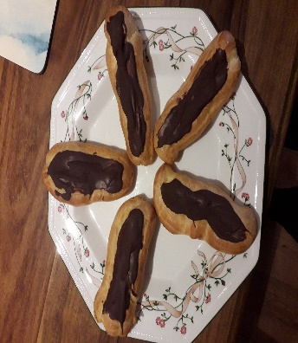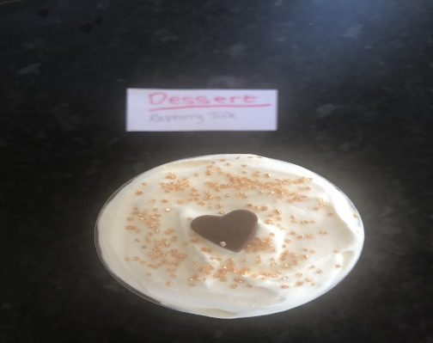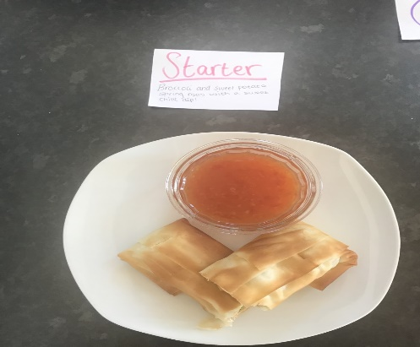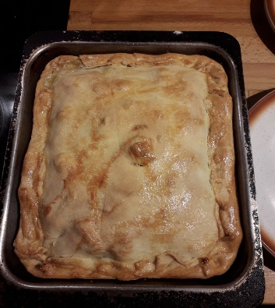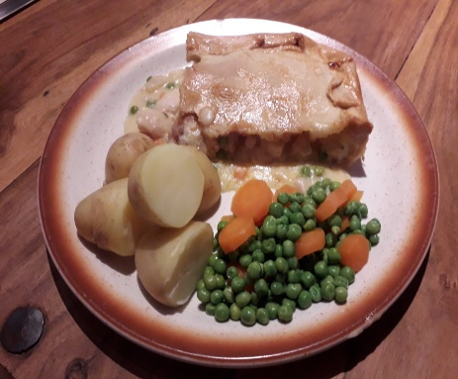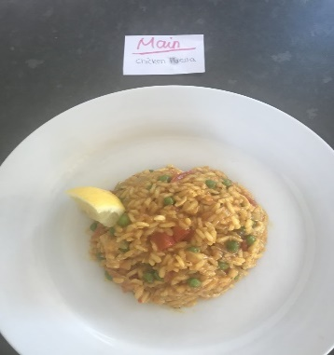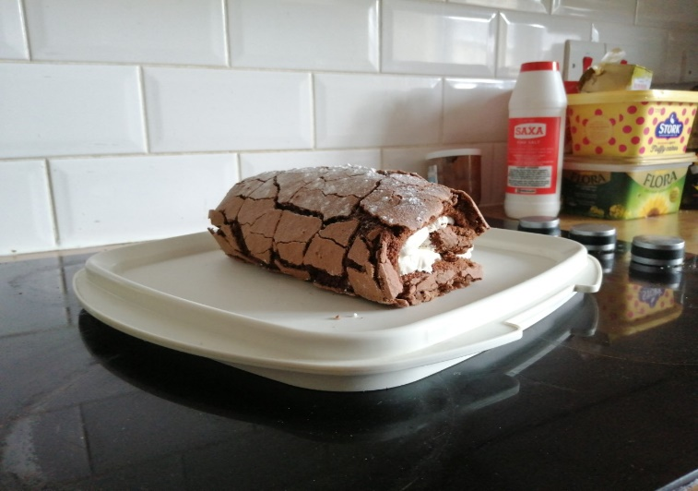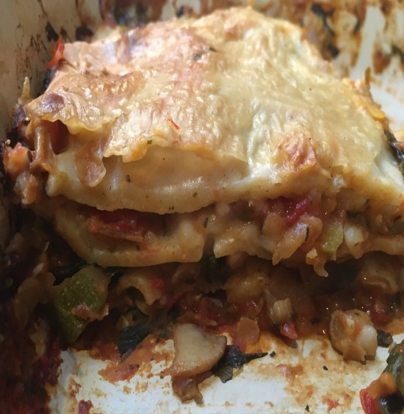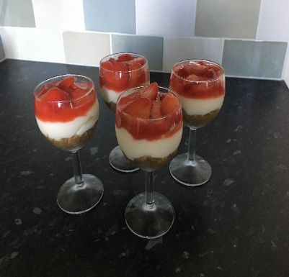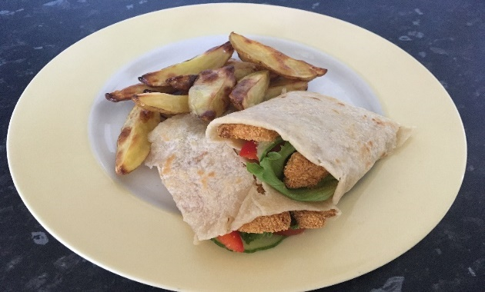

Go to films to support skill acquisition in preparation for Assessment 2: The Food Preparation Assessment. : https://resources.eduqas.co.uk/Pages/ResourceSingle.aspx?rIid=691

Justifying Your Final Menu Choices
Why have you chosen this menu? E.g consider presentation/ colours/textures/ appearance/ seasonal/ nutritional considerations/ restaurant style finish. How will your choices help you get a high mark in your final assessment? How does it meet the needs of your target group of people?
…as part of this section show off the skills ( ideally high!) that you will be using as shown below……
Love this! …. Lots of use of key technical terms used in the making of the proposed dishes e.g griddling, dicing, laminating, sauteing.
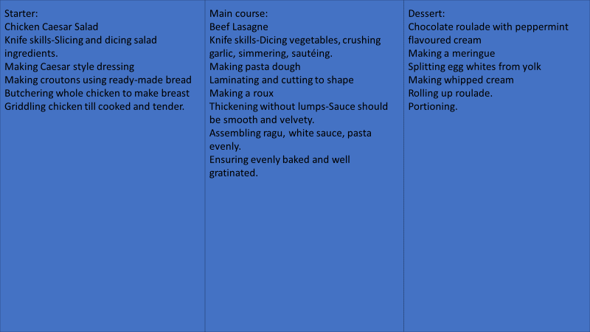
This is also a good choice of dishes – meringue making, pasta and roux sauce making all high skills::

For my three dishes:
Tomato and basil soup with a wholemeal bread roll - making bread, yeast.
Hunters chicken lasagne - making pasta from scratch, making a cheese sauce, knife skills to cut chicken.
Toffee and pecan roulade - making meringues, making a toffee sauce.

Now look at the timeplan on the next page to see how the above three dishes can be sequenced and tasks completed so that all dishes are served at the same time.

Include an equipment and shopping list in this exam board specified format:

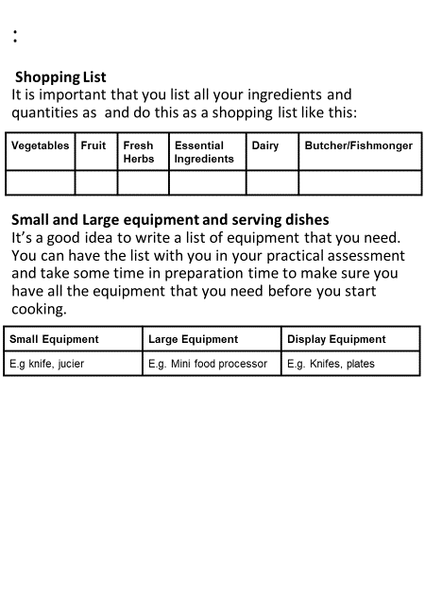Complete a clear, easy to follow timeplan like this one. Don’t forget special points ( notes) to include at least two quality, two safety and two food hygiene points. Colour coding each line of your plan a different colour for each dish will make it easier to follow at a glance in your practical assessment.
Include all the ingredients you will need under each heading of the shopping list e.g if you need 50g butter for your shortbread recipe and 50g butter for your roux sauce in your main course you would enter 100g under the dairy heading. Be specific – don’t just say 100g cheese, say what type it is e.g cheddar
With the equipment list we need to know ALL of the equipment needed including what you will use on your display table when you serve it e.g vase of flowers/ wine glass etc.
Writing a Timeplan
The first ½ hour will be prep time ONLY – no cooking! ( but you can preheat the oven)
Time | Order of work |  |  |  | Notes
9.10am | Set up table. Collect serving dishes. Chop onions. Prepare garnishes (soup). Cut chicken into smaller pieces. Insure table is tidy. |  |  |  | Keep chicken and bacon refrigerated. Preheat oven to 210degreesC.
9.25am | Soup – melt butter, add half an onion and chopped tomatoes. |  |  |  | Over a medium heat.
9.35am | Bring to a low simmer and add water and salt and leave to simmer for 40 minutes. |  |  |  | Add water gradually.
9.40am | Bread roll – put flour and salt into a bowl. Stir in sugar and yeast and rub in butter. Finally add enough water to form a dough. |  |  |  | Soft dough.
9.50am | Knead the dough. |  |  |  | Elastic and smooth dough.
10.00am | Separate dough into balls, cover them and leave to prove for 30mins. |  |  |  | Put the dough in a warm place.
10.05am | BBQ sauce – oil in a sauce pan, cook diced onion, add chopped tomatoes, garlic, brown sugar, vinegar, Worcester sauce and tomato puree. Simmer for 20-30minutes. |  |  |  | Turn the heat down when left to simmer.  Thickened sauce.
10.15am | Blend the soup and add garnish. |  |  |  | Herb garnish.  Keep the soup hot!
10.20am | Brown the chicken in a pan, once browned add the BQQ sauce and leave to simmer for 20 minutes. |  |  |  | Make sure chicken is cooked.  Stir chicken with wooden spoon.
10.30am | Glaze the dough with egg and cook for 20-25 minutes. |  |  | Oven is 210.
10.35am | Prep salad to go with the lasagne – cucumber, tomatoes, lettuce, rocket plus a salad dressing. |  |  | Equal parts when cutting.  Put in fridge.
10.40am | Remove chicken from the heat. Cook bacon in a frying pan, 2 minutes each side. |  |  | Equal cook on both sides.
10.45am | Add the bacon to the chicken and BQQ sauce. Now in the bottom of the lasagne dish put chicken, top with bacon, then add grated cheddar and mozzarella and top with pasta sheets. |  |  | Layers.
10.55am | Take bread rolls out of the oven and leave to cool, increase oven temp to 210. Cook lasagne for 35 minutes. |  |  | Wire rack for cooling.
11.00am | Roulade – grease a swiss roll tin and line with greaseproof paper.  Whisk egg whites. |  |  | Stiff and foamy egg whites.
11.10am | Gradually whisk in sugar and spoon into the tin, level it off. |  |  | Use pallet knife to level off.
11.15am | Scatter pecans over the top. |  |  | Wait for lasagne to come out the oven before going in the oven.
11.20am |  | Begin to wash up equipment.
11.30am |  | Take lasagne out the oven and turn down to 160 and put meringue in the oven for 25mins. | Put lasagne in the grill (not on) to keep hot.
11.40am |  | Continue to wash up and wipe down surfaces.
11.55am |  | Take meringue out the oven and lay a damp towel on the surface. Remove meringue from the tin. | Another bit of greaseproof paper on top.
12.00am |  | Whisk cream into soft peaks and spread over the meringue. | Make sure meringue has cooled.
12.05am |  | Roll the meringue and drizzle it with toffee sauce.
12.10am |  | Serve food. Finish washing up. Clean kitchen.

Section B The three hour practical ( 45 out of 70 marks)
Presenting your final menu……… This is what you need to put on your presentation table
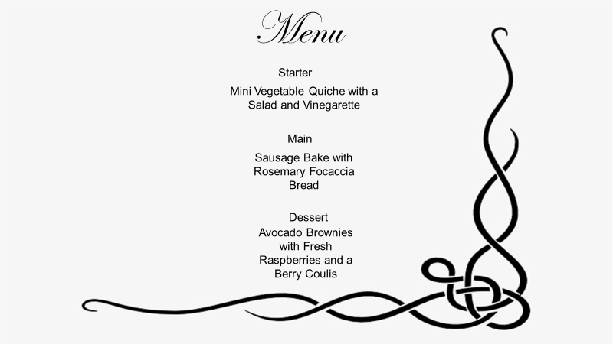
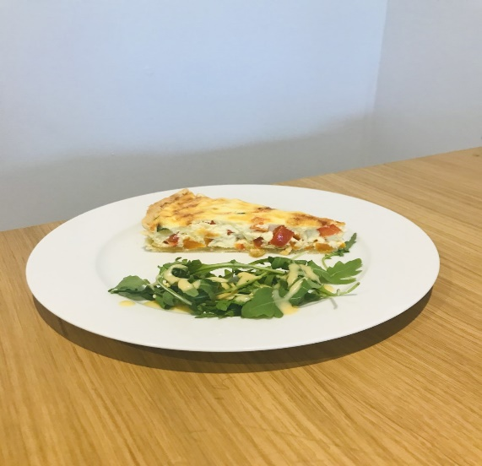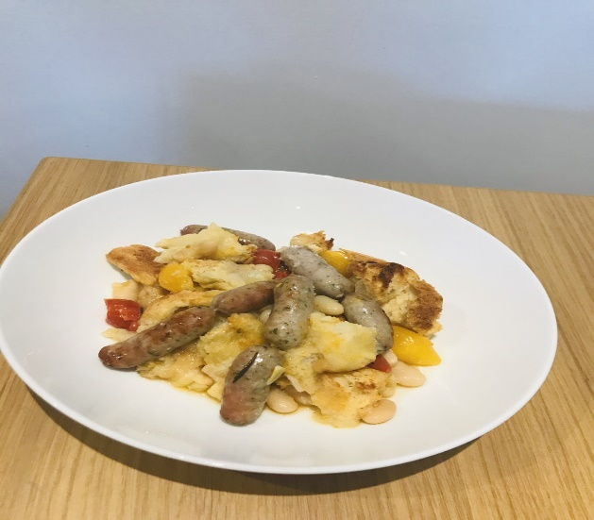
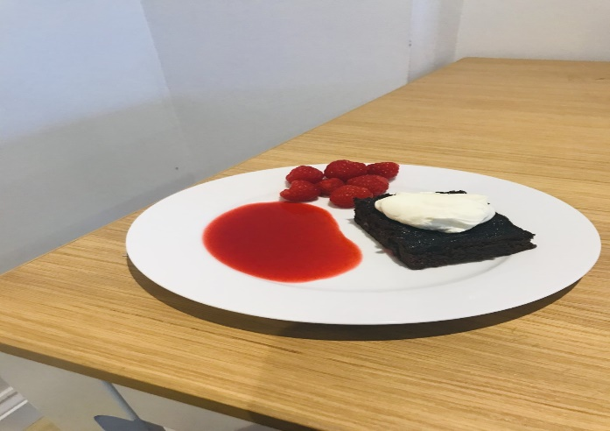

Ideally, you will cook all dishes to see if you can complete in three hours ( washing up and presentation!) If this is not possible see if you can plan and cook at least two courses of ANY meal ( e.g Sunday lunch is a good one!) to see how it feels to be cooking several dishes at once! It’s good experience for your real assessment!
Section C :Evaluation ( 10 /70 marks)
Answer all these questions in detail , with creative and relevant improvements.
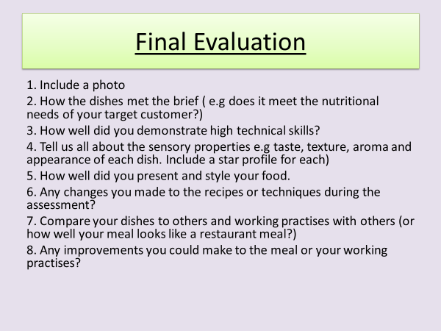
If you go onto Okehampton College's Sharepoint site go to Technology Faculty you will see an Illuminate Publishing app for the text book we use in class. Use the login details provided to access the book digitally.
Go to pages 395 – 427 for all stages of a completed NEA 2 Assessment example . This will give you an example of how to set out your planning and evaluation work.

Don’t forget to include a bibliography at the end of your project to acknowledge your sources of information! …….
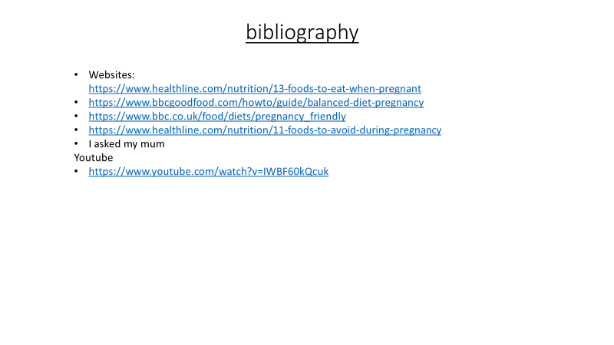
Deadline for Project: 7th September or before!: Email to joconnell@okehamptoncollege.devon.sch.uk.

Revision Topics
We have covered two main sections from the five main revision topics during the school closure period: Healthy Eating Guidelines and Nutritional Needs
And Science and Food
Spend 40 minutes completing the standardised assessment set up for you on the Seneca online revision site as an assignment entitled ‘ Science of Food and Healthy Eating’.

Or

Challenge yourself to answer these 10 questions on the below. All the answers can be found in the relevant sections of your own revision guide. Please email the answers to me @ joconnell@okehamptoncollege.devon.sch.uk.

Healthy Eating Guidelines and Nutritional Needs
- Sketch and label each section of the Eatwell Guide
- Describe the nutritional needs for:
- Toddlers ii) teenagers iii) young adults iv) elderly adults.
- What is Basal metabolic rate? (BMR)
- What is physical activity level ( PAL)
- According to the government guidelines, what % of our total energy should come from:
- Carbohydrates
- Fat
- Protein
- What is nutritional analysis? Where can you find nutritional data?
- Give one example of how you can modify a recipe to:
- Reduce sugar ii) reduce salt iii) reduce salt iv) increase fibre
- Diet Related Problems: Describe the cause and health problems for the following :
- Obesity ii) cardiovascular disease iii) anaemia iv) type 2 diabetes
- Explain the following health problems and how you could prevent them:
- Rickets ii) osteoporosis iii) dental caries
- Plan a meal for each dieatary requirement below. Explain why you chose each ingredient:
- Lactose intolerance ii) cardiovascular disease iii) coeliac
iv) lacto-ovo vegetarian

Science and Food
- Give three ways protein can be denatured.
- Describe the process of protein coagulation and explain how it affects the texture of food.
- Explain how foam formation happens in egg whites
- What is the name of the protein that gives bread dough it’s elasticity?
- Explain how starch can be used to thicken a cheese sauce.
- Name the process that makes biscuits browner and crisper when they are baked.
- Name and describe the process that takes place when sugar is cooked at a high temperature.
- What does the term ‘aeration’ mean?
- Explain how you can prevent gluten molecules from forming long strands.
- Explain how emulsifiers can be used to keep oil and water in a stable emulsion.

