C6 Electrolysis Quiz Questions
- What is electrolysis?
- What is the name for the positive electrode?
- What is the name for the negative anode?
- Do positive ions move to the anode or the cathode?
- Do negative ions move to the anode or the cathode?
- What is an electrolyte?
- State 2 disadvantages of extracting aluminium using electrolysis.
Exam question:
The figure below shows an apparatus to produce elements from a solution of an ionic compound.
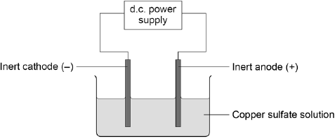
(a) What is the name of the process in the figure?
Tick one box.

Combustion
Crystallisation
Distillation
Electrolysis
(1 mark)

(b) The table below shows the products formed from three experiments using different compounds and the apparatus shown in the figure above.

Compound | State | Product at cathode | Product at anode
Copper chloride | Molten | Copper | Chlorine
Copper chloride | Aqueous solution | Copper | Chlorine
Potassium bromide | Molten | Potassium | Bromine
Use the table above to name the products formed at each electrode if using an aqueous solution of potassium bromide.
At cathode
At anode
(2 marks)
(c) Explain why copper is formed at the cathode during the electrolysis of its salts.

(2)

