Electrolysis Tutorial
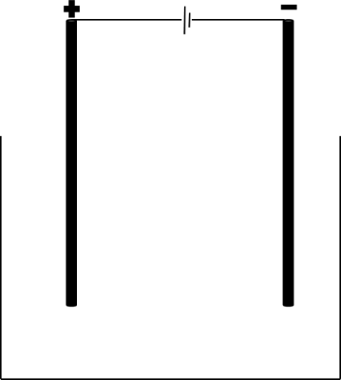
Electrolysis is the process of using electricity to split apart ionic compounds. The compounds can either be molten (liquid) or in a solution. The basic apparatus for electrolysis is always very similar:
Power source
Negative electrode: cathode
Positive electrode: anode
Container
The compound to be split up goes in the container. It is called the electrolyte.

A useful mnemonic to remember the names of the electrodes is PANIC: positive anode, negative is cathode.
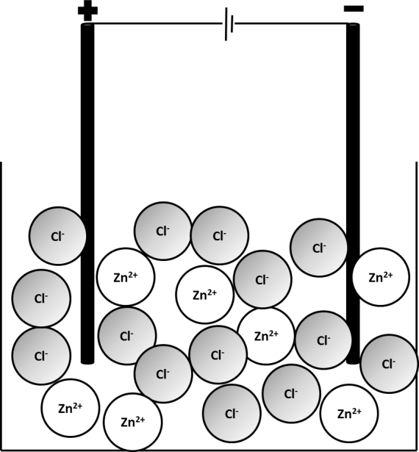
- A student is to electrolyse sodium chloride. If the sodium chloride is a solid, what must be done to it before it can be electrolysed?
- What is the electrolyte in this case?
- List the apparatus required to electrolyse sodium chloride

Electrolysis of liquids
Ionic compounds need to be molten or in solution for electrolysis to work. This is because the charged particles that make them up (ions) need to be free to move to the electrodes.
The positive ion (always a metal) will travel to the cathode, where it will gain electrons to become an element,
The negative ion (the non-metal) will travel to the anode, where it will lose electrons to become an element.
The example below involves electrolysis of molten zinc chloride, ZnCl₂(l). When zinc chloride is melted, the ions which make it up become free to move. The Zn²⁺(l) will travel to the cathode and the Cl⁻(l) will travel to the anode.
Pure zinc metal will be produced at the cathode and chlorine will be produced at the anode.
- In the electrolysis of zinc chloride, what is the electrolyte?
- In the electrolysis of each of the molten compounds below, state which elements will be produced:

  - Zinc iodide
  - Lithium bromide
  - Iron fluoride
  - Sodium oxide
  - Potassium chloride

- For each of the compounds in question 5, state at which electrode each element will be produced.

- Why can electrolysis not be performed on covalent substances.

Redox and half equations recap
In previous units, we have learnt that:
- Oxidation is Loss of Electrons
- Reduction is Gain of Electrons
Example 1: electrolysis of zinc chloride
The zinc ion, Zn²⁺(l) gains two electrons to form Zn(s). This can be represented by a half equation:
Zn²⁺(l) + 2e⁻ Zn(s)
This occurs at the cathode. At the anode, Cl⁻(l) turns into Cl₂(g). This can also be represented by a half equation:
Cl⁻(l) Cl₂(g) + e⁻
This is not balanced as we need two Cl⁻ ions in order to form Cl₂. Each of those ions will lose one electron so two electrons are lost overall:
2Cl⁻(l) Cl₂(g) + 2e⁻
Example 2: electrolysis of NaCl(l)
NaCl(l) will split up into Na⁺(l) and Cl⁻(l). Na⁺(l) will travel to the cathode where it will be reduced to form Na(s). Cl⁻(l) will travel to the anode where it will be oxidised to form Cl₂(g).
Na⁺(l) + e⁻ Na(s)
2Cl⁻(l) Cl₂(g) + 2e⁻
Ideally, there should be the same number of electrons in each half equation so we multiply the first equation by 2:
2Na⁺(l) + 2e⁻ 2Na(s)
2Cl⁻(l) Cl₂(g) + 2e⁻
- Complete the table below.
Formula | Positive ion | Negative ion | Element formed at cathode | Element formed at anode | Half equation at cathode | Half equation at anode
ZnCl₂ | Zn²⁺(l) | Cl⁻(l) | Zn(s) | Cl₂(g) | Zn²⁺(l) + 2e⁻ Zn(s) | 2Cl⁻(l) Cl₂(g) + 2e⁻
NaCl
NaBr
KI
AlBr₃

Electrolysis of aluminium oxide
Because aluminium is more reactive than carbon, it must be extracted using electrolysis. Electrolysis requires a lot of energy so scientists have to find ways to minimise the energy use
Aluminium oxide’s melting point is very high so we mix it with a substance called cryolite which brings down the melting point.
At the cathode, Al³⁺(l) is reduced to Al(s):
Al³⁺(l) + 3e⁻ Al(l)
Al is formed as a liquid as the temperatures used are so hot.
At the anode, O²⁻(l) is oxidised to O₂(g):
2O²⁻(l) O₂(g) + 4e⁻
The electrodes are made of carbon. When the oxygen gas is produced, it reacts with the carbon to make carbon dioxide:
C(s) + O₂(g) CO₂(g)
This means that gradually the anode wears away over time and needs to be replaced. This is another cost to consider in the production of aluminium.
- In terms of its bonding and structure, explain why aluminium oxide has a high melting point.
- Explain why aluminium oxide needs to be molten before it can be electrolysed.
- In the electrolysis of aluminium oxide, the electrodes are made of graphite. Explain how graphite can conduct electricity.
- Why must the anodes be regularly replaced?
- Sometimes, the anodes react with oxygen to form carbon monoxide (CO). Write a balanced symbol equation for this reaction.

ANSWERS
- The solid needs to be melted or dissolved in water.
- Sodium chloride.
- Sodium chloride, graphite electrodes, power source and a container for the molten sodium chloride.
- Molten zinc chloride.
- .
- Zinc iodide- Zinc and iodine  - Lithium bromide- Lithium metal and Bromine  - Iron fluoride- Iron and fluorine | - Sodium oxide- Sodium and oxygen.  - Potassium chloride- Potassium and chlorine
- Zinc- negative electrode, iodine- positive electrode
Lithium- negative electrode, bromine – positive electrode.
Iron- negative, fluorine- positive
Sodium- negative, oxygen- positive.
Potassium- negative, chlorine- positive.

- Covalent substances do not conduct electricity.

Formula | Positive ion | Negative ion | Element formed at cathode | Element formed at anode | Half equation at cathode | Half equation at anode
ZnCl₂ | Zn²⁺(l) | Cl⁻(l) | Zn(s) | Cl₂(g) | Zn²⁺(l) + 2e⁻ Zn(s) | 2Cl⁻(l) Cl₂(g) + 2e⁻
NaCl | Na ⁺ (l) | Cl⁻(l) | Na (s) | Cl₂(g) | Na⁺(l) + 1 e⁻ Na(s) | 2Cl⁻(l) Cl₂(g) + 2e⁻
NaBr | Na ⁺ (l) | Br ⁻(l) | Na (s) | Br₂(g) | Na⁺(l) + 1 e⁻ Na(s) | 2Br ⁻(l) Br₂(g) + 2e⁻
KI | K ⁺ (l) | Br ⁻(l) | K(s) | Br₂(g) | K⁺(l) + 1 e⁻ K(s) | 2I ⁻(l) I₂(g) + 2e⁻
AlBr₃ | Al ³⁺ | Br ⁻(l) | Al (s) | Br₂(g) | Al³⁺(l) + 3 e⁻ Al(s) | 2Br ⁻(l) Br₂(g) + 2e⁻
- Aluminium oxide is an ionic compound. The ions form a giant lattice with strong forces between the ions, a lot of energy is required to break the forces between the ions.
- Ionic compounds only conduct electricity when molten or dissolved in water and then the ions are free to move and carry the charge.
- Graphite is a giant covalent structure. The carbon forms 3 covalent bonds with other carbon atoms. The other electron from each carbon is delocalised within the structure and free to move through the graphite structure.
- The carbon anodes react with the oxygen produced during the electrolysis to form carbon dioxide. They do therefore need to be replaced.
- 2 C + O₂ → 2 CO

