BTEC Sport open book questions – 4

Q35. Daniel joined a gym to prepare for a 10k cross-country run. He trained for 3 months.

At the club, Daniel participated in a training programme, which included swimming, aerobic circuit classes and stretching classes.

Daniel took part in a number of fitness tests before and after the training programme.

Both sets of results are shown in the table below.

Fitness test | Pre-training results | Post-training results
Sit and reach | 5cm | 15cm
BMI | 27kg/m2 | 23kg/m2
VO2 Max | 35ml/kg/min | 45ml/kg/min

Using the fitness test results, evaluate how the training programme is suitable preparation for a 10k run (8 marks).

Q36. Sports performers need to know about the additional principles of training to ensure that their training programmes are effective.

Which one of these is an additional principle of training? (1 mark)

- Agility
- Specificity
- Intensity
- Type

Q37. The picture shows a fitness test being carried out.
- What fitness test is being carried out in the picture? (1 mark)
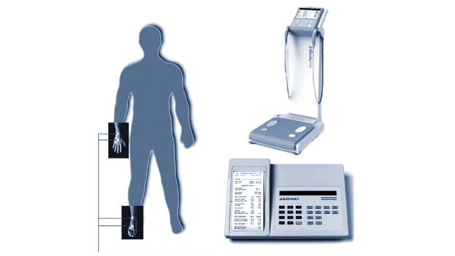

- Which one of the following is a site that is used to test males in the Jackson-Pollock nomogram method for prediction of percent body fat? (1 mark)

- Suprailiac
- Shoulder
- Triceps
- Chest

Q38. Each picture (A and B) shows a type of fitness test.
Match the fitness test to the component of fitness that is being tested (2 marks)

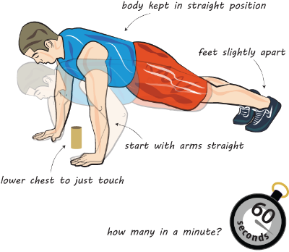
Strength
Speed
Anaerobic Power

Agility
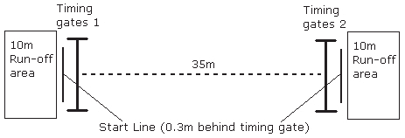
Muscular Endurance

Q39. Karen is 21 years old she has a total skinfold of 58mm.
Bob is a 35-year-old male who has a total skinfold of 75mm

Using this information, identify the appropriate rating for both Bob and Karen, using the nomogram and data table below. (2 marks)

Rating | Male | Female
Athletic | 5-10% | 8-15%
Good | 11-14% | 16-23%
Acceptable | 15-20% | 24-30%
Overweight | 21-24% | 31-36%

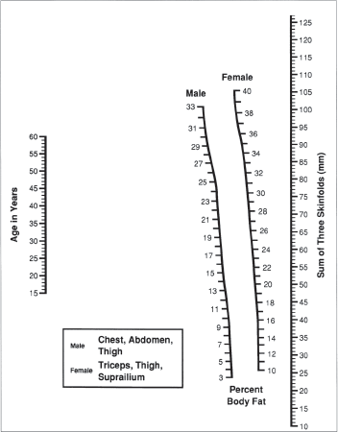

Q40. All fitness tests are usually measured using a specific type of unit.

Choose from the choices below to match the fitness test to the units they are measured in. (2 marks)

Grip Dynamometer Sit and reach test 35m Sprint

Body Mass Index (BMI) Multi-stage fitness test

Test | Units
 | Usually measured in cm
 | Usually measured in kg/m2

Q41. Maxine trains with free weights to improve her fitness. Her training routine includes lifting 6 reps of heavy weights.

- State the component of fitness that is being trained (1 mark)

Maxine also swims regularly for at least 30 minutes at a constant speed.
- State the component of fitness that is being trained (1 mark)

Q42. Badminton players need to be able to run around the court quickly and get into the right position to play shots accurately and precisely without losing their balance

- Identify the component of fitness that this is referring to (1 mark)
- Coordination
- Power
- Agility
- Reaction time

- Identify the component of fitness that is defined as ‘having an adequate range of motion in all joints of the body’

- Complete the definition (1 mark)

……………………………………………… is defined as distance divided by time taken.

- Identify the component of fitness that is defined as ‘the smooth flow of movement needed to perform a motor task efficiently and accurately’ (1 mark)

- Coordination
- Power
- Agility
- Reaction time

Q43 The basic principles of training are called the FITT Principle

- What does the F stand for in the FITT principles (1 mark)

- Fitness
- Familiar
- Facilitate
- Frequency

- State which one of the additional principles of training refers to avoiding boredom and maintaining enjoyment (1 mark)

Q44. Balance is important for many different types of sport.

Identify two types of balance (2 marks)

Q45. Ann is 30 years old and has just started an exercise programme.

- Calculate the maximal heart rate for Ann (1 mark)
- 170bpm
- 190bpm
- 160bpm
- 200bpm

- Complete the sentence below about recommended training zone for cardiovascular health and fitness (1 mark)
To increase cardiovascular fitness, a performer will need to cycle at an intensity of what percentage of Heart rate max?

- 35%
- 55%
- 75%
- 95%

Q46. Before a sports performer takes part in the multi-stage fitness test, there are a number of pre-test procedures that should be carried out. These pre-test procedures include the completion of an informed consent form and the calibration of equipment.

Explain why these two pre-test procedures should be carried out before administrating the multi-stage fitness test ( 4 marks)

Q47. Donna is a high jumper and her coach wants to test Donna’s anaerobic power. She selects the vertical jump test.

Explain one advantage and one disadvantage of using the vertical jump test to assess the anaerobic power of a high jumper (4 marks)

Q48. A school teacher selects the forestry step test to test the aerobic endurance of a group of 15-year-old girls and boys.

Describe how two pieces of equipment should be used to administer the forestry step test (4 marks)

Q49. Fiona is a personal trainer. She is deciding the best method to assess the body composition of her clients. She decides not to use the skinfold test or Bioelectrical Impedance Analysis (BIA) as there are disadvantages associated with both methods.

Explain one disadvantage of using the skinfold test and one disadvantage of using BIA to assess body composition (4 marks)

Q50. Chantel would like to test her body composition using Body Mass Index (BMI)

Select two pieces of equipment that Chantel should use to carry out a BMI test

- Weighing scales
- Grip Dynamometer
- Stopwatch
- Tape Measure
- Skinfold callipers

Q51. Ranjit is a volleyball player. He carries out plyometric to improve his explosive power.

Explain how plyometrics will help Ranjit to improve his explosive power for volleyball (2 marks)

Q52. Mark is a long jumper. His coach is planning a training programme to improve Mark’s performance.

Before planning the programme, Mark takes part in fitness tests that re relevant to his long jump performance.

Mark’s test results are shown in the table below.

Using the test results, discuss different training methods that Mark could use to improve his long jump performance (8 marks)

Fitness tests | Results | Rating
35m Sprint test | 5.10 s | Average
Vertical Jump | 42cm | Average
Sit and Reach test | -5 cm | Below Average

