Open Book Questions

Q11. Three women are running on treadmills. They have been running on the treadmills at a steady pace and moderate intensity for 60 minutes.

- Which fitness training method are they undertaking? (1 mark)

- Acceleration sprints
- Hollow Sprints
- Continuous training
- Ballistic training

The women decide to alter their running intensity by varying running speed without taking any rest.

- What is this fitness method called? (1 mark)

Q12. Table A contains the skinfold results for two different students.

Use the nomogram to predict their percent body fat and complete the information in the table. (2 marks)

Use a ruler to plot your measurements to predict the percent body fat.

Table A
Gender | Age | Skinfold results | Percent body fat
Male | 16 | 58mm
Female | 21 | 50mm

Nomogram:
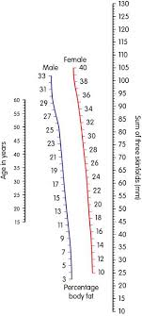

Q13. Parul is a 25-year-old female athlete.

- What is Pauls Maximum heart rate (HR Max) in beats per minute (bpm)? (1 mark)
- 185 bpm
- 200 bpm
- 195 bpm
- 245 bpm

Parul’s friend, Alex wants to improve his cardiovascular fitness. To do this, he needs to work at 60-85% of his maximum heart rate (HR Max). Alex’s HR max is 180 bpm

- Calculate Alex’s lower and upper heart rate training zones in beats per minute (bpm) (2 marks)

Q14 One important component of fitness needed for success in football is agility.

- Define the term agility (2 marks)

- Give one example of how a football player would use agility when taking part in a football game ( 1 mark)

Q15. A Basketball team take part in a multistage fitness test.

Explain two factors, which could affect the reliability of the test results, (4 marks)

Q16. Max’s BTEC group all participate in different sports.
Each week Max, their teacher takes them for a circuit training session.

Explain the advantages and disadvantages of the group using circuit training to improve their fitness for their sports (6 marks)

Q17. When training a sports performer there are 6 different components of physical fitness to consider.

Which one of these is a component of physical fitness? (1 mark)

- Aerobic Endurance
- Agility
- Balance
- Reaction Time

Q18. Diego and Amin complete fitness testing to assess their fitness for tennis.

Tennis players need high levels of strength, speed, flexibility and power to play well.

Test | Rating
 | Diego | Amin
Illinois agility run test | Average | Excellent
35m sprint | Average | Excellent
Vertical jump test | Average | Excellent
Sit and reach test | Poor | Poor

Evaluate, using the information in the table, whether Diego or Amin should use the Sam training programme to increase their fitness for tennis. (6 marks)
Q19. Fitness tests are used to determine baseline fitness levels and set realistic goals for improvement. The step test is a popular fitness test used by sports coaches and performers.

Discuss the use of the step test in determining the level of fitness of a performer (9 marks)

Q20. The picture shows a sports performer in training.

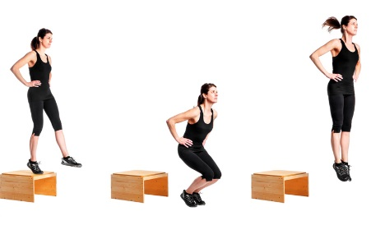

- What type of training does the picture show? (1 mark)
- Flexibility
- Plyometric
- Speed
- Endurance

- Which sports performer would benefit most from this training method? (1 mark)
- Marathon runner
- Long distance swimmer
- Basketball player
- Rugby player

Q21. Diana is a rower who has designed a training programme using the FITT principles to improve her performance.

Identify which one of the FITT principles has been applied to each statement from Diana’s training programme. (2 marks)

Write your answer in the boxes

Statement | FITT Principle
Diana will train five days a week with two rest days
For the main part of her training. Diana will use a rowing machine at an RPE of 13-15 on the Borg scale

Q22. The picture shows a piece of fitness testing equipment.

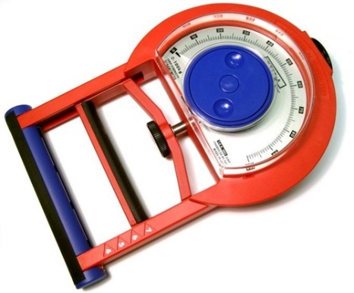

- State the name of this equipment (1 mark)

- State the component of fitness that this equipment measures (1 mark)

- Identify the body part that this equipment tests? (1 mark)

- When this equipment is used for a fitness test, what are the usual units of measurement? (1 mark)
- KgW
- Kg/m2
- Ml/kg/min
- cm

