BTEC Sport open book questions (Lesson 3)

Q23. Maximal heart rate (HR Max) is often used to help work out an athlete’s training intensity and make sure they are exercising in the right training zone.

- Which is the correct equation for working out an athlete’s HR Max? (1 mark)

- 160-age (years)
- 180- age (years)
- 220-age (years)
- 280-age (years)

- State the recommended training zone, in percentage of HR Max, for the cardiovascular health and fitness (1 mark)

Q24. The picture shows a person taking part in a fitness test.
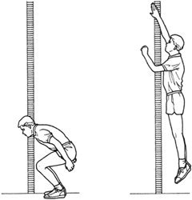

- Identify the test shown in the picture ( 1 mark)

- Vertical Jump test
- Illinois agility test
- Sit and reach test
- Bleep test

- Identify the component of fitness that this test measures

- Strength
- Speed
- Anaerobic power
- Agility

Q25. Each picture (A and B) shows a type of fitness training.
State which method of training is being used in each picture (2 marks)

- 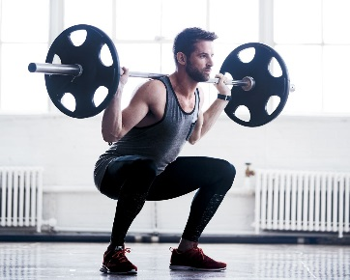 B. 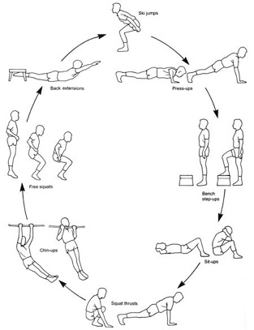

Q26. Fitness tests are used to measure different components of fitness.
Complete the following sentences, using the options in the box below, about the two components of fitness (2 marks)

……………………………………….. is measured using height and weight

……………………………………….. Is measured by counting the number of repetitions that can be completed in one minute.

Body Composition Muscular Endurance Power
Reaction Time Muscular Strength

Q27. Flexibility is important for sports performers.
- Identify the sport in which an elite performer requires the highest levels of flexibility. (1 mark)

- Gymnastics
- Rowing
- Netball
- Badminton

An elite sports performer is recovering from a muscle injury and is now undergoing a rehabilitation programme.

- Identify which method of flexibility training would be most appropriate for their rehabilitation. (1 mark)

- Active stretching
- Ballistic stretching
- PNF Stretching
- Passive stretching

Q28. A football player would need to use different types of speed training in their fitness training programme. Acceleration sprints and hollow sprints are good methods of speed training.

Explain how hollow sprint raining and acceleration sprint training could improve a footballers sporting performance. (4 marks)

Q29. A long distance cyclist plans to increase their endurance through training.

Identify the intensity they should use for their strength endurance training programme. (1 mark)

- 50-60% 1 RM and 20 reps
- 75% 1 RM and 12 reps
- 30-40% 1 RM and 15 reps
- 90% 1 RM and 12 reps

Q30. A gymnast uses balance and power to perform effectively in their sport.

Explain why balance and power are both important for a gymnast to perform a floor routine effectively. (4 marks).

Q31. Frank has taken a forestry step test.

His pulse reading after 5 minutes of stepping is 24.

- Calculate Frank’s beats per minute from his pulse reading please show your workings. ( 2 marks)

- Explain one disadvantage of using the forestry step test to measure a person’s aerobic endurance. (2 marks)

Q32. A coach is trying to improve aerobic endurance of his sports performers.

Explain using examples, how two fitness training methods can improve a sports performer’s aerobic endurance. (4 marks)

Q33. Praveen would like to take the Illinois agility run test.

Select 2 pieces of equipment from the box below that could be used to carry out the Illinois agility run test (2 marks)
Audio Player Weighing scales Tape measure Sit and reach box Stopwatch

Q34. Tyrone is going to start a strength training programme. His coach has told him that he must choose a valid test to check his progress. He chooses to do the one minute sit up test before and after the strength training programme. However, his coach tells him that this is not valid test.

Explain the validity of this test as a measure of muscular strength (2 marks)

