Core Knowledge Map
Subject: Mathematics | Year: Year 11 Higher |  | Term: Autumn 1
What are we learning?
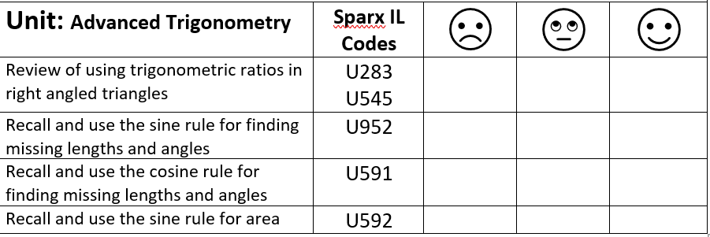
How will I be assessed
Mock exams, retrieval tasks, exit tickets.
Big questions:
How does this build on previous learning? |  | How will this link to my future learning?
Use of trigonometry in right-angled triangles.
Solving equations which include fractions.
Solving multi-step problems

Core knowledge: |  | Key vocabulary:
Need more help?

