Lesson 8 – The ‘Sublime’ in Gothic
What does ‘the sublime’ mean?
A natural event or view which is both beautiful and dangerous – creates a sense of awe and fear. The simplest way to explain ‘the sublime’ is that it creates a feeling of both AWE and TERROR. For example, somebody trying to understand the size of the universe might feel amazed and incredulous (awe) but also frightened (terror) by the idea.
- Can you give a modern example of experiencing the sublime (like the one given above)? Explain why is might count as the sublime.

- Read these extracts from Gothic novels, then answer the questions, making links to how the sublime is shown (the first one has been done for you):

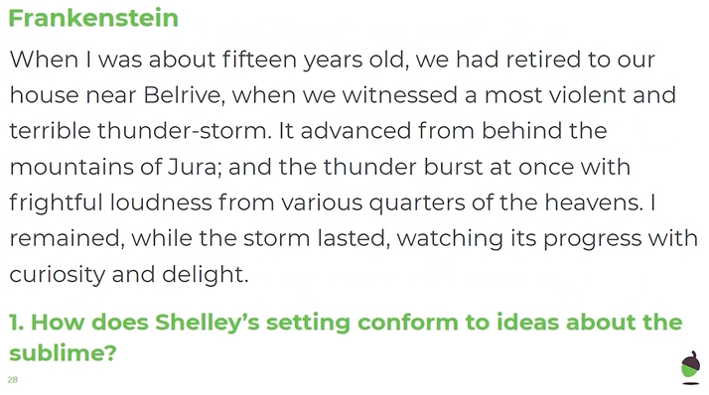
E.g. Firstly, the adjectives “violent” and “terrible” personify the storm as something dangerous, which is to be feared. Then, the nouns “curiosity” and “delight” show the awe and amazement that the narrator feels. These contrasting words are typical of the sublime because they create both a sense of fear and also of awe.

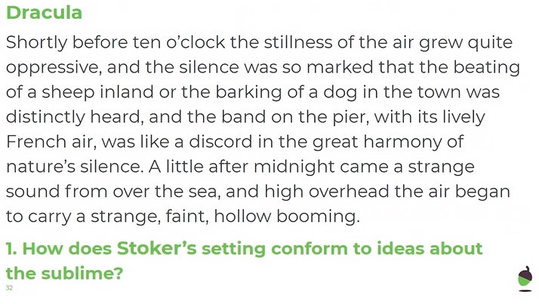

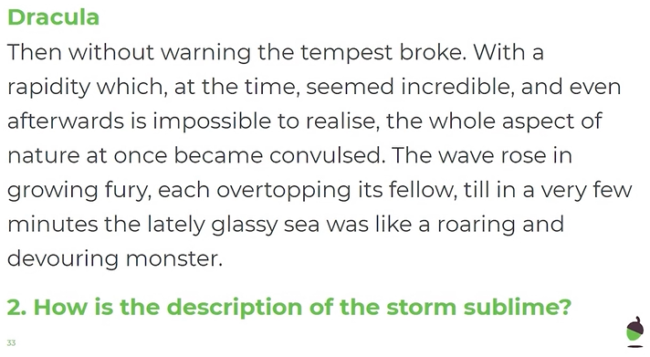

Well done!

You have completed your lesson on the sublime!

