Lesson 8: Homer, Troy and Odysseus
- Revise this information about Ancient Greece:
  - How long ago did Ancient Greece exist?
    - 700-480 B.C./over 2000 years ago

  - What was life like in Ancient Greece?
    - Simple way of life – not advanced
    - Divided into kingdoms. People tended to stay in their areas.
    - Stories were passed down orally.

  - How might people travel between two different lands and regions?
    - Typically, by sea

- Homer is given credit for writing down two of the oldest tales known to us: The Iliad and The Odyssey. Use this information to answer the questions below:
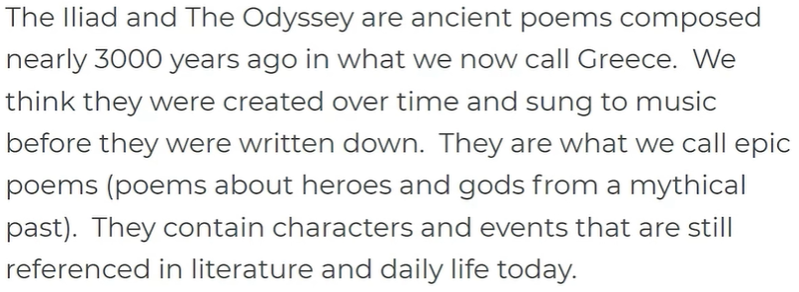
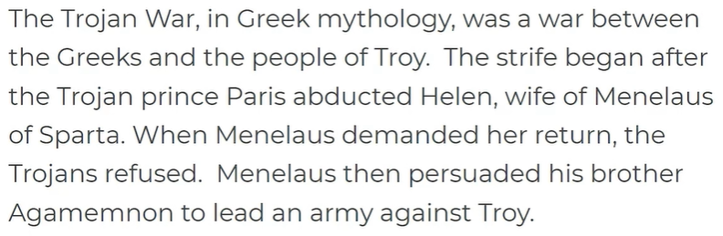
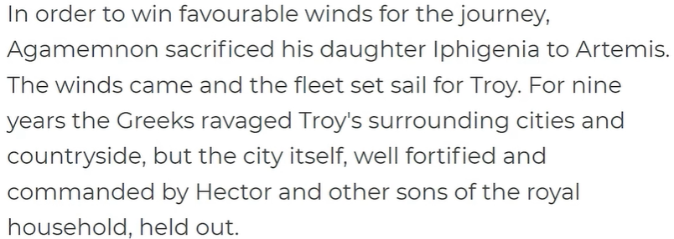
Here’s a great recap: https://www.youtube.com/watch?v=TOAraslCkgU

The Trojan War:
  - Who was the conflict between?

  - How did the war begin?

  - How long did the war go on?

Now, let’s learn about The Odyssey
- Use the information below to answer these questions:
  - What form is The Odyssey written in?

  - Who wrote The Odyssey?

  - How long does it take Odysseus to get home from the Trojan War?

  - How long has Odysseus been away from home in total?

  - What is Odysseus’ home called?

  - What does Odysseus encounter on his way home from the Trojan War?

  - Which two family members are waiting for Odysseus?

  - What is happening in Odysseus’ home?

  - What is Odysseus’ most notable quality?

  - How does The Odyssey end?

