Lesson 7 – Using Techniques
- Read/revise these key language techniques and word classes (look up the definition of any which you do not know):
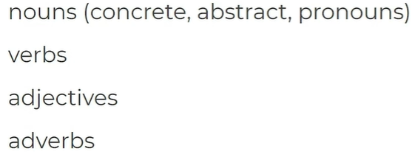
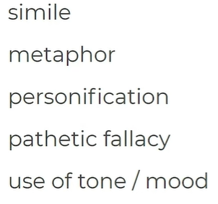

- Identify the word classes and techniques in the sentences below (you can annotate the slide):
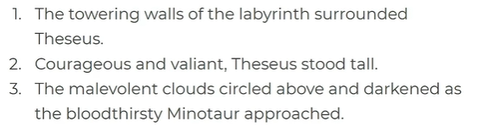
- Check your answers at the bottom of the page.

- Write your own practice sentences, including the ingredient listed below:
  - A sentence using pairs of adjectives:

  - A sentence using personification:

  - A sentence using a metaphor:

  - A sentence using powerful verbs:

- Here is the definition of ‘pathetic fallacy’:
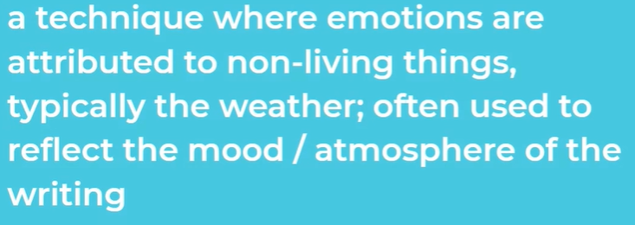

- Complete the table below to identify the effect of pathetic fallacy:

Example | Quotation (which bit is pathetic fallacy?) | Effect – why has it been used? What does it make you think about?
It was, in all, miserable weather and lowering to the spirits in the drearest month of the year. | “miserable weather”  “lowering to the spirits”  “drearest month” | “Miserable weather” implies…  “lowering to the spirits” shows that…  “Drearest month” could suggest…
I have seen temptest, when the scolding winds have rived the knotty oaks, and I have seen the ambitious ocean swell and rage and foam, to be exalted with the threatening clouds

