Lesson 6: Language Techniques
- Recall: What can you remember about what happens in the Minotaur myth?

- Read through and revise these word classes and techniques:
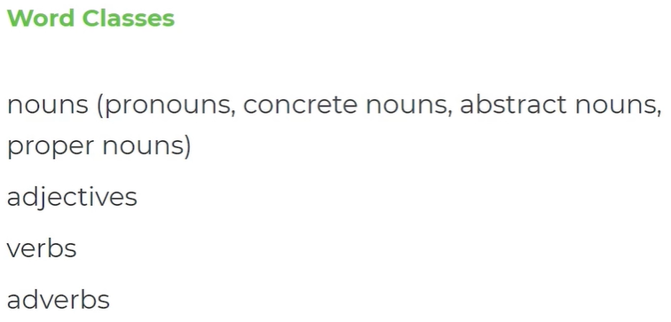
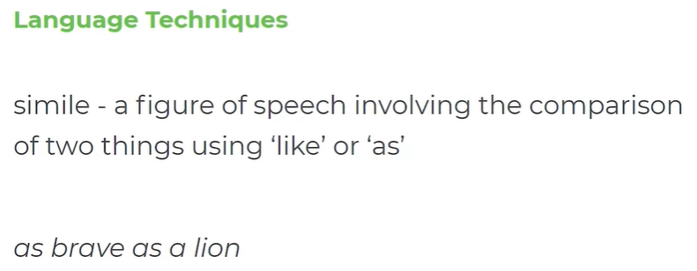
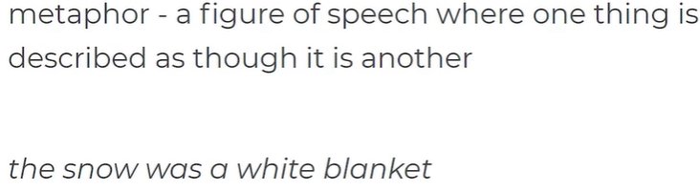
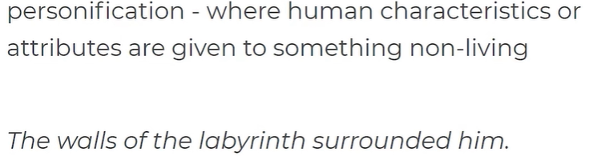

- (OPTIONAL ACTIVITY) Covering up the previous activity, can you now write down everything you can remember (from memory!) about language techniques:

- Re-read the description of the Minotaur:
  - Highlight examples of the beast as fearsome
  - Highlight/label any language techniques you notice
  - Highlight/label any interesting vocabulary choices you notice (identify the word class, too)
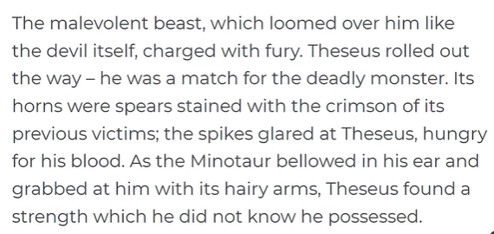

- Now, use your ideas from Question 5 to complete this table. An example has been done for you:
Quotation | Technique/word class | How does it make the Minotaur seem fearsome?
“The malevolent beast” | Adjective | This implies that the Minotaur has desires to harm Theseus and will do whatever it takes to kill him. This gives the Minotaur powerful and fearsome qualities.
- Write a What, How, Why? paragraph answering the question: How is the Minotaur described as a fearsome beast?
First, here’s the start of a paragraph for you to complete:
During the myth of Theseus and the Minotaur, the Minotaur is presented as fearsome, bloodthirsty and ruthless. The writer uses the adjectival phrase “the malevolent beast”. This implies he is fearsome because….

Now, have a go at writing your own What, How, Why? paragraph, using the other quotations from Question 6 (CHALLENGE: identify a language technique/word class):
Furthermore, the Minotaur is also portrayed as fearsome when…

