Lesson 5: The Myth of Theseus and the Minotaur
- Read this information about key characters from this myth:
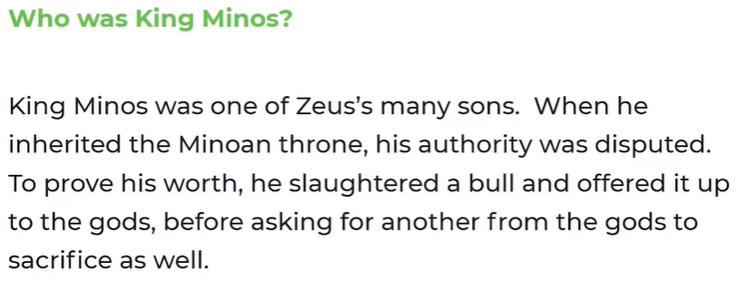
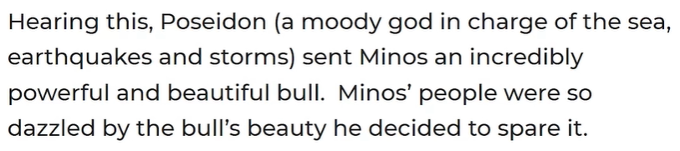
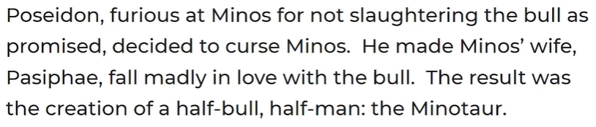
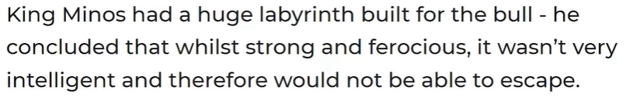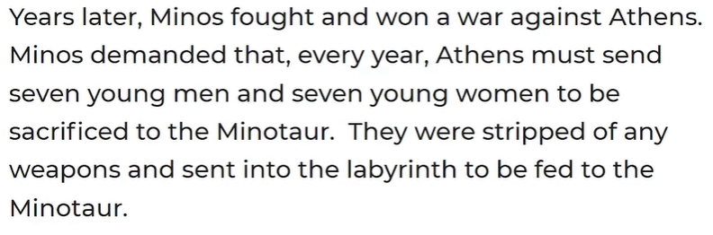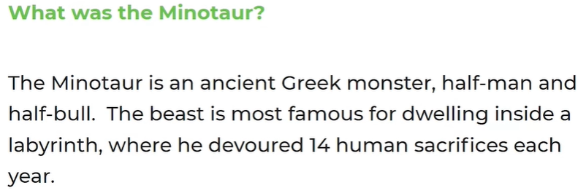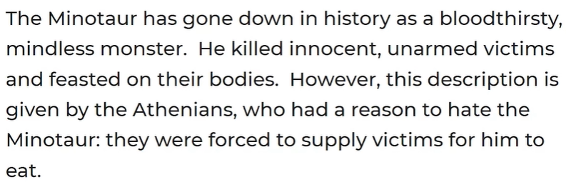
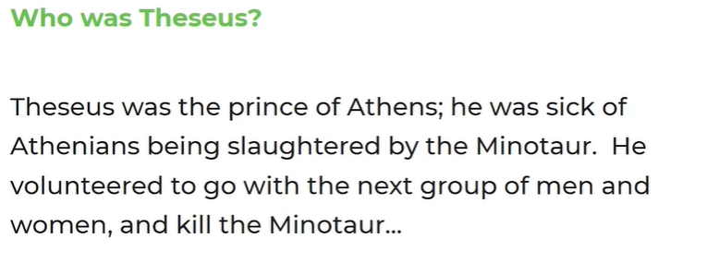
- Let’s consolidate your knowledge of these characters:
  - Make a list of the key features of the minotaur:

  - Explain how the minotaur came to exist, including where it lives now:

  - Explain who wants to come and fight the minotaur and why.

  - Which key concepts of Greek Mythology might appear in this myth? (xenia (hospitality), aristeia (heroism), moira (fate), philotimia (honour))

This is a long myth – you do not need to do it all in one lesson!

- While you read the Myth of Theseus and the Minotaur, or afterwards, answer these questions:

  - What did King Minos have built for him?

  - What did he keep in the maze?

  - Why did the king of Athens send tributes to King Minos?

  - How did Theseus say he would communicate that he was coming home safe to his father?

  - How did Ariadne help Theseus?

  - What did Theseus realise once he had defeated the Minotaur?

  - Why did Ariadne have to come back with Theseus to Athens?

  - What did Theseus decide to do with Ariadne?

  - What had Theseus forgotten to do?

  - How was Theseus punished for his treatment of Ariadne?

