Core Knowledge Map
Subject: Mathematics | Year: 10 |  | Term: Spring 1
What are we learning?
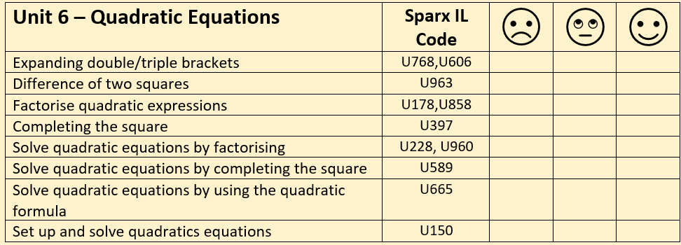
How will I be assessed
Retrieval Tasks, Exit tickets, end of half-term test.
Big questions:
Can you….?
- Describe the four methods that you can use to solve a quadratic equation.
- Factorise and solve y² + 7y + 12 = 0
- Use the formula to solve 2p² – 5p + 2 = 0 giving your solutions to 2 dp
- Derive the quadratic formula from the general form ax² + bx + c = 0
How does this build on previous learning? |  | How will this link to my future learning?
- Expanding double and triple brackets  - Factorising quadratic expressions into double brackets  - Rounding  - Solving linear equations  - Substituting into formula and rearranging. |  | - GCSE synoptic and multi-step problem solving questions  - Linear and non-linear simultaneous equations  - Quadratic graphs.  - Finding the min/max point of a quadratic function by completing the square  - A Level – quadratic equations and the discriminant are used extensively in both pure and applied maths.
Core knowledge: |  | Key vocabulary:
- To solve a quadratic equation, ensure the equation is equal to zero – rearrange if necessary.  - Quadratic formula  $$x= \frac{-b±\sqrt{b^{2}-4ac}}{2a}$$  - A quadratic equation will have none, one or two solutions.  - The discriminant is b² – 4ac and can help determine the number of solutions an equation will have. |  | Quadratic  Formula  Factorising  Solve  Root/Solution  Complete the square  Geometric interpretation  Discriminant
Need more help? Use the Sparx Independent Learning Codes above

