Lesson 4: Word Classes and Connotations
- Read through and revise the word classes below:
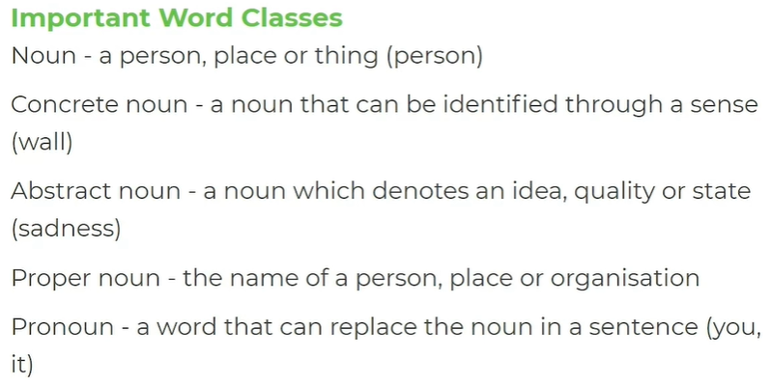
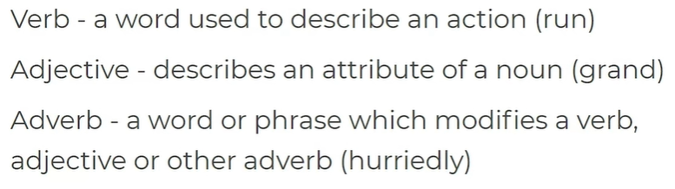
- Cover up the definitions above and have a go at remembering as many as you can from memory. Write in the definitions, too:
  - N____:

  - P_______ n_____:

  - A_______ n_____:

  - C_______ n_____:

  - V_____:

  - A_________:

  - A_________:

- Can you identify the word classes in these sentences? Label them.
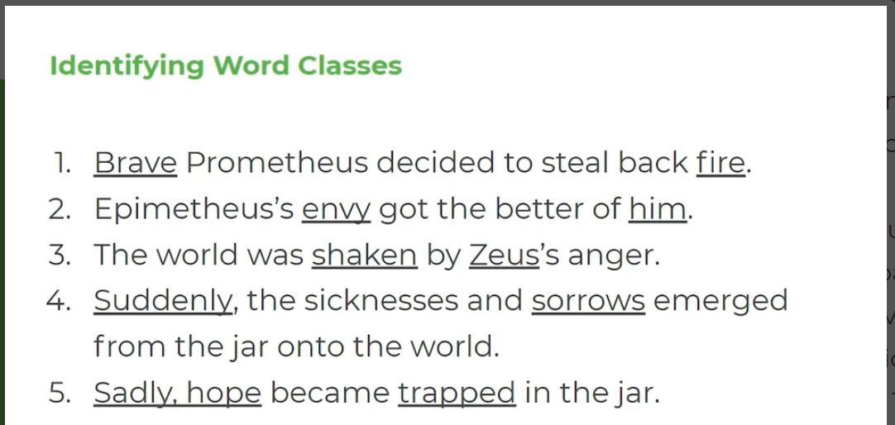

- Check your answers at the bottom of the page.

- Read the definition of ‘connotation’:

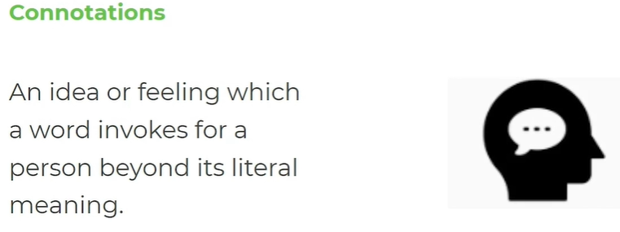

- This is an example of the connotations of ‘red’:

- What connotations come to mind based on the following words:
  - Whisper –

  - Pale –

  - Huge –

  - Crept –

  - Green –

- Complete the table with connotations from key quotations from Pandora. An example has been done for you.

Quotation | Key word and word class | Connotations and effect
“Prometheus, the courageous titan.” | ‘courageous’ - adjective | Courageous connotes a sense of heroic bravery, suggesting that Prometheus is a valiant character who is to be admired for his action in the face of difficulties.
“inquisitive and deceitful nature” (Pandora) | ‘inquisitive’ - | This connotes….
“sorrows and sicknesses”
(in the jar)
“wrath of Zeus”

