Core Knowledge Map
Subject: Mathematics | Year: 10 |  | Term: Autumn 2
What are we learning?
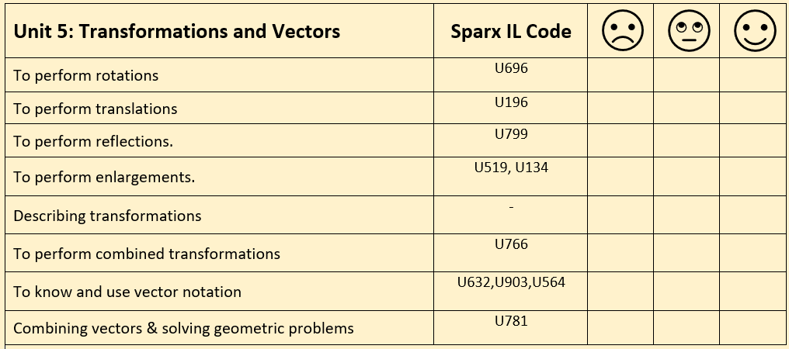
How will I be assessed
Retrieval Tasks, Exit tickets, end of half-term test.
Big questions:
Can you….?
- Write down the four bits of information you need to describe a rotation
- Tell which of these vectors are parallel? 2a + 3b, -4a + 6b, $\frac{1}{3}$(6a + 9b)
- Sketch these graphs on a coordinate graph? y = x , y = -x, x = -5, y = 8
- Write down the equations of the lines that are the coordinate axes?
- Describe the process for proving that a given line segment is a straight line using vectors?

How does this build on previous learning? |  | How will this link to my future learning?
- Reflections. (Y8)  - Link to gradient of straight lines. (Y9)  - Equations of straight line graphs.(Y9) |  | - GCSE synoptic and multi-step problem solving questions  - L2 Further Maths an AS Leel Further Maths explores vectors and matrices in more detail.  - Year 11 – transformation of graphs  - A Level – we add stretches to the family of transformations
Core knowledge: |  | Key vocabulary:
- Rotation, reflection, translation and enlargement are the four types of transformation studied at GCSE.  - A vector describes a movement in a 2D plane.  - Vectors are parallel if their vector components are a multiple of each other. |  | Transformation  Rotation  Reflection  Translation  Enlargement  Vector  Scale factor
Need more help? Use the Sparx Independent Learning Codes above

