Lesson 3: The Myth of Pandora
- Write down everything you can remember about Prometheus:

- What was Prometheus’ punishment?

- What did Zeus say he would do to mankind?

- As you read to the myth of Pandora – or afterwards – answer the following questions:

  - What was the purpose behind Zeus creating Pandora?

  - What did he ask Hephaestus to make Pandora appear like?

  - What qualities did Aphrodite gift Pandora with?

  - What kind of nature did Zeus ask Hermes to gift Pandora with?

  - What item did Pandora carry?

  - Who immediately married Pandora?

  - What had Prometheus warned Epimetheus of?

  - What was Pandora tempted into doing?

  - What emerged from the jar? What became stuck?

  - Why did Zeus carry out this punishment?

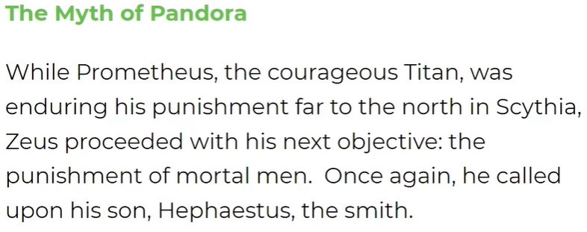
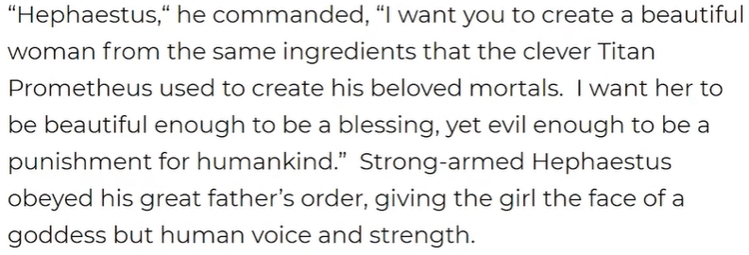
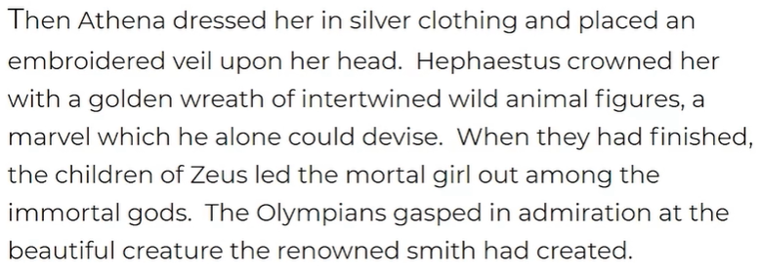
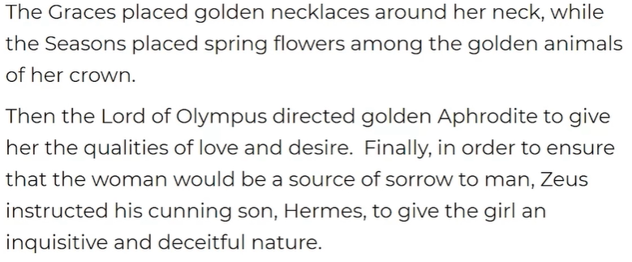
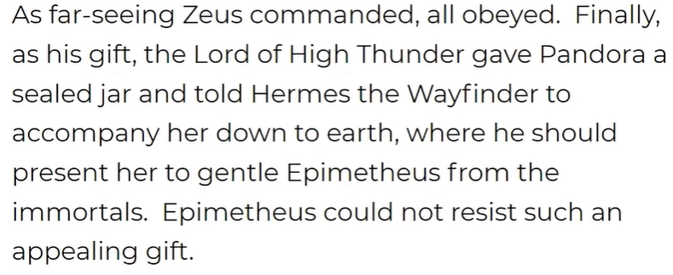
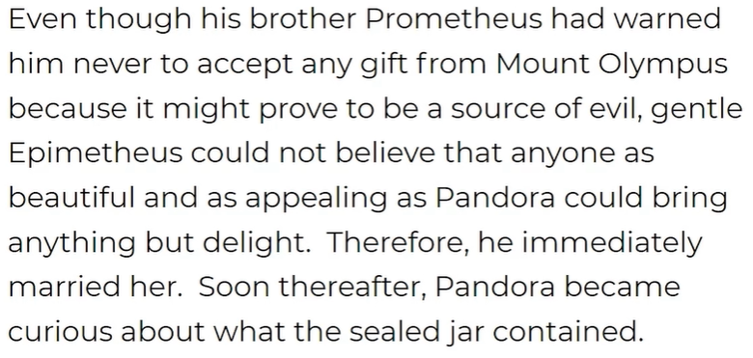
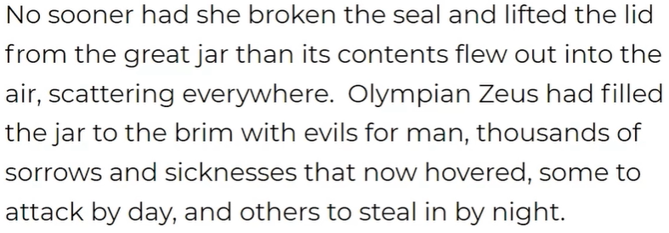
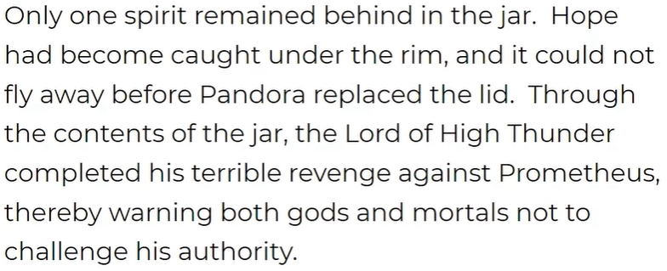

- Have a go at these more challenging questions. You’ll need to think carefully and use your own ideas:

  - Why did Zeus give Pandora beautiful qualities? What did Zeus need to make sure happened?

  - Why did Zeus give Pandora an inquisitive and deceitful nature? What did this lead to?

  - Why is it significant that Epimetheus married Pandora?

  - What kinds of sorrows and sicknesses might have been released from the jar?

  - What was the impact of ‘hope’ being stuck in the jar?

