Core Knowledge Map
Subject: Mathematics | Year: 10 |  | Term: Autumn 2
What are we learning?
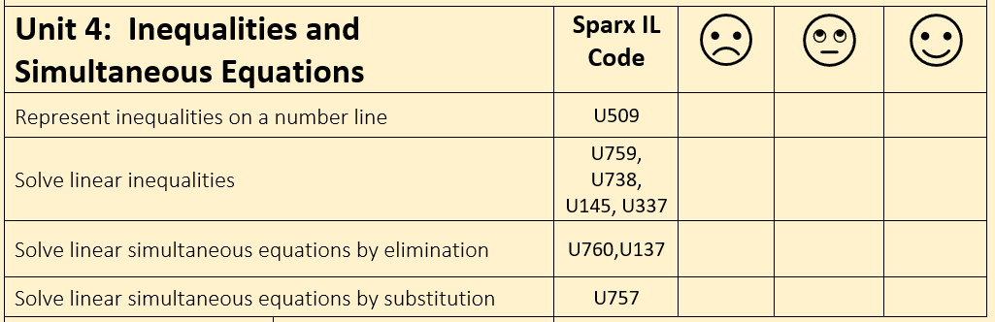
How will I be assessed
Retrieval Tasks, Exit tickets, end of half-term test.
Big questions:
Can you….?
- Represent -3 < n ≤ 2 on a number line?
- List all the integer values for n for the inequality -3 < n ≤ 2
- Solve 3y + 7 < y – 5
- Form an equation and solve: If a café sells 3 soups and 2 sandwiches for £8.10 and 5 soups and 1 sandwich for £9.30, how much will 2 soups and 3 sandwiches cost?
How does this build on previous learning? |  | How will this link to my future learning?
- Yr9 Simultaneous equations  - Substituting and solving linear equations |  | - GCSE synoptic and multi-step problem solving questions – there are often hidden simultaneous equations relating to sequences or shape questions.  - Year 11 solving simultaneous equations by substituting where one equation is linear and one is non-linear.  - Solving equations, inequations and simultaneous equations graphically.
Core knowledge: |  | Key vocabulary:
- A closed circle on a number line means < or >  - An open circle on a number line means ≤ or ≥  - When solving a pair of equations simultaneously you are finding the values of the two variables (x,y) that satisfy BOTH the equations.  - When solving an inequality, if you divide or multiply through by a negative value the direction of the inequality sign changes. |  | Inequality/Inequation  Solution  Simultaneous  Elimination  Substitution
Need more help? Use the Sparx Independent Learning Codes above

