Core Knowledge Map
Subject: Mathematics | Year: 10 |  | Term: Autumn 2
What are we learning?
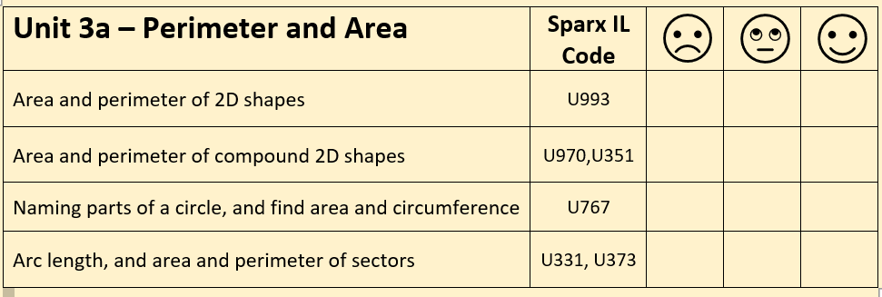
How will I be assessed
Retrieval Tasks, Exit tickets, end of half-term test.
Big questions:
Can you….?
- Draw a tangent, chord, diameter and radius on a circle?
- Describe the difference between a segment and a sector?

*Can you write an algebraic expression for the areas of both shapes? | *Can you calculate the area and the perimeter of this sector?

How does this build on previous learning? |  | How will this link to my future learning?
- Recall and use the formula for basic 2D shapes: square, rectangle, triangle, parallelogram, trapezium and circles  - Calculate the numerical value or derive an algebraic expressions for the perimeter of a 2D shape.  - Estimation |  | - Calculating volumes of prisms  - Calculating the volume of compound 3D shapes.
Core knowledge: |  | Key vocabulary:
Area of circle = $πr^{2}$  Circumference of a circle = $πD or 2πr$  Arc Length = $\frac{θ}{360} × πD$  Area of sector = $\frac{θ}{360} × πr^{2}$ |  | Perimeter  Area  Sector  Segment  Chord, tangent, diameter and radius
Need more help? Use the Sparx Independent Learning Codes above

